**Lab Exercise 6: Throughput, IP Fragmentation and Routing**

-------z5286124 Jinghan Wang

**Exercise 1: Setting up NS2 simulation for measuring TCP throughput**

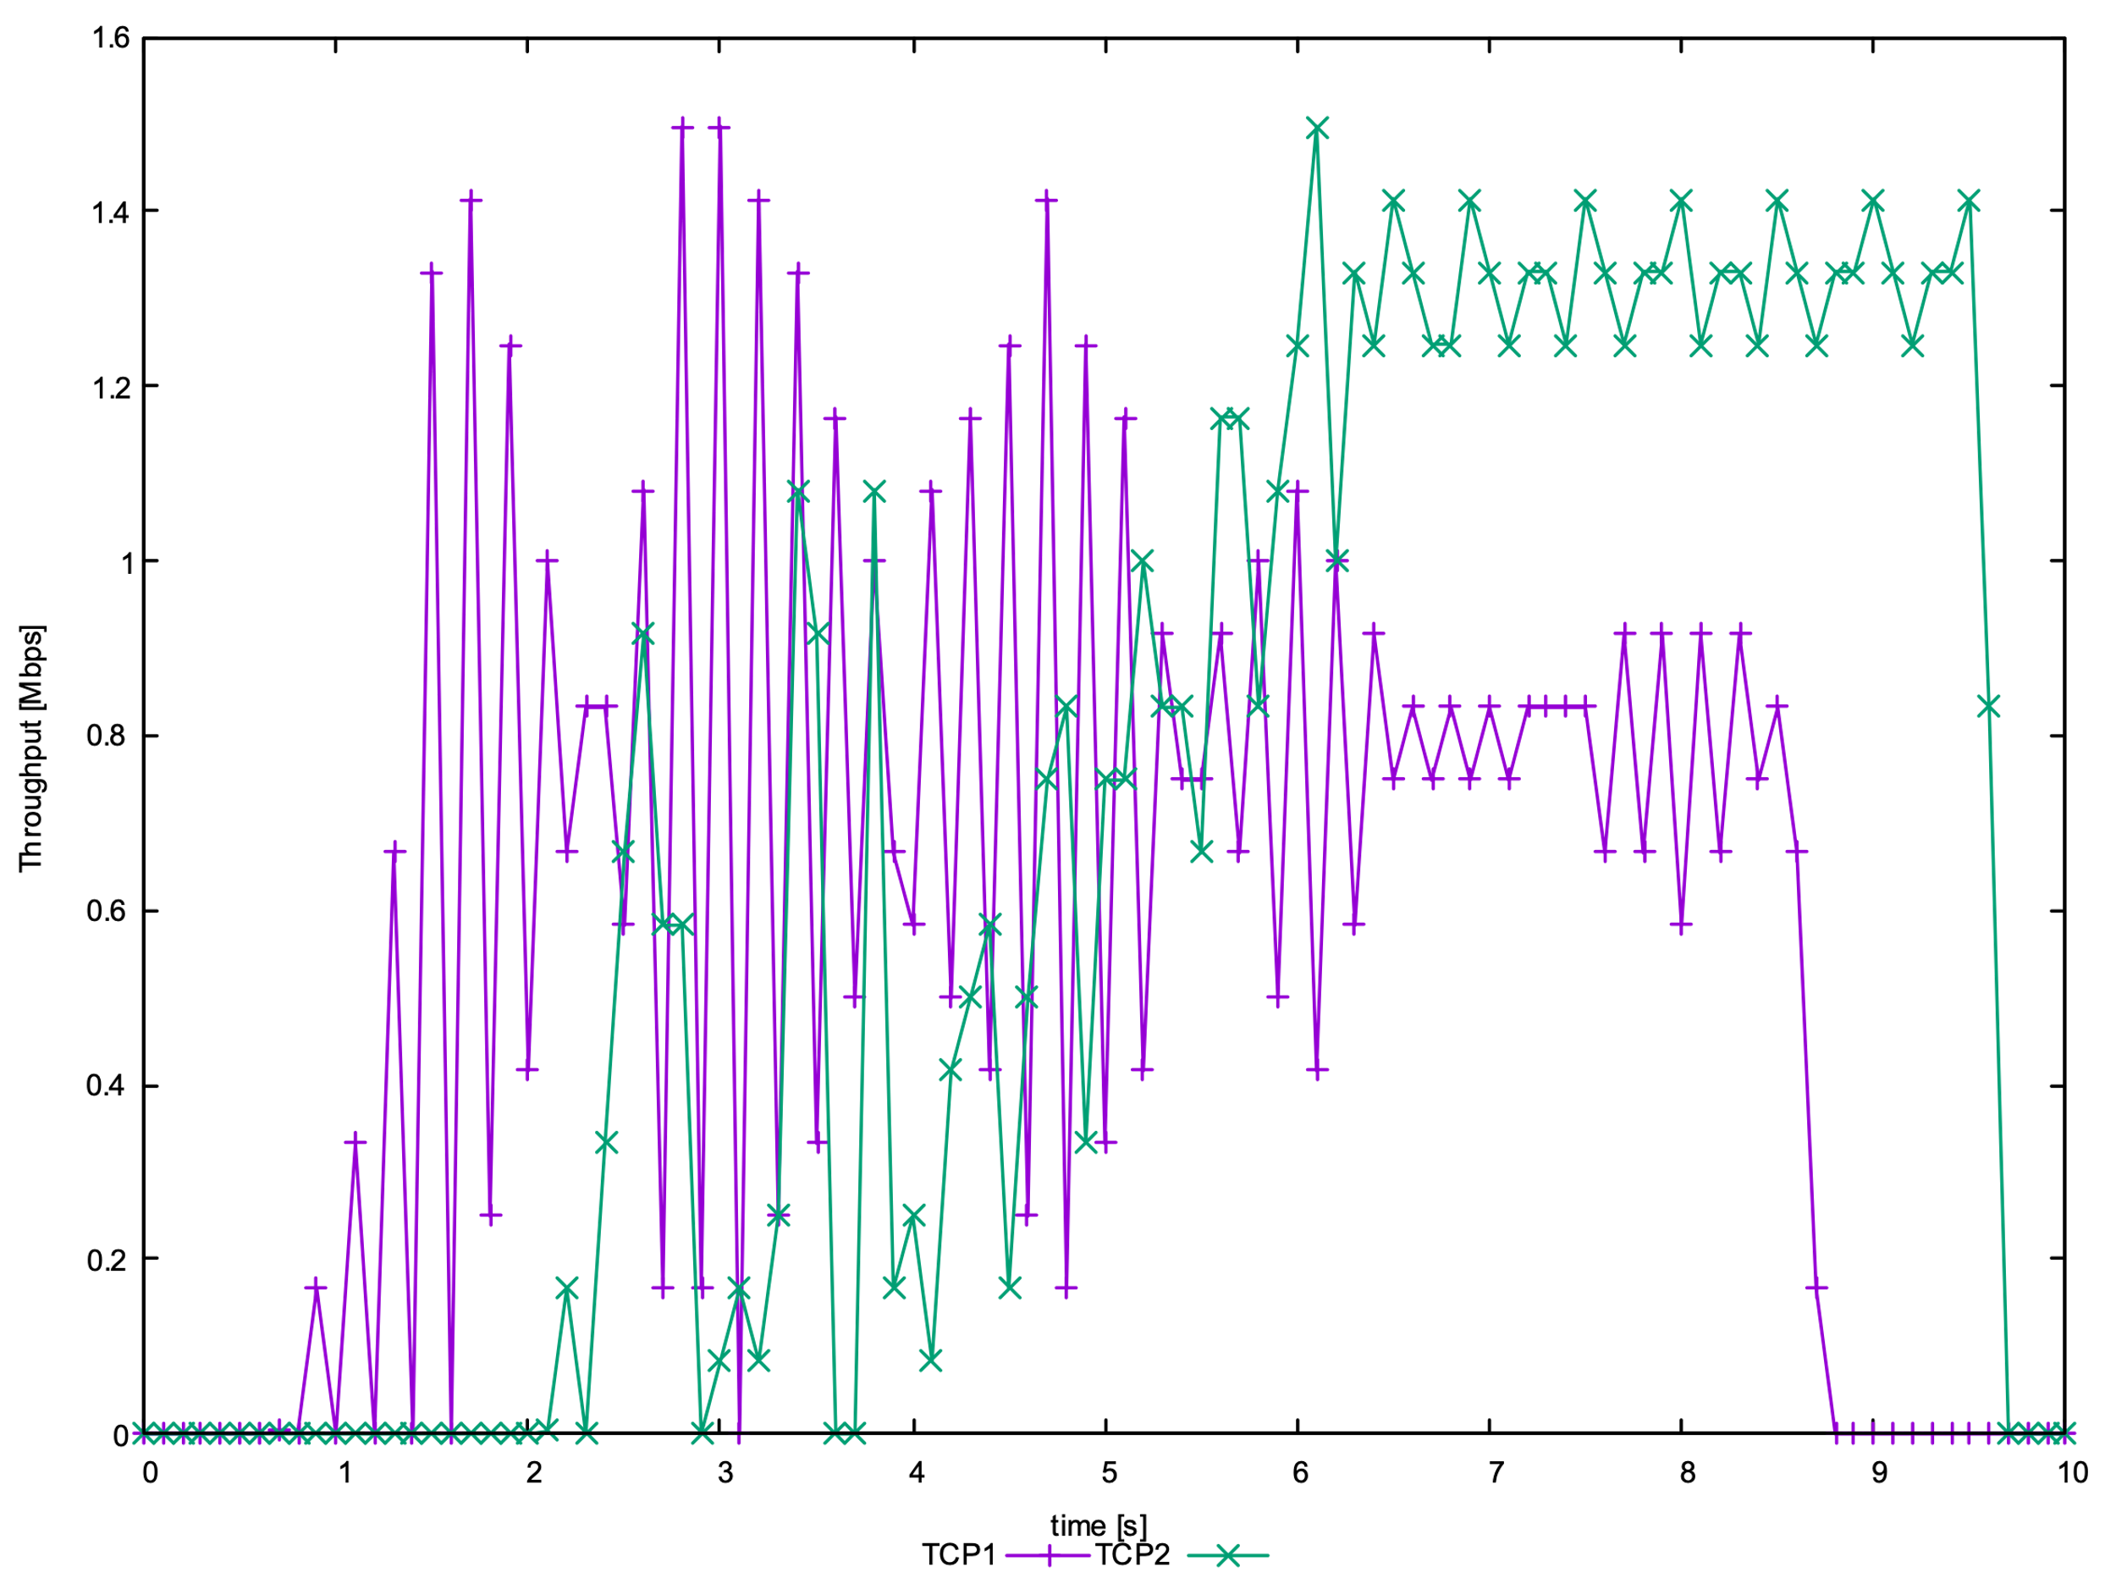

**Question 1: Why the throughput achieved by flow tcp2 is higher than tcp1 between time span 6 sec to 8 sec?**

TCP1 competes with TCP4 on n1-n2 link and completes with TCP2 on n2-n4 link. In addition, TCP2 has less RTT. Therefore, TCP2 gets more bandwidths share on n2-n4 link.

**Question 2: Why the throughput for flow tcp1 is fluctuating between time span 0.5 sec to 2 sec?**

Because TCP1 is in the slow-start stage.

**Question 3: Why is the maximum throughput achieved by anyone flow capped at around 1.5Mbps?**

About two seconds ago, TCP1 is the only flow but is in the slow-start stage. After two seconds, TCP2 adds and will share bandwidth with TCP1.

**Exercise 2: Understanding IP Fragmentation**

**Question 1: Which data size has caused fragmentation and why?**

2000 and 3500 size of data has caused fragmentation, because the max maximum transmission unit (MTU) is 1500bytes.

**Which host/router has fragmented the original datagram?**

192.168.1.103

**How many fragments have been created when the data size is specified as 2000?**

2 fragments have been created when data size is specified as 2000.

**Question 2: Did the reply from the destination 8.8.8.8. for 3500-byte data size also get fragmented? Why or why not?**

It will pass through the last link to the sender and the MTU of the last link is 1500 bytes, so it must be fragmented.

**Question 3: Give the ID, length, flag and offset values for all the fragments of the first packet sent by 192.168.1.103 with a data size of 3500 bytes?**

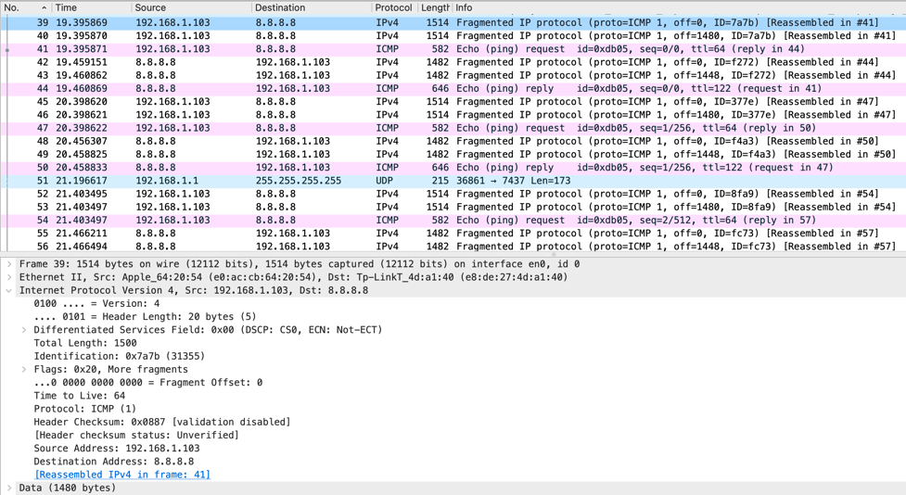

ID: 0x7a7b

length: 1500

flag: 0x20, More fragments

offset: 0

ID: 0x7a7b

length: 1500

flag: 0x20, More fragments

offset: 1480

ID: 0x7a7b

length: 568

flag: 0x01

offset: 2960

**Question 4: Has fragmentation of fragments occurred when data of size 3500 bytes has been used? Why or why not?**

No.

**Question 5: What will happen if for our example one fragment of the original datagram from 192.168.1.103 is lost?**

Because of using the Reliable Transport Protocol, the reciver checks that the fragment is incomplete and will discard it.

**Exercise 3: Understanding the Impact of Network Dynamics on Routing**

**Question 1: Which nodes communicate with which other nodes?**

Node 0 communicate with Node 5

Node 2 communicate with Node 5

**Which route do the packets follow?**

Node 0 - Node 1 - Node 4 - Node 5

Node 2 - Node 3 - Node 5

**Does it change over time?**

No, the routes do not change over time.

**Question 2: What happens at time 1.0 and at time 1.2? Does the route between the communicating nodes change as a result of that?**

When time t = 1.0, link Node 1 – Node 4 goes down. Node 0 cannot reach Node 5 and the packets are waiting at Node 1.

When time t = 1.2, link Node 1 – Node 4 goes up. The packets can reach Node 4 from Node 1.

**Question 3: Did you observe any additional traffic as compared to Step 3 above? How does the network react to the changes that take place at time 1.0 and time 1.2 now?**

Yes. When link Node 1- Node 4 goes down, Node 0 – Node 5 will change to another path (Node 0 – Node 1 – Node 2 – Node 3 – Node 5).

If the link Node 1 – Node goes up, it will revert to original path.

**Question 4: How does this change affect the routing? Explain why.**

After increasing the cost to 3 between Node 1 and Node 4, the original path (Node 0 -(1)- Node 1 -(3)- Node 4 -(1)- Node 5) cost is 5. Another path (Node 0 -(1)- Node 1 -(1)- Node 2 -(1)- Node 3 -(1)- Node 5) cost is 4. Because it prefers the lower cost, therefore, Node 0 – Node 5 will use route Node 0 – Node 1 – Node 2 – Node 3 – Node 5.

**Question 5: Describe what happens and deduce the effect of the line you just uncommented.**

After changing, the Node 0 to Node 5 (Node 0 -(1)- Node 1 -(2)- Node 4 -(1)- Node 5) cost is 4. The Node 2 to Node 5 (Node 2 -(1)- Node 3 -(3)- Node 5) cost is also equal to 4. Therefore, it will split equally on each routes.