**Tratto da url:**

<https://github.com/intersystems-ru/cache-source-control>

**cache-source-control**

The simplest source control for Caché Studio

Setup. Import SourceControl.cls.xml in target namespace. Open Management Portal and set in **Configuration/Additional Settings/Source Control/ Util.SourceControl** as source control class for the namespace. [Screenshot](https://cloud.githubusercontent.com/assets/14019396/16948872/e1667516-4dbf-11e6-85b5-632cffdf2601.PNG)

Sulla nostra insotallazione in italiano il percorso è:

Amministrazione Del Sistema -> Configurazione -> Impostazioni Aggiuntive -> Controllo Origine ->

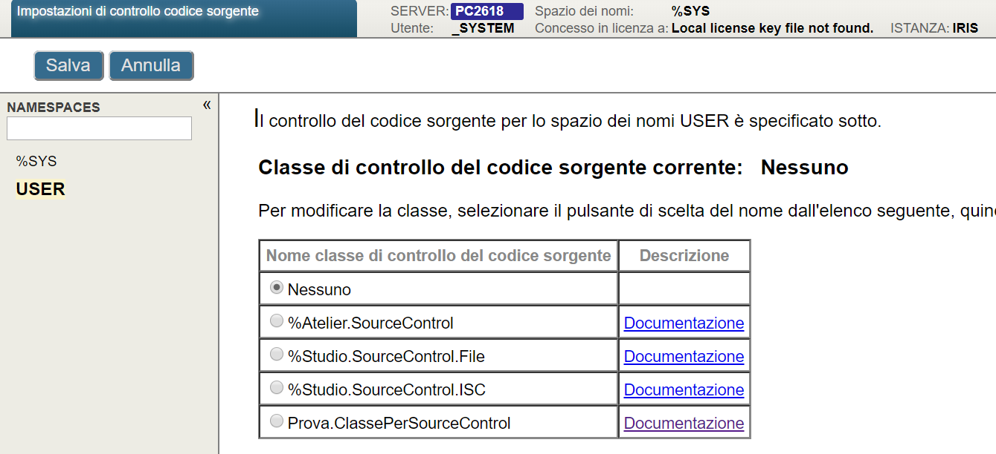

Open the terminal and run do ##class(Util.SourceControl).Init()  
It will export all the classes to the specified folder. The source control can work in three modes(XML files, new XML files(compatible with cache-tort-git), UDL)

Parameters to adjust:  
-**ExpMode**: number

0 - export in classname.xml

1 - export in classname.cls.xml (compatible with cache-tort-git)

2 - export in classname.cls (udl format)

-**SourceFolder**: string - specifies where exported files should be stored

-**RefreshTime**: number - specifies the frequency of checking for new files in the SourceFolder(in seconds)

File hierarchy:

1. **XML**:

/src

/cls

/PackageName

Classname.xml

/mac

Routine.xml

/int

SomeFile.xml

/dfi

SomeAnotherFile.xml

/inc

def.xml

1. **New XML files(compatible with cache-tort-git)**:

/src

/cls

/PackageName

Classname.cls.xml

/mac

Routine.mac.xml

/int

SomeFile.int.xml

/dfi

SomeAnotherFile.dfi.xml

/inc

def.inc.xml

1. **UDL**:

/src

/cls

/PackageName

Classname.cls

/mac

Routine.mac

/int

SomeFile.int

/dfi

SomeAnotherFile.dfi

/inc

def.inc

During your coding process it will export class from studio after every successful compilation.  
Moreover, the files that are added from an external source will be automatically imported into a project.

Sample project that shows the structure of files in UDL format: <https://github.com/RustamIbragimov/SourceControlTest>

It is very simple tool so pull requests are very welcomed.