# Using Quarto to Generate Documents in APA Style (7th Edition)

Ana Fulano1, Blanca Zutano1, Carina Mengano2,3, and Dolorita C. Perengano4

1Clinical Psychology Program, Department of Psychology, Ana and Blanca’s University

2Carina’s Primary Affiliation

3Carina’s Secondary Affiliation

4Buffalo, NY

# Author Note

Ana Fulano  http://orcid.org/0000-0000-0000-0001

Blanca Zutano  http://orcid.org/0000-0000-0000-0002

Carina Mengano  http://orcid.org/0000-0000-0000-0003

Dolorita C. Perengano  http://orcid.org/0000-0000-0000-0004

Carina Mengano is now at Generic University.

The authors have no conflicts of interest to disclose.

Author roles were classified using the Contributor Role Taxonomy (CRediT; https://credit.niso.org/) as follows: *Ana Fulano***:** conceptualization and writing – original draft. *Blanca Zutano***:** project administration and formal analysis. *Carina Mengano***:** formal analysis and writing – original draft. *Dolorita C. Perengano***:** writing – original draft, methodology, and formal analysis

Correspondence concerning this article should be addressed to Ana Fulano, Clinical Psychology Program, Department of Psychology, Ana and Blanca’s University, 1234 Capital St., Albany, NY 12084-1234, USA, Email: sm@example.org

# Abstract

This document is a template demonstrating the apaquarto format.

*Keywords*: keyword1, keyword2, keyword3

# Using Quarto to Generate Documents in APA Style (7th Edition)

This is my introductory paragraph. The title will be placed above it automatically. *Do not start with an introductory heading* (e.g., “Introduction”). The title acts as your Level 1 heading for the introduction.

Details about writing headings with markdown in APA style are [here](https://wjschne.github.io/apaquarto/writing.html#headings-in-apa-style).

## Displaying Figures

A reference label for a figure must have the prefix fig-, and in a code chunk, the caption must be set with fig-cap. Captions are in [title case](https://apastyle.apa.org/style-grammar-guidelines/capitalization/title-case).

Figure 1

The Figure Caption

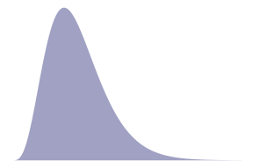

*Note*. This is the note below the figure.

To refer to any figure or table, use the @ symbol followed by the reference label (e.g., Figure 1).

## Imported Graphics

One way to import an existing graphic as a figure is to use knitr::include_graphics in a code chunk. For example, Figure 2 is an imported image. Note that in apaquarto-pdf documents, we can specify that that a figure or table should span both columns when in journal mode by setting the apa-twocolumn chunk option to true. For other formats, this distinction does not matter.

Figure 2

An Imported Graphic

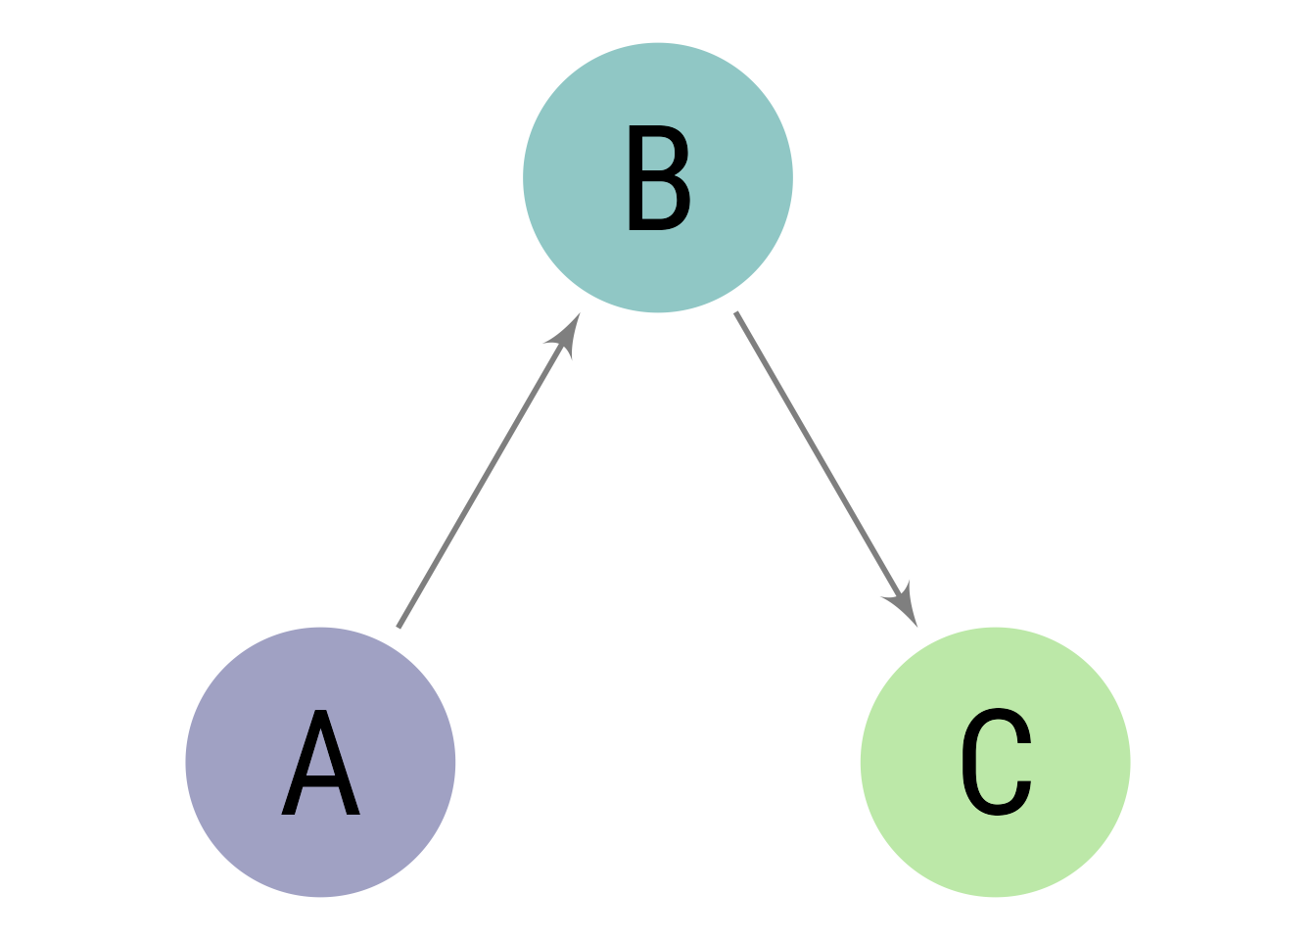

*Note*. A note below the figure

Figure graphics can be imported directly with Markdown, as with Figure 3.

Figure 3

Another Way to Import Graphics



*Note*. A note below the figure

Which style of creating figures you choose depends on preference and need.

## Displaying Tables

We can make a table the same way as a figure. Generating a table that conforms to APA format in all document formats can be tricky. When the table is simple, the kable function from knitr works well. Feel free to experiment with different methods, but I have found that David Gohel’s [flextable](https://davidgohel.github.io/flextable/) to be the best option when I need something more complex.

Table 1

The Table Caption

| Numbers | Letters |
| --- | --- |
| 1 | A |
| 2 | B |
| 3 | C |
| 4 | D |

*Note*. The note below the table.

To refer to this table in text, use the @ symbol followed by the reference label like so: As seen in Table 1, the first few numbers and letters of the alphabet are displayed.

In Table 2, there is an example of a plain markdown table with a note below it.

Table 2

Table Caption of a Markdown Table

| Default | Left | Right | Center |
| --- | --- | --- | --- |
| 12 | 12 | 12 | 12 |
| 123 | 123 | 123 | 123 |
| 1 | 1 | 1 | 1 |

*Note*. This is a note below the markdown table.

What if you want the tables and figures to be at the end of the document? In the .pdf format, you can set the floatsintext option to false. For .html and .docx documents, there is not yet an automatic way to put tables and figures at the end. You can, of course, just put them all at the end, in order. The reference labels will work no matter where they are in the text.

## Tables and Figures Spanning Two Columns in Journal Mode

When creating tables and figures in journal mode, care must be taken not to make figures and tables wider than the columns, otherwise LaTeX sometimes makes them disappear.

As demonstrated in Figure 4, you can make figures tables span the two columns by setting the apa-twocolumn chunk option to true.

Figure 4

A Figure Spanning Two Columns When in Journal Mode

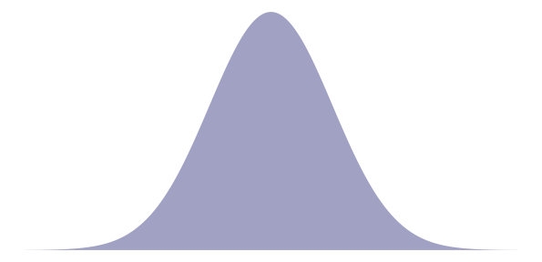

*Note*. Figures in two-column mode are only different for jou mode in .pdf documents

## Math and Equations

Inline math uses LaTeX syntax with single dollar signs. For example, the reliability coefficient of my measure is $r_{XX}=.95$.

If you want to display and refer to a specific formula, enclose the formula in two dollar signs. After the second pair of dollar signs, place the label in curly braces. The label should have an #eq- prefix. To refer to the formula, use the same label but with the @ symbol. For example, Equation 1 is Euler’s Identity, which is much admired for its elegance.

## Citations

See [here](https://quarto.org/docs/authoring/footnotes-and-citations.html) for instructions on setting up citations and references.

A parenthetical citation requires square brackets (**CameronTrivedi2013?**). This reference was in my bibliography file. An in-text citation is done like so:

(**CameronTrivedi2013?**) make some important points …

See [here](https://wjschne.github.io/apaquarto/writing.html#references) for explanations, examples, and citation features exclusive to apaquarto. For example, apaquarto can automatically handle possessive citations:

(**schneider2012cattell?**) position was …

## Masking Author Identity for Peer Review

Setting mask to true will remove author names, affiliations, and correspondence from the title page. Any references listed in the masked-citations field will be masked as well. See [here](https://wjschne.github.io/apaquarto/writing.html#masked-citations-for-anonymous-peer-review) for more information.

$$e^{iπ}+1=0 \left(1\right)$$

## Block Quotes

Sometimes you want to give a longer quote that needs to go in its own paragraph. Block quotes are on their own line starting with the > character. For example, (**austenMansfieldPark1990?**) *Mansfield Park* has some memorable insights about the mind:

If any one faculty of our nature may be called more wonderful than the rest, I do think it is memory. There seems something more speakingly incomprehensible in the powers, the failures, the inequalities of memory, than in any other of our intelligences. The memory is sometimes so retentive, so serviceable, so obedient; at others, so bewildered and so weak; and at others again, so tyrannic, so beyond control! We are, to be sure, a miracle every way; but our powers of recollecting and of forgetting do seem peculiarly past finding out. (p. 163)

If your quote has multiple paragraphs, like this passage from (**brownHowKilledPluto2012?**), separate them with a lone > character between the lines:

In the entire field of astronomy, there is no word other than *planet* that has a precise, lawyerly definition, in which certain criteria are specifically enumerated. Why does *planet* have such a definition but *star*, *galaxy*, and *giant molecular cloud* do not? Because in astronomy, as in most sciences, scientists work by concepts rather than by definitions. The concept of a star is clear; a star is a collection of gas with fusion reactions in the interior giving off energy. A galaxy is a large, bound collection of stars. A giant molecular cloud is a giant cloud of molecules. The concept of a planet—in the eight-planet solar system—is equally simple to state. A planet is a one of a small number of bodies that dominate a planetary system. That is a concept, not a definition. How would you write that down in a precise definition?

I wouldn’t. Once you write down a definition with lawyerly precision, you get the lawyers involved in deciding whether or not your objects are planets. Astronomers work in concepts. We rarely call in the attorneys for adjudication. (p. 242)

## Hypotheses, Aims, and Objectives

The last paragraph of the introduction usually states the specific hypotheses of the study, often in a way that links them to the research design.

# Method

General remarks on method. This paragraph is optional.

Not all papers require each of these sections. Edit them as needed. Consult the [Journal Article Reporting Standards](https://apastyle.apa.org/jars) for what is needed for your type of article.

## Participants

Who are they? How were they recruited? Report criteria for participant inclusion and exclusion. Perhaps some basic demographic stats are in order. A table is a great way to avoid repetition in statistical reporting.

## Measures

This section can also be titled **Materials** or **Apparatus**. Whatever tools, equipment, or measurement devices used in the study should be described.

### Measure A

Describe Measure A.

### Measure B

Describe Measure B.

#### Subscale B1.

A paragraph after a 4th-level header will appear on the same line as the header.

#### Subscale B2.

A paragraph after a 4th-level header will appear on the same line as the header.

##### Subscale B2a.

A paragraph after a 5th-level header will appear on the same line as the header.

##### Subscale B2b.

A paragraph after a 5th-level header will appear on the same line as the header.

## Procedure

What did participants do? How are the data going to be analyzed?

# Results

## Descriptive Statistics

Describe the basic characteristics of the primary variables. My ideal is to describe the variables well enough that someone conducting a meta-analysis can include the study without needing to ask for additional information.

# Discussion

Describe results in non-statistical terms.

## Limitations and Future Directions

Every study has limitations. Based on this study, some additional steps might include…

## Conclusion

Describe the main point of the paper.

# References

# Appendix

# The Title for Appendix

If there are multiple appendices, label them with level 1 headings as Appendix A, Appendix B, and so forth.

Tables and figures in the first appendix automatically get the prefix “A”, and the numbering starts again at 1. See Figure A1.

If there were a second appendix, tables and figures would get the prefix “B”, and the numbering starts again at 1. Make as many appendices as needed.

Figure A1

Appendix Figure



*Note*. A note below the figure