# Self-Conscious Emotions in Sport and Exercise: Relationships of Implicit and Explicit Processes of Authentic and Hubristic Pride and Physical Activity

Sascha Leisterer

Department of Sport Science, Leipzig University

# Author Note

Sascha Leisterer  http://orcid.org/0000-0000-0000-0001

Correspondence concerning this article should be addressed to Sascha Leisterer, Department of Sport Science, Leipzig University, Jahnallee 59, Leipzig, Saxony, Germany, Email: sascha.leisterer@uni-leipzig.de

# Abstract

Self-conscious emotions play a crucial role in sports and exercise by reflecting self-related goal achievements. Traditionally, these emotions are explained through explicit attributional processes. However, implicit processes that influence self-related goal orientation are often overlooked. This cross-sectional correlation study reveals that the implicit affiliation motive negatively correlates with authentic pride in ambitious recreational athletes. Additionally, a positive correlation exists between authentic pride and positive affect. No significant relationships were found between these emotions and physical activity. Explicit attribution styles were not associated with either pride or physical activity. Therefore, considering implicit processes in recreational athletes as potential determinants of self-conscious emotions appears to be more significant than previously thought.

*Keywords*: keyword1, keyword2, keyword3

# Self-Conscious Emotions in Sport and Exercise: Relationships of Implicit and Explicit Processes of Authentic and Hubristic Pride and Physical Activity

[1] 0

Warning in log(long_df$SessionKM_lead1): NaNs wurden erzeugt

# Method

Kipchoge (March 6, 2020) R Core Team (2024)

## Analysis

We excluded participants manually if they reported data on less than two training sessions, if they did not participate in a structured training programme, or if they were neither runners nor triathletes. The baseline kilometer variable were standardized within their respective sport group, that is, running vs. triathlon. 17 of data were missings. Since most of the incomplete date was due to training sessions that were not completed, we decided against multiple imputation, following the reccomendations of [Lit]. Descriptive statistics were calculated for all variables - descriptive statistics - correlation

For the hierarchical linear models,the time-varying predictors pride and positive affect were group-mean centered, and the stable predictors attribution style (globality, dynamics, locus) and implicit motives (achievement, affiliation, power) were grand mean centered. This procedure entangles the between-person-effects from the within-person-effects. This is in line with recommendations of Wang and Maxwell (2015). They authors emphasize that a within-person effect can be present regardless of the between-person-effect, and vice versa. To illustrate this, it is possible that within a person, a lack of pride after a run predicts the running distance in the next running session. At the same time, people who less proud on average do not necessarily run more. ## Participants

The participants were 35.85 old on average (*SD* = 12.89) ranging from 20 to 60 years

## Measures

## Procedure

# Results

Correlations are shown in Figure 1.

The results for the Hierarchical Linear Models are presented separately for each the dependent variables of this study: Session distance, session duration and rate of perceived exhaustion.

## Session distance

In this model, we used interaction terms of pride with positive affect, causal attribution and implicit motives to predict running distance. The running distance was z-standardized to allow a comparison between the kilometer values reported by swimmers, runners, and triathlets. To allow We added predictors to the null model in three steps: First, the interaction term of pride and positive affect, second, the interaction terms of pride and attribution styles, and third, interaction terms of pride and implicit motives. The result is shown in Table 2.

The residuals were normally distributed (*p* = 0.11 ). Figure 2 shows the deviation from the normal distribution along with the distribution of residuals. The latter should show no pattern, since this would indicate that there are predictors unaccounted for. While this seems to be the case, the residuals are slightly skewed to the left, indicating limited variance in the kilometer variable.

## Session duration

In this model, we used interaction terms of pride with positive affect, causal attribution and implicit motives to predict running distance. The running distance was z-standardized to allow a comparison between the kilometer values that triathletes reported, and those that were reported by runners. We added predictors to the null model in three steps: First, the interaction term of pride and positive affect, second, the interaction terms of pride and attribution styles, and third, interaction terms of pride and implicit motives. The result is shown in Table 3.

The residuals were normally distributed (*p* = 0.32 ). Figure 3 shows the deviation from the normal distribution along with the distribution of residuals. The latter should show no pattern, since this would indicate that there are predictors unaccounted for. While this seems to be the case, the residuals are slightly skewed to the left, indicating limited variance in the kilometer variable.

## Session Rate of Perceived Exhaustion

In this model, we used interaction terms of pride with positive affect, causal attribution and implicit motives to predict the rate of perceived exhaustion. The running distance was z-standardized to allow a comparison between the kilometer values that triathletes reported, and those that were reported by runners. We added predictors to the null model in three steps: First, the interaction term of pride and positive affect, second, the interaction terms of pride and attribution styles, and third, interaction terms of pride and implicit motives. The result is shown in Table 3.

The residuals were normally distributed in a Kolmogorov-Smirnov test (*p* = 0.13 ). This test is less sensitivie to small deviations from the norm [LIT]. Figure 3 shows the deviation from the normal distribution in a QQ-Plot along with the distribution of residuals. The linear patterns that emerge in the residuals are a result of the discrete values in the session RPE data.

To assess multicollinearity, we computed the variance influence factor which ranged from *vifmin* = 1.09 to *vifmax* = 2.72.

Table 1

The Table Caption

|  | **Correlations** | | | | | | | | | | | | | | | | | | |
| --- | --- | --- | --- | --- | --- | --- | --- | --- | --- | --- | --- | --- | --- | --- | --- | --- | --- | --- | --- |
| **Measure** | **1** | **2** | **3** | **4** | **5** | **6** | **7** | **8** | **9** | **10** | **11** | **12** | **13** | **14** | **15** | **16** | **17** | **18** | **19** |
| 1. Pride |  |  |  |  |  |  |  |  |  |  |  |  |  |  |  |  |  |  |  |
| 2. Hubris | 0 |  |  |  |  |  |  |  |  |  |  |  |  |  |  |  |  |  |  |
| 3. Session Training Distance | -0.01 | 0.1 |  |  |  |  |  |  |  |  |  |  |  |  |  |  |  |  |  |
| 4. Session Training Hours | 0.22 | -0.41 | 0.22 |  |  |  |  |  |  |  |  |  |  |  |  |  |  |  |  |
| 5. Session Training RPE | 0.32 | 0.21 | 0.15 | -0.02 |  |  |  |  |  |  |  |  |  |  |  |  |  |  |  |
| 6. Positive Affect | 0.67** | 0.16 | 0.06 | 0.01 | 0.2 |  |  |  |  |  |  |  |  |  |  |  |  |  |  |
| 7. Negative Affect | 0.1 | 0.47* | -0.01 | 0.09 | 0.42 | 0.09 |  |  |  |  |  |  |  |  |  |  |  |  |  |
| 8. Achievement | -0.1 | -0.26 | -0.09 | 0.39 | -0.24 | -0.19 | -0.17 |  |  |  |  |  |  |  |  |  |  |  |  |
| 9. Affiliation | -0.06 | 0.01 | 0 | 0.48* | -0.26 | -0.04 | 0.13 | 0.47* |  |  |  |  |  |  |  |  |  |  |  |
| 10. Power | -0.29 | 0.26 | 0.48* | 0.04 | 0.16 | -0.23 | 0.08 | 0.3 | -0.26 |  |  |  |  |  |  |  |  |  |  |
| 11. Hope for Success | 0.46 | -0.1 | -0.3 | 0.12 | 0 | 0.17 | -0.2 | -0.1 | -0.18 | -0.2 |  |  |  |  |  |  |  |  |  |
| 12. Fear of Failure | -0.25 | -0.01 | -0.19 | -0.23 | -0.02 | -0.15 | 0.18 | 0.28 | 0.12 | 0.28 | -0.15 |  |  |  |  |  |  |  |  |
| 13. Hope for Belonging | 0.32 | 0.04 | 0.16 | 0.21 | -0.16 | 0.14 | -0.22 | 0.18 | -0.03 | -0.05 | 0.19 | 0.19 |  |  |  |  |  |  |  |
| 14. Fear of Rejection | -0.3 | 0.36 | -0.32 | -0.41 | 0.07 | -0.25 | 0.32 | 0.07 | -0.03 | 0.16 | 0 | 0.61* | -0.24 |  |  |  |  |  |  |
| 15. Hope for Control | -0.24 | -0.13 | 0.07 | 0.01 | -0.27 | -0.38 | -0.48* | -0.03 | -0.35 | 0.3 | 0.14 | 0.12 | 0.35 | -0.2 |  |  |  |  |  |
| 16. Fear of Loss of Control | -0.05 | -0.11 | -0.04 | -0.31 | 0.09 | -0.14 | 0.02 | 0.01 | 0.06 | -0.03 | -0.04 | 0.68** | 0.05 | 0.22 | -0.14 |  |  |  |  |
| 17. Locus | 0.17 | -0.09 | -0.49* | 0.02 | -0.15 | 0.4 | -0.3 | 0.15 | 0.09 | -0.28 | 0.4 | -0.04 | 0.01 | 0.03 | 0.04 | -0.09 |  |  |  |
| 18. Dynamics | 0.04 | 0 | -0.2 | 0.35 | -0.17 | -0.2 | 0.15 | 0.04 | 0.33 | -0.18 | 0.29 | -0.19 | 0.05 | -0.01 | -0.19 | 0.22 | 0.16 |  |  |
| 19. Controllability | -0.02 | 0.24 | 0.34 | -0.23 | 0.51* | -0.02 | 0.37 | -0.31 | -0.28 | 0.24 | -0.2 | 0.27 | 0.18 | -0.09 | -0.13 | 0.39 | -0.68** | -0.13 |  |

*Note*. The note below the table.

Table 2

Hierarchical Linear Model Coefficients Predicting Running Distance

|  |  |  |  |  |  |  |  |  |
| --- | --- | --- | --- | --- | --- | --- | --- | --- |
|  | Nullmodell | | Model 1 | | Model 2 | | Model 3 | |
| (Intercept) | 0.02 | (0.15) | -0.03 | (0.17) | 0.05 | (0.19) | -0.02 | (0.19) |
| Pride |  |  | 0.22 | (0.46) | -0.36 | (0.64) | -0.48 | (0.68) |
| Positive Affect |  |  | -0.01 | (0.33) | 0.22 | (0.38) | 0.31 | (0.37) |
| Dynamics |  |  |  |  | -0.20 | (0.29) | -0.39 | (0.30) |
| Locus |  |  |  |  | 0.01 | (0.27) | 0.17 | (0.30) |
| Globality |  |  |  |  | -0.05 | (0.13) | -0.10 | (0.14) |
| Affiliation |  |  |  |  |  |  | 0.00 | (0.04) |
| Achievement |  |  |  |  |  |  | -0.01 | (0.05) |
| Power |  |  |  |  |  |  | 0.03 | (0.06) |
| Pride × Dynamics |  |  |  |  | 1.34 | (1.06) | 1.92 | (1.07) |
| Pride × Positive Affect |  |  | 0.60 | (0.81) | 0.02 | (0.94) | -0.17 | (0.98) |
| Pride × Locus |  |  |  |  | -0.31 | (0.50) | -1.02 | (0.61) |
| Pride × Globality |  |  |  |  | 0.20 | (0.38) | -0.09 | (0.43) |
| Pride × Affiliation |  |  |  |  |  |  | -0.17 | (0.11) |
| Pride × Achievement |  |  |  |  |  |  | 0.16 | (0.11) |
| Pride × Power |  |  |  |  |  |  | -0.25 | (0.13) |
| nobs | 59 |  | 59 |  | 59 |  | 57 |  |
| nobs.1 | 59.00 |  | 59.00 |  | 59.00 |  | 57.00 |  |
| sigma | 0.79 |  | 0.80 |  | 0.83 |  | 0.77 |  |
| logLik | -75.40 |  | -75.60 |  | -75.39 |  | -76.99 |  |
| AIC | 156.79 |  | 163.20 |  | 174.78 |  | 189.98 |  |
| BIC | 163.02 |  | 175.24 |  | 197.48 |  | 220.82 |  |
| deviance | 150.79 |  |  |  |  |  |  |  |
| df.residual | 42.00 |  | 39.00 |  | 36.00 |  | 32.00 |  |
| *** p < 0.001; ** p < 0.01; * p < 0.05. | | | | | | | | |

*Note*. Time varying predictors Pride and Positive Affect were cluster-mean-centered, fixed predictors were grand mean centered. In Model 4, the dependent variable was log-transformed to address heteroscedasticity and normality of residues. The fit indices of Model 4 are not directly comparable to models 1-3.

Table 3

Hierarchical Linear Model Coefficients Predicting Running Time

|  |  |  |  |  |  |  |  |  |
| --- | --- | --- | --- | --- | --- | --- | --- | --- |
|  | Nullmodell | | Model 1 | | Model 2 | | Model 3 | |
| (Intercept) | **4.22 \*\*\*** | **(0.13)** | **4.20 \*\*\*** | **(0.14)** | **4.26 \*\*\*** | **(0.14)** | **4.21 \*\*\*** | **(0.14)** |
| Pride |  |  | -0.25 | (0.30) | -0.28 | (0.30) | -0.30 | (0.28) |
| Positive Affect |  |  | -0.11 | (0.24) | -0.13 | (0.24) | -0.12 | (0.22) |
| Dynamics |  |  |  |  | -0.19 | (0.20) | -0.36 | (0.21) |
| Locus |  |  |  |  | -0.19 | (0.22) | -0.04 | (0.24) |
| Globality |  |  |  |  | 0.00 | (0.11) | -0.04 | (0.12) |
| Affiliation |  |  |  |  |  |  | 0.03 | (0.04) |
| Achievement |  |  |  |  |  |  | 0.01 | (0.05) |
| Power |  |  |  |  |  |  | 0.04 | (0.05) |
| Pride × Dynamics |  |  |  |  | -0.08 | (0.30) | 0.37 | (0.32) |
| Pride × Positive Affect |  |  | 0.16 | (0.23) | -0.23 | (0.27) | **-0.61 \*** | **(0.28)** |
| Pride × Locus |  |  |  |  | -0.54 | (0.28) | **-1.02 \*\*** | **(0.31)** |
| Pride × Globality |  |  |  |  | -0.40 | (0.23) | **-0.65 \*\*** | **(0.23)** |
| Pride × Affiliation |  |  |  |  |  |  | -0.10 | (0.07) |
| Pride × Achievement |  |  |  |  |  |  | **0.25 \*\*\*** | **(0.07)** |
| Pride × Power |  |  |  |  |  |  | -0.16 | (0.09) |
| nobs | 77 |  | 77 |  | 77 |  | 72 |  |
| nobs.1 | 77.00 |  | 77.00 |  | 77.00 |  | 72.00 |  |
| sigma | 0.67 |  | 0.64 |  | 0.62 |  | 0.58 |  |
| logLik | -87.57 |  | -87.57 |  | -86.71 |  | -85.84 |  |
| AIC | 181.14 |  | 187.13 |  | 197.42 |  | 207.68 |  |
| BIC | 188.18 |  | 200.88 |  | 223.88 |  | 244.13 |  |
| deviance | 175.14 |  |  |  |  |  |  |  |
| df.residual | 58.00 |  | 55.00 |  | 52.00 |  | 45.00 |  |
| *** p < 0.001; ** p < 0.01; * p < 0.05. | | | | | | | | |

*Note*. Time varying predictors Pride and Positive Affect were cluster-mean-centered, fixed predictors were grand mean centered. In Model 4, the dependent variable was log-transformed to address heteroscedasticity and normality of residues. The fit indices of Model 4 are not directly comparable to models 1-3.

Table 4

Hierarchical Linear Model Coefficients Predicting Session Rate of Perceived Exhaustion

|  |  |  |  |  |  |  |  |  |
| --- | --- | --- | --- | --- | --- | --- | --- | --- |
|  | Nullmodell | | Model 1 | | Model 2 | | Model 3 | |
| (Intercept) | **5.17 \*\*\*** | **(0.30)** | **5.28 \*\*\*** | **(0.32)** | **5.35 \*\*\*** | **(0.30)** | **5.42 \*\*\*** | **(0.36)** |
| Pride |  |  | -0.61 | (0.82) | -1.24 | (0.81) | -1.39 | (0.80) |
| Positive Affect |  |  | -0.95 | (0.66) | -0.91 | (0.64) | -0.81 | (0.63) |
| Dynamics |  |  |  |  | **-1.19 \*\*** | **(0.40)** | **-1.38 \*** | **(0.52)** |
| Locus |  |  |  |  | 0.22 | (0.44) | 0.27 | (0.58) |
| Globality |  |  |  |  | 0.17 | (0.22) | 0.26 | (0.29) |
| Affiliation |  |  |  |  |  |  | 0.03 | (0.09) |
| Achievement |  |  |  |  |  |  | -0.10 | (0.11) |
| Power |  |  |  |  |  |  | -0.00 | (0.12) |
| Pride × Dynamics |  |  |  |  | -1.36 | (0.80) | -0.05 | (0.90) |
| Pride × Positive Affect |  |  | -0.87 | (0.62) | **-1.41 \*** | **(0.69)** | **-2.10 \*\*** | **(0.77)** |
| Pride × Locus |  |  |  |  | -1.18 | (0.74) | **-2.70 \*\*** | **(0.87)** |
| Pride × Globality |  |  |  |  | 1.07 | (0.61) | 0.42 | (0.65) |
| Pride × Affiliation |  |  |  |  |  |  | **-0.52 \*** | **(0.20)** |
| Pride × Achievement |  |  |  |  |  |  | **0.54 \*\*** | **(0.19)** |
| Pride × Power |  |  |  |  |  |  | **-0.49 \*** | **(0.24)** |
| nobs | 78 |  | 77 |  | 77 |  | 72 |  |
| nobs.1 | 78.00 |  | 77.00 |  | 77.00 |  | 72.00 |  |
| sigma | 1.82 |  | 1.76 |  | 1.68 |  | 1.64 |  |
| logLik | -163.77 |  | -157.41 |  | -149.08 |  | -142.80 |  |
| AIC | 333.54 |  | 326.83 |  | 322.17 |  | 321.59 |  |
| BIC | 340.61 |  | 340.57 |  | 348.62 |  | 358.05 |  |
| deviance | 327.54 |  |  |  |  |  |  |  |
| df.residual | 59.00 |  | 55.00 |  | 52.00 |  | 45.00 |  |
| *** p < 0.001; ** p < 0.01; * p < 0.05. | | | | | | | | |

*Note*. Time varying predictors Pride and Positive Affect were cluster-mean-centered, fixed predictors were grand mean centered. In Model 4, the dependent variable was log-transformed to address heteroscedasticity and normality of residues. The fit indices of Model 4 are not directly comparable to models 1-3.

# Discussion

The variance influence factors suggest low multicollinearity (for a discussion see O’brien, 2007), which is also evident from the correlation table.

## Limitations and Future Directions

## Conclusion

# References

Kipchoge, E. [@kipchogeeliud]. (March 6, 2020). *"I am so proud to win in the streets of Tokyo, where the people have running in their heart and minds.* [Photograph] Instagram. <https://www.instagram.com/p/CavzZYZIbGo>

O’brien, R. M. (2007). A caution regarding rules of thumb for variance inflation factors. *Quality &Amp; Quantity*, *41*(5), 673–690. <https://doi.org/10.1007/s11135-006-9018-6>

R Core Team. (2024). *R: A language and environment for statistical computing*. R Foundation for Statistical Computing. <https://www.R-project.org/>

Wang, L. (Peggy)., & Maxwell, S. E. (2015). On disaggregating between-person and within-person effects with longitudinal data using multilevel models. *Psychological Methods*, *20*(1), 63–83. <https://doi.org/10.1037/met0000030>

Figure 1

Heatmap

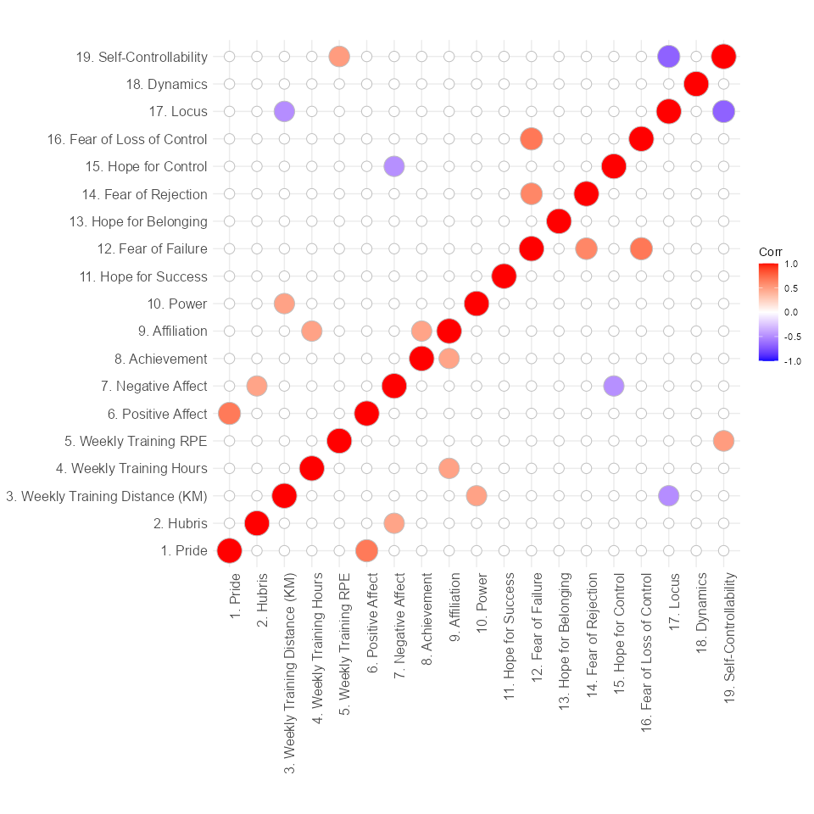

*Note*. This is the note below the figure.

Figure 2

Histogram and QQ-Plot of Residuals for the running Distance Model

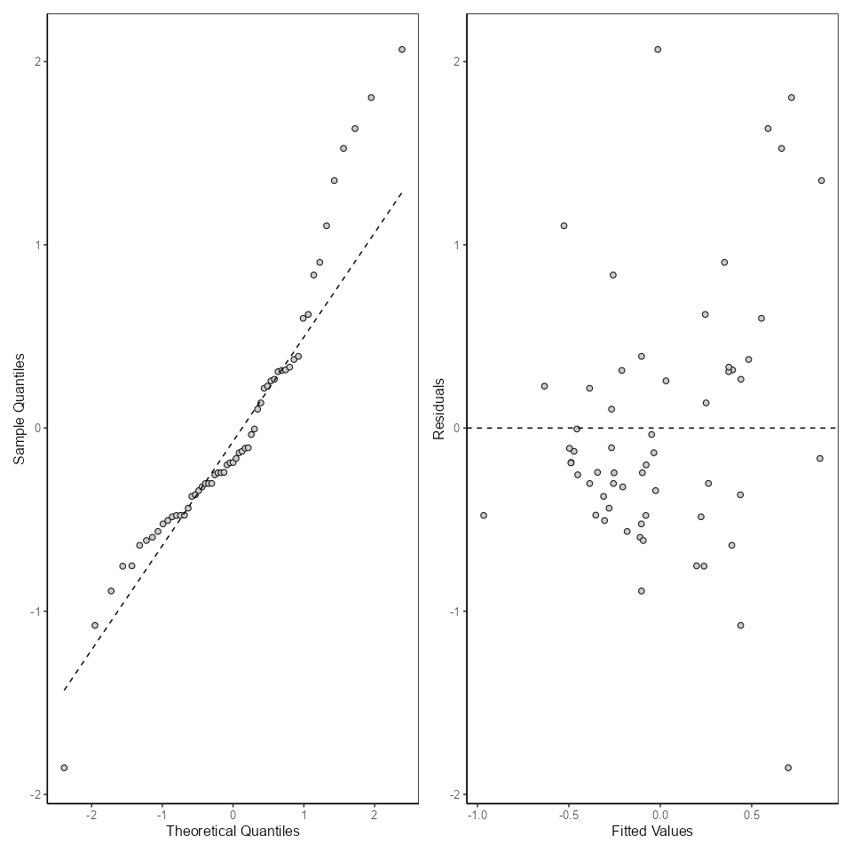

*Note*. This is the note below the figure.

Figure 3

Histogram of Residuals

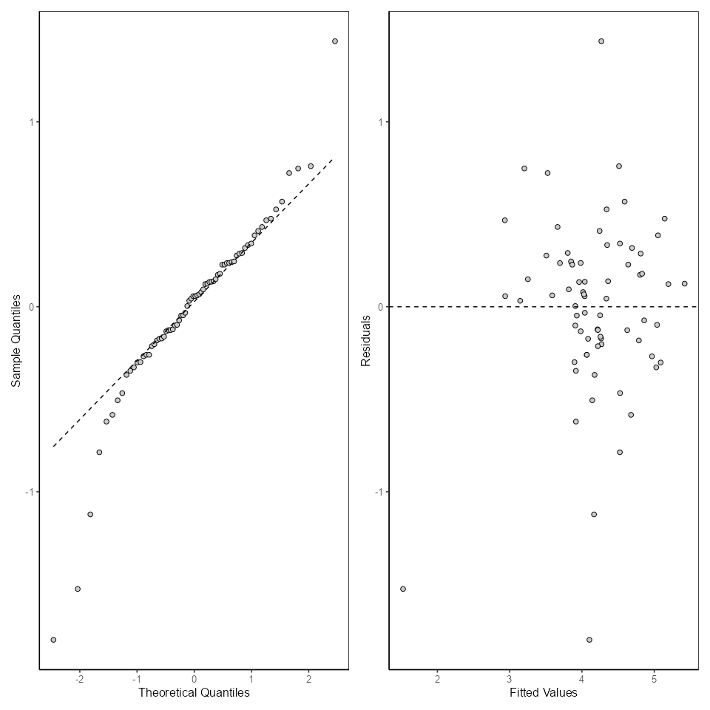

*Note*. This is the note below the figure.

Figure 4

Histogram of Residuals

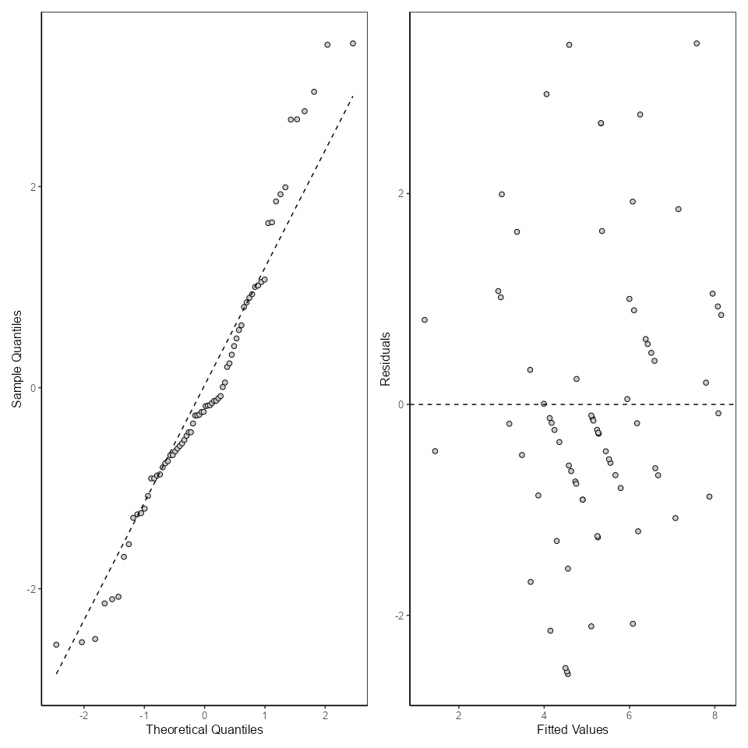

*Note*. This is the note below the figure.

Figure 5

Violin Plot with boxplots

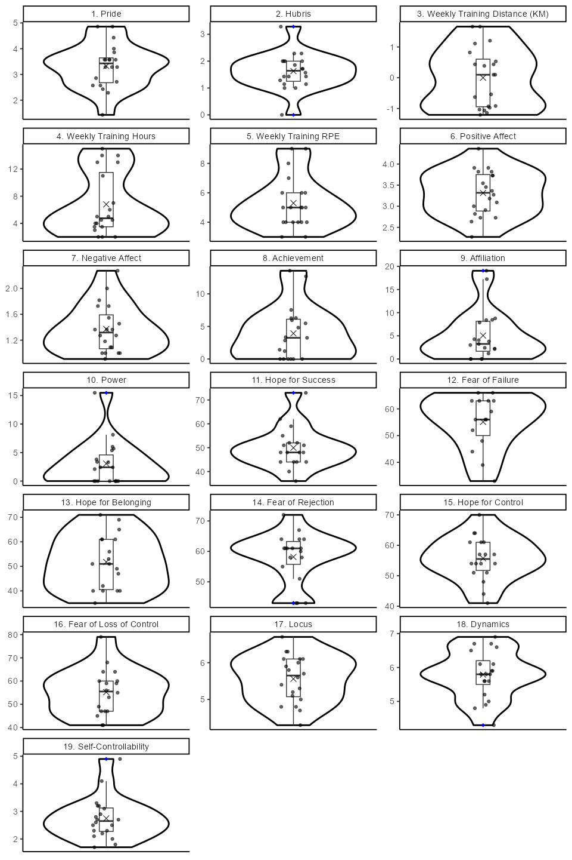

*Note*. This is the note below the figure.

Figure 6

Predictive Contribution of Globality, which interacts with pride

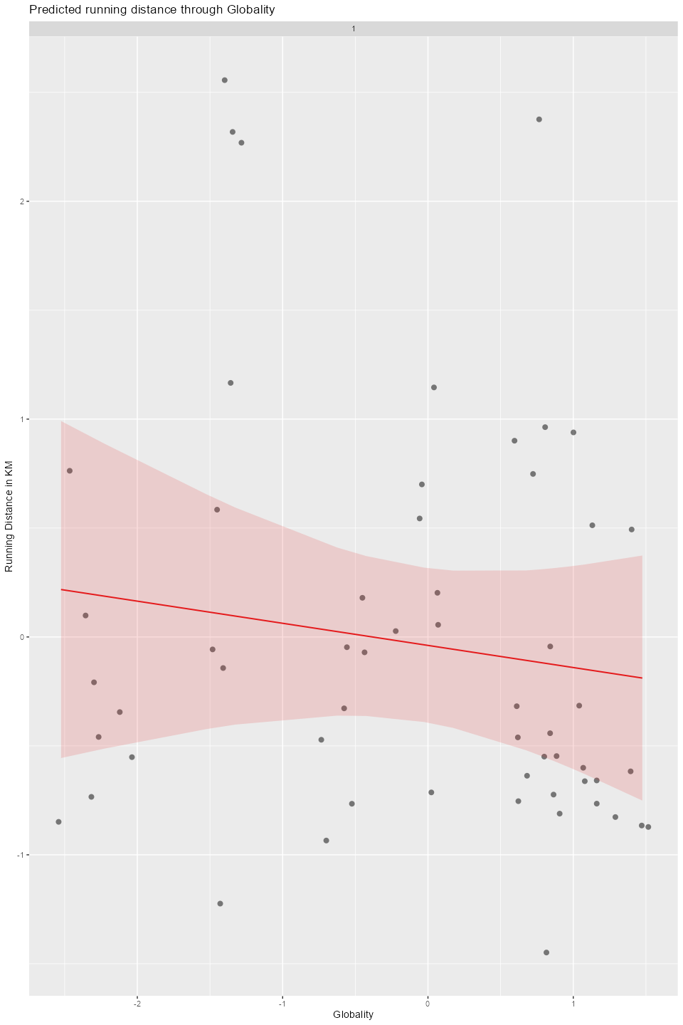

*Note*. This is the note below the figure.

# Appendix

# Title for Appendix