# Self-Conscious Emotions in Sport and Exercise: Relationships of Implicit and Explicit Processes of Authentic and Hubristic Pride and Physical Activity

Sascha Leisterer

Department of Sport Science, Leipzig University

# Author Note

Sascha Leisterer  http://orcid.org/0000-0000-0000-0001

Correspondence concerning this article should be addressed to Sascha Leisterer, Department of Sport Science, Leipzig University, Jahnallee 59, Leipzig, Saxony, Germany, Email: sascha.leisterer@uni-leipzig.de

# Abstract

Self-conscious emotions play a crucial role in sports and exercise by reflecting self-related goal achievements. Traditionally, these emotions are explained through explicit attributional processes. However, implicit processes that influence self-related goal orientation are often overlooked.

*Keywords*: keyword1, keyword2, keyword3

# Self-Conscious Emotions in Sport and Exercise: Relationships of Implicit and Explicit Processes of Authentic and Hubristic Pride and Physical Activity

# Note

You can access the code that generated these results [here](https://github.com/Enno-W/Self-Conscious-Emotions-in-Sport-and-Exercise/blob/main/index.qmd)

# Hypotheses

Hypothesis 1: The implicit achievement motive correlates positively with authentic pride. In contrast, hubristic pride is associated with social dominance, reflecting the power motive, which leads to our second hypothesis: Hypothesis 2: The implicit power motive correlates positively with hubristic pride. As authentic pride relates to pro-social behavior and hubristic pride is associated with more anti-social behavior, our third hypothesis is: Hypothesis 3 is: The implicit affiliation motive correlates positively with authentic pride and negatively with hubristic pride. Additionally, in our fourth hypothesis, we assume that implicit motive component cues highlight situations as favorable for either authentic or hubristic pride: Hypothesis 4: Hope for success, hope for control, and hope for social belonging correlate positively with authentic pride; fear of failure, fear of loss of control, and fear of social rejection correlate positively with hubristic pride. Second, we hypothesize that causal attribution styles, as explicit regulation processes, correlate with either authentic or hubristic pride. This leads to the following hypotheses: Hypothesis 5: Individuals who tend to attribute their achievements, power, or social gains internally, variably, controllably, and specifically will report higher levels of authentic pride. Hypothesis 6: Individuals who tend to attribute their achievements, power, or social gains internally, stably, uncontrollably, and globally will report higher levels of hubristic pride. Third, based on existing literature, we hypothesize that authentic and hubristic pride are associated with physical activity parameters. This leads to the following hypotheses: Hypothesis 7: Authentic pride and its associated regulation processes correlate with higher physical activity parameters. Hypothesis 8: Hubristic pride and its associated regulation processes correlate with lower physical activity parameters.

H1: Positive correlation between achievement motive and pride H2: Positive correlation between power motive and hubris H3: Positive correlation between affiliation motive and pride, negative correlation between affiliation and hubris H4: Positive correlation between hope and pride, Positive correlation between fear and hubris H5: Positive correlation between internal, variable, controllable, specific attribution and pride H6: Positive correlation between internal, stable, uncontrollable, global attribution and hubris H7: Positive correlation between PA parameters and pride H8: Negative correlation between PA parameters and hubris

# Study 1

## Participants

Participants were adults with specific goals (e.g., running a marathon, competing in a triathlon, aesthetics, bodybuilding) and/or pre-defined workout routines (e.g., running routine, weight training log). A sample size calculation using G*Power29 for testing one-sided point biserial correlation with |ρ| = .5, α = .05, and 1 – β = .95 indicated a necessary sample size of *N* = 34. As an incentive, participants were offered feedback on their results and suggestions for improving their workout routine motivation. *N* = 41 participants completed the survey. After excluding participants that did not follow a training routine (*N* = 9), the sample consisted of *N* = 32 recreational athletes (*mean age* = 34.69 years, *SD* = 14), including 19 females, 8 males, and 2 identifying as diverse. Participants followed individual workout routines averaging 6.79 hours per week (*SD* = 4.04) with a self-rated intensity (perceived exertion) of 5.41 (*SD* = 1.74). The sports they engaged in included running (n = 10), triathlon (n = 6), weight training (n = 5), and other endurance sports (n = 11). 17 % of data were missing.

## Measures

(see article)

## Procedure

(see article)

## Analysis

First, implicit motives for achievement, affiliation, and power motives were z-standardized, motive components were gender balanced t-standardized and the entire data was checked for normal distribution. Applying the Shapiro-Wilk test, session training distance (*p* < .001), session training duration (*p* = 0.008) and perceived rate of exhaustion (*p* = 0.008) as well as fear of rejection (*p* = 0.042) were not normally distributed. We then calculated the speed from the time and distance values for each session, and found a great variability. The speed in a session ranged from 1 to 33 kilometers per hour. As a consequence, we separated the data into three categories that fit with common speed of swimming, running, and cycling. If the speed was less than five kilometers per hour, the session was regarded as “swimming”, less than 20 kilometers per hour as “running”, and more than 20 kilometers per hour as “cycling”. We then z-standardised the session distance within these groups. After this, running distance was normally distributed (*p* 0.05) Second, descriptive statistics were calculated. Third, according to the small sample size and normally distributed variables, Spearman rank correlations were calculated. For the analysis, the programming language R (R Core Team, 2024) was used.

## Results

Table 1 presents descriptive statistics, including mean, standard deviation, skewness, and kurtosis. The sample represents medium authentic pride and medium positive affect, low hubristic pride and low negative affect. Additionally, the sample shows a slightly stronger implicit affiliation motive but regular motive components in all 3 implicit motives. Further, the sample applies more internal, variable, and less uncontrollable attribution styles. Figure 2 visualises the distibution of these variables.

Correlations are presented in Table 2 and shown in Figure 1.

Exploratory analyses revealed significant correlations between pride and positive affect (*Ρ* = 0.5, *p* < .01), weekly training duration and training distance (*Ρ* = 0.71, *p* < .001), the implicit achievement and affiliation motives (*Ρ* = 0.49, *p* < .01), hope for success and hope for belonging (*Ρ* = 0.5, *p* < .01), hope for success and hope for control (*Ρ* = 0.59, *p* < .01), fear of failure and fear of social rejection (*Ρ* = 0.59, *p* < .01), fear of failure and fear of loss of control (*Ρ* = 0.52, *p* < .01), fear of social rejection and negative affect (*Ρ* = 0.56, *p* < .01), and uncontrollable and internal attributions (*Ρ* = -0.75, *p* < .001).

# Study 2

## Analysis

We excluded participants manually if they reported data on less than two training sessions, if they did not participate in a structured training programme, or if they were neither runners nor triathletes. Subsequent analyses were performed using the R language (R Core Team, 2024). 17 of data were missings. Since most of the incomplete date was due to dropouts, we decided against multiple imputation, following the reccomendations of [Lit]. Since the questionnaires were sent out in weekly intervals, we expected autocorrelation between measurement points. Through inspecting variograms, we assessed the correlation structure between measurement points. The results suggested that autoregressive noise was present: The semivariance changed substantially with distance between observations. Thus, we included an autocorrelation structure of order 1 (AR1) in the models.

Time was not included as predictor, since we did not expect a trend over time. The time-varying predictors pride and positive affect were group-mean centered, and the stable predictors attribution style (globality, dynamics, locus) and implicit motives (achievement, affiliation, power) were grand mean centered. This disentangles the between-person-effects from the within-person-effects, in line with recommendations of Wang and Maxwell (2015): The authors emphasize that a within-person effect can be present regardless of the between-person-effect, and vice versa. To illustrate this, it is possible that within a person, less pride after a run predicts a greater running distance in the next session. At the same time, people who are less proud on average do not necessarily run more. Lastly, we z-standardised all predictors for easier interpretation.

The results for the hierarchical linear models are presented separately for each the dependent variables of this study: Session distance, session duration and rate of perceived exhaustion. We used interaction terms of pride with positive affect, causal attribution and implicit motives to predict these dependent variables. The predictors were added in three steps: First, the interaction term of pride and positive affect, second, the interaction terms of pride and attribution styles, and third, interaction terms of pride and implicit motives. We then decided on the appropriate model based on fit indices and explanatory power, and then examined the model quality, checking for normal distribution of residuals, homoscedasticity (constant variance of residuals), absence of multicollinearity, linearity and outliers. We also assessed if a correlation matrix improved the model fit.

## Participants

## Measures

(see article)

## Procedure

(see article)

## Results

## Session distance

In these models, we used interaction terms of pride with positive affect, causal attribution and implicit motives to predict running distance. The running distance was z-standardized to allow a comparison between the kilometer values reported by swimmers, runners, and triathletes. We added predictors to the null model in three steps: First, the interaction term of pride and positive affect, second, the interaction terms of pride and attribution styles, and third, interaction terms of pride and implicit motives. The result is shown in Table 3.

The intraclass correlation coefficient was *ICC* = 0.25. Model 3 included meaningful predictors and the lowest log-likelihood, it also fit significantly better than the same model without a correlation matrix *p* < .001. Thus, Model 3 was selected for further analysis of statistical assumptions and the discussion.

The residuals were normally distributed (*p* = 0.095 ). Figure 3 shows a QQ-plot and scatterplot of the residuals. Here, the residuals are concentrated in the left, indicating a slight deviation from the assumption of homoscedasticity.

The variance influence factor ranged from *vifmin* = 1.38 to *vifmax* = 4.61.

Linearity was assessed by plotting each predictor against the outcome variable and examining LOESS-smoothed lines for deviations from linear trends. Figure 4 shows substantial deviations from linearity. Figure 5 shows the distribution of outliers in the residuals according to each individual.

The marginal and conditional R-squared values, representing the portion of variance explained by the fixed effects and the random effects respectively, were *R2marginal* = 0.25 and *R2conditional* = 0.663.

On the individual level (level 2), the residuals were not normally distributed (*p* 0.017). No deviation from the assumption of homoscedasticity was present (*p* 0.252).

Several interaction terms emerged as significant predictors: The interactions between pride and positive affect (*b* = 0.393, *p* = 0.393), and achievement motive (*b* = 0.583, *p* = 0.583) were positive, meaning that the effect of pride on the training distance in the *next* session is stronger when there is a high achievement motive or a high positive affect (in the previous session). The interaction terms between pride and globality (*b* = 0.393, *p* = 0.393), the affiliation motive (*b* = -0.721, *p* = < .001) and the power motive (*b* = -0.807, *p* < .001) were negative: When globality, affiliation or power are high, pride reduces the running distance in the next session.

## Session duration

The parameters for this model that predicted session duration are shown in Table 4. The ICC was *ICC* = 0.482.

No model showed meaningful predictors of session duration. A correlation matrix only slightly and non-significantly improved model fit (*p* = 0.817). The model with the correlation matrix (Model 3) was retained for further examination.

The residuals were normally distributed in a Kolmogorov-Smirnov-Test (*p* = 0.066 ), but not in a Shapiro-Wilk-test (*p* < .001). A slight deviation from the normal distribution of residuals and the assumption of homoscedasticity is apparent in Figure 6.

The variance influence factor ranged from *vifmin* = 1.08 to *vifmax* = 3.4.

Figure 8 shows the predictors plotted against session duration to assess linearity.

Figure 7 shows two outliers in the residuals of the model.

The marginal and conditional R-squared values were *R2marginal* = 0.12 and *R2conditional* = 0.68.

On the individual level (level 2), the residuals were not normally distributed (*p* < .01). No deviation from the assumption of homoscedasticity was present (*p* = 0.637).

No predictors predicted session time significantly.

## Session Rate of Perceived Exhaustion

The regression coefficients are shown in Table 5. The third model with all predictors shows the lowest AIC and log likelihood. A correlation matrix did not result in a better fit ( *p* 0.84), so we used the model without the correlation structure. It shows the lowest AIC and log likelihood and was tested for statistical assumptions and model quality.

A more stable attribution style predicted a lower RPE, and so did the interaction terms of pride with positive affect, pride with a more external locus of control, pride with a higher implicit affiliation as well as a higher power motive. Only the interaction between pride and the implicit achievement motive predicted a higher rate of perceived exhaustion for each session.

The residuals were normally distributed in a Kolmogorov-Smirnov test (*p* = 0.143 ), but not in a Shapiro-Wilk-test (*p* < .05). Figure 9 shows the deviation from the normal distribution in a QQ-Plot along with the distribution of residuals. The linear patterns that emerge in the residuals are a result of the discrete values in the session RPE data.

The variance influence factor was between *vifmin* = 1.09 and *vifmax* = 2.72.

The marginal and conditional R-squared values, representing the portion of variance explained by the fixed effects and the random effects respectively, were *R2marginal* = 0.32 and *R2conditional* = 0.53.

Figure 10 shows the predictors plotted against the target variable.

On the individual level (level 2), the residuals were not normally distributed (*p* 0.017). No deviation from the assumption of homoscedasticity was present (*p* 0.252).

Several interaction terms emerged as significant predictors: When a person had a tendency to more stable attributions, session RPE was reduced (*b* = -0.462, *p* < .05). Pride predicted the session rate of perceived exhaustion negatively if positive affect in the last session was high (*b* = -0.183, *p* < .01), if people had a more external attribution style (*b* = -0.317, *p* < .01), and if the affiliation motive (*b* = -0.521, *p* = < .001) or power motive (*b* = -0.352, *p* < .001) were high. If the achivement motive was high, higher pride also predicted a higher RPE (*b* = 0.406, *p* = 0.406).

# Discussion

The variance influence factors suggest low multicollinearity (for a discussion see O’brien, 2007).

## Limitations and Future Directions

## Conclusion

# References

O’brien, R. M. (2007). A caution regarding rules of thumb for variance inflation factors. *Quality & Quantity*, *41*(5), 673–690. <https://doi.org/10.1007/s11135-006-9018-6>

R Core Team. (2024). *R: A language and environment for statistical computing*. R Foundation for Statistical Computing. <https://www.R-project.org/>

Wang, L. (Peggy)., & Maxwell, S. E. (2015). On disaggregating between-person and within-person effects with longitudinal data using multilevel models. *Psychological Methods*, *20*(1), 63–83. <https://doi.org/10.1037/met0000030>

Table 1

Descriptive statistics table

| Variable | Median | Mean | 95% CI | SD | Skewness | Kurtosis | p-Value |
| --- | --- | --- | --- | --- | --- | --- | --- |
| 1. Pride | 3.57 | 3.56 | 0.32 | 0.86 | -0.22 | -0.48 | 0.547 |
| 2. Hubris | 1.43 | 1.58 | 0.23 | 0.62 | 0.42 | 1.16 | 0.086 |
| 3. Session Training Distance | 25.00 | 58.12 | 30.11 | 74.56 | 1.57 | 1.26 | < .001 |
| 4. Session Training Hours | 6.00 | 6.79 | 1.54 | 4.04 | 0.65 | -0.90 | 0.008 |
| 5. Session Training RPE | 5.00 | 5.41 | 0.66 | 1.74 | 0.67 | -0.44 | 0.013 |
| 6. Positive Affect | 3.46 | 3.40 | 0.20 | 0.54 | -0.07 | -0.98 | 0.451 |
| 7. Negative Affect | 1.27 | 1.33 | 0.14 | 0.38 | 0.82 | -0.50 | 0.002 |
| 8. Achievement | 0.00 | 0.00 | 0.00 | 0.00 | 0.66 | -0.12 | 0.01 |
| 9. Affiliation | 0.00 | 0.00 | 0.00 | 0.00 | 1.17 | 0.76 | 0.002 |
| 10. Power | 0.00 | 0.00 | 0.00 | 0.00 | 1.36 | 2.39 | < .001 |
| 11. Hope for Success | 49.50 | 50.81 | 3.74 | 9.27 | 0.38 | -0.59 | 0.43 |
| 12. Fear of Failure | 56.00 | 54.91 | 4.47 | 10.07 | -0.58 | -0.88 | 0.1 |
| 13. Hope for Belonging | 53.00 | 53.15 | 4.51 | 11.16 | 0.18 | -1.15 | 0.299 |
| 14. Fear of Rejection | 59.00 | 55.81 | 4.14 | 10.25 | -0.57 | -0.42 | 0.089 |
| 15. Hope for Control | 54.00 | 55.69 | 3.54 | 8.76 | -0.29 | -0.16 | 0.36 |
| 16. Fear of Loss of Control | 56.00 | 55.50 | 4.14 | 10.25 | 0.12 | -0.71 | 0.747 |
| 17. Locus | 5.70 | 5.63 | 0.24 | 0.67 | -0.23 | -0.73 | 0.75 |
| 18. Dynamics | 5.90 | 5.92 | 0.25 | 0.69 | -0.37 | -0.76 | 0.345 |
| 19. Controllability | 2.60 | 2.64 | 0.27 | 0.75 | 0.82 | 1.01 | 0.165 |

*Note*. The p-value results from Shapiro-Wilk-tests of normality.

Table 2

Correlation matrix of Spearman Rho (Ρ) coefficients

|  | **Correlations** | | | | | | | | | | | | | | | | | | |
| --- | --- | --- | --- | --- | --- | --- | --- | --- | --- | --- | --- | --- | --- | --- | --- | --- | --- | --- | --- |
| **Measure** | **1** | **2** | **3** | **4** | **5** | **6** | **7** | **8** | **9** | **10** | **11** | **12** | **13** | **14** | **15** | **16** | **17** | **18** | **19** |
| 1. Pride |  |  |  |  |  |  |  |  |  |  |  |  |  |  |  |  |  |  |  |
| 2. Hubris | -0.01 |  |  |  |  |  |  |  |  |  |  |  |  |  |  |  |  |  |  |
| 3. Session Training Distance | -0.19 | -0.18 |  |  |  |  |  |  |  |  |  |  |  |  |  |  |  |  |  |
| 4. Session Training Hours | 0.14 | -0.18 | 0.58** |  |  |  |  |  |  |  |  |  |  |  |  |  |  |  |  |
| 5. Session Training RPE | 0.21 | 0.2 | -0.27 | 0.06 |  |  |  |  |  |  |  |  |  |  |  |  |  |  |  |
| 6. Positive Affect | 0.48** | 0.11 | -0.1 | 0.2 | 0.25 |  |  |  |  |  |  |  |  |  |  |  |  |  |  |
| 7. Negative Affect | -0.17 | 0.52** | 0.01 | 0.16 | 0.24 | 0.1 |  |  |  |  |  |  |  |  |  |  |  |  |  |
| 8. Achievement | 0.07 | -0.25 | -0.05 | 0.36 | 0.08 | -0.05 | 0.02 |  |  |  |  |  |  |  |  |  |  |  |  |
| 9. Affiliation | -0.08 | -0.04 | 0.36 | 0.43* | -0.02 | -0.05 | 0.35 | 0.48** |  |  |  |  |  |  |  |  |  |  |  |
| 10. Power | -0.04 | 0.16 | 0.04 | 0.17 | 0.3 | -0.01 | 0.15 | 0.47** | 0.12 |  |  |  |  |  |  |  |  |  |  |
| 11. Hope for Success | 0.32 | 0.1 | -0.34 | 0.19 | 0.16 | 0.29 | 0.04 | -0.06 | -0.17 | -0.1 |  |  |  |  |  |  |  |  |  |
| 12. Fear of Failure | -0.36 | 0.1 | -0.1 | -0.02 | 0.19 | 0 | 0.51* | 0.35 | 0.42 | 0.35 | -0.04 |  |  |  |  |  |  |  |  |
| 13. Hope for Belonging | 0.24 | 0.26 | -0.08 | 0.21 | 0.02 | 0.28 | 0.05 | 0.23 | 0.08 | 0.24 | 0.28 | 0.25 |  |  |  |  |  |  |  |
| 14. Fear of Rejection | -0.54** | 0.27 | -0.04 | -0.07 | 0.06 | -0.25 | 0.53** | 0.07 | 0.36 | 0.08 | 0.09 | 0.58** | -0.14 |  |  |  |  |  |  |
| 15. Hope for Control | -0.18 | 0.16 | 0.16 | 0.28 | -0.02 | -0.11 | -0.09 | -0.07 | -0.29 | -0.11 | 0.38 | 0.15 | 0.38 | 0.04 |  |  |  |  |  |
| 16. Fear of Loss of Control | -0.1 | 0.12 | -0.27 | 0.01 | 0.05 | -0.01 | 0.34 | 0.04 | 0.19 | 0.02 | 0.27 | 0.56** | 0.21 | 0.29 | 0.03 |  |  |  |  |
| 17. Locus | 0.18 | -0.25 | -0.05 | 0.05 | -0.02 | 0.23 | -0.42* | 0.05 | -0.11 | -0.22 | 0.17 | -0.11 | -0.06 | -0.06 | 0.13 | -0.23 |  |  |  |
| 18. Dynamics | 0.13 | -0.15 | 0.13 | 0.38* | 0.04 | -0.16 | 0.02 | 0.12 | 0.29 | -0.09 | 0.25 | -0.13 | 0.09 | 0.05 | 0 | 0.25 | 0.32 |  |  |
| 19. Controllability | -0.07 | 0.2 | -0.13 | -0.24 | 0.11 | -0.08 | 0.42* | -0.07 | 0.05 | 0.2 | -0.28 | 0.26 | 0.21 | -0.1 | -0.33 | 0.1 | -0.79** | -0.29 |  |

*Note*. p < .05, ** p < .01, *** p < .001.

Table 3

Hierarchical Linear Model Coefficients Predicting Running Distance

|  |  |  |  |  |  |  |  |  |  |  |
| --- | --- | --- | --- | --- | --- | --- | --- | --- | --- | --- |
|  | Nullmodell | | Model 1 | | Model 2 | | Model 3 | | Model 4 | |
| (Intercept) | -0.00 | (0.17) | -0.10 | (0.19) | -0.10 | (0.23) | -0.33 | (0.22) | -0.26 | (0.25) |
| Pride |  |  | -0.09 | (0.19) | -0.15 | (0.26) | 0.14 | (0.21) | 0.13 | (0.32) |
| Positive Affect |  |  | 0.03 | (0.16) | 0.08 | (0.20) | 0.03 | (0.15) | -0.07 | (0.19) |
| Dynamics |  |  |  |  | 0.02 | (0.25) | 0.11 | (0.27) | 0.09 | (0.30) |
| Locus |  |  |  |  | -0.03 | (0.21) | 0.12 | (0.24) | 0.09 | (0.26) |
| Globality |  |  |  |  | 0.04 | (0.19) | 0.34 | (0.23) | 0.25 | (0.26) |
| Affiliation |  |  |  |  |  |  | 0.42 | (0.28) | 0.33 | (0.31) |
| Achievement |  |  |  |  |  |  | -0.34 | (0.27) | -0.27 | (0.30) |
| Power |  |  |  |  |  |  | 0.53 | (0.26) | 0.44 | (0.29) |
| Pride × Dynamics |  |  |  |  | 0.21 | (0.34) | -0.04 | (0.29) | -0.22 | (0.40) |
| Pride × Positive Affect |  |  | 0.22 | (0.15) | 0.19 | (0.20) | **0.39 \*** | **(0.15)** | 0.31 | (0.21) |
| Pride × Locus |  |  |  |  | 0.01 | (0.15) | -0.14 | (0.11) | -0.13 | (0.15) |
| Pride × Globality |  |  |  |  | -0.08 | (0.19) | **-0.86 \*\*\*** | **(0.20)** | -0.57 | (0.29) |
| Pride × Affiliation |  |  |  |  |  |  | **-0.72 \*\*** | **(0.21)** | **-0.66 \*** | **(0.25)** |
| Pride × Achievement |  |  |  |  |  |  | **0.58 \*\*\*** | **(0.12)** | **0.51 \*** | **(0.20)** |
| Pride × Power |  |  |  |  |  |  | **-0.81 \*\*\*** | **(0.18)** | **-0.74 \*\*** | **(0.24)** |
| nobs | 56 |  | 56 |  | 56 |  | 54 |  | 54 |  |
| nobs.1 | 56.00 |  | 56.00 |  | 56.00 |  | 54.00 |  | 54.00 |  |
| sigma | 0.86 |  | 0.81 |  | 0.84 |  | 0.68 |  | 0.76 |  |
| logLik | -76.73 |  | -78.06 |  | -81.71 |  | -70.02 |  | -75.82 |  |
| AIC | 159.45 |  | 170.12 |  | 189.42 |  | 178.05 |  | 187.64 |  |
| BIC | 165.53 |  | 183.77 |  | 213.20 |  | 209.16 |  | 217.12 |  |
| deviance | 153.45 |  |  |  |  |  |  |  |  |  |
| df.residual | 39.00 |  | 36.00 |  | 33.00 |  | 29.00 |  | 29.00 |  |
| *** p < 0.001; ** p < 0.01; * p < 0.05. | | | | | | | | | | |

*Note*. The time varying predictors—Pride and Positive Affect— were cluster-mean-centered, fixed predictors were grand mean centered.

Table 4

Hierarchical Linear Model Coefficients Predicting Running Time

|  |  |  |  |  |  |  |  |  |  |  |
| --- | --- | --- | --- | --- | --- | --- | --- | --- | --- | --- |
|  | Nullmodell | | Model 1 | | Model 2 | | Model 3 | | Model 3 without correlation matrix | |
| (Intercept) | -0.01 | (0.18) | -0.04 | (0.19) | -0.03 | (0.20) | -0.13 | (0.22) | -0.13 | (0.22) |
| Pride |  |  | 0.07 | (0.13) | 0.07 | (0.14) | 0.11 | (0.13) | 0.11 | (0.13) |
| Positive Affect |  |  | -0.13 | (0.12) | -0.13 | (0.13) | -0.18 | (0.12) | -0.18 | (0.12) |
| Dynamics |  |  |  |  | -0.09 | (0.20) | -0.23 | (0.24) | -0.23 | (0.24) |
| Locus |  |  |  |  | -0.06 | (0.20) | 0.06 | (0.24) | 0.06 | (0.24) |
| Globality |  |  |  |  | 0.08 | (0.20) | 0.02 | (0.23) | 0.02 | (0.23) |
| Affiliation |  |  |  |  |  |  | 0.23 | (0.31) | 0.23 | (0.31) |
| Achievement |  |  |  |  |  |  | -0.00 | (0.30) | -0.00 | (0.30) |
| Power |  |  |  |  |  |  | 0.20 | (0.29) | 0.20 | (0.29) |
| Pride × Dynamics |  |  |  |  | 0.00 | (0.09) | 0.04 | (0.09) | 0.04 | (0.09) |
| Pride × Positive Affect |  |  | 0.04 | (0.04) | 0.04 | (0.06) | 0.03 | (0.07) | 0.03 | (0.07) |
| Pride × Locus |  |  |  |  | -0.00 | (0.08) | -0.08 | (0.09) | -0.08 | (0.09) |
| Pride × Globality |  |  |  |  | -0.05 | (0.13) | -0.09 | (0.13) | -0.09 | (0.13) |
| Pride × Affiliation |  |  |  |  |  |  | -0.14 | (0.16) | -0.14 | (0.16) |
| Pride × Achievement |  |  |  |  |  |  | 0.16 | (0.13) | 0.16 | (0.13) |
| Pride × Power |  |  |  |  |  |  | -0.24 | (0.14) | -0.24 | (0.14) |
| nobs | 76 |  | 76 |  | 76 |  | 71 |  | 71 |  |
| nobs.1 | 76.00 |  | 76.00 |  | 76.00 |  | 71.00 |  | 71.00 |  |
| sigma | 0.70 |  | 0.67 |  | 0.69 |  | 0.63 |  | 0.63 |  |
| logLik | -94.79 |  | -98.48 |  | -104.71 |  | -95.69 |  | -95.69 |  |
| AIC | 195.58 |  | 210.97 |  | 235.43 |  | 229.37 |  | 229.37 |  |
| BIC | 202.57 |  | 226.91 |  | 263.89 |  | 267.51 |  | 267.51 |  |
| deviance | 189.58 |  |  |  |  |  |  |  |  |  |
| df.residual | 57.00 |  | 54.00 |  | 51.00 |  | 44.00 |  | 44.00 |  |
| *** p < 0.001; ** p < 0.01; * p < 0.05. | | | | | | | | | | |

*Note*. Time varying predictors Pride and Positive Affect were cluster-mean-centered, fixed predictors were grand mean centered.

Table 5

Hierarchical Linear Model Coefficients Predicting Session Rate of Perceived Exhaustion

|  |  |  |  |  |  |  |  |  |  |  |
| --- | --- | --- | --- | --- | --- | --- | --- | --- | --- | --- |
|  | Nullmodell | | Model 1 | | Model 2 | | Model 3 | | Model 3 without correlation matrix | |
| (Intercept) | -0.00 | (0.15) | 0.05 | (0.15) | 0.08 | (0.14) | 0.11 | (0.17) | 0.12 | (0.17) |
| Pride |  |  | -0.14 | (0.15) | -0.24 | (0.15) | -0.26 | (0.15) | -0.26 | (0.15) |
| Positive Affect |  |  | -0.18 | (0.15) | -0.18 | (0.15) | -0.18 | (0.15) | -0.18 | (0.15) |
| Dynamics |  |  |  |  | **-0.39 \*\*** | **(0.13)** | **-0.46 \*** | **(0.17)** | **-0.46 \*** | **(0.17)** |
| Locus |  |  |  |  | 0.07 | (0.13) | 0.09 | (0.18) | 0.08 | (0.18) |
| Globality |  |  |  |  | 0.10 | (0.13) | 0.16 | (0.17) | 0.15 | (0.17) |
| Affiliation |  |  |  |  |  |  | 0.08 | (0.23) | 0.07 | (0.23) |
| Achievement |  |  |  |  |  |  | -0.19 | (0.22) | -0.19 | (0.22) |
| Power |  |  |  |  |  |  | -0.00 | (0.22) | -0.01 | (0.22) |
| Pride × Dynamics |  |  |  |  | -0.17 | (0.10) | -0.01 | (0.12) | -0.01 | (0.12) |
| Pride × Positive Affect |  |  | -0.08 | (0.05) | **-0.12 \*** | **(0.06)** | **-0.18 \*\*** | **(0.07)** | **-0.18 \*\*** | **(0.07)** |
| Pride × Locus |  |  |  |  | -0.12 | (0.09) | **-0.31 \*\*** | **(0.10)** | **-0.32 \*\*** | **(0.10)** |
| Pride × Globality |  |  |  |  | 0.24 | (0.14) | 0.10 | (0.15) | 0.10 | (0.15) |
| Pride × Affiliation |  |  |  |  |  |  | **-0.52 \*** | **(0.20)** | **-0.52 \*** | **(0.20)** |
| Pride × Achievement |  |  |  |  |  |  | **0.40 \*\*** | **(0.14)** | **0.41 \*\*** | **(0.14)** |
| Pride × Power |  |  |  |  |  |  | -0.34 | (0.17) | **-0.35 \*** | **(0.17)** |
| nobs | 78 |  | 77 |  | 77 |  | 72 |  | 72 |  |
| nobs.1 | 78.00 |  | 77.00 |  | 77.00 |  | 72.00 |  | 72.00 |  |
| sigma | 0.89 |  | 0.83 |  | 0.80 |  | 0.79 |  | 0.80 |  |
| logLik | -107.79 |  | -107.75 |  | -108.22 |  | -104.24 |  | -104.26 |  |
| AIC | 221.59 |  | 229.51 |  | 242.44 |  | 246.48 |  | 244.52 |  |
| BIC | 228.66 |  | 245.54 |  | 271.11 |  | 284.96 |  | 280.98 |  |
| deviance | 215.59 |  |  |  |  |  |  |  |  |  |
| df.residual | 59.00 |  | 55.00 |  | 52.00 |  | 45.00 |  | 45.00 |  |
| *** p < 0.001; ** p < 0.01; * p < 0.05. | | | | | | | | | | |

*Note*. Time varying predictors Pride and Positive Affect were cluster-mean-centered, fixed predictors were grand mean centered.

Figure 1

Correlation Plot showing Spearman Rho coefficients between investigated variables.

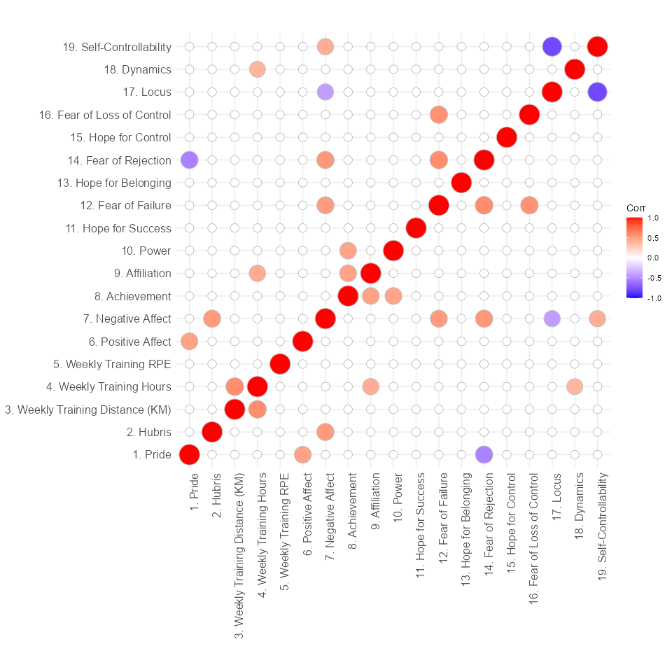

*Note*. Bullets depict significant correlations (p < .05) and show positive (darker blue tones) or negative (darker red tones) correlations. Spearman’s rank correlation coefficient was used.

Figure 2

Violin Plot with boxplots

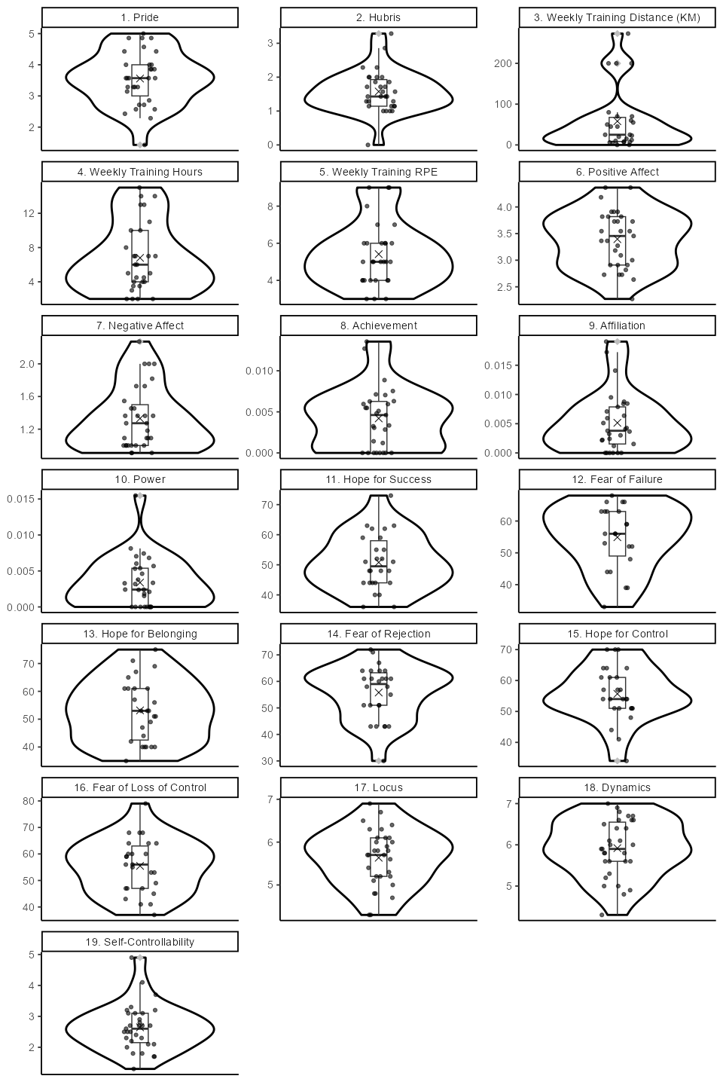

*Note*. The “X” represents the mean. Outliers are shown as grey diamonds.

Figure 3

QQ-Plot and Scatterplot of Residuals for the HLM predicting running distance

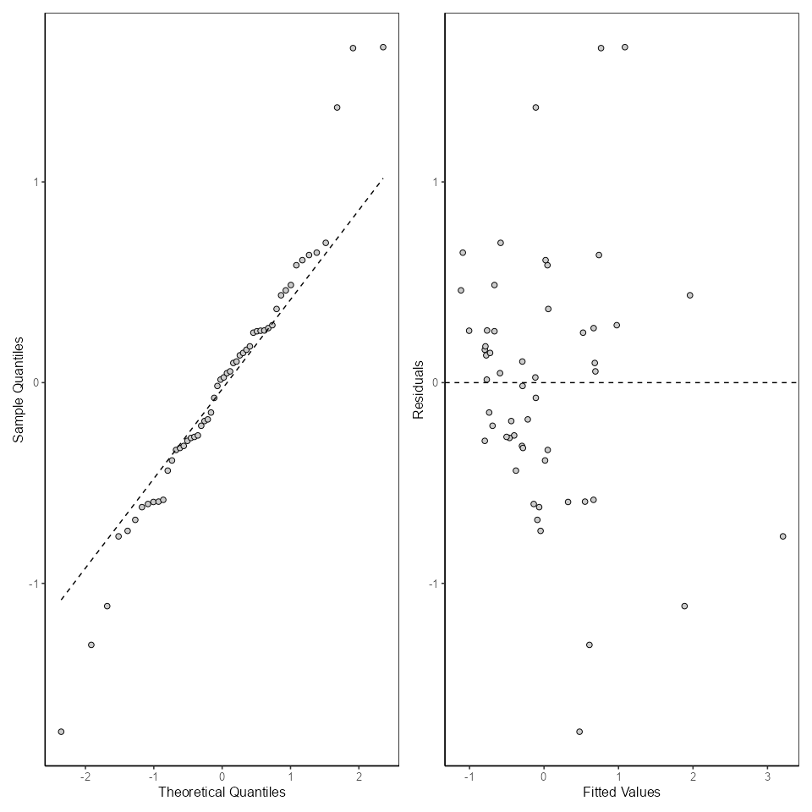

*Note*. The residuals follow the straight line in the QQ-plot, indicating normal distribution. An even spread in the scatterplots indicates homoscedasticity, here a slight deviation from this assumption is present, with residuals concentrated in the lower range.

Figure 4

Predictors plottet against the target variable (Session Distance) with LOESS smoothing

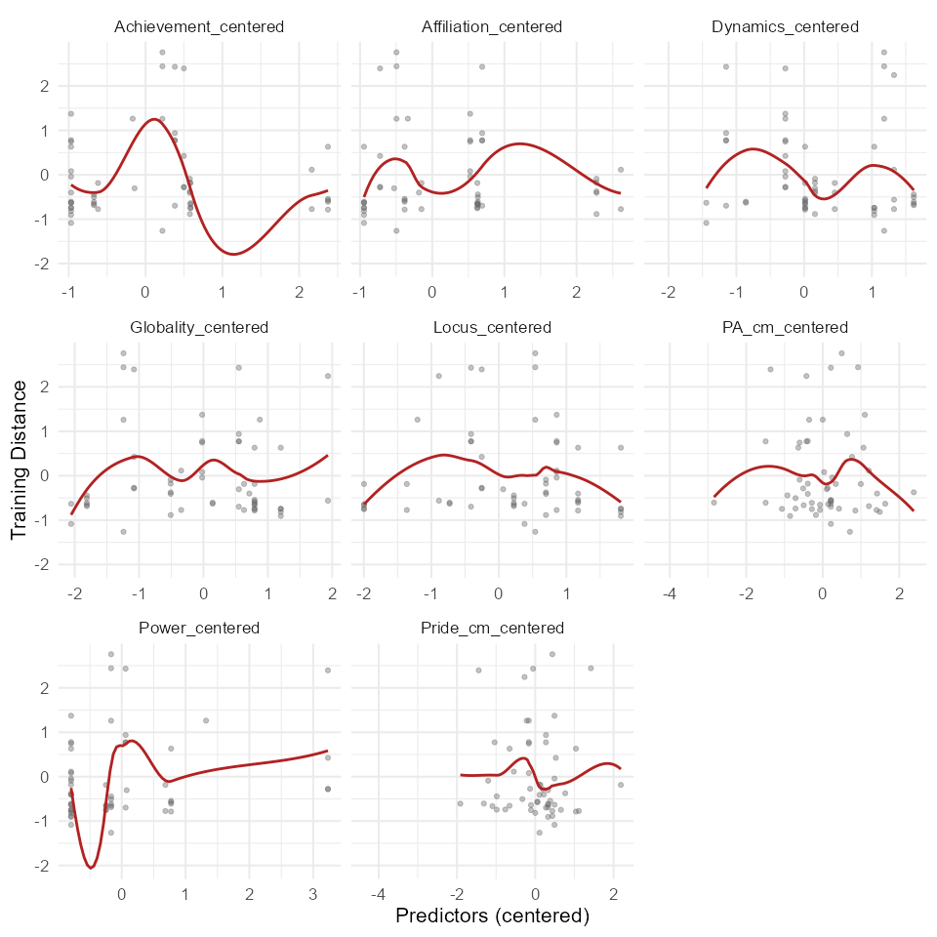

*Note*. None of the predictors show a strictly linear association with the target variable.

Figure 5

Outliers of residuals for each individual

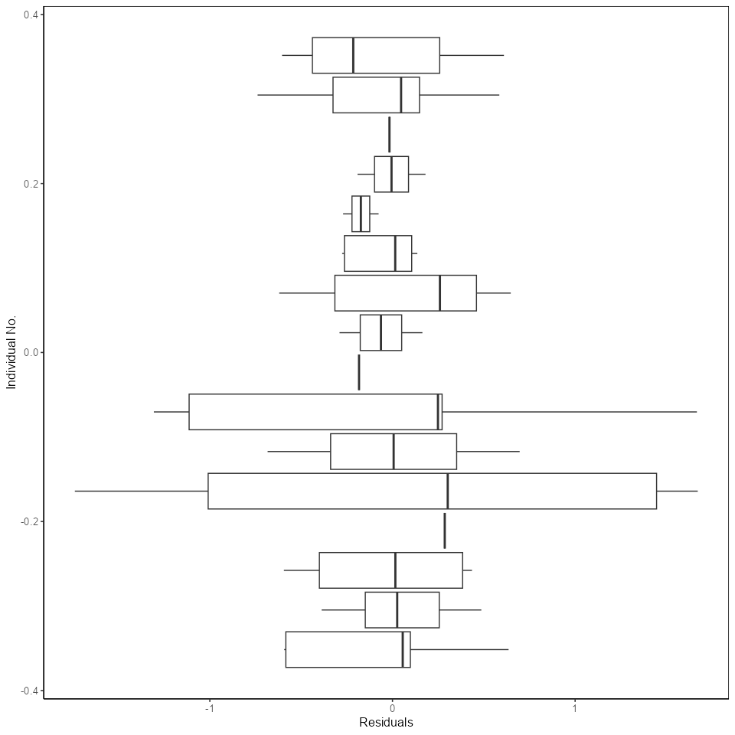

*Note*. Outliers are shown as grey circle. Here, no outliers are present.

Figure 6

QQ-Plot and Scatterplot of Residuals for the HLM predicting running distance

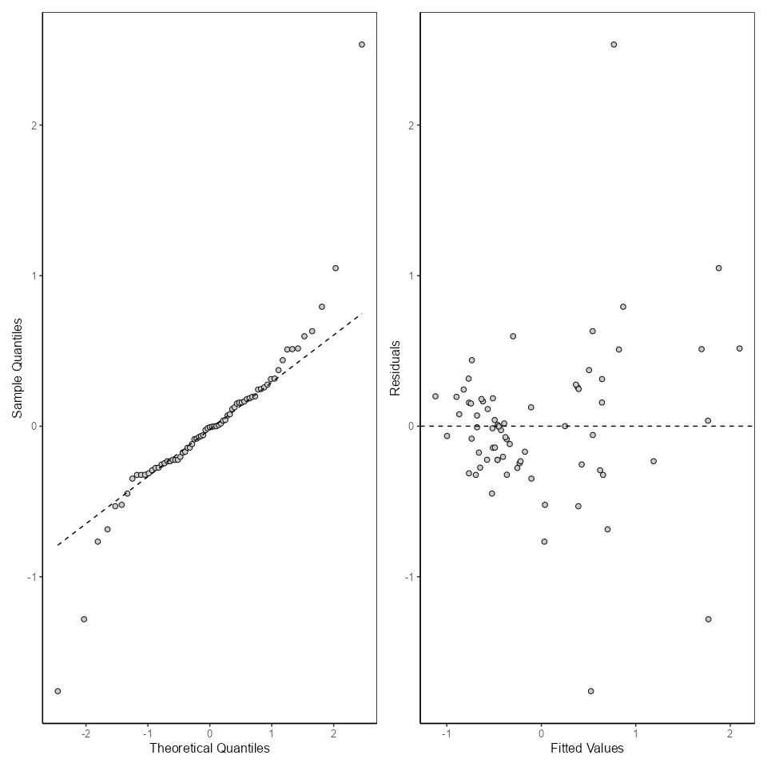

*Note*. The residuals follow the straight line in the QQ-plot, indicating normal distribution. An even spread in the scatterplots indicates homoscedasticity, here a slight deviation from this assumption is present, with residuals concentrated in the lower range of training time.

Figure 7

Outliers of residuals for each individual

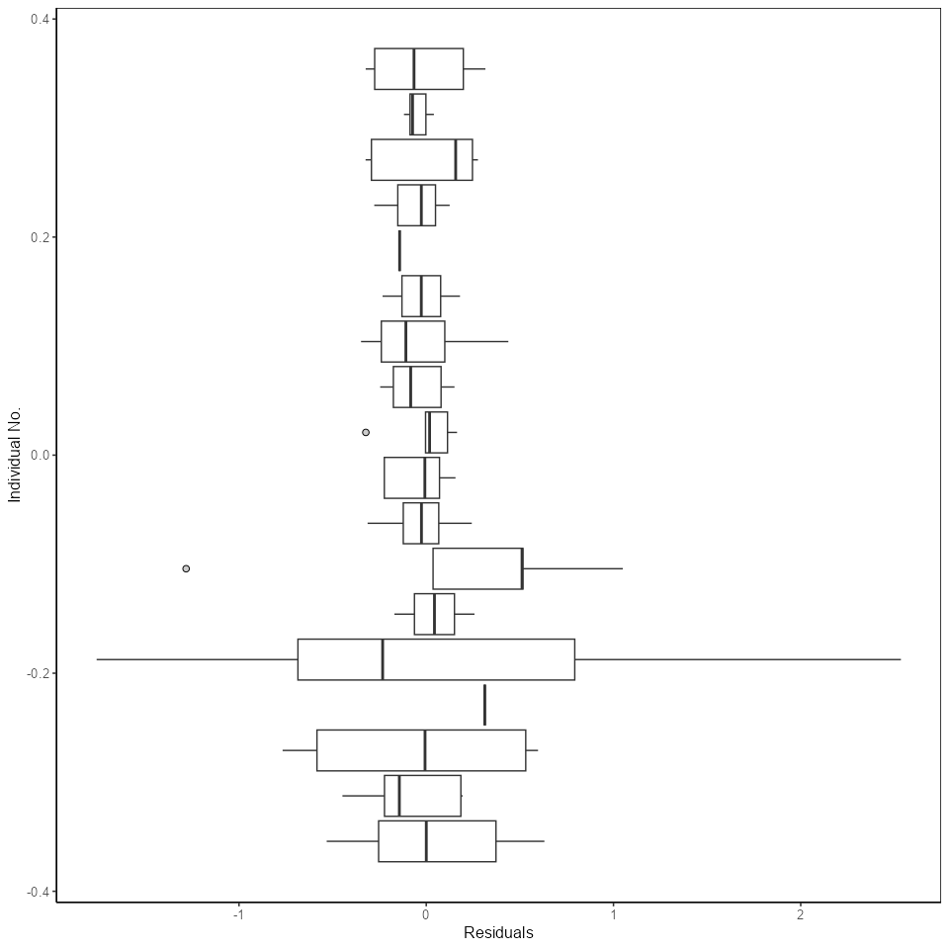

*Note*. Outliers are shown as grey circle

Figure 8

Predictors plottet against the target variable with LOESS smoothing

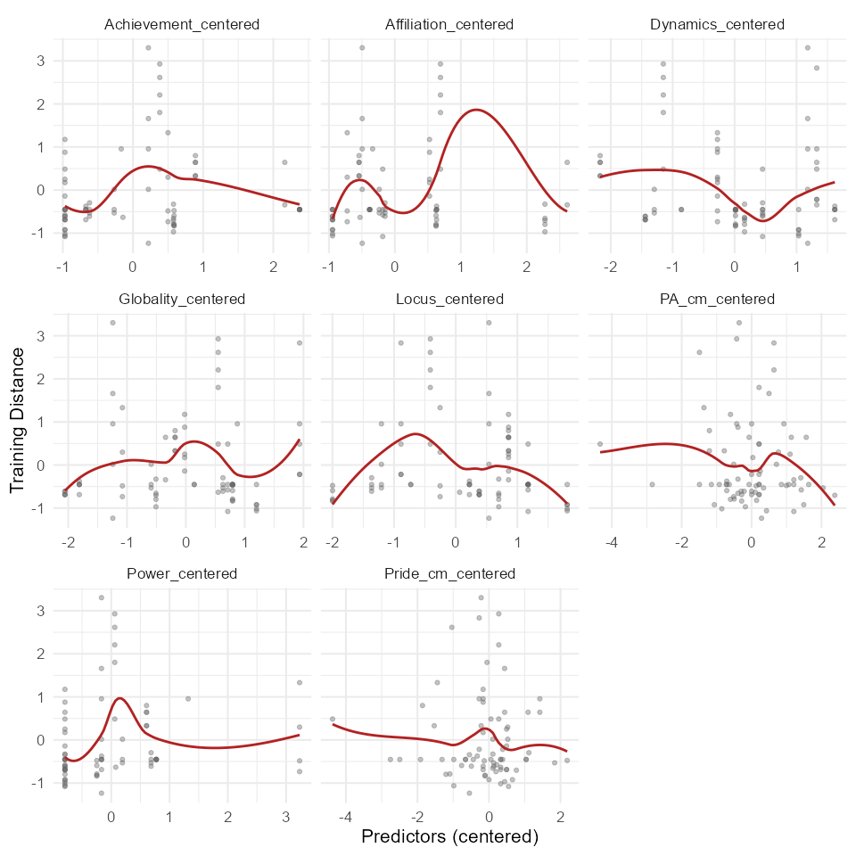

*Note*. This is the note below the figure.

Figure 9

Histogram of Residuals

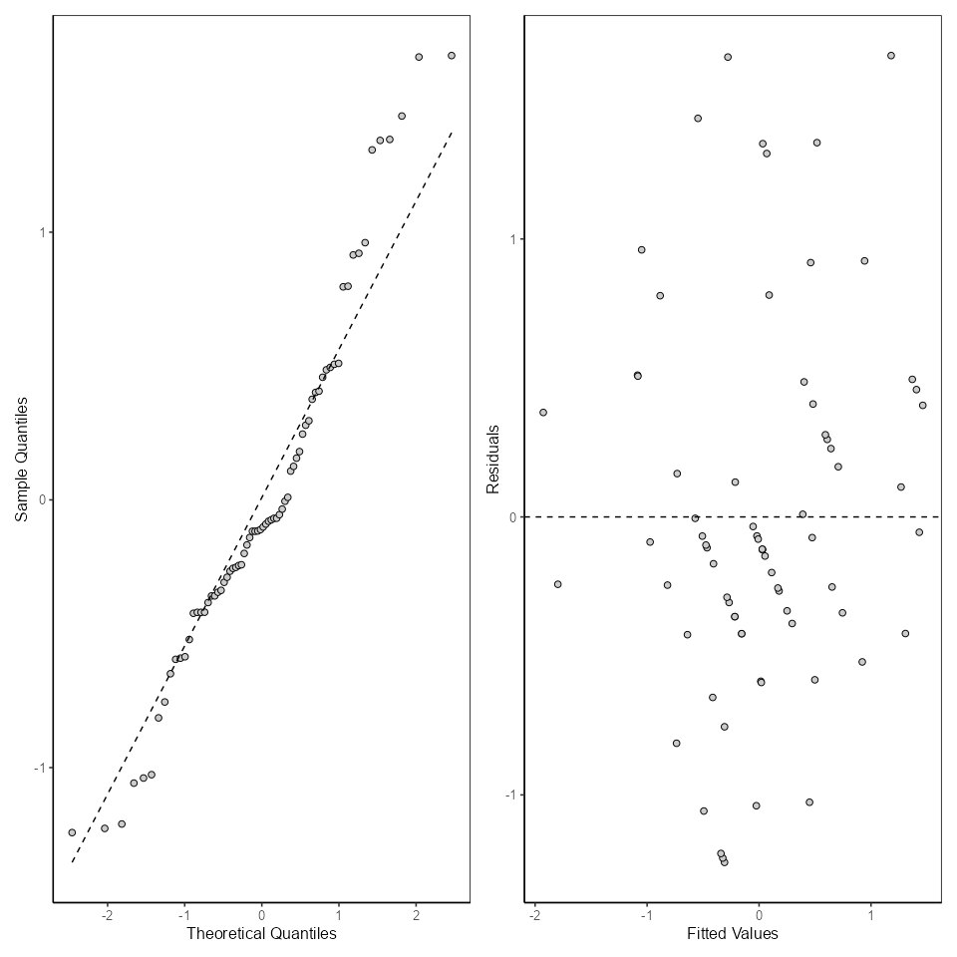

*Note*. This is the note below the figure.

Figure 10

Predictors plottet against the target variable with LOESS smoothing



*Note*. This is the note below the figure.