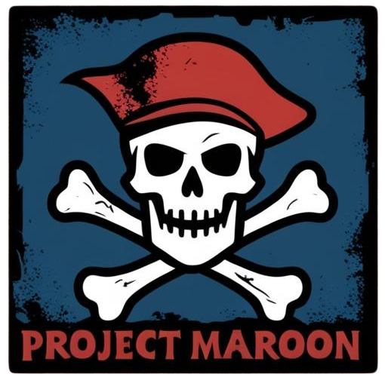
Project Maroon

PegHead
Request for Proposal
Version 1.0
Document History
Version | When | Who | What
1.0 | 2/5/25 | Josh N. | Initial Drafting

Table of Contents
- Problem description
- Project Objectives
- Current System(s) – if any or similar systems
- Intended users and their interaction with the system
- Known interactions with other systems inside/outside the client organization
- Known constraints to development
- Project Schedule
- How to Submit Proposals
- Dates
- Glossary of terms

- Problem description / opportunity / expression of need

The intended goal for this project is to create a pirate-themed, side-scroller game called PegHead. The game will feature the main character, a pirate with a distinctive peg leg, embarking on a high-seas adventure. Players will navigate through diverse environments, battling formidable bosses, solving puzzles, and collecting treasures across the seven seas. The game aims to combine fast-paced action with strategic gameplay, offering a nostalgic yet fresh experience reminiscent of classic titles like Cuphead and Hollow Knight.

- Project Objectives

Our objective is to develop PegHead as an engaging, visually captivating, and challenging single-player game. Key objectives include:
- Fluid, responsive gameplay mechanics that emphasize skill and timing.
- Hand-drawn, vintage-style animations to evoke a classic aesthetic.
- Multi-stage boss fights with unique mechanics and increasing difficulty.
- Diverse levels with varying themes, enemies, and environmental hazards.
- A compelling narrative woven through animated cutscenes.
- Robust performance across multiple platforms without gameplay glitches.

- Current system(s) – if any / similar systems

While no current systems exist for PegHead, similar games include:
- Cuphead: A run-and-gun action game with a focus on boss battles and 1930s cartoon-inspired visuals.
- Hollow Knight: A platformer with retro graphics, tight controls, and challenging gameplay.

- Intended users and their basic interaction with the system

- Gamers who enjoy challenging platformers and action side-scrollers.
- Fans of retro-inspired art styles and hand-drawn animation. User interactions involve:
- Using keyboards or controllers to navigate, jump, attack, and dodge.
- Engaging with in-game tutorials to learn mechanics.
- Tracking progress through a save system and leaderboard rankings.

- Known interactions with other systems within or outside of the client organization.

- Integration with a high-score leaderboard server.
- Compatibility with multiple operating systems (Windows, macOS, Linux).
- Development environment tools such as version control systems (e.g., Git).

- Known constraints to development

- Limited development time within the course schedule.
- Resource constraints, including team size and available assets.
- Technical limitations related to multi-platform deployment.

- Project Schedule
Date | Time | Objective
1/27 | 3 hrs. | Divide group into sections to separate tasks/objectives/setup Git Repository
2/5 | 2 hrs. | Begin RFP and Statement of Work/Finisbh
2/11 | 10 mins. | Present RFP
2/20 | 40 hrs. | Skeleton code running, makefile complete
3/1 | 5 hrs. | Compile paths complete
3/22 | 30 hrs. | Complete missing features
4/5 | 5 hrs. | Complete project and final presentation
5/3 | 1 hr. | Final Presentation

8.0 | How To Submit Proposals
 | Proposals should be submitted electronically in PDF format. Please include detailed design concepts, proposed technologies, development timelines, and resource requirements.
9.0 | Dates
Proposal Submission Deadline: 2/7/2025
Notification of Selection 2/8/2025

10.0 Glossary of terms

Terms that are meaningful to your client group but might not be understood by someone outside your group.

- Side-Scroller: A game where the player views the action from a side perspective.
- Boss Battles: Challenging fights against powerful enemies that often require strategy and skill.
- Cutscenes: Non-interactive sequences used to advance the game's story.
- Prototype: An early playable version of the game showcasing core mechanics.
- Leaderboard: A system that displays player rankings based on performance.
- Git Repository: A platform for managing and sharing code collaboratively
- Hitbox: An invisible shape used for collision detection to determine if an object has been hit.
- Power-Up: An item that temporarily or permanently enhances the player's abilities.
- Platforming: Gameplay focused on navigating environments by jumping between platforms.
- Cooldown: A period of time during which an ability or action cannot be used again.
- Projectile: An object fired or thrown in the game, typically as a form of attack.
- Checkpoint: A save point within a level where the player can respawn after losing a life.
- NPC (Non-Playable Character): Characters controlled by the game that interact with the player.

*Note: Remember that “system” means product, service, and/or system your group would like to see created, built, upgraded, and/or changed. It is a broad term.

