**PERSONAL BLOG ON CLOUD STATIC WEB APPS**

**PHASE 3 SUBMISSION DOCUMENT**

**Project : Personal Blog**

**Team member : J.Enoch**

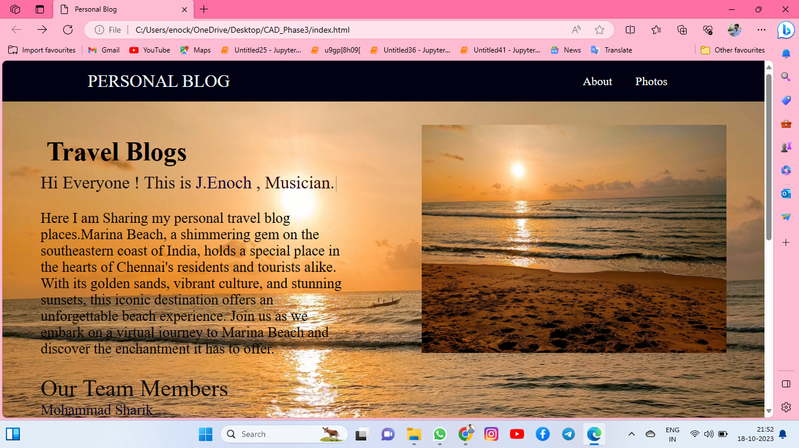

**Introduction**

Welcome to "My Personal blog," your personal gateway to the ethereal world of cloud computing. In this digital journal, we'll embark on a captivating journey through the boundless realms of the cloud, uncovering its mysteries, and embracing its transformative power.

The cloud has become the beating heart of the digital era, a catalyst for change that influences every facet of our lives. As we navigate the ever-evolving landscapes of technology, this blog aims to serve as your compass and guide through the intricate pathways of the digital skies.

Here I am sharing my personal blogs through posts.

Html index.html code

<!DOCTYPE html>

<html lang="en">

<head>

<meta charset="UTF-8">

<meta name="viewport" content="width=device-width, initial-scale=1.0">

<title>Personal Blog</title>

<link rel="preconnect" href="https://fonts.googleapis.com">

<link rel="preconnect" href="https://fonts.gstatic.com" crossorigin>

<link href="https://fonts.googleapis.com/css2?family=Poppins:ital,wght@0,600;1,900&display=swap" rel="stylesheet">

<style>

*{

margin: 0;

padding: 0;

}

body

{

background-color: rgb(2, 2, 29);

color: aliceblue;

font-family: 'Times New Roman', Times, serif;

height: 1000v;

background-image: url(./images/beach.jpg);

background-attachment: fixed;

}

nav{

display: flex;

font-size: 20px;

justify-content: space-around;

align-items: center;

height: 70px;

background-color: rgb(1, 1, 19)

}

nav ul{

display: flex;

justify-content: center;

}

nav ul li a

{

text-decoration: none;

color: white;

}

nav ul li a:hover

{

color:black;

}

nav ul li{

list-style: none;

margin: 0 20px;

}

.left

{

font-size:1rem;

}

.firstsection

{

display: flex;

justify-content:space-around;

margin: 0px 0px;

width: 100%;

}

.firstsection > div{

width: 40%;

height: 30%;

}

.leftsection

{

font-size: 30px;

margin: 50px 0;

color: rgb(10, 10, 9);

font-family: 'Times New Roman', Times, serif;

}

.PB

{

align-items: flex-start;

margin:0px ;

padding: 0%;

font-size: 30px;

}

.rightsection img

{

width: 100%;

margin: 40px 0px;

}

h1

{

justify-content:space-around ;

color: black;

padding: 10px;

margin-left: 0%;

}

.purple

{

color:rgb(13, 2, 63)

}

#element

{

color:rgb(53, 3, 3)

}

.secondsection

{

max-width: 80vw;

margin: auto;

}

.secondsection h1

{

font-size: 40px;

}

.secondsection p

{

font-size: 25px;

}

.Thirdsection

{

max-width: 80vw;

margin: auto;

font-size: 25px;

font-weight: 75;

color:rgb(1, 10, 27) ;

}

.Thirdsection h1

{

font-size: 40px;

}

p

{

margin: 30px 0px;

color: rgb(0, 0, 0);

font-size: 25px;

}

.team

{

font-size: 40px;

font-weight: 100;

}

.team ul

{

color:rgb(4, 4, 48);

font-size: 25px;

font-weight: 75px;

}

</style>

</head>

<body style="background-image: url(./images/beach.jpg);">

<header>

<nav>

<div class="PB">PERSONAL BLOG</div>

<div class="left"></div>

<div class="right">

<ul>

<li><a href="about.html">About</a></li>

<li><a href="photos.html">Photos</a></li>

</ul>

</div>

</nav>

</header>

<main>

<div class="container">

</div>

<section class="firstsection">

<div class="leftsection">

<h1>Travel Blogs</h1>

Hi Everyone ! This is <span class="purple">J.Enoch</span> ,

<span id="element"></span>

<p>Here I am Sharing my personal travel blog places.Marina Beach, a shimmering gem on the southeastern coast of India, holds a special place in the hearts of Chennai's residents and tourists alike. With its golden sands, vibrant culture, and stunning sunsets, this iconic destination offers an unforgettable beach experience. Join us as we embark on a virtual journey to Marina Beach and discover the enchantment it has to offer.</p>

<div class="team">Our Team Members

<br>

<ul>Mohammad Sharik</ul>

<ul>Mohammad Muqbil Sinan</ul>

<ul>Jai Ganesh</ul>

<ul>Enoch</ul>

</div>

</div>

<div class="rightsection">

<img src="images/beach.jpg" alt="#">

</div>

</section>

<section class="secondsection">

<h1>Landmarks Along the Shore:</h1> <br>

<p>Marina Lighthouse: Start your exploration with a visit to the iconic lighthouse. Climb to the top for panoramic views of the city and the sea.

Anna Memorial: This memorial dedicated to C.N. Annadurai, a revered Tamil politician, is a prominent landmark on the beach.

Victory War Memorial: A poignant reminder of India's military history, this memorial is a place of reflection and honor. </p>

</section>

<section class="Thirdsection"><h1><b>Sunsets to Remember:</b></h1>

<p>As evening descends, Marina Beach transforms into a magical wonderland. The horizon is painted with hues of orange and pink, and the warm sea breeze carries the sounds of laughter and joy. Sunset at Marina Beach is a sight you'll cherish forever.</p></section>

</main>

<script [src="https://unpkg.com/typed.js@2.0.16/dist/typed.umd.js"></script](mailto:src="https://unpkg.com/typed.js@2.0.16/dist/typed.umd.js"></script)>

<script>

var typed = new Typed('#element', {

strings: ['College Student', 'Programmer','Musician.'],

typeSpeed: 50,

});

</script>

</body>

</html>

Index.html

<!DOCTYPE html>

<html lang="en">

<head>

<meta charset="UTF-8">

<meta name="viewport" content="width=device-width, initial-scale=1.0">

<title>Personal Blog</title>

</head>

<style>

*

{

margin: 0;

padding: 0;

}

body

{

color: aliceblue;

font-family:'Times New Roman', Times, serif;

font-size: 20px;

justify-content: space-around;

height: 70px;

background-color: rgb(1, 1, 19)

}

.about

{

margin: 50px;

justify-content: space-around;

}

.about img

{

width: 50%;

margin: 40px 20px;

}

</style>

<body>

<div class="about">

<h1>ABOUT</h1>

<p>We 4 are College Students who developed a website for our personal travel Blogs</p>

<p>Traveling with friends is like embarking on a grand adventure where each moment becomes a cherished memory. The camaraderie, laughter, and shared experiences make these trips truly extraordinary. Here's a recount of an unforgettable travel experience with some of my closest friends.</p>

<img src="images/we4.jpg" alt="#">

</div>

</body>

</html>

Photos.html

<!DOCTYPE html>

<html lang="en">

<head>

<meta charset="UTF-8">

<meta name="viewport" content="width=device-width, initial-scale=1.0">

<title>Personal Blog</title>

</head><link rel="stylesheet" href="style.css">

<body>

<h2>Photos</h2>

<div class="row">>

<div class="column"><img src="images/we4.jpg" alt=""></div>

<div class="column"><img src="images/we41.jpg" alt=""></div>

<div class="column"><img src="images/beach.jpg" alt=""></div>

<div class="column"><img src="images/eno.jpg" alt="">

<div class="column"><img src="images/mud.jpg" alt=""></div>

</div>

</body>

</html>