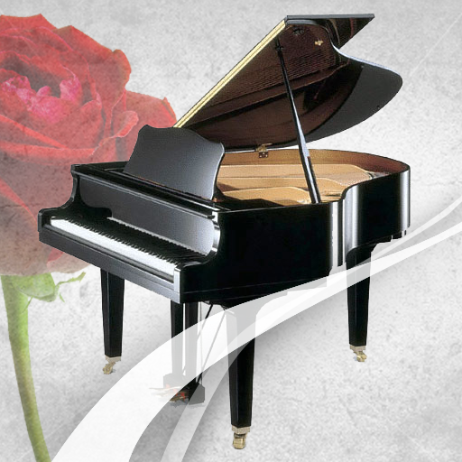
Classical Piano Book
A collection of classical piano pieces
the whole world loves
v 6.0
Dedicated to my father & mother
Milton黃燊權 & Lillian傅蘭芳Hwang

To install this app:
- For iOS, in Safari, tap the Share icon , and select Add to Home Screen , then click Add.
- For Android, in Chrome, tap the three-dot icon, and select Add to Home Screen , then click Install.

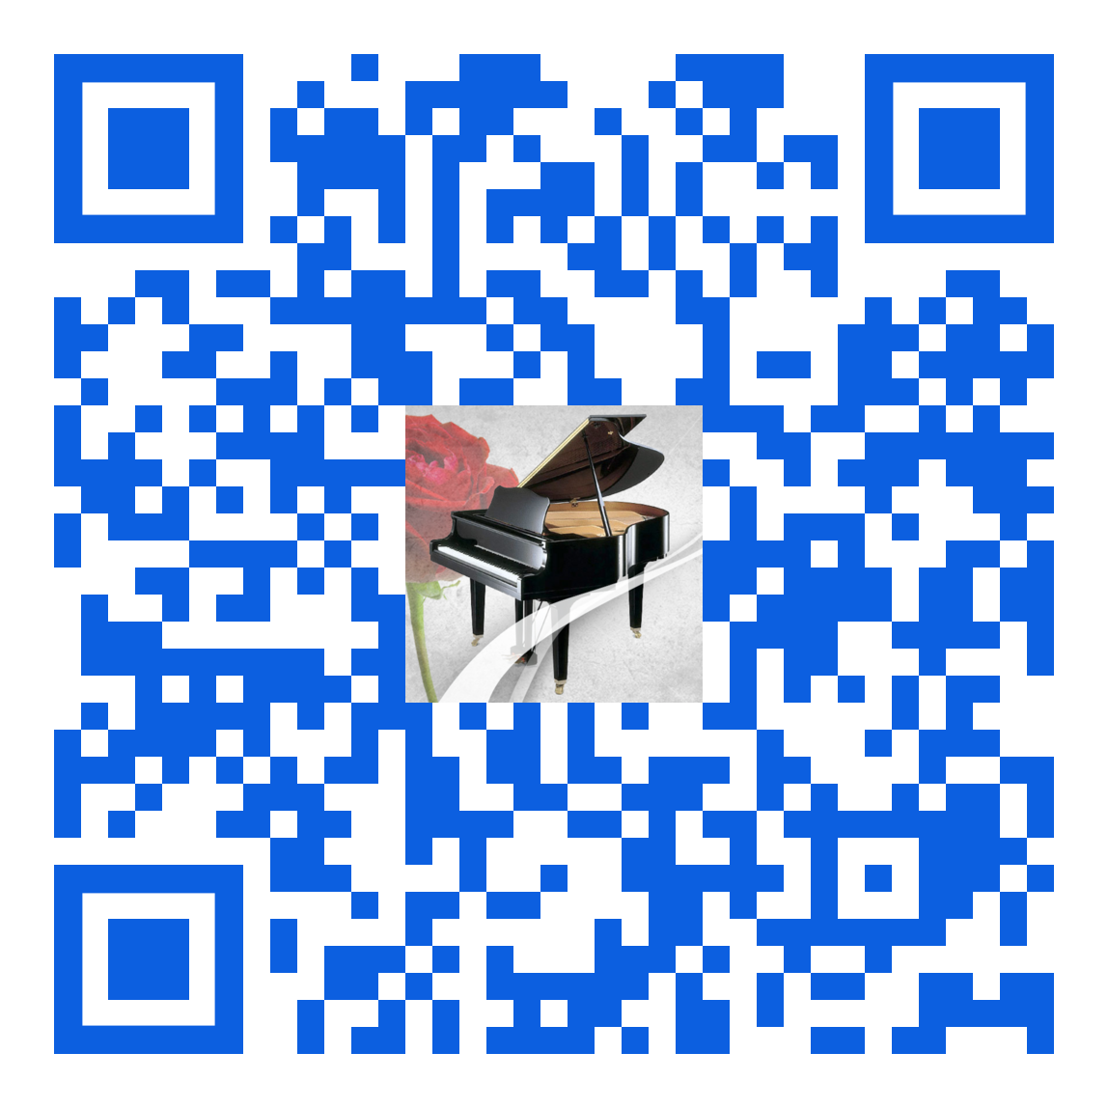

Completely free with no distracting ads for you to enjoy and to share!

All the piano playing are performed by me, Enoch Hwang, except for the Prelude in C-sharp Minor by Rachmaninoff that is performed by my son, Jonathan Hwang, when he was 14, CS Theme and Variations – Compton, a duet by us, and My Tribute – Crouch, a piano and organ duet by us with Jonathan on the piano.

Copyrighted © 2012, 2013, 2018, 2022, 2024, 2025, 2026 Enoch Hwang.
All rights reserved.
No part of this app may be reproduced, stored in a retrieval system or transmitted, in any form or by any means, electronic, mechanical, photocopying, recording or otherwise, without the prior written permission of the owner. Email to EnochHwangPhD@gmail.com if you have any comments or questions.

