Register Pressure Analysis Tool Report

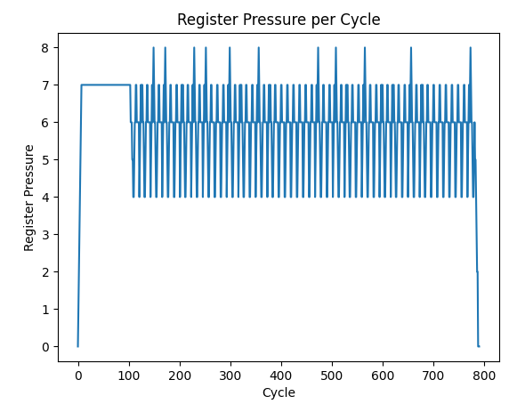
Figure: Plot of register pressure vs. Cycle

- Which regions of execution show the highest register pressure, and why?
From plotting the register pressure against cycle count, it seems like there are multiple regions where the pressure spikes to the highest number of 8. This is likely because the region has a loop or computation heavy sequence that requires more live values.
- Why must register x0 be excluded from register pressure analysis?
Register x0 is excluded because it never holds a live value. It is always hardwired to 0. Including x0 in register pressure would inflate the pressure when it does not contribute to any storage demand.
- If the processor had only 16 registers, how many cycles would exceed this limit? What does this imply?
The maximum register pressure is 8. Therefore, no cycles would exceed this limit. This implies that even if the processor was designed with only 16 registers it would still be sufficient to run this program.

