Group 3

COS 420

April 14, 2019

Below are the design class diagrams for all 5 of the Sprout team’s sequence diagrams. The design class diagrams are followed by the UML class diagram for the design pattern.

**Design Class Diagram 1: Creating Account**

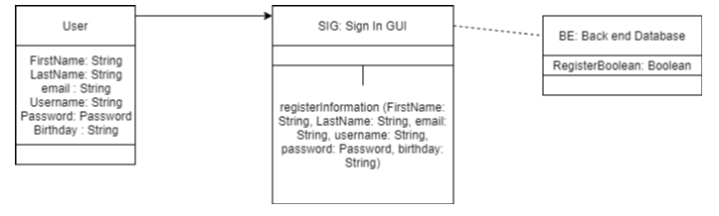

**Design Class Diagram 2: Logging In**

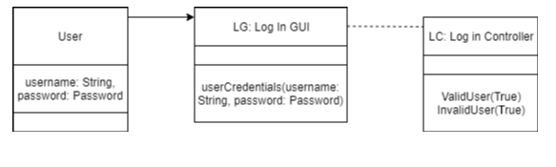

**Design Class Diagram 3: Matching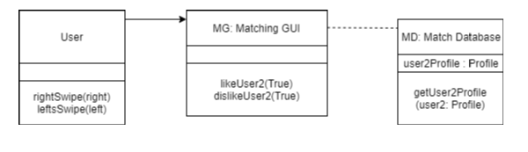Design Class Diagram 4: Messaging**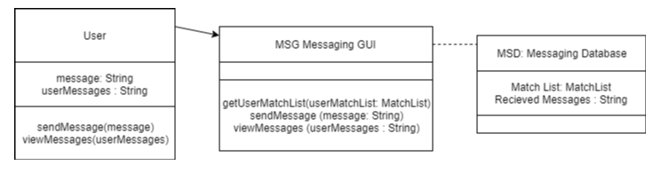

**Design Class Diagram 5: Profile Customization**

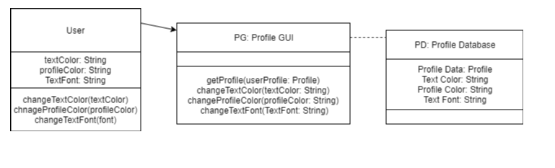

**UML Class Diagram for Design Pattern**

