Group 3

COS 420

March 17, 2019

**Sequence Diagram Document**

On each page below are the analysis sequence diagrams of some our most important features. These will be updated for the next deliverable and converted to design sequence diagrams as we make further progress on how our development and implementation will be done. Therefore, we do not include any design sequence diagrams this deliverable because we are still building our application infrastructure. In addition, detailed descriptions of the steps will be included with the next update for deliverable 3.

**Analysis Sequence Diagram 1:**

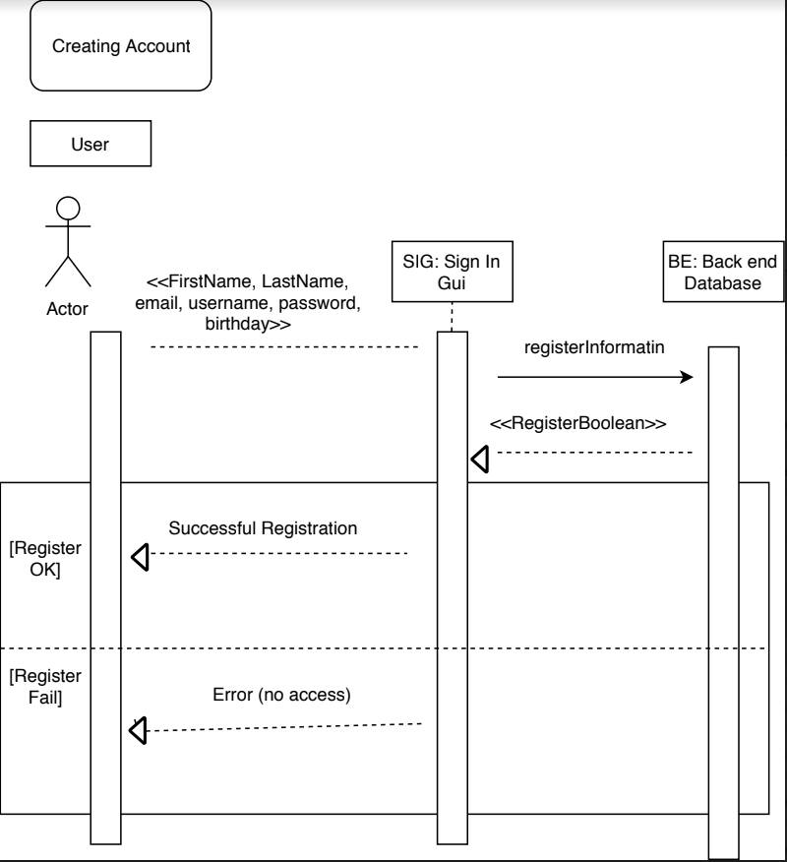

**Analysis Sequence Diagram 2:**

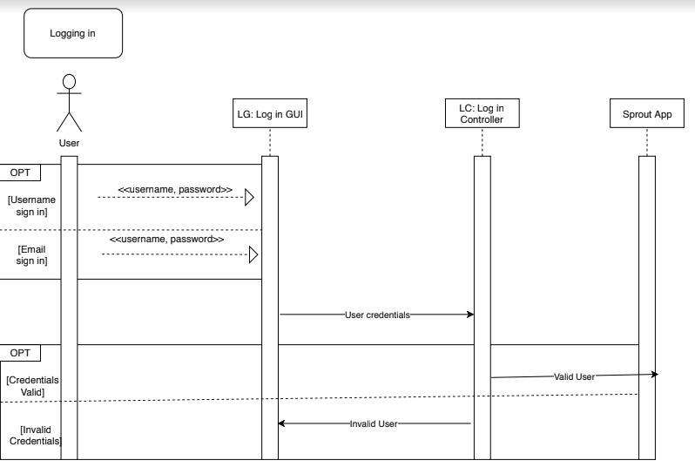

**Analysis Sequence Diagram 3:**

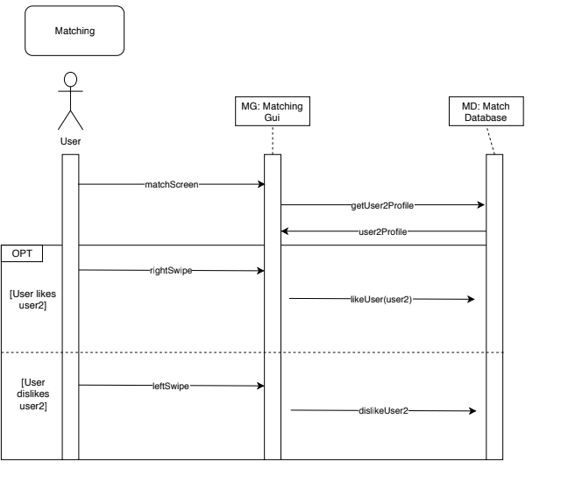

**Analysis Sequence Diagram 4:**

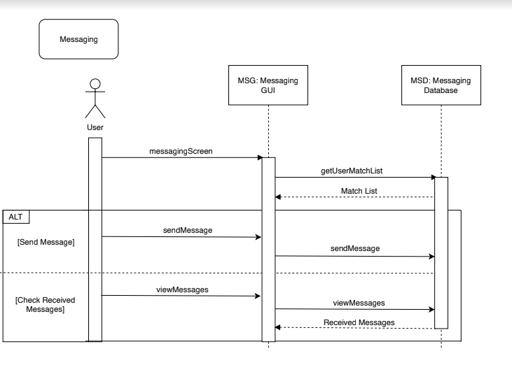

**Analysis Sequence Diagram 5:**

