Unit Testing:

Unit test 1:

|  |  |
| --- | --- |
| Test name (ID) | Hash Password (001) |
| Test description | User tries to register for an account with password which then gets hashed for |
| Precondition | User submits non-null password |
| Example input | hashPassword(“Hello”) |
| Expected output | Hashed + Salted value of “Hello” |

Unit test 1 screenshot:

Code that achieves this:

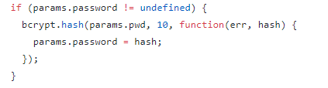

Unit test 2:

|  |  |
| --- | --- |
| Test name (ID) | Empty Login(002) |
| Test description | User tries to login for an account but does not provide any info |
| Precondition | User enters in no account info and tries to login. |
| Example input | loginUser(username =NULL, pwd = NULL, …) |
| Expected output | Failure to lopin notice. |

Unit test 2 screenshot:

Input:

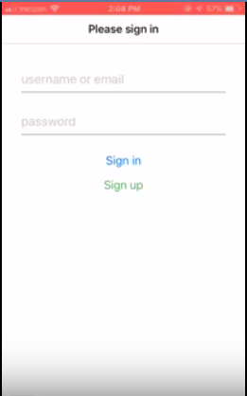

Output:

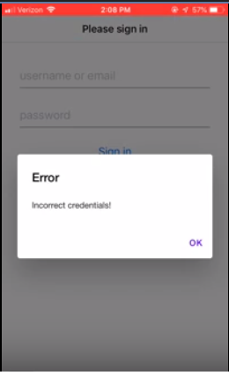

Use Case Testing:

Use case test 1:

|  |  |
| --- | --- |
| Test name (ID) | Block User (003) |
| Test description | User A blocks User B, at which point User B can no longer see User A |
| Precondition | User A and User B are valid users |
| Example steps | 1. User A navigates to User B’s profile 2. User A selects “Block User” 3. User A confirms block |
| Expected output | User B is now unable to see User A’s profile |

Use case test 1 screenshot:

(Feature not currently implemented)

Use case test 2:

|  |  |
| --- | --- |
| Test name (ID) | Change Profile Color (004) |
| Test description | User A |
| Precondition | User A and User B are valid users |
| Example steps | 1. User A navigates to “edit my profile” 2. User A selects “Change profile color” 3. User A selects color from predetermined options 4. User |
| Expected output | User A’s profile now displays the new color |

Use case test 2 screenshot:

(Feature not currently implemented)

Acceptance Testing:

Acceptance test 1:

|  |  |
| --- | --- |
| Test name (ID) | Register User (05) |
| Test description | User tries to register for an account and the account gets added to the database. |
| Precondition | User submits valid account info |
| Example steps | 1. User navigates to register user 2. User enters first name “Enoch” 3. User enters last name “Lin” 4. User enters email “[enoinoo@gmail.com](mailto:enoinoo@gmail.com)” 5. User enters username “Enoinoo” 6. User enters password 7. User verifies password 8. User enters DOB as “5/14/99” 9. User selects gender “male” 10. User selects preference “male/female” 11. User clicks register |
| Expected output | Profile Screen |

Input:

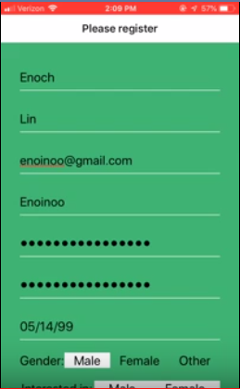

Output:

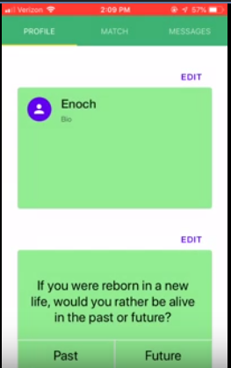

Acceptance test 2:

|  |  |
| --- | --- |
| Test name (ID) | Match users (006) |
| Test description | Two users match like each other and decide to match |
| Precondition | Two valid users signed up |
| Example steps | 1. User A agrees to match with user B 2. User B agrees to match with user A |
| Expected output | Match Screen |

Acceptance test 2 screenshot:

