TC id – 001

Test Name – wallpaper change

Pre con

Author – lior Orshter tsur

Date – 31.5.24

Status – ready for testing

Priority – high

Type – compatibility

Platform – web

category –

steps 2

|  |  |  |  |  |  |  |
| --- | --- | --- | --- | --- | --- | --- |
| Step Number | Description | Expected Result | Actual Result | Pass/Failed | Remarks | Attachments |
| 1 | Open app via Git | App will open successfully |  |  |  | מסך הבית |
| 2 | click on right mouse button and then click on "display settings" | Context menu will open with top buttons cut out |  |  |  | איתור מיקוד |

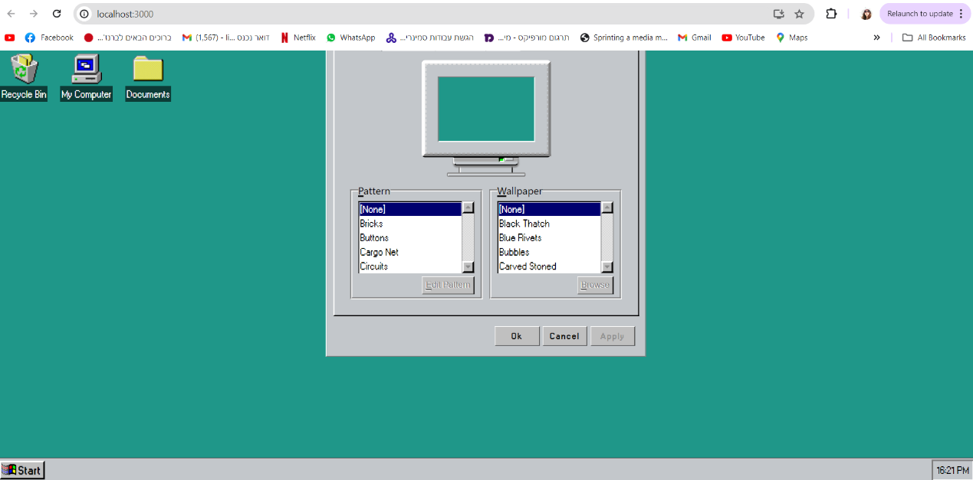

TC id – 002

Test Name – browse image from computer

Pre con

Author – lior Orshter tsur

Date – 31.5.24

Status – ready for testing

Priority – medium

Type – functionality

Platform – web

category –

steps

|  |  |  |  |  |  |
| --- | --- | --- | --- | --- | --- |
| Step number | description | Expected result | Actual result | Pass/failed | remarks |
| 1 | Open app via Git | App will open successfully |  |  |  |
| 2 | click on right mouse button and then click on "display settings" | Context menu will open successfully |  |  |  |
| 3 | Click browse | Folder will open successfully |  |  |  |
| 4 | Click on docx file and then click on open | System will not allowed docx files to open | Docx filles added to list of backgrounds | **Failed** |  |

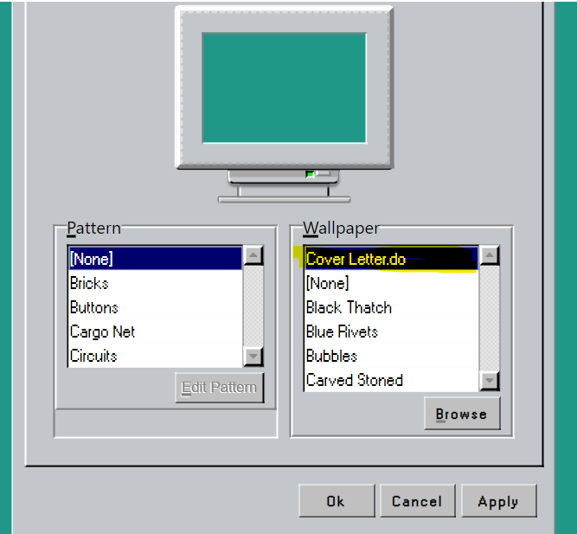

TC id – 003

Test Name – apply image from computer

Pre con

Author – lior Orshter tsur

Date – 31.5.24

Status – ready for testing

Priority – high

Type – functionality

Platform – web

category –

steps

|  |  |  |  |  |  |
| --- | --- | --- | --- | --- | --- |
| Step number | description | Expected result | Actual result | Pass/failed | remarks |
| 1 | Open app via Git | App will open successfully |  |  |  |
| 2 | click on right mouse button and then click on "display settings" | Context menu will open successfully |  |  |  |
| 3 | Click browse | Folder will open successfully |  |  |  |
| 4 | Click on jpg file and click open | jpg filles added to list of backgrounds successfully |  |  |  |
| 5 | Click on apply buttons | Image will be display on background successfully | Image did not displayed on background | **Failed** |  |

