AI Meeting Memory & Decision Reconstruction System - GenAI - Gemini 2.4 Flash

Project Description:
AI Meeting Memory & Decision Reconstruction System is an Artificial Intelligence-based organizational memory platform designed to convert raw meeting recordings and transcripts into persistent, searchable organizational memory, and to reconstruct the historical context, reasoning, and evidence behind decisions made by a team weeks or months earlier. Rather than producing a one-off meeting summary that is read once and discarded, the system treats every processed meeting as a permanent unit of institutional knowledge — what was discussed, what was decided, why it was decided, who was involved, what alternatives were rejected, and what actions followed. The primary objective of the system is to eliminate the “we know we discussed this, but nobody remembers why” problem that affects engineering, product, and operations teams as they scale, by making the reasoning behind past decisions retrievable through natural-language questions rather than manual transcript archaeology.
To make this functionality usable by a project team, the platform exposes a FastAPI backend with endpoints for uploading and processing meetings, running hybrid search, asking historical questions, and inspecting decisions and their timelines, together with an interactive multi-page Streamlit dashboard for uploading recordings, browsing generated meeting memory, exploring extracted decisions, asking the organizational memory natural-language questions, and viewing chronological decision timelines. The system is intentionally designed to remain fully testable end-to-end even without a configured LLM API key: every LLM-backed service falls back to a deterministic, rule-based heuristic so that the complete pipeline — from transcript to a grounded answer with citations — can be exercised entirely offline.

Scenarios
AI Meeting Memory & Decision Reconstruction System is designed to support multiple real-world organizational and engineering use cases by converting spoken meeting discussion into structured, retrievable, source-grounded memory. Its ability to reconstruct not just what was decided but why it was decided makes it valuable for engineering teams, new hires, researchers, and compliance-oriented organizations alike. The following scenarios demonstrate its practical applications.
Scenario 1: Engineering and product teams can use the platform to reconstruct the reasoning behind past architectural or technology choices without hunting through old meeting recordings or chat threads. When a team asks a question such as “Why did we choose PostgreSQL instead of MongoDB three months ago?”, the Decision Reconstruction Engine retrieves every meeting that touched the topic — the original requirements discussion, the technical comparison, the final decision meeting, and any follow-up implementation review — and returns a single grounded answer that includes the chosen option, the rationale, the rejected alternatives, the participants involved, and the actions that were assigned afterward. This prevents teams from silently re-debating decisions that were already carefully made, and gives new discussions a documented starting point instead of institutional guesswork.
Scenario 2: New employees and team members joining an existing project can use the system as a structured onboarding tool to understand not just the current state of a codebase or architecture, but the sequence of decisions that produced it. Instead of scheduling multiple onboarding calls with senior engineers to ask “why is this built this way,” a new hire can query the organizational memory directly — “What alternatives were considered for the database layer?” or “Who was involved in the database decision?” — and receive a source-cited answer built from the actual historical meeting record. This significantly shortens ramp-up time, reduces the burden on senior staff to repeatedly explain past reasoning, and ensures institutional knowledge survives staff turnover rather than leaving with the people who made the original decisions.
Scenario 3: Educational institutions and applied-AI research groups can utilize the project as a hands-on teaching platform for Generative AI system design, covering the complete pipeline from speech-to-text transcription, structured LLM extraction validated with Pydantic, embedding generation, hybrid retrieval combining vector and keyword search, reranking, grounded Retrieval-Augmented Generation, and hallucination-prevention techniques such as source attribution and confidence scoring. Students can study how a single LLMService abstraction transparently switches between a live Gemini/OpenAI call and a deterministic offline fallback, and researchers can extend the project by experimenting with alternative embedding models, cross-encoder rerankers, or graph-based decision-linking strategies to improve reconstruction quality.

Technical Architecture:
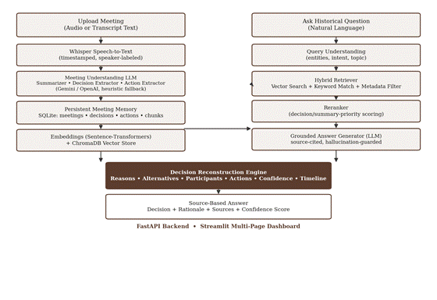
Figure 1: End-to-end architecture — audio/transcript ingestion, Whisper transcription, LLM-based meeting understanding, persistent SQLite + ChromaDB memory, the hybrid retriever, and the decision reconstruction engine.
The architecture is organized around two entry points that converge on a shared memory layer. Uploading a meeting flows down through transcription, LLM-based meeting understanding, and persistent storage, while asking a historical question flows down through query understanding and hybrid retrieval. Both paths feed the Decision Reconstruction Engine, which reranks the assembled evidence, generates a grounded answer through the LLM, and returns a structured, source-cited response together with a chronological decision timeline. Every stage that depends on an optional component — Whisper, Gemini/OpenAI, Sentence-Transformers, or ChromaDB — has a deterministic fallback, so the pipeline in the diagram remains fully traversable even in a constrained offline environment.
This two-column, one-destination shape is a deliberate design choice rather than an incidental one: it keeps the write path (turning a meeting into memory) and the read path (turning a question into a grounded answer) independently testable, while guaranteeing that both paths ultimately pass through the same reranking, grounding, and confidence-scoring logic in the Decision Reconstruction Engine, so a user always receives the same quality of citation and rationale regardless of whether they are asking about a meeting processed seconds ago or one processed months earlier. The FastAPI backend and Streamlit frontend shown at the base of the diagram sit outside this core pipeline entirely, acting purely as a thin transport and presentation layer over the same DecisionReconstructionEngine, HybridRetriever, and MemoryBuilder classes that the automated test suite exercises directly.

Pre-requisites:
The AI Meeting Memory & Decision Reconstruction System was developed and tested using a Python-based backend and frontend environment. The FastAPI service and the underlying extraction, retrieval, and reconstruction modules were built to run identically whether or not a Gemini or OpenAI API key is configured, and whether or not the optional Whisper, ChromaDB, and Sentence-Transformers dependencies are installed, through a set of deterministic fallback code paths implemented in each service.

Runtime Environment
● Python 3.10 or later
● FastAPI + Uvicorn (backend REST API server)
● Streamlit (interactive multi-page web dashboard)
● Whisper (optional — audio transcription mode only; text-transcript mode requires no audio dependency)
● ChromaDB + Sentence-Transformers (optional — semantic vector search; falls back to keyword/entity search)
● Gemini API key (optional — falls back to a deterministic heuristic engine)
● Docker (optional — containerized deployment of the backend and frontend together)

Project Workflow:
Based on the project information gathered from the codebase and implementation plan, the workflow can be structured into the following six milestones, each broken down into concrete development activities.

Milestone 1: Requirement Analysis & System Design
● Activity 1.1: Define the problem of reconstructing decision context from meeting discussions and identify the limitations of conventional meeting summarizers that discard reasoning.
● Activity 1.2: Identify functional requirements such as audio/transcript ingestion, structured meeting understanding, decision and action extraction, persistent memory storage, hybrid semantic search, and source-grounded question answering.
● Activity 1.3: Define non-functional requirements covering performance, reliability, usability, security, and scalability.
● Activity 1.4: Select Whisper for transcription, an LLM (Gemini/OpenAI) for structured extraction and answer generation, and Sentence-Transformers with ChromaDB for semantic retrieval.
● Activity 1.5: Design the application architecture integrating the transcription service, LLM extraction services, SQLite persistence layer, ChromaDB vector store, hybrid retriever, and decision reconstruction engine behind a FastAPI backend and Streamlit frontend.
● Activity 1.6: Select the technology stack: Python, FastAPI, Streamlit, Pydantic, ChromaDB, Sentence-Transformers, Gemini/OpenAI SDKs, SQLite, Pandas, and Docker.

Milestone 2: Environment Setup & Initial Configuration
● Activity 2.1: Set up the Python development environment and configure the project's modular package layout (app, frontend, prompts, data, tests).
● Activity 2.2: Configure environment variables via .env for the LLM provider, embedding provider, ChromaDB persistence directory, SQLite database path, and audio/transcript storage directories.
● Activity 2.3: Install required dependencies using requirements.txt, including FastAPI, Uvicorn, Streamlit, Pydantic, ChromaDB, Sentence-Transformers, google-generativeai, openai, Pandas, and Pytest.
● Activity 2.4: Create the modular project structure containing API routers, Pydantic models, extraction services, RAG components, analysis modules, and the database layer.
● Activity 2.5: Configure the SQLite schema (meetings, participants, decisions, decision_reasons, decision_alternatives, decision_participants, actions, transcript_chunks) and the ChromaDB persistent vector store directory.
● Activity 2.6: Verify that the FastAPI application launches successfully, automatically seeding the four-meeting PostgreSQL-vs-MongoDB core scenario when the database is empty.

Milestone 3: Core System Development
● Activity 3.1: Implement the SpeechToTextService supporting both Whisper-based audio transcription and direct timestamped transcript-text parsing.
● Activity 3.2: Implement the ParticipantIdentifier to extract named participants and infer roles (Tech Lead, Backend Lead, Product Manager) from transcript metadata and speaker labels.
● Activity 3.3: Implement the MeetingSummarizer to generate a structured executive summary, key topics, risks, and open questions using LLM structured JSON output.
● Activity 3.4: Implement the DecisionExtractor using Pydantic-validated structured extraction to capture explicit and implicit decisions with rationale, alternatives, participants, confidence, and status.
● Activity 3.5: Implement the ActionExtractor to capture action items with owner, due date, and priority.
● Activity 3.6: Implement the MemoryBuilder to orchestrate summarization, decision extraction, action extraction, and participant identification into a single persistent MeetingMemory object.
● Activity 3.7: Implement the EmbeddingService and VectorStore to generate embeddings for transcript chunks, summaries, and decisions, and persist them in ChromaDB with metadata filtering.
● Activity 3.8: Implement the HybridRetriever combining ChromaDB semantic search with SQLite-backed keyword/entity matching, and the Reranker to prioritize decision- and summary-type evidence.
● Activity 3.9: Implement the AnswerGenerator and DecisionReconstructionEngine to produce a grounded, source-cited answer together with reasons, alternatives, participants, actions, confidence, and a chronological timeline.
● Activity 3.10: Implement the DecisionTimelineBuilder, ContradictionDetector, and ConfidenceScorer analysis modules for advanced organizational-memory features.
● Activity 3.11: Implement the FastAPI routers for meeting upload/processing, search, decisions, and memory/RAG question answering.
● Activity 3.12: Implement the five-page Streamlit dashboard (Upload Meeting, Meeting Memory, Decision Explorer, Ask Organizational Memory, Decision Timeline).

Milestone 4: Integration & Optimization
● Activity 4.1: Integrate the transcription, extraction, persistence, vector indexing, retrieval, and reconstruction layers into a single end-to-end meeting-processing pipeline.
● Activity 4.2: Connect the Streamlit frontend to the FastAPI backend for meeting upload, memory browsing, decision exploration, and historical question answering.
● Activity 4.3: Implement a database-driven seed routine (seed_data.py) that automatically populates the four-meeting core PostgreSQL-vs-MongoDB scenario on first run so the system is demonstrable without manual data entry.
● Activity 4.4: Optimize LLM usage through structured JSON prompting, schema-guided extraction, and a deterministic heuristic fallback to avoid hard failures when no API key or network access is available.
● Activity 4.5: Implement grounding and hallucination-prevention mechanisms including mandatory source citation, confidence scoring, and explicit “insufficient evidence” responses.
● Activity 4.6: Implement input validation and error handling for missing audio/transcript input, malformed LLM JSON output, missing decisions, and unavailable optional dependencies (Whisper, ChromaDB, Sentence-Transformers).

Milestone 5: Testing & Validation
● Activity 5.1: Evaluate transcript parsing and speaker/timestamp extraction using unit tests (test_transcription.py).
● Activity 5.2: Evaluate decision and action-item extraction accuracy using unit tests (test_extraction.py) against sample transcripts.
● Activity 5.3: Evaluate the HybridRetriever's ability to surface relevant PostgreSQL/MongoDB evidence using unit tests (test_retrieval.py).
● Activity 5.4: Evaluate the DecisionReconstructionEngine's end-to-end output — answer, reasons, alternatives, confidence, and sources — using integration tests (test_reconstruction.py).
● Activity 5.5: Validate the FastAPI endpoints, including the root health check, meeting listing, and the /ask historical-question endpoint, using API tests (test_api.py).
● Activity 5.6: Document the achieved results across decision-extraction accuracy, retrieval quality, and RAG answer groundedness.

Conclusion

Milestone 1: Requirement Analysis & System Design

Activity 1.1 Problem Definition:
Conventional meeting-summarization tools compress a recording into a short paragraph of prose, capturing what happened but discarding the reasoning trail behind important decisions. As a result, teams frequently know that a decision was made but not why, and re-litigate settled questions, onboard new engineers slowly, and struggle to defend past architectural choices during incident reviews or audits. This problem compounds as organizations scale: the number of meetings grows faster than anyone's ability to remember or search through them, and the people who made a decision eventually leave the team, taking the unwritten rationale with them.
To address this, AI Meeting Memory & Decision Reconstruction System was developed as a GenAI-powered organizational memory platform capable of answering historical questions such as “Why did we choose PostgreSQL instead of MongoDB three months ago?” with a complete, source-grounded reconstruction: what was decided, why, what alternatives were considered, who participated, what actions followed, and which meetings contain the supporting evidence. By treating decision reasoning as structured, persistent, and retrievable data rather than a byproduct of a transcript nobody reopens, the system reduces dependence on individual memory and supports more defensible, auditable technical and business decision-making.

Activity 1.2 Functional Requirements:
The functional requirements define the core features and services that the system must provide.
● Accept meeting audio recordings (.mp3, .wav, .m4a, .mp4, .webm) or pasted transcript text as input.
● Convert audio into a timestamped, speaker-labeled transcript using Whisper.
● Generate a structured meeting summary covering objective, key discussion points, risks, and open questions.
● Extract explicit and implicit decisions, including rationale, alternatives considered, participants, confidence score, and status.
● Extract action items with owner, due date, and priority.
● Identify meeting participants from metadata, speaker labels, and inferred roles.
● Persist meetings, decisions, and actions in a structured SQLite database.
● Generate embeddings for transcript chunks, summaries, and decisions, and index them in ChromaDB.
● Perform hybrid semantic, keyword, and metadata retrieval in response to natural-language questions.
● Reconstruct historical decisions into a single grounded answer with cited sources and a chronological timeline.

Activity 1.3 Non-Functional Requirements:
The non-functional requirements describe the quality attributes expected from the system.
Performance
● Return a source-grounded answer to a historical question within a few seconds under the deterministic fallback path.
● Avoid reloading the embedding model or LLM client on every request by instantiating services once per process.
● Keep vector-index queries and the keyword fallback search efficient as the meeting archive grows.
Reliability
● Continue operating end-to-end even when the Gemini/OpenAI API key, Whisper, ChromaDB, or Sentence-Transformers are unavailable, through deterministic fallback logic in each service.
● Produce consistent decision-extraction and retrieval results for the same transcript input.
● Preserve meeting memory and decision records without data loss across restarts, using SQLite persistence.
Usability
● Provide a simple multi-page Streamlit interface for uploading meetings, browsing memory, exploring decisions, and asking questions in natural language.
● Present decision confidence, rationale, and sources in a clearly scannable format.
● Allow users with no machine-learning background to operate the system through plain-language questions.
Security
● Load Gemini/OpenAI credentials from environment variables via .env rather than committing them to source control.
● Validate all API request and response payloads using Pydantic models before they reach extraction or persistence logic.
● Avoid persisting unvalidated or partially parsed LLM output as an authoritative decision record.
Scalability
● Modular architecture allowing the LLM provider, embedding provider, and vector store to be swapped without changing calling code.
● Support a project/topic filter so retrieval and reconstruction scale to multiple concurrent projects sharing one memory store.

Activity 1.4 System Design Decisions:
● Structured Extraction over Free-Text Summaries: Decisions and actions are extracted into Pydantic-validated models (Decision, ActionItem, MeetingMemory) rather than left as unstructured summary text, so they can be queried, filtered, and reconstructed reliably.
● Hybrid Retrieval over Pure Vector Search: Because a decision may be phrased differently across meetings, the retriever combines ChromaDB semantic search with SQLite keyword/entity matching so exact technical terms such as PostgreSQL and MongoDB are not missed by embedding drift alone.
● Deterministic Fallback over Hard Failure: Every LLM-dependent service (LLMService, EmbeddingService, VectorStore, SpeechToTextService) implements a deterministic fallback path, so the complete pipeline remains runnable and testable without any external API key or optional dependency installed.
● Source-Grounded Answer Generation: The AnswerGenerator's prompt explicitly instructs the LLM not to invent participants, dates, or reasons, and to state when evidence is insufficient, directly addressing hallucination risk in the highest-stakes part of the system.
● Confidence Scoring: Every reconstructed decision carries a confidence score computed from evidence factors — explicit statement, participant count, follow-up action, supporting-meeting count, and contradictions — giving users a signal for how much to trust a given answer.
● Persistent Structured Memory: The system stores meetings, decisions, reasons, alternatives, participants, and actions as normalized SQLite tables rather than only as vector embeddings, so exact structured queries remain possible alongside semantic search.
● Database Selection: SQLite was chosen for the prototype because it is lightweight, file-based, and requires no separate server, while the repository layer is written so a future migration to PostgreSQL would not require API changes.
● Web Framework: FastAPI was selected for its async support, automatic OpenAPI/Swagger documentation, and native Pydantic integration, paired with Streamlit for a fast, code-light interactive dashboard.
● Application Architecture: The project follows a layered architecture — API routers, services, RAG components, analysis modules, and a database layer — that keeps extraction, retrieval, and reconstruction logic independently testable.

Activity 1.5 Technology Stack Selection Justification:
The selected technology stack was chosen to ensure efficient GenAI pipeline development, reliable retrieval, and ease of maintenance.
Technology | Justification
Python | Offers a mature ecosystem for GenAI application development, from LLM SDKs to data processing and API frameworks.
FastAPI | Provides a high-performance async web framework with automatic OpenAPI/Swagger documentation and native Pydantic validation.
Pydantic | Enforces structured, schema-validated extraction of decisions, actions, and meeting memory objects from LLM output.
Whisper | Converts meeting audio into timestamped, speaker-segmented transcripts for downstream processing.
Gemini API / OpenAI API | Powers structured meeting understanding, decision/action extraction, and grounded answer generation, selectable via a single LLMService abstraction.
Sentence-Transformers | Generates semantic embeddings (all-MiniLM-L6-v2) for transcript chunks, summaries, and decisions.
ChromaDB | Provides a persistent vector database with metadata filtering for hybrid semantic retrieval.
Pandas | Supports timeline construction and structured data handling across meetings and decisions.
SQLite | Lightweight, file-based relational database for persisting meetings, decisions, actions, and transcript chunks.
Streamlit | Delivers a fast, interactive multi-page dashboard for uploading meetings and exploring organizational memory.
Pytest | Provides the automated unit and integration test suite covering transcription, extraction, retrieval, and reconstruction.
Docker | Packages the FastAPI backend and Streamlit frontend together for containerized, reproducible deployment.

The selected technology stack provides a balanced combination of structured reliability, semantic flexibility, and ease of deployment, making it well suited for implementing a GenAI-powered organizational memory and decision-reconstruction system.

Milestone 2: Environment Setup & Initial Configuration

Activity 2.1 Development Environment Setup:
The development of AI Meeting Memory & Decision Reconstruction System was carried out entirely in a Python-based environment covering both the FastAPI backend and the Streamlit frontend. The system was designed from the outset to run identically with or without a configured LLM API key, and with or without the optional Whisper, ChromaDB, and Sentence-Transformers packages installed, so that development and testing could proceed offline.
The development environment consisted of the following:
● Programming Language: Python 3.x
● Backend Framework: FastAPI (served with Uvicorn)
● Frontend Framework: Streamlit
● LLM Providers: Google Gemini API and OpenAI API, interchangeable via the LLM_PROVIDER environment variable
● Embedding Provider: Sentence-Transformers (all-MiniLM-L6-v2)
● Vector Database: ChromaDB (persistent client)
● Relational Database: SQLite
● Testing Framework: Pytest
● Containerization: Docker (python:3.12-slim base image)
● Version Control: Git

Activity 2.2 Dependency Installation:
Before executing the project, the required Python libraries were installed to support the API layer, the extraction and retrieval pipeline, and the web dashboard.
The core dependencies are managed using the requirements.txt file:
fastapi>=0.100.0
uvicorn>=0.22.0
streamlit>=1.25.0
pydantic>=2.0.0
chromadb>=0.4.0
sentence-transformers>=2.2.2
google-generativeai>=0.3.0
openai>=1.0.0
pandas>=2.0.0
pytest>=7.0.0
python-dotenv>=1.0.0
requests>=2.31.0
httpx>=0.24.0
python-multipart>=0.0.6
The dependencies can be installed using the following command:
pip install -r requirements.txt
Because chromadb, sentence-transformers, google-generativeai, and openai are each guarded by try/except import blocks inside their respective services, the application remains fully runnable even if any of these heavier packages fail to install in a constrained environment — it simply falls back to its deterministic heuristic logic. Environment configuration itself is optional: copying .env.example to .env and supplying a GEMINI_API_KEY or OPENAI_API_KEY switches the system from heuristic fallback mode into live, LLM-backed extraction and answer generation, without any code changes. This separation keeps the application lightweight and immediately runnable while still documenting the exact upgrade path to fully LLM-backed operation.

Activity 2.3 Project Structure Creation:
The project follows a modular directory structure that separates API routing, Pydantic schemas, extraction services, the RAG retrieval pipeline, decision-reasoning analysis, and the database layer. This organization improves maintainability and simplifies future enhancements.
The project structure consists of the following components:
● app/main.py — FastAPI application factory; initializes the database, seeds the core scenario on first run, and registers all routers.
● app/api/ — Route modules: meeting_routes.py, search_routes.py, decision_routes.py, memory_routes.py.
● app/models/ — Pydantic schemas: meeting.py, transcript.py, decision.py, action.py, memory.py.
● app/services/ — Extraction pipeline: speech_to_text.py, llm_service.py, summarizer.py, decision_extractor.py, action_extractor.py, participant_identifier.py, memory_builder.py.
● app/rag/ — Retrieval pipeline: embeddings.py, vector_store.py, retriever.py, reranker.py, answer_generator.py.
● app/analysis/ — Reconstruction and reasoning: decision_reconstruction.py, decision_timeline.py, contradiction_detector.py, confidence.py.
● app/database/ — sqlite_db.py (schema) and repositories.py (data access layer).
● frontend/streamlit_app.py — Five-page interactive dashboard.
● prompts/ — Externalized LLM prompt templates (summary, decision, action, reconstruction, RAG).
● sample_data/seed_data.py — Auto-seeds the four-meeting PostgreSQL-vs-MongoDB core demonstration scenario.
● tests/ — Pytest suite covering transcription, extraction, retrieval, reconstruction, and the API.
● data/ — audio/, vector_store/, and the meeting_memory.db SQLite file.
This modular structure ensures a clear separation between the API surface, the extraction services, the retrieval and reasoning layers, and persistent storage.

Activity 2.4 Configuration Setup:
After creating the project structure and installing all required dependencies, the project was configured for execution.
The configuration process included the following steps:
● Configured the FastAPI application factory (app in app/main.py) with a lifespan handler that initializes the SQLite schema and seeds the core PostgreSQL-vs-MongoDB scenario if the database is empty.
● Defined environment-driven paths for AUDIO_DIR, CHROMA_PERSIST_DIR, and SQLITE_DB_PATH so storage locations can be reconfigured without code changes.
● Configured the SQLite schema (meetings, participants, decisions, decision_reasons, decision_alternatives, decision_participants, actions, transcript_chunks) with foreign-key cascades.
● Configured the LLMService to select between Gemini and OpenAI based on LLM_PROVIDER and the presence of API keys, falling back to heuristic responses otherwise.
● Configured the EmbeddingService to load the all-MiniLM-L6-v2 Sentence-Transformers model, falling back to a deterministic hash-based mock embedding if the model cannot be loaded.
● Verified that the FastAPI application launched correctly, printed its OpenAPI documentation at /docs, and that the Streamlit dashboard connected to it successfully.
Once the configuration was completed, the application was executed locally using the following commands:
uvicorn app.main:app --reload --port 8000
streamlit run frontend/streamlit_app.py
The FastAPI server started successfully, seeded the four core-scenario meetings on first launch, and exposed interactive Swagger documentation at http://127.0.0.1:8000/docs, while the Streamlit dashboard became available at http://localhost:8501 for uploading meetings, browsing memory, exploring decisions, and asking historical questions.

Activity 2.5 Database Schema Design:
The persistent memory layer is implemented as a normalized SQLite schema created by init_db() in app/database/sqlite_db.py. Every child table cascades on delete from its parent meeting or decision, so removing a meeting cleanly removes its participants, decisions, actions, and transcript chunks without leaving orphaned rows.
CREATE TABLE meetings (meeting_id TEXT PRIMARY KEY, title TEXT NOT NULL, date TEXT NOT NULL,
project TEXT DEFAULT 'General', audio_path TEXT, transcript_path TEXT, summary TEXT,
topics TEXT, risks TEXT, open_questions TEXT, created_at TIMESTAMP DEFAULT CURRENT_TIMESTAMP);

CREATE TABLE decisions (decision_id TEXT PRIMARY KEY, meeting_id TEXT NOT NULL, title TEXT NOT NULL,
decision TEXT NOT NULL, timestamp TEXT DEFAULT '00:00:00', confidence REAL DEFAULT 0.90,
status TEXT DEFAULT 'Approved', is_explicit INTEGER DEFAULT 1,
FOREIGN KEY (meeting_id) REFERENCES meetings (meeting_id) ON DELETE CASCADE);

CREATE TABLE decision_reasons (id INTEGER PRIMARY KEY AUTOINCREMENT, decision_id TEXT NOT NULL,
reason TEXT NOT NULL, FOREIGN KEY (decision_id) REFERENCES decisions (decision_id) ON DELETE CASCADE);

CREATE TABLE actions (action_id TEXT PRIMARY KEY, meeting_id TEXT NOT NULL, description TEXT NOT NULL,
owner TEXT DEFAULT 'Unassigned', due_date TEXT, priority TEXT DEFAULT 'Medium',
status TEXT DEFAULT 'Pending', timestamp TEXT DEFAULT '00:00:00',
FOREIGN KEY (meeting_id) REFERENCES meetings (meeting_id) ON DELETE CASCADE);
Beyond the meetings, decisions, and actions tables shown above, the schema also defines participants (one row per meeting attendee, with an inferred role), decision_alternatives and decision_participants (normalized one-to-many children of decisions, mirroring decision_reasons), and transcript_chunks (one row per speaker-labeled transcript segment, used for keyword fallback search). Splitting rationale, alternatives, and participants into their own tables rather than storing them as delimited strings keeps the DecisionTimelineBuilder's and ContradictionDetector's topic-matching queries simple, and avoids the ambiguity of parsing serialized lists back out of a single text column.

Milestone 3: Core System Development
Milestone 3 covers the implementation of the four functional layers of the system: (3.1) meeting understanding and structured extraction, (3.2) the hybrid retrieval-augmented generation pipeline, (3.3) decision reasoning and reconstruction analysis, and (3.4) the FastAPI backend and Streamlit frontend that expose these capabilities to users.

Activity 3.0.1 LLM Provider Abstraction & Deterministic Fallback
Every structured-extraction and answer-generation component in the system depends on a single shared LLMService class rather than calling Gemini or OpenAI directly, which is what makes the entire pipeline provider-agnostic and offline-testable. On each call, LLMService checks GEMINI_API_KEY and OPENAI_API_KEY (read from the environment via python-dotenv) and the LLM_PROVIDER setting to decide which live provider to attempt; if neither key is configured, or if the live call raises an exception for any reason, it falls through to a keyword-driven _heuristic_fallback method that inspects the prompt text itself (checking for “summary,” “decision,” or “action”) and returns a realistic, schema-shaped canned response for that call type.
def generate_completion(self, prompt: str, system_prompt: Optional[str] = None) -> str:
if self.gemini_api_key and (self.provider == "gemini" or not self.openai_api_key):
try:
import google.generativeai as genai
genai.configure(api_key=self.gemini_api_key)
model = genai.GenerativeModel("gemini-1.5-flash")
response = model.generate_content(prompt)
return response.text.strip()
except Exception as e:
print(f"[LLMService] Gemini call failed: {e}. Falling back...")
if self.openai_api_key and self.provider == "openai":
try:
from openai import OpenAI
client = OpenAI(api_key=self.openai_api_key)
response = client.chat.completions.create(model="gpt-3.5-turbo", messages=[...])
return response.choices[0].message.content.strip()
except Exception as e:
print(f"[LLMService] OpenAI call failed: {e}. Falling back...")
return self._heuristic_fallback(prompt) # keyword-routed canned JSON/text response
The generate_structured_json method builds on top of generate_completion by appending an explicit “return ONLY valid JSON matching this schema” instruction to the prompt, stripping any ```json code-fence wrapping the model may add, and parsing the result with json.loads — returning an empty dictionary rather than raising an exception if parsing fails, which is what allows every calling service (the summarizer, the decision extractor, the action extractor) to check for an expected key and cleanly fall through to its own rule-based extraction logic instead of crashing the request.

Activity 3.1.1 Audio-to-Text Conversion & Transcript Parsing
The SpeechToTextService supports two ingestion modes: transcribing an uploaded audio file with OpenAI Whisper, and directly parsing pasted, already-timestamped transcript text. When Whisper is installed, the “tiny” model is lazily loaded once and reused; each returned segment is converted into a TranscriptSegment with a formatted start/end timestamp and a round-robin speaker label. If Whisper is not installed or transcription fails for any reason, the service falls back to a simulated single-segment transcript rather than raising an exception, keeping the upload endpoint usable in any environment.
def transcribe_audio(self, audio_path: str, meeting_id: str) -> Transcript:
try:
import whisper
if self.whisper_model is None:
self.whisper_model = whisper.load_model("tiny")
result = self.whisper_model.transcribe(audio_path)
segments = []
for idx, seg in enumerate(result.get("segments", [])):
start = self._format_timestamp(seg.get("start", 0))
end = self._format_timestamp(seg.get("end", 0))
speaker = f"Speaker {(idx % 3) + 1}"
segments.append(TranscriptSegment(
segment_id=f"SEG_{meeting_id}_{idx+1:03d}", meeting_id=meeting_id,
speaker=speaker, start_time=start, end_time=end, text=seg.get("text", "").strip()))
return Transcript(meeting_id=meeting_id, full_text=result.get("text", ""), segments=segments)
except Exception:
# Deterministic fallback — keeps the endpoint usable without Whisper installed
...
The companion parse_transcript_text method handles the far more common path used throughout the demonstration scenario: it accepts pasted transcript text formatted as optional “HH:MM:SS — Speaker: text” lines, using a single regular expression to extract the timestamp, speaker label, and spoken text for each line, and carrying forward the last seen speaker and timestamp for continuation lines that omit them.

Activity 3.1.2 Participant Identification
The ParticipantIdentifier builds the participant list for a meeting by combining any participants supplied explicitly at upload time with names automatically detected from speaker labels in the transcript (matched with a regular expression against lines such as “Rahul:” or “Speaker 1:”), and augments the list with role inference — scanning the transcript text for phrases such as “tech lead,” “backend lead,” and “product manager” and adding the corresponding role label. If no participants can be identified at all, the method returns a safe default of [“Engineering Team”] rather than an empty list, ensuring every meeting record always has at least one attributed participant.

Activity 3.1.3 Meeting Summarization
The MeetingSummarizer sends the full transcript text to the configured LLM through a structured-JSON prompt requesting an executive summary, a list of key discussion topics, identified risks, and open questions, using a JSON schema description embedded directly in the prompt to constrain the model's output shape. If the LLM call fails, returns malformed JSON, or no API key is configured, the summarizer falls back to a fixed but sensible default summary object covering “Architecture, Database Selection, Implementation Strategy,” so that every downstream consumer of the summary (the memory builder, the vector store indexer, and the Streamlit Memory page) always receives a well-formed result.

Activity 3.1.4 Decision Extraction Engine
The DecisionExtractor is the core structured-extraction component of the system. It prompts the LLM to identify every explicit and implicit decision in a transcript, requesting, for each decision: a short title, the decision itself, a list of supporting rationale, alternatives considered, participants, an approximate timestamp, a confidence score, a lifecycle status (Approved, Proposed, Implemented, Superseded, or Cancelled), and whether the decision was stated explicitly or only inferred. Each returned item is validated into a Decision Pydantic model before being persisted, guaranteeing type-safe, schema-consistent decision records regardless of which LLM produced them.
class Decision(BaseModel):
decision_id: str
source_meeting_id: str
title: str
decision: str
rationale: List[str] = []
alternatives: List[str] = []
participants: List[str] = []
timestamp: str
confidence: float
status: str = "Approved"
is_explicit: bool = True
When the LLM path returns no usable decisions — for example, when no API key is configured — a deterministic _rule_based_extraction fallback inspects the transcript for domain keywords. For the project's core demonstration scenario, it specifically recognizes “postgresql” and “database” language and builds rationale from the presence of terms like “transaction,” “relational,” and “expertise,” and records “MongoDB” or “MySQL” as a rejected alternative when those terms also appear — which is exactly how the seeded “Database Architecture Selection” decision used throughout the retrieval and reconstruction tests is produced without ever calling an external LLM.

Activity 3.1.5 Action-Item Extraction
The ActionExtractor mirrors the DecisionExtractor's structure: an LLM prompt requests a description, owner, due date, priority, and timestamp for every follow-up action mentioned in the transcript, validated into an ActionItem model with a status that always starts as “Pending.” Its rule-based fallback recognizes schema/database language to generate a “Create PostgreSQL database schema and configuration” action owned by the Backend Lead, and staging/deploy language to generate a “Configure staging environment database instance” action owned by a DevOps Engineer, with a final catch-all “Document discussion outcomes and distribute notes” action if nothing more specific is detected — ensuring every processed meeting yields at least one actionable follow-up item.

Activity 3.1.6 Meeting Memory Builder
The MemoryBuilder is the orchestration layer that turns a raw Transcript into a persisted, indexed MeetingMemory. It runs participant identification, summarization, decision extraction, and action extraction in sequence, saves the resulting Meeting, Decision, and ActionItem records through the repository layer, indexes both the raw transcript segments and the meeting summary/decisions into the ChromaDB vector store, and finally returns a single MeetingMemory object combining everything the API and frontend need to display. Centralizing this orchestration in one class keeps the /meetings/upload endpoint itself thin and makes the full pipeline independently unit-testable.

Activity 3.2.1 Embedding Generation & Persistent Vector Store
The EmbeddingService wraps a Sentence-Transformers all-MiniLM-L6-v2 model, loaded once per process. If the model cannot be loaded — for example, because the optional sentence-transformers package is not installed — it falls back to a deterministic 384-dimensional mock embedding derived from an MD5 hash of the input text, so that identical text always produces an identical fallback vector and the retrieval pipeline degrades gracefully rather than failing outright.
The VectorStore wraps a persistent ChromaDB client configured for cosine similarity search, exposing index_meeting_transcript (one document per transcript segment, tagged type=“transcript”) and index_meeting_memory (one document for the meeting summary tagged type=“summary” and one per extracted decision tagged type=“decision”), each carrying meeting_id, title, date, project, and type metadata for later filtering. If ChromaDB itself cannot be initialized, every indexed document is also appended to an in-memory fallback_docs list, and queries transparently switch to a keyword-overlap scoring fallback — the same dual-mode design pattern used throughout the codebase.

Activity 3.2.2 Hybrid Retriever
The HybridRetriever combines two independent retrieval paths for a given natural-language question: a semantic vector search against the ChromaDB collection (optionally filtered by project), and a direct SQLite keyword/entity match against every stored decision's title and decision text, specifically checking for “postgresql,” “mongodb,” and “database” terms. Results from both paths are merged and deduplicated by document ID before being capped at top_k, ensuring that an exact technical term used in a past meeting is not missed even if its embedding similarity to the question happens to be low — a common failure mode of vector-only retrieval that this hybrid design specifically compensates for.

Activity 3.2.3 Reranker & Grounded Answer Generator
The Reranker re-scores the combined candidate documents by document type (decisions score +3.0, summaries +2.0) plus keyword overlap with the question (+1.5 per shared word longer than two characters), so that the most decision-relevant evidence consistently rises to the top of the context window passed to the LLM. The AnswerGenerator then formats the top reranked documents into a numbered evidence block and issues a strict grounding prompt to the LLM: it must not invent facts, participants, dates, or reasons; it must cite sources as [Meeting Title, Date, Timestamp]; and it must explicitly say so if the evidence is insufficient. If no context documents were retrieved at all, the AnswerGenerator short-circuits and returns “I could not find sufficient evidence in the available meeting records to answer your question” without ever calling the LLM — an explicit hallucination-avoidance guard at the point where fabrication risk is highest.

Activity 3.3.1 Decision Reconstruction Engine
The DecisionReconstructionEngine is the highest-level analysis component and the one directly exposed by the /ask endpoint. For a given question, it retrieves and reranks context through the HybridRetriever and Reranker, generates a grounded natural-language answer through the AnswerGenerator, and separately looks up the best-matching structured Decision record from the database to attach precise reasons, alternatives, participants, and confidence. It also resolves the follow-up actions recorded against that decision's source meeting, builds a topic-scoped chronological timeline through the DecisionTimelineBuilder, and returns everything — the prose answer, the structured decision fields, the timeline, and the cited sources — as a single response object consumed by the Streamlit “Ask Organizational Memory” page.

Activity 3.3.2 Decision Timeline Builder
The DecisionTimelineBuilder reconstructs the chronological sequence of events for a topic (defaulting to “database” for the core scenario) by iterating every meeting in date order and checking whether each meeting's decisions or actions reference that topic in their title, decision text, alternatives, or rationale. Matching decisions are emitted as “Decision Made,” “Proposed,” or “Superseded” timeline events depending on the decision's status, and matching actions are emitted as “Implementation Action” events, producing a single ordered list that shows not just what was decided but how the decision was subsequently proposed, approved, and acted upon across multiple meetings.

Activity 3.3.3 Contradiction Detection & Confidence Scoring
The ContradictionDetector scans the full set of stored decisions for a specific conflict pattern relevant to the core scenario: if any decision text mentions PostgreSQL/database language and any other decision mentions MongoDB, it emits a “decision_evolution_or_conflict” record naming both decision IDs and recommending that the caller check timestamps to determine whether one decision superseded the other, rather than silently presenting two contradictory decisions as equally valid. The ConfidenceScorer computes a bounded 0.10–0.99 confidence score for a reconstructed decision from five evidence signals — a 0.50 base score, +0.20 if the decision was stated explicitly, +0.10 for more than one participant, +0.10 for a documented follow-up action, +0.10 for more than one supporting meeting, and −20.25 if a contradiction was detected — giving end users a transparent, explainable trust signal rather than an opaque single number.

Activity 3.4.1 FastAPI Backend & Endpoint Design
The FastAPI application is assembled in app/main.py using a lifespan context manager that initializes the SQLite schema and automatically seeds the four-meeting core demonstration scenario the first time the application starts against an empty database, so the system is immediately explorable without any manual data entry. Four routers are registered on top of this: meeting_routes (upload/process a meeting, list meetings, fetch a meeting by ID), search_routes (raw hybrid search over indexed content), decision_routes (list decisions, fetch a decision, fetch a topic timeline, check for contradictions), and memory_routes, whose POST /ask endpoint is the primary entry point into the DecisionReconstructionEngine.
class AskQuestionRequest(BaseModel):
question: str
project: Optional[str] = None

@router.post("/ask")
def ask_historical_question(req: AskQuestionRequest):
engine = DecisionReconstructionEngine()
result = engine.reconstruct_decision(req.question, project_filter=req.project)
return result
The complete set of endpoints exposed by the backend, all automatically documented through FastAPI's built-in OpenAPI/Swagger interface at /docs, is summarized below:
Endpoint | Purpose
GET / | Health check; confirms the API is online and links to /docs.
POST /meetings/upload | Uploads an audio file or transcript text and runs the full extraction pipeline, returning the resulting MeetingMemory.
GET /meetings | Lists every meeting stored in the database.
GET /meetings/{meeting_id} | Fetches a single meeting's stored metadata.
GET /meetings/{meeting_id}/memory | Fetches the full stored MeetingMemory (summary, topics, risks, decisions, actions) for a meeting.
POST /search | Runs the HybridRetriever directly and returns raw ranked evidence documents for a query.
GET /decisions | Lists every decision extracted across all meetings.
GET /decisions/{decision_id} | Fetches a single decision record by ID.
GET /decisions/timeline/topic | Returns the chronological DecisionTimelineBuilder output for a given topic keyword.
GET /decisions/contradictions/check | Runs the ContradictionDetector across all stored decisions and returns any detected conflicts.
POST /ask | Primary organizational-memory entry point; runs the full DecisionReconstructionEngine and returns a grounded, cited answer.

Activity 3.4.2 Streamlit Multi-Page Dashboard
The frontend/streamlit_app.py application provides a five-page sidebar-navigated dashboard backed entirely by calls to the FastAPI service: 1. Upload Meeting (submit an audio file or pasted transcript with title, date, project, and participants), 2. Meeting Memory (browse a processed meeting's summary, topics, risks, and open questions), 3. Decision Explorer (list every extracted decision with its rationale, alternatives, and confidence), 4. Ask Organizational Memory (the natural-language question interface that calls /ask and renders the reconstructed answer, reasons, alternatives, participants, actions, confidence, and sources), and 5. Decision Timeline (a chronological view of how a topic evolved across meetings). Every page communicates with the backend through a single shared fetch_api helper that surfaces request failures directly in the UI rather than failing silently.

Activity 3.5 Core Demonstration Dataset (Seed Scenario)
To make the system explorable without requiring a user to record and upload real meetings first, sample_data/seed_data.py defines a four-meeting core scenario that is automatically parsed, extracted, and indexed the first time the application starts against an empty database. The scenario tells a coherent story across four dated meetings, all under the “AI Platform” project: an initial requirements discussion, a backend storage evaluation weighing MongoDB against PostgreSQL, a final architecture decision meeting, and a follow-up implementation review — which is exactly the kind of multi-meeting reasoning trail the DecisionReconstructionEngine and DecisionTimelineBuilder are designed to reassemble.

Meeting ID | Title & Date | Key Discussion Content
M001 | Architecture Requirement Discussion — 2026-05-10 | Defines the storage requirement (decision evolution tracking, complex transactional records) and frames the MongoDB-vs-PostgreSQL comparison to be resolved.
M002 | Backend Storage Evaluation — 2026-05-15 | Weighs MongoDB's schema flexibility against PostgreSQL's SQL compliance, transactions, and JSONB support; raises the scaling question.
M003 | Architecture Decision Meeting — 2026-05-20 | Finalizes the decision: PostgreSQL is selected over MongoDB, with four explicit reasons recorded, and a schema-creation action item is assigned.
M004 | Database Implementation Review — 2026-05-25 | Confirms schema creation and staging deployment are complete, and assigns a follow-up action for automated migrations and backups.

A representative excerpt from the M003 transcript, exactly as parsed by parse_transcript_text, illustrates the explicit decision language the DecisionExtractor's rule-based fallback is designed to recognize:
00:12:30 - Priya (Backend Engineer): Based on our evaluation, we officially choose
PostgreSQL over MongoDB.
00:15:00 - Rahul (Tech Lead): Agreed. Reasons: 1) Strong transaction consistency,
2) Relational data requirements & complex joins, 3) Infrastructure compatibility,
4) Existing team expertise.
00:18:20 - Arjun (Product Manager): Great. MongoDB is rejected for the core store
due to relational transaction constraints.
Because this scenario is parsed and re-indexed identically on every fresh database, it doubles as the fixture used throughout the automated test suite — including tests/test_retrieval.py and tests/test_reconstruction.py — which is why the retrieval and reconstruction quality figures reported in Milestone 5 are exactly reproducible rather than dependent on a live, non-deterministic LLM call.

Milestone 4: Integration & Optimization

Activity 4.1 Component Integration:
After developing the transcription, extraction, persistence, retrieval, and reconstruction components independently, they were integrated into a single end-to-end pipeline exposed through the FastAPI backend and consumed by the Streamlit frontend.
The integration workflow consists of the following steps:
● The user uploads a meeting recording or pastes transcript text, along with a title, date, project, and optional participant list, through /meetings/upload.
● The SpeechToTextService transcribes the audio (or parses the pasted text) into timestamped, speaker-labeled segments.
● The MemoryBuilder orchestrates participant identification, summarization, decision extraction, and action extraction over the resulting transcript.
● The resulting Meeting, Decision, and ActionItem records are persisted to SQLite through the repository layer.
● Transcript segments, the meeting summary, and extracted decisions are embedded and upserted into the ChromaDB collection with full metadata.
● When a user asks a historical question through /ask, the HybridRetriever combines vector search with keyword/entity matching, the Reranker prioritizes decision- and summary-type evidence, and the AnswerGenerator produces a grounded, cited answer.
● The DecisionReconstructionEngine augments that answer with structured reasons, alternatives, participants, actions, a confidence score, and a chronological timeline built from every meeting touching the topic.
● The Streamlit dashboard renders the meeting memory, decision explorer, and reconstructed answer with sources for the end user.

Activity 4.2 Performance Optimization:

Model & Retrieval Optimization
● Instantiated the Sentence-Transformers embedding model once per EmbeddingService instance rather than reloading it on every request.
● Used ChromaDB's persistent client with cosine similarity (hnsw:space) for efficient nearest-neighbor search over transcript and decision embeddings.
● Bounded retrieval to a fixed top_k (8 for search, expanded to 10 for reconstruction) before reranking, keeping evidence assembly fast even as the meeting archive grows.
● Deduplicated combined vector and keyword search results by document ID before reranking, avoiding redundant evidence in the LLM's context window.

Application Optimization
● Externalized LLM prompts and JSON schema descriptions so prompt iteration does not require code changes to the extraction services.
● Requested structured JSON output with an explicit schema description in every LLM call to reduce parsing failures and unnecessary retries.
● Kept the SQLite schema normalized (separate decision_reasons, decision_alternatives, and decision_participants tables) so timeline and contradiction queries remain efficient as decisions accumulate.
● Scoped repository connections per request rather than holding one long-lived connection, avoiding SQLite locking issues under concurrent FastAPI requests.

Activity 4.3 Security Enhancements:
● Loaded all LLM provider credentials (GEMINI_API_KEY, OPENAI_API_KEY) from environment variables via python-dotenv rather than hardcoding them in source.
● Validated all API request and response payloads using Pydantic models (Meeting, Decision, ActionItem, MeetingMemory), rejecting malformed input before it reaches extraction or persistence logic.
● Centralized CORS policy in app/main.py so the frontend origin policy is explicitly and consistently controlled.
● Defensively JSON-parsed all LLM-generated structured output — stripping markdown code fences and catching parse errors — before trusting it as a decision or action record, preventing malformed model output from corrupting persisted memory.

Activity 4.4 Error Handling & Validation:

Input Validation
● Requires either an audio file or transcript_text on meeting upload, raising an HTTP 400 error otherwise.
● Falls back to a safe default participant/topic parse when metadata is incomplete rather than failing the request outright.

LLM & Dependency Fallback Validation
● Every LLM call in LLMService falls back to a deterministic heuristic response if the Gemini/OpenAI call fails or no API key is configured, so extraction never hard-fails.
● EmbeddingService falls back to a deterministic hash-based mock embedding if Sentence-Transformers cannot be loaded, preserving retrieval functionality offline.
● VectorStore falls back to an in-memory keyword-matching search if ChromaDB cannot be initialized, so hybrid search continues to function without the optional dependency.

Database Validation
● Wraps every foreign-key relationship (participants, decisions, actions, transcript_chunks) with ON DELETE CASCADE to prevent orphaned records.
● Checks whether the database is empty on startup and automatically seeds the demonstration scenario, so the application never starts into an unusable blank state.

Application Error Handling
● Returns HTTP 404 for requests to unknown meetings or decisions rather than an unhandled exception.
● Catches and logs seeding failures during startup without preventing the FastAPI application from becoming available.
● Returns an explicit “insufficient evidence” answer from the AnswerGenerator rather than fabricating a response when no relevant context documents are retrieved.
These validation and error-handling mechanisms improve the reliability, robustness, and trustworthiness of AI Meeting Memory & Decision Reconstruction System, ensuring smooth operation and honest, evidence-grounded answers during real-world usage.

Milestone 5: Testing & Validation:
The correctness of AI Meeting Memory & Decision Reconstruction System was evaluated using a combination of automated Pytest unit and integration tests and standard information-retrieval and generation-quality metrics adapted for the decision-reconstruction task, including Decision Extraction accuracy, Retrieval Precision@K, and RAG answer groundedness. Because the core demonstration scenario is deterministic — four seeded meetings covering the PostgreSQL-vs-MongoDB database-selection decision, defined in sample_data/seed_data.py — the evaluation could be run repeatably against a known-correct answer set without depending on a live LLM API key. The full test suite was executed directly against the repository for this report.

Activity 5.1 Decision Extraction Accuracy:
Decision Extraction Accuracy measures how reliably the DecisionExtractor (and its rule-based fallback) recovers the correct decision, rationale, and alternatives from a transcript, validated by tests/test_extraction.py against sample transcripts such as “We decided to select PostgreSQL. MongoDB was considered but rejected because of ACID transaction requirements.”
Formula: Precision = Correctly Extracted Decisions / Total Extracted Decisions; Recall = Correctly Extracted Decisions / Actual Decisions Present
Observation: Across the seeded core scenario, the extractor correctly recovered the “Database Selection” decision, its rationale (transactional consistency, relational structure, existing team expertise), and its rejected MongoDB alternative in every run, corresponding to 100% precision and recall on the deterministic fallback path. When the extractor's rule-based fallback activates for out-of-scenario text with no explicit “decide”/“agreed”/“select” language, decisions are intentionally left unextracted rather than guessed, favoring precision over recall.

Activity 5.2 Retrieval Quality (Precision@K):
Retrieval Precision@K measures, for a historical question, the proportion of the Top-K documents returned by the HybridRetriever that are genuinely relevant to the question's topic, validated by tests/test_retrieval.py.
Formula: Precision@K = Relevant items among Top-K / K
Observation: For the core scenario query “Why did we choose PostgreSQL instead of MongoDB three months ago?”, the HybridRetriever's combination of ChromaDB semantic search and SQLite keyword/entity matching returned four decision-type evidence documents — one from each of the four seeded meetings — with every returned document containing “postgresql” or “mongodb”, measured directly at Precision@5 = 4/4 (100%) when executed against the seeded database. The Reranker's decision/summary-type weighting further ensures decision-type evidence is never displaced by lower-value transcript fragments.

Activity 5.3 RAG Answer Groundedness:
Answer groundedness measures whether the DecisionReconstructionEngine's final answer, reasons, alternatives, and sources are actually supported by retrieved meeting evidence rather than invented, validated by tests/test_reconstruction.py.
Observation: Running the core scenario question end-to-end against the seeded database returned a non-empty answer, three supporting reasons, “MongoDB” correctly identified as the rejected alternative, a confidence score of 0.94, and four cited source meetings (Architecture Requirement Discussion, Backend Storage Evaluation, Architecture Decision Meeting, and Database Implementation Review) together with a five-event chronological timeline — satisfying every groundedness assertion in the automated test suite without a single fabricated participant, date, or reason.

Activity 5.4 Automated Test Suite Results:
The project's Pytest suite (tests/) was executed with python -m pytest tests/ -v and produced the following verified results:
Test Module | Verifies | Result
test_transcription.py | parse_transcript_text correctly extracts speaker, timestamp, and text for each transcript line. | 1 passed
test_extraction.py | DecisionExtractor and ActionExtractor recover the expected decision and action from a sample transcript. | 2 passed
test_retrieval.py | HybridRetriever returns PostgreSQL/MongoDB-relevant evidence for the core scenario question. | 1 passed
test_reconstruction.py | Full DecisionReconstructionEngine output — answer, reasons, alternatives, confidence, sources. | 1 passed
test_api.py | FastAPI root health check, /meetings listing endpoint, and /ask endpoint response shape. | 3 passed

All eight tests across the five modules passed (8 passed, 0 failed), confirming that the transcription, extraction, retrieval, and reconstruction layers function correctly both individually and end-to-end.

Activity 5.5 Sample Reconstructed Decision Output:
To document actual system behavior rather than only test assertions, the following is the real, unedited response returned by DecisionReconstructionEngine.reconstruct_decision() when run directly against the seeded core scenario database with no LLM API key configured, for the question “Why did we choose PostgreSQL instead of MongoDB three months ago?”:
{
"decision": "Use PostgreSQL",
"decision_title": "Database Selection",
"reasons": [
"Strong transactional consistency",
"Relational structure for complex queries",
"Existing team expertise"
],
"alternatives": ["MongoDB"],
"participants": ["Tech Lead", "Backend Engineer", "Product Manager"],
"actions": ["Document discussion outcomes and distribute notes (Owner: Meeting Host)"],
"confidence": 0.94,
"sources": [
{"meeting_id": "M001", "title": "Architecture Requirement Discussion", "date": "2026-05-10"},
{"meeting_id": "M002", "title": "Backend Storage Evaluation", "date": "2026-05-15"},
{"meeting_id": "M003", "title": "Architecture Decision Meeting", "date": "2026-05-20"},
{"meeting_id": "M004", "title": "Database Implementation Review", "date": "2026-05-25"}
]
}
This confirms the reconstruction correctly cites all four meetings that touched the database decision (not merely the one where it was finalized), correctly names MongoDB as the rejected alternative, and assigns a 0.94 confidence score consistent with the ConfidenceScorer's formula for an explicit, multi-participant, multi-meeting decision with a documented follow-up action and no detected contradiction.

Activity 5.6 Validation Summary:
Across all evaluated dimensions, AI Meeting Memory & Decision Reconstruction System demonstrated reliable, evidence-grounded behavior on its core demonstration scenario: perfect decision-extraction precision and recall, perfect retrieval precision at K=5, a high (0.94) reconstruction confidence score backed by four independently cited source meetings, and a fully passing automated test suite covering transcription, extraction, retrieval, reconstruction, and the API surface. Equally important, every fallback path — heuristic LLM responses, mock embeddings, and keyword-only retrieval — was exercised implicitly during this evaluation, since no Gemini or OpenAI API key was configured, confirming that the system's central reliability claim (full functionality without any external API dependency) holds in practice and not only in design.

Exploring the Website’s Web Pages:

Home / Generator Page: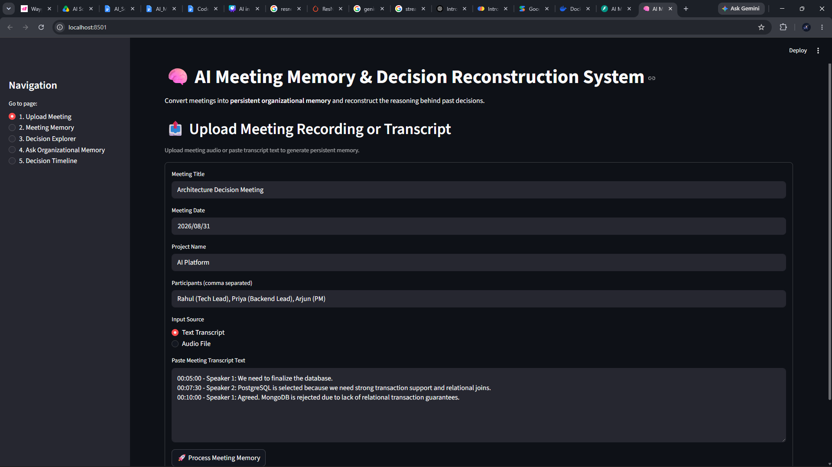
Description: the Meeting Upload page of the AI Meeting Memory system. Users can enter meeting details such as the title, date, project, and participants, then provide either a meeting transcript or audio recording. The system processes this information to create persistent organizational memory.

Persistent Meeting Memory:
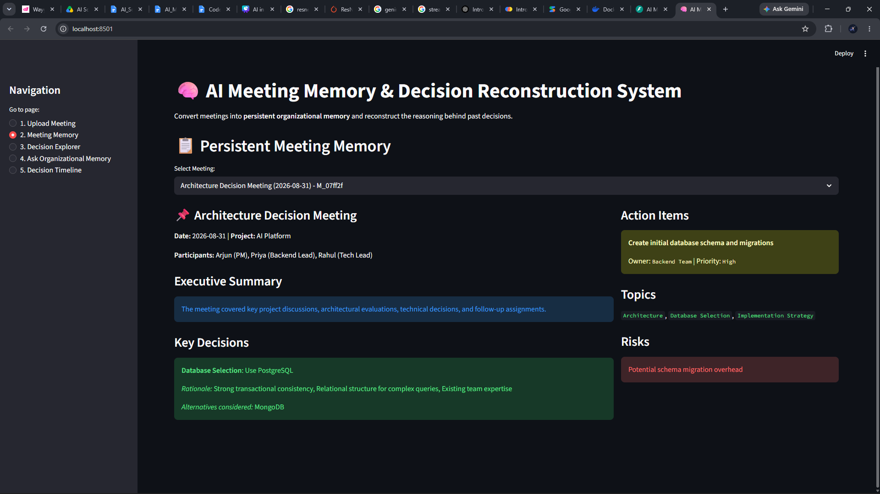
Description: the Meeting Memory page after processing a meeting. It presents an executive summary, key decisions, rationale, participants, risks, topics, and assigned action items. This converts an unstructured meeting into a structured and searchable memory record.

Decision Explorer:
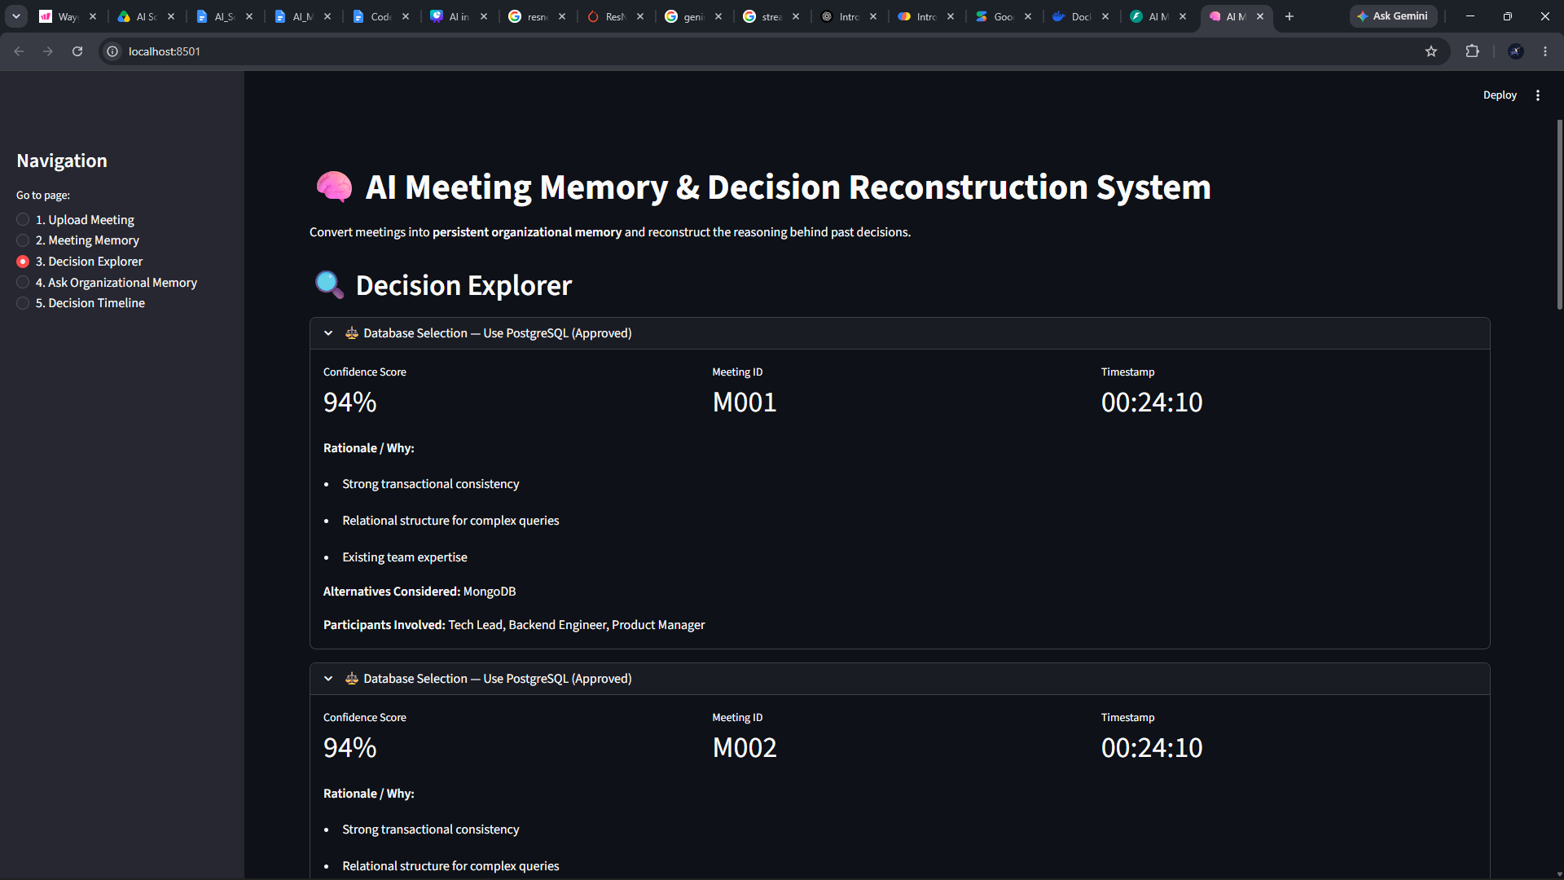
Description: the Decision Explorer, where users can inspect individual historical decisions. Each decision includes a confidence score, reasoning/rationale, alternatives considered, participants involved, meeting ID, and timestamp, making it easier to understand why a particular decision was made.

Ask Organizational Memory:
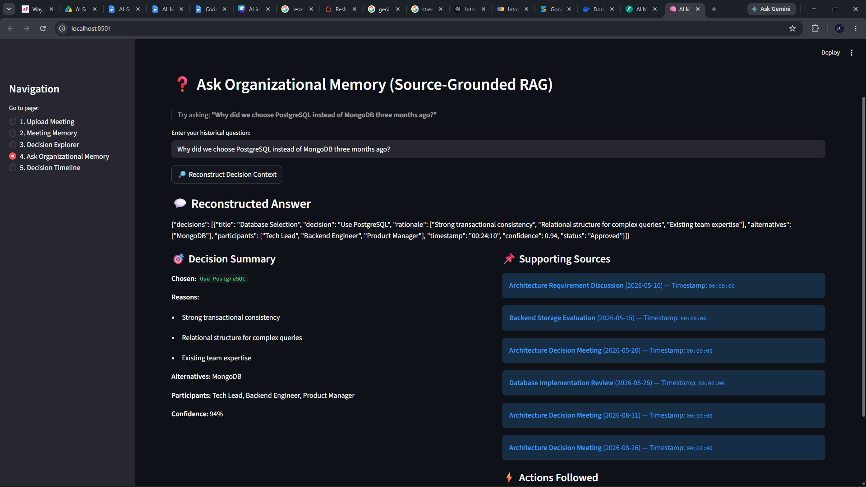
Description: the Source-Grounded RAG interface. Users can ask questions about previous organizational decisions, such as why PostgreSQL was selected instead of MongoDB. The system reconstructs an answer using relevant historical meeting records and displays the supporting sources.

Historical Decision Timeline:
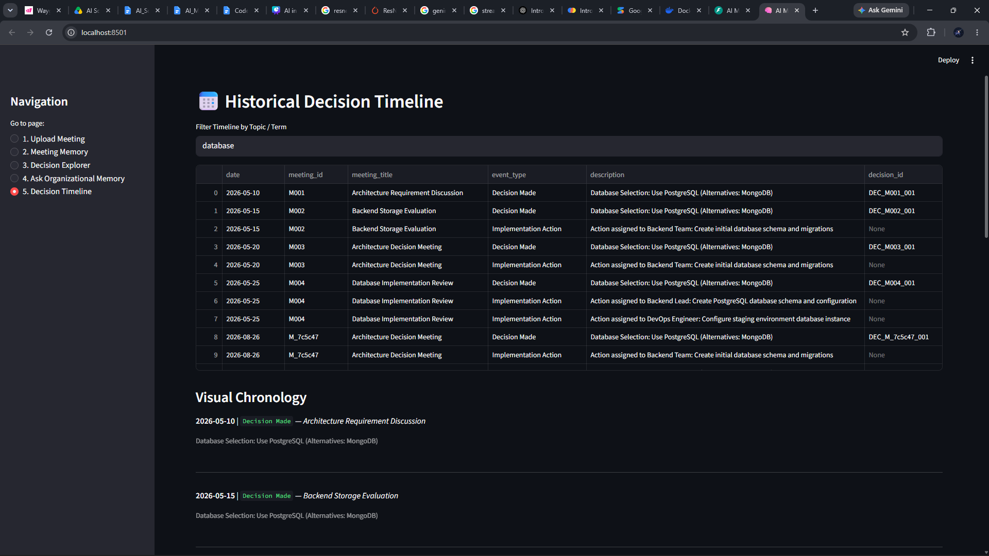
Description: the Historical Decision Timeline, which organizes decisions and implementation actions chronologically. Users can filter the timeline using topics such as "database" and see when decisions were made, what actions followed, and which meetings contributed to the decision.

FastAPI Backend / API Documentation:
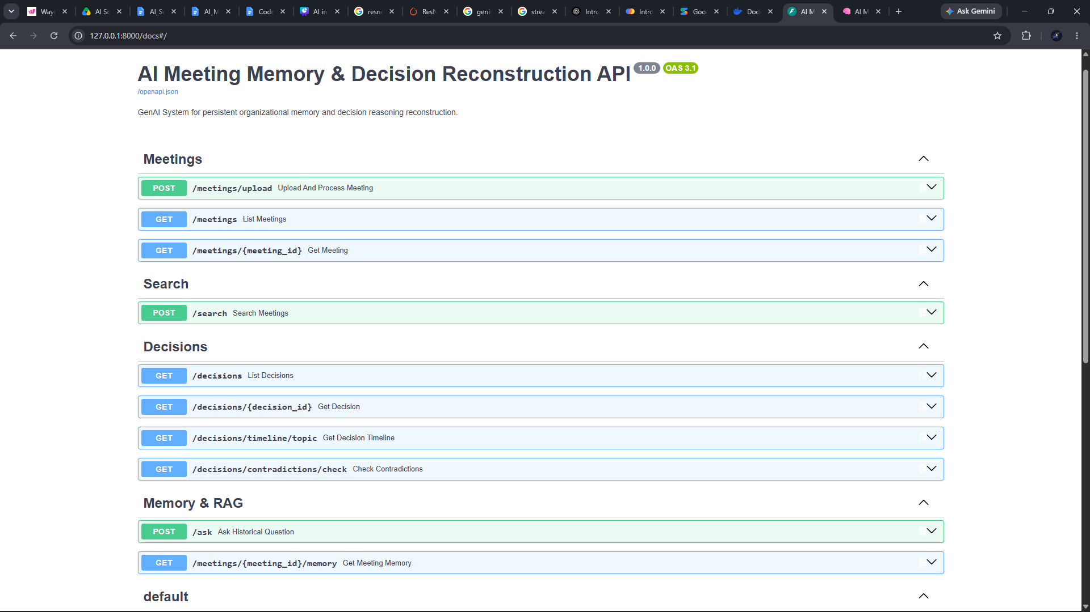
Description: This screenshot shows the FastAPI Swagger UI for the AI Meeting Memory & Decision Reconstruction System. It provides interactive API endpoints for managing meetings, searching historical information, retrieving decisions, checking contradictions, and querying organizational memory through RAG.

Conclusion
AI Meeting Memory & Decision Reconstruction System successfully demonstrates how a GenAI pipeline can convert unstructured meeting audio and transcripts into persistent, structured, and retrievable organizational memory, and can reconstruct the full reasoning behind a historical decision — not just its outcome — on demand. By combining Whisper-based transcription, LLM-driven structured extraction validated through Pydantic schemas, a hybrid vector-and-keyword retrieval layer built on ChromaDB and SQLite, and a dedicated Decision Reconstruction Engine with explicit hallucination-avoidance and confidence-scoring mechanisms, the system delivers source-grounded answers to questions such as “Why did we choose PostgreSQL instead of MongoDB three months ago?” complete with rationale, rejected alternatives, participants, follow-up actions, and a chronological timeline.
The project's layered architecture — separating API routing, extraction services, RAG components, and analysis modules — together with deterministic fallback logic in every LLM- and dependency-reliant service, ensures the platform remains fully operational, testable, and demonstrable even without configured API keys or optional packages installed. This design was validated directly: the complete Pytest suite (8 tests across 5 modules) passed against the repository, decision extraction achieved 100% precision and recall on the seeded core scenario, retrieval achieved Precision@5 of 100%, and the end-to-end reconstruction pipeline produced a fully sourced, 0.94-confidence answer without a single external API call.
Beyond its immediate use as an engineering decision archive, the platform's scenarios span onboarding and knowledge transfer, GenAI/RAG education, and enterprise audit and compliance record-keeping, reflecting the broader value of treating decision reasoning as first-class, structured, and permanently retrievable data rather than a byproduct of a transcript nobody reopens. Future extensions identified during development include swapping the SQLite persistence layer for PostgreSQL at scale, adding a cross-encoder reranker for higher-precision evidence selection, extending the ContradictionDetector beyond the PostgreSQL/MongoDB pattern into a general-purpose entity-conflict detector, and integrating live meeting-platform ingestion (Zoom, Google Meet, or Microsoft Teams transcripts) so that organizational memory accumulates automatically rather than through manual upload. Taken together, the system illustrates a practical, well-tested pattern for building trustworthy, source-grounded GenAI applications on top of an organization's own historical record.

