**LOGO**

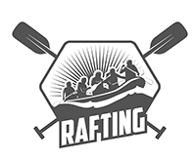

**Colors**

Primary-color: 271F27

Secondary-color: 62534C

Accent1: 98C1D9

Accent2: B8803C

**Fonts**

Heading-font: Merriweather

Text-font: Roboto

https://coolors.co/98c1d9-62534c-ffffff-271f27-b8803c