Coffee Game Report

Elizaveta Oginskaya

November 6, 2016

## Overview

The year has passed. The macroparameters of the market were as follows:

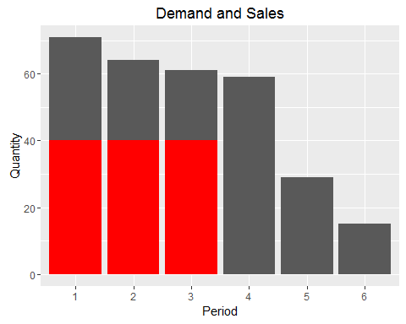

|  |  |  |  |  |  |  |
| --- | --- | --- | --- | --- | --- | --- |
| Period | Weather.Conditions | Economic.Conditions | Demand | Sales | Total.Revenue | Mean.Salary |
| 1 | good | decrease | 71 | 40 | 231.00 | 1 |
| 2 | excelent | stability | 64 | 40 | 231.00 | 1 |
| 3 | hot | stability | 61 | 40 | 225.00 | 1 |
| 4 | hot | stability | 59 | 0 | 22.75 | 1 |
| 5 | good | increase | 29 | 0 | 0.00 | 1 |
| 6 | excelent | increase | 15 | 0 | 0.00 | 1 |

### Newsletter

Messages on production chain

## [1] "BREAKING NEWS! Workers on coffee plantations refused to turn up to work due to underpayments. Coffee harvesting has been stopped."   
## [2] "BREAKING NEWS! Workers on coffee packing factories refused to turn up to work due to underpayments. Coffee packing has been stopped."

## Planter Results

### Results

### Messages

Here some messages from Labor Union You can also embed plots, for example:

Note that the echo = FALSE parameter was added to the code chunk to prevent printing of the R code that generated the plot.