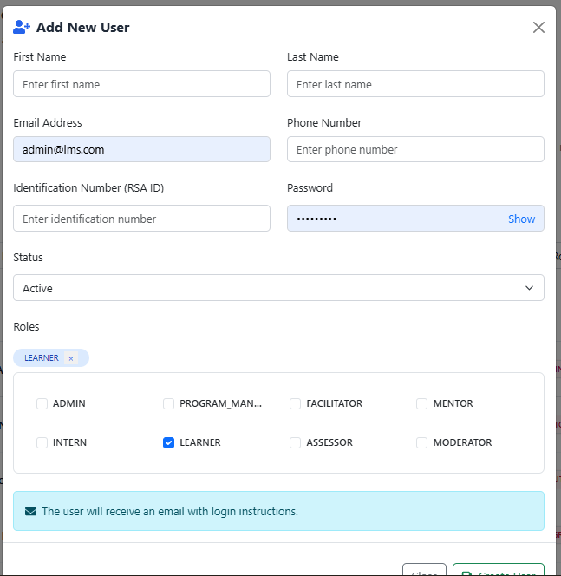

The current system design allows a user to have one or more of the roles shown in the picture.
The biggest problem you mentioned in our presentation was that a facilitator cannot moderate their own work. Therefore, we are going to keep multi-role functionality, but only allow a user to have both the facilitator and assessor roles together. No other role combinations will be permitted.

