Entity Relationship Diagram (ERD)
Interactive Quiz Show Platform Database Design

Version: 1.0
Date: January 28, 2026
Course: CSIS3126 - Design Project I

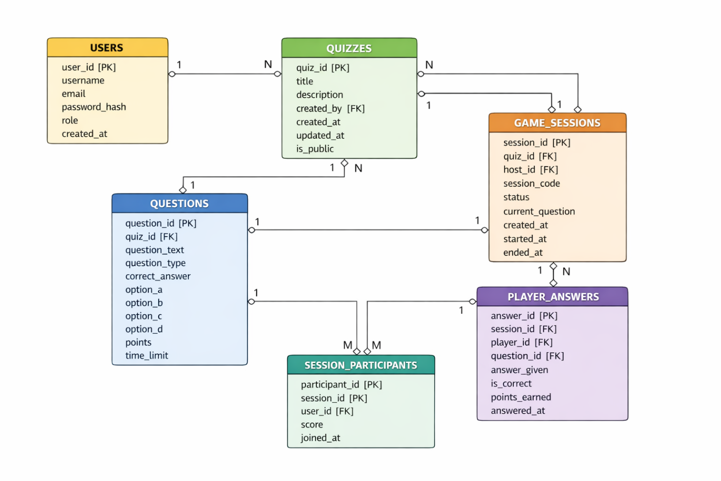

Database Overview

The quiz platform database consists of 6 main entities that manage users, quizzes, questions, game sessions, and player participation.

Entity Descriptions

1. USERS
Stores all user accounts (hosts, players, admins)
Business Rules:
- Username must be unique across all users
- Email must be unique and valid format
- Passwords must be hashed using bcrypt before storage
- Default role is 'player' unless specified

2. QUIZZES
Stores quiz metadata and information
Business Rules:
- Each quiz must have a title
- Quiz must be associated with a user (creator)
- When a user is deleted, their quizzes are also deleted (CASCADE)
- Quizzes are private by default

3. QUESTIONS
Stores individual questions for each quiz.
Business Rules:
- Each question must belong to a quiz
- When a quiz is deleted, all its questions are deleted (CASCADE)
- Multiple choice questions must have at least 2 options
- True/false questions use option_a and option_b only
- Points must be positive integer
- Time limit must be between 5 and 300 seconds

4. GAME_SESSIONS
Stores active and completed game sessions.
Business Rules:
- Each session must have a unique join code
- Session code is generated randomly (6 alphanumeric characters)
- Status progresses: waiting → active → completed
- When quiz is deleted, associated sessions are deleted (CASCADE)
- When host user is deleted, their sessions are deleted (CASCADE)

5. PLAYER_ANSWERS
Stores individual answer submissions during games.
Business Rules:
- Each answer must be linked to a session, player, and question
- Points earned is 0 for incorrect answers
- Points earned equals question.points for correct answers
- Answer is evaluated immediately upon submission
- Cascade delete when session, player, or question is deleted

6. SESSION_PARTICIPANTS
Tracks which users participated in which game sessions.
Business Rules:
- Links users to game sessions they participated in
- Score is cumulative of all points earned in the session
- Updated in real-time as player answers questions
- Cascade delete when session or user is deleted

Relationships
One-to-Many Relationships
USERS → QUIZZES (1:N)
- One user can create many quizzes
- Each quiz is created by exactly one user
- Relationship: `quizzes.created_by` → `users.user_id`
- Delete: CASCADE (delete user → delete their quizzes)

QUIZZES → QUESTIONS (1:N)
- One quiz contains many questions
- Each question belongs to exactly one quiz
- Relationship: `questions.quiz_id` → `quizzes.quiz_id`
- Delete: CASCADE (delete quiz → delete its questions)

USERS → GAME_SESSIONS (1:N)
- One user (host) can create many game sessions
- Each session is hosted by exactly one user
- Relationship: `game_sessions.host_id` → `users.user_id`
- Delete: CASCADE (delete user → delete their sessions)

QUIZZES → GAME_SESSIONS (1:N)
- One quiz can be used in many game sessions
- Each session uses exactly one quiz
- Relationship: `game_sessions.quiz_id` → `quizzes.quiz_id`
- Delete: CASCADE (delete quiz → delete sessions using it)

GAME_SESSIONS → PLAYER_ANSWERS (1:N)
- One game session contains many player answers
- Each answer belongs to exactly one session
- Relationship: `player_answers.session_id` → `game_sessions.session_id`
- Delete: CASCADE

USERS → PLAYER_ANSWERS (1:N)
- One user can submit many answers
- Each answer is submitted by exactly one user
- Relationship: `player_answers.player_id` → `users.user_id`
- Delete: CASCADE

QUESTIONS → PLAYER_ANSWERS (1:N)
- One question can receive many answers
- Each answer is for exactly one question
- Relationship: `player_answers.question_id` → `questions.question_id`
- Delete: CASCADE

Many-to-Many Relationships

USERS ↔ GAME_SESSIONS (M:N)
- Many users can participate in many sessions
- Implemented through SESSION_PARTICIPANTS junction table
- Relationship: `session_participants.user_id` ↔ `session_participants.session_id`

Database Normalization

First Normal Form (1NF):
- All tables have primary keys
- All attributes contain atomic values
- No repeating groups

Second Normal Form (2NF):
- All non-key attributes are fully dependent on primary key
- No partial dependencies

Third Normal Form (3NF):
- No transitive dependencies
- All non-key attributes depend only on primary key

Indexes

For performance optimization, the following indexes are recommended:
```sql
-- Users table
CREATE INDEX idx_users_username ON users(username);
CREATE INDEX idx_users_email ON users(email);

-- Quizzes table
CREATE INDEX idx_quizzes_created_by ON quizzes(created_by);

-- Questions table
CREATE INDEX idx_questions_quiz_id ON questions(quiz_id);

-- Game Sessions table
CREATE INDEX idx_sessions_code ON game_sessions(session_code);
CREATE INDEX idx_sessions_host ON game_sessions(host_id);
CREATE INDEX idx_sessions_status ON game_sessions(status);

-- Player Answers table
CREATE INDEX idx_answers_session ON player_answers(session_id);
CREATE INDEX idx_answers_player ON player_answers(player_id);

-- Session Participants table
CREATE INDEX idx_participants_session ON session_participants(session_id);
CREATE INDEX idx_participants_user ON session_participants(user_id);
```

Sample Queries

Get all quizzes created by a specific user:
```sql
SELECT * FROM quizzes WHERE created_by = ?;
```

Get all questions for a specific quiz:
```sql
SELECT * FROM questions WHERE quiz_id = ? ORDER BY question_order;
```

Get active game sessions:
```sql
SELECT * FROM game_sessions WHERE status = 'active';
```

Get leaderboard for a session:
```sql
SELECT u.username, sp.score
FROM session_participants sp
JOIN users u ON sp.user_id = u.user_id
WHERE sp.session_id = ?
ORDER BY sp.score DESC;
```

Get player's answer history for a session:
```sql
SELECT q.question_text, pa.answer_given, pa.is_correct, pa.points_earned
FROM player_answers pa
JOIN questions q ON pa.question_id = q.question_id
WHERE pa.session_id = ? AND pa.player_id = ?
ORDER BY pa.answered_at;
```

Database Creation SQL

See `database_schema.sql` for complete database creation script.

Future Enhancements

Potential database additions for future versions:
- achievements table for player badges
- quiz_categories for organizing quizzes
- question_images for image-based questions
- session_chat for in-game communication
- leaderboards_global for cross-session rankings

