UNIVERSITY OF BUEA
Department of Computer Engineering
CEF 440 – Internet and Mobile Programming

Diagram Analysis Report
Context Diagram and Data Flow Diagram
Design and Implementation of a Mobile Application for Car Fault Diagnosis

Group 12 | Supervisor: Dr. Valery Nkemeni | Academic Year: 2025–2026

1. Introduction
This report presents and analyses two fundamental system diagrams produced for the Car Fault Diagnosis Mobile Application: the Context Diagram and the Data Flow Diagram (DFD). Both diagrams were derived from the requirements analysis conducted in Task 3 and represent the system as it is expected to function once developed.

The Context Diagram (also called a Level 0 DFD) provides a high-level view of the entire system, showing it as a single process surrounded by all the external actors that interact with it. The Data Flow Diagram expands this view by breaking the system down into its internal processes and showing exactly how data moves between those processes, the people involved, and the data storage components.

Together, the two diagrams serve as a communication tool between the development team and stakeholders, and as a blueprint that guides the system design phase that follows.

2. Context Diagram

2.1 Purpose
The context diagram treats the entire car diagnostic application as one black box placed at the centre of the drawing. Its sole purpose is to answer the question: who or what does this system talk to, and what information is exchanged? It does not show any internal logic. That level of detail is left to the DFD.
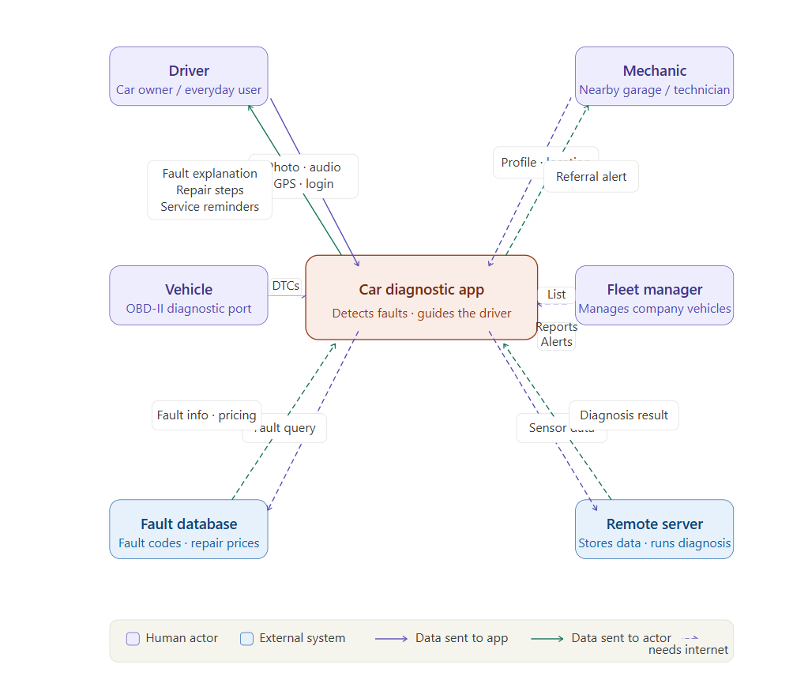

2.2 External actors identified
Six external actors were identified in the context diagram. They are grouped into two categories.

Human actors (people who use the system directly)

Actor | Role and data exchanged
Driver / car owner | The primary user. Sends photos, audio recordings, GPS location, and login credentials. Receives fault explanations, step-by-step repair guidance, cost estimates, and service reminders.
Vehicle (OBD-II port) | Not a person, but treated as an actor because it is an independent source of data. The vehicle transmits raw diagnostic trouble codes (DTCs) to the app via a Bluetooth or Wi-Fi OBD-II adapter.
Mechanic | A nearby garage or technician. Shares their profile and location with the system, and receives referral notifications when a user needs help.
Fleet manager | A person responsible for a company vehicle fleet. Sends a list of vehicles to monitor and receives maintenance reports and alerts in return.

External systems (non-human data sources)

System | Role and data exchanged
Fault code library | An external database of vehicle fault codes and repair prices. The app queries it to match OBD-II codes with fault descriptions and cost ranges.
Remote server | A backend server that stores user data and runs the heavier diagnostic processing. The app sends sensor data to it and receives a structured diagnosis result in return.

2.3 Key data flows
The context diagram highlights the following important data exchanges between the system and its actors.

Data flow | Content
Driver → App | Photo, audio recording, GPS location, login credentials
App → Driver | Fault explanation, repair steps, cost estimate, service reminders
Vehicle → App | OBD-II diagnostic trouble codes (DTCs)
Mechanic → App | Profile and current location (dashed: needs internet)
App → Mechanic | Referral alert when a nearby user needs help (dashed)
Fleet manager → App | List of company vehicles to monitor (dashed)
App → Fleet manager | Maintenance reports and alerts for the fleet (dashed)
App → Remote server | Raw sensor data for advanced diagnosis (dashed)
Remote server → App | Structured diagnosis result (dashed)
App ↔ Fault code library | Query for fault info and pricing (dashed)

Flows shown as solid lines work offline using data cached on the phone. Flows shown as dashed lines require an active internet connection.

2.4 Observations and design implications
- The driver is the most central actor. More data flows connect to and from the driver than to any other actor, confirming that the app must prioritise a simple, non-technical user experience.
- The fleet manager and mechanic are secondary actors. Their flows are all marked as requiring internet connectivity, which means these features can be deferred to a later version without breaking the core offline experience.
- The vehicle communicates one-way only. Data flows from the vehicle to the app but never back, which means the app does not write to the vehicle ECU. This simplifies the OBD-II integration significantly.
- Two categories of external system exist: a fault database for local matching and a remote server for heavy processing. This two-tier architecture directly supports the hybrid offline/online approach described in the requirements.

3. Data Flow Diagram (DFD)

3.1 Purpose
The Data Flow Diagram expands what the context diagram summarised into a single circle. It opens the system and shows six internal processes, the storage components that support them, and how data moves between everything. This is a Level 1 DFD, meaning each circle represents one major function of the application.
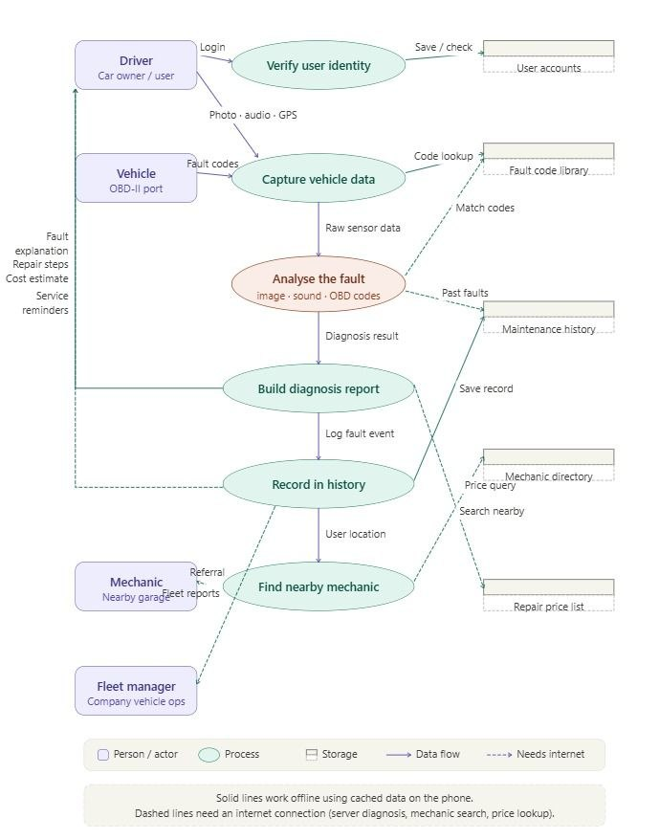

3.2 Internal processes
The six processes identified in the DFD are listed below in the order they execute during a typical session.

Process | Description
Verify user identity | Checks the driver’s credentials against the user accounts store before granting access to the app.
Capture vehicle data | Collects all raw inputs: OBD-II fault codes from the vehicle, photos and audio from the driver, and GPS location. Also performs an initial code lookup in the fault library.
Analyse the fault | The core processing step. Combines OBD-II codes, image analysis, and sound analysis to produce a diagnosis. Reads the fault code library for code matching and reads maintenance history for predictive checks.
Build diagnosis report | Assembles the final output: a plain-language fault explanation, step-by-step repair guidance, and a cost estimate looked up from the repair price list. Sends all of this back to the driver.
Record in history | Writes the fault event into the maintenance history store. Generates service reminders for the driver and sends fleet reports to the fleet manager.
Find nearby mechanic | Takes the driver’s GPS location, searches the mechanic directory, and returns contact details. Sends a referral notification to the relevant mechanic.

3.3 Storage components
Five storage components support the processes. They are represented in the diagram as open-ended rectangles (the standard DFD notation for a data store).

Storage | Contents and usage
User accounts | Holds driver profiles, login credentials, and vehicle registration details. Read and written by the identity verification process.
Fault code library | A catalogue of known vehicle fault codes with descriptions and typical repair cost ranges. Read by both the data capture and fault analysis processes. Updated remotely without requiring a full app release.
Maintenance history | Records every past fault event per vehicle. Written by the record-keeping process and read by the fault analysis process to support predictive maintenance alerts.
Mechanic directory | A list of registered mechanics with their locations and contact information. Read by the mechanic locator process. Requires internet to query.
Repair price list | A local database of estimated repair costs per fault type and geographic area. Read by the report builder to produce cost estimates for the driver.

3.4 Key data flows inside the system
Beyond the external flows already described in the context diagram, the DFD reveals the following internal exchanges.

Flow | Content
Capture vehicle data → Analyse the fault | Raw sensor data (codes, image, audio) passed to the analysis engine
Analyse the fault → Fault code library | Code matching query (dashed: internet preferred but cached copy works offline)
Analyse the fault → Maintenance history | Read past faults to support predictive alerts (dashed)
Analyse the fault → Build diagnosis report | Structured diagnosis result passed downstream
Build diagnosis report → Repair price list | Query for estimated repair costs (dashed)
Build diagnosis report → Driver | Complete report: explanation, steps, cost estimate
Build diagnosis report → Record in history | Triggers the logging of the fault event
Record in history → Maintenance history | Writes the new fault record
Record in history → Driver | Service reminders (dashed)
Record in history → Fleet manager | Fleet-level maintenance reports (dashed)
Record in history → Find nearby mechanic | Passes GPS location to trigger mechanic search
Find nearby mechanic → Mechanic directory | Search query for nearby mechanics (dashed)
Find nearby mechanic → Mechanic | Referral notification (dashed)

3.5 Observations and design implications
- The fault analysis process is the most connected node in the diagram. It reads from two stores and receives data from the capture process. This confirms it is the most complex process to implement and the one most likely to require careful optimisation for performance on low-end phones.
- The maintenance history store is accessed by two different processes: the analysis engine reads it and the record-keeping process writes it. Care must be taken to avoid read/write conflicts, especially when the app is used offline and later synchronises with the server.
- The report-building process is the only step that produces the output the driver actually sees. All upstream processes exist to feed it with the right information. This makes it the most user-facing component and the one that must most carefully follow the plain-language and bilingual requirements.
- The mechanic locator and fleet manager flows are entirely dashed. These two actors only benefit from the system when internet is available, which supports the requirements decision to treat their features as secondary.
- The repair price list is only read, never written, by the app itself. This means it must be maintained and updated externally, which is a database administration responsibility outside the app’s scope.

USE CASE SPECIFICATION
Introduction

Use Case Diagrams in the Car Fault Diagnosis Application
Use case diagrams describe the functional behaviour of the AI-Based Car Fault Diagnosis Application from the perspective of its users and external systems. Specifically, they answer three fundamental questions: who interacts with the system, what they can do with it, and how those functions relate to one another — without going into the technical detail of how each function is implemented internally.
In the context of this project, the use case diagrams serve the following descriptive purposes:
- They define the system's functional boundaries.
- They identify who uses the system and in what capacity.
- They describe the complete set of things a user can achieve
- They show how use cases depend on one another..
- They communicate scope to non-technical stakeholders.

2. Actors Description
The following actors were identified from the UML diagrams.
Actor | Type | Description
Car Owner | Primary Actor | Main user who interacts with the mobile application
Admin | Primary Actor | Maintains system datasets and updates AI models
AI Recognition Engine | Secondary Actor | External AI component responsible for dashboard image recognition
AI Audio Engine | Secondary Actor | External AI component responsible for engine sound analysis
Video Platform | Secondary Actor | External system providing repair and maintenance tutorial videos
Local AI Engine | Secondary Actor | Offline intelligent component used without internet connectivity
Fault Database | Secondary | Stores warning symbol definitions, sound fault patterns, repair guides, and urgency levels.
Update Server | Secondary | Hosts the latest versions of the fault database and ML model weights for UC10.

Here's a concise version:

Main System Use Case Diagram

Overview
The Main System Use Case Diagram presents a high-level view of the AI-Based Car Fault Diagnosis Application, showing all top-level user goals and the actors involved. It defines what the system does from the user's perspective and serves as the primary reference for functional scope.

Actors
The diagram contains two primary actors and four secondary actors.
Car Owner is the main user who initiates all eight diagnostic and management interactions. Admin holds exclusive access to the Update Fault Database function, maintaining the system's diagnostic knowledge base.
On the secondary side, the AI Recognition Engine processes dashboard images for visual fault detection. The AI Audio Engine handles engine sound recording and acoustic fault classification. The AI System coordinates automated database and model updates. The Video Platform supplies repair tutorial video content linked to detected faults.

Use Cases
Nine use cases are enclosed within the system boundary. The Car Owner can register or log in, scan dashboard warning lights, record engine sounds, view consolidated diagnosis results, watch repair tutorials, review diagnosis history, perform offline diagnosis, and manage their vehicle profile. The Admin can update the fault database, triggering version checks, delta downloads, and video content synchronisation through the AI System and Video Platform.
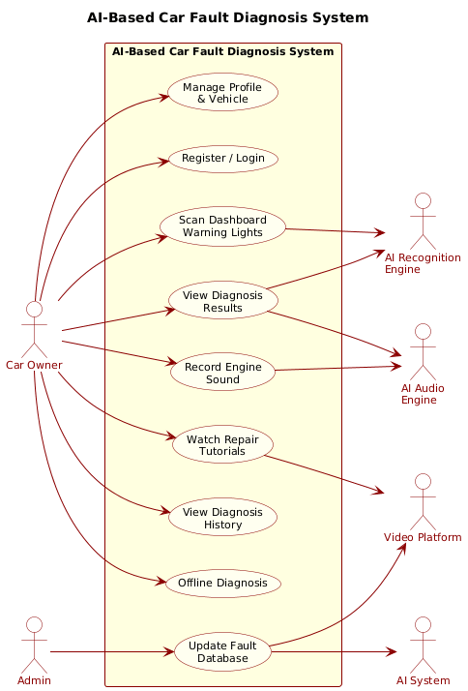

Main System Use Case Specifications
The following specifications are based on the System Use Case Diagram.

UC -1: Register / Login
• Description: Allows a car owner to create a new profile or securely log into an existing account to manage their personalized profile, sync vehicle specifications, and persist diagnosis histories across cloud servers.
• Primary Actor: Car Owner
• Pre-conditions: The application is successfully installed. The mobile device possesses an active cellular or Wi-Fi network connection to communicate with the central authentication gateway.
• Basic Flow of Events:
1. The user launches the application and selects the registration or login option.
2. The user inputs their identification criteria (e.g., email address, password, optional vehicle model data).
3. The client application securely securely hashes credentials and transmits an authentication request to the remote database API.
4. The system validates the credentials against the user table, authorizes the terminal instance, and passes a secure authentication token back to the device.
5. The client application initializes the persistent session context and routes the user directly onto the primary diagnostic dashboard.
• Post-conditions: The user session is authorized; the system unlocks personalized data logging, cloud-based fault histories, and custom vehicle-specific tutorial recommendations.
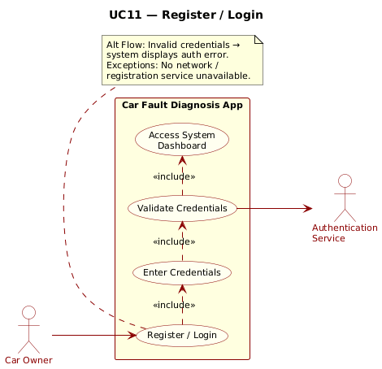

UC-2. Dashboard Warning Light Detection Module
• Description: The user captures a photographic image or streaming feed of their vehicle's running instrument cluster. The computer vision model processes the frame, detects single or multiple illuminated dashboard warning indicators simultaneously, identifies symbol metadata, determines mechanical urgency, and renders actionable guidance.
• Primary Actor: Car Owner
• Supporting Subsystem: AI Recognition Engine (Computer Vision Pipeline)
• Pre-conditions: The user must grant the application native OS permissions to control the smartphone's camera assembly. The dashboard illumination must be sufficient to yield crisp feature definitions.
• Full Integrated Flow (Including Structural Dependencies):
1. The Car Owner accesses the visual diagnostic feature from the mobile app's main control view.
2. [Includes UC1: Capture Dashboard Image]: The user aligns the camera overlay to frame the instrument panel and triggers a capture event. The application extracts raw pixel tensors.
3. [Includes UC2: Detect Warning Symbols]: The application passes the matrix payload to the AI Recognition Engine, which executes image normalization, scaling, and contrast filtering.
4. [Includes UC3: Identify Multiple Warning Lights]: The computer vision neural network performs bounding-box regression to isolate and handle multiple concurrent active indicators in a single image pass.
5. [Includes UC4: Interpret Warning Meaning]: The engine routes regions-of-interest through a multi-class image classification model, mapping visual symbols to exact diagnostic database keys.
6. [Includes UC6: Estimate Urgency Level]: Based on the mapped indicator severity matrix, the system establishes a safety threat tier (e.g., Red/Critical - Pull over immediately vs. Yellow/Muted - Maintenance required).
7. [Includes UC5: Display Causes and Solutions]: The application returns a compiled output view displaying the formal symbol title, suspected mechanical failure vectors, and immediate roadside procedures.
• Alternate Flows:
- Alternate Flow A (Zero Network State): If the device is detected to be completely isolated from network infrastructure, the app automatically reroutes processing tasks away from backend APIs and activates the edge runtime architecture using a lightweight mobile model weights file (See Section 6).
• Post-conditions: The comprehensive dashboard diagnosis reports are rendered on the user interface, and the event timestamp, localized GPS coordinates, and matched warning categories are saved to the device's diagnostic history register.
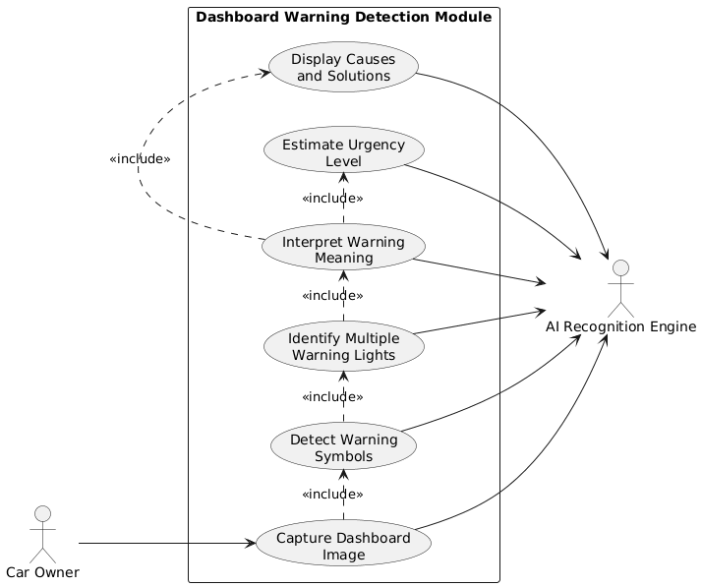

UC-3. Engine Sound Analysis Module
• Description: The user records audio anomalies originating from the vehicle's engine compartment. The machine learning pipeline processes the acoustic properties, isolates ambient patterns, maps audio signatures against known fault models, and generates an engine health profile.
• Primary Actor: Car Owner
• Supporting Subsystem: AI Audio Processing Engine
• Pre-conditions: The application must hold native operating system permissions to utilize the mobile microphone. The engine must be running, and the user must safely position the device to catch engine acoustic characteristics while preventing wind or exterior traffic clipping.
• Full Integrated Flow (Including Structural Dependencies):
1. The Car Owner initiates the Acoustic Diagnostic function and places the microphone proximity near the engine block.
2. [Includes UC1: Record Engine Sound]: The user records an uncompressed digital audio stream (PCM/WAV format) for a predefined analysis window (e.g., 5 to 10 seconds).
3. [Includes UC2: Process Audio Recording]: The app applies digital signal processing techniques, filtering environmental background noise, normalizing amplitude, and executing a Short-Time Fourier Transform (STFT) to map raw time-domain waveforms into frequency-domain spectrogram matrices.
4. [Includes UC3: Analyse Engine Sound]: The AI Audio Engine passes the spectrogram to a deep Convolutional Neural Network (CNN) configured for acoustic event detection.
5. [Includes UC4: Match Fault Patterns & UC5: Detect Abnormal Noise]: The classification network identifies mechanical artifacts, isolating standard timing variations from explicit structural faults (e.g., sharp metallic knocking, serpentine belt squealing, vacuum line hissing, or structural bearing grinding).
6. [Includes UC6: Generate Fault Diagnosis]: The engine maps the identified anomaly vector against mechanical failure modes to extract confidence levels and structural fault definitions.
7. [Includes UC7: Suggest Repairs and Maintenance]: The user interface displays a list of suspected failure components, diagnostic descriptions, potential preventative maintenance tips, and safety instructions.
• Post-conditions: The application presents an audio-metric analysis report highlighting component defect probabilities, and queues associated repair and procedural metadata.
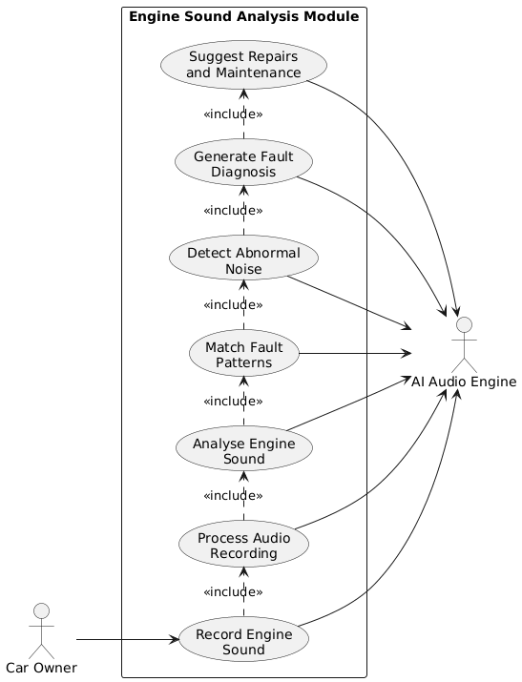

UC-4. Online Support and Services Module
• Description: Bridges the gap between raw diagnosis and resolution by fetching step-by-step video tutorials from verified automotive experts, mapped to the exact fault profile generated during visual or audio scanning routines.
• Primary Actor: Car Owner
• Supporting Subsystem: External Video Platform API Handler (e.g., YouTube Developer Data API)
• Pre-conditions: The application must have resolved a specific mechanical fault validation key, and the device must establish a valid connection to an active internet gateway.
• Basic Flow of Events:
1. Upon generating an active diagnosis overview, the application triggers a lookup routine via the support module.
2. [Includes UC1: Search Repair Tutorials]: The system extracts technical keyword arrays (e.g., '2018 Honda Civic Alternator Replacement Tutorial') and sends a search query through the Video Platform API.
3. The API validates the system's developer tokens and returns an indexed JSON object containing metadata for verified, high-authority instructional content.
4. [Includes UC2: Watch Video Guides]: The app embeds the video asset directly within a native media controller wrapper, allowing the Car Owner to review mechanics performing step-by-step physical repairs without leaving the application environment.
5. [Includes UC3: Access Online Fault Database]: Simultaneously, the view links out to comprehensive online databases detailing technical bulletins and recall lists.
• Post-conditions: The video content streams natively inside the designated application context, providing users with the necessary visual knowledge to repair the mechanical failure or safely discuss servicing options with mechanical professionals.
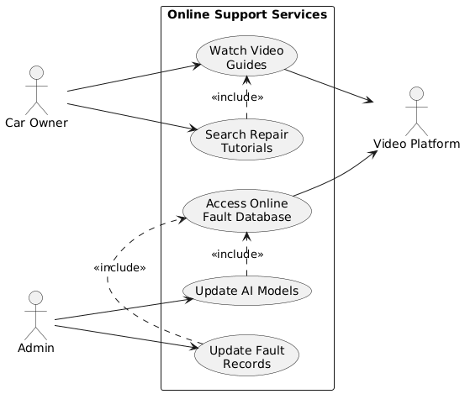

UC-5. Offline Diagnostic Functionality Module
• Description: Guarantees basic visual warning symbol recognition and engine acoustic analysis capabilities when the vehicle owner is stranded in a remote location lacking data or cellular connectivity.
• Primary Actor: Car Owner
• Supporting Subsystem: Local On-Device AI Execution Engine (e.g., TensorFlow Lite / ONNX Mobile Runtime Frameworks)
• Pre-conditions: The user must have previously opened the application while online to initialize and cache the lookups, metadata tables, and compressed on-device machine learning binary layers.
• Full Integrated Flow (Including Structural Dependencies):
1. The client core intercepts processing requests and detects a network timeout or disconnected connectivity state.
2. The system dynamically alters routing paths away from cloud APIs and locks onto the Local AI Engine context.
3. [Includes UC1: Offline Light Recognition] or [Includes UC2: Offline Sound Analysis]: The user captures data via their peripheral sensors. The raw matrix structures pass directly to on-device memory.
4. [Includes UC3: Use Preloaded Fault Database]: The Local AI Engine uses optimized quantized inference algorithms, matching sensory characteristics against the edge storage space.
5. [Includes UC4: Generate Basic Diagnosis]: The application constructs a simplified baseline diagnosis report detailing primary symbol identifiers, generic mechanical system definitions, and crucial safety instructions.
• Post-conditions: The system renders immediate, localized safety insights and basic fault classifications on screen. An alert banner notifies the user that comprehensive web analytics and online tutorial video streaming will execute once an active connection is re-established.
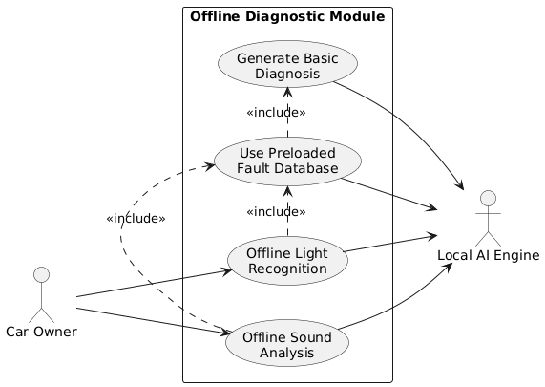

UC-06 Manage User Profile & Vehicle

Field | Description
Use Case ID | UC07
Use Case Name | Manage User Profile & Vehicle
Actors | - Car Owner (Primary)  - Guest User (Primary)
Description | The car owner creates and manages their personal profile, registers their vehicle make and model, and reviews their complete diagnostic history — enabling personalised recommendations and maintenance notifications.
Preconditions | - The application has been installed on the user's device.
Postconditions | - The vehicle profile is saved and linked to all future diagnoses.  - Diagnostic history is accessible and filterable by date.  - Maintenance notification preferences are stored.
Main Flow | - The Car Owner opens the Profile screen and enters personal details.  - The Car Owner adds a vehicle profile: make, model, year, and fuel type.  - The system links all future diagnoses to the registered vehicle profile.  - The Car Owner views their full diagnostic history sorted by date.  - The Car Owner optionally enables scheduled maintenance notifications.
Alternative / Exception Flow | Guest users may skip registration and use all core diagnostic features; however, their diagnostic history will not be saved between sessions.
<<include>> | - Register Vehicle Profile  - View Diagnostic History
<<extend>> | - Enable Maintenance Notifications (optional preference)

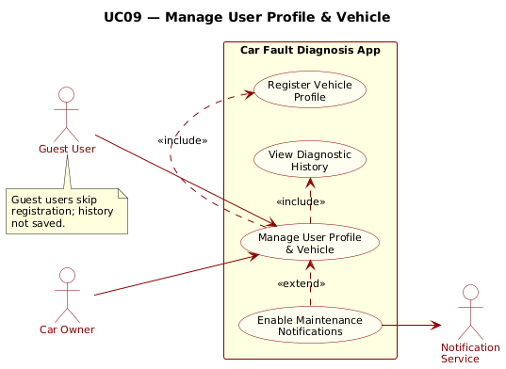

UC-07 Update Fault Database
Field | Description
Use Case ID | UC-07
Use Case Name | Update Fault Database
Actors | - AI System (Primary)  - Update Server (Secondary)  - Fault Database (Secondary)
Description | The system periodically checks for and applies updates to the fault pattern database and machine learning model weights in the background, ensuring diagnoses reflect the latest known fault signatures and symbol definitions.
Preconditions | - The application is running with an active internet connection.  - A newer version of the fault database or model weights is available on the update server.
Postconditions | - The local fault database and model files are updated to the latest version.  - An update changelog is logged internally.  - The user is notified via an in-app toast notification.
Main Flow | - The application checks the update server on launch or via a daily background sync.  - The installed version number is compared with the latest available version.  - If a newer version exists, the delta update is downloaded.  - Local database records and model weight files are replaced or patched.  - The user is notified of the successful update via an in-app toast.
Alternative / Exception Flow | If the update download fails due to network interruption, the system retains the previous version and schedules an automatic retry at the next application launch.
<<include>> | - Check for New Version  - Download Delta Update
<<extend>> | - Schedule Retry on Failure (when download is interrupted)

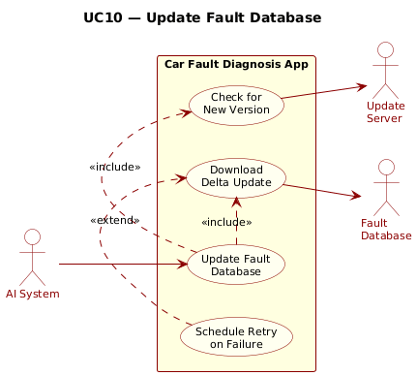

Sequence Diagrams Description

Overview
Sequence diagrams describe the dynamic behaviour of the AI-Based Car Fault Diagnosis Application by illustrating how actors and system components interact over time for each major use case. Unlike use case diagrams which define what the system does, sequence diagrams define how and in what order those interactions occur. Eight sequence diagrams were developed, each covering one core scenario.

SD-01 — Register / Login
This diagram captures the authentication flow between the Car Owner, the Mobile App, the Auth Service, and the User Database. The Car Owner submits credentials which are hashed and forwarded to the Auth Service for validation. Three alternative flows are modelled: new user registration, existing user login, and invalid credential handling. On success, an authentication token is returned and the user is routed to the dashboard.
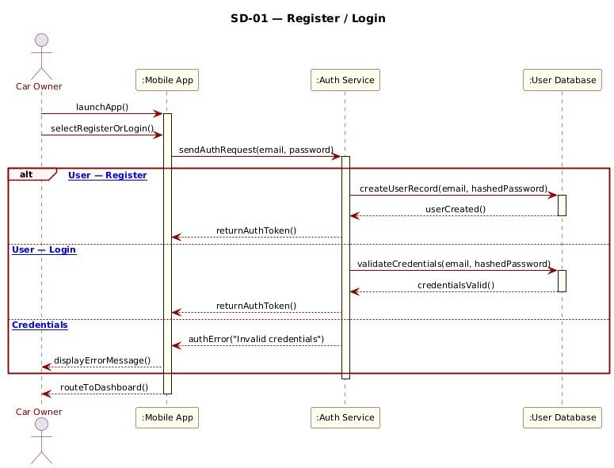

SD-02 — Scan Dashboard Warning Lights
This diagram models the visual diagnostic pipeline triggered when the Car Owner captures a dashboard image. The Mobile App forwards the image matrix to the AI Recognition Engine, which normalises the frame, runs object detection, and classifies any detected symbols. Matched symbol identifiers are queried against the Fault Database, which returns meaning, probable cause, and urgency level. If no symbols are detected, the user is prompted to adjust the camera.
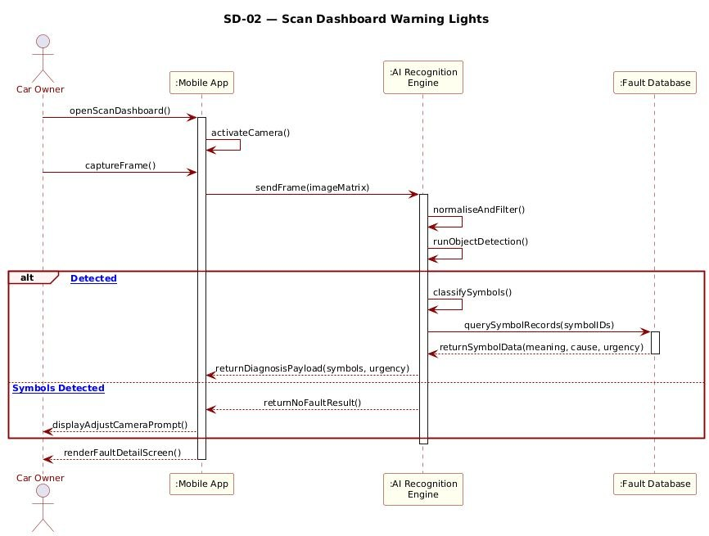

SD-03 — Record & Analyse Engine Sound
This diagram illustrates the acoustic diagnostic flow. After the Car Owner records engine audio, the Mobile App sends the raw PCM stream to the AI Audio Engine, which normalises the signal, extracts MFCC features, and runs the CNN classifier. On a successful pattern match, the Fault Database is queried and a fault list with confidence scores is returned. If the audio quality is insufficient, the user is prompted to re-record.
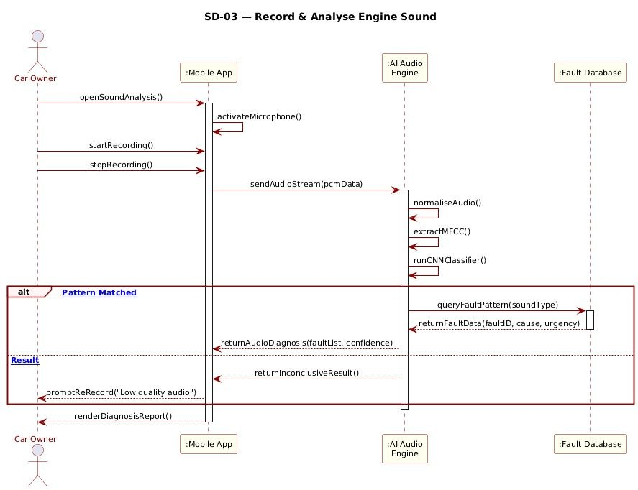

SD-04 — View Diagnosis Results
This diagram shows how the Mobile App consolidates outputs from both the AI Recognition Engine and the AI Audio Engine into a single unified fault report. Each engine independently queries the Fault Database for its respective fault data. The app then compiles the results and optionally fetches repair suggestions if the user requests them, before rendering the complete report on screen.
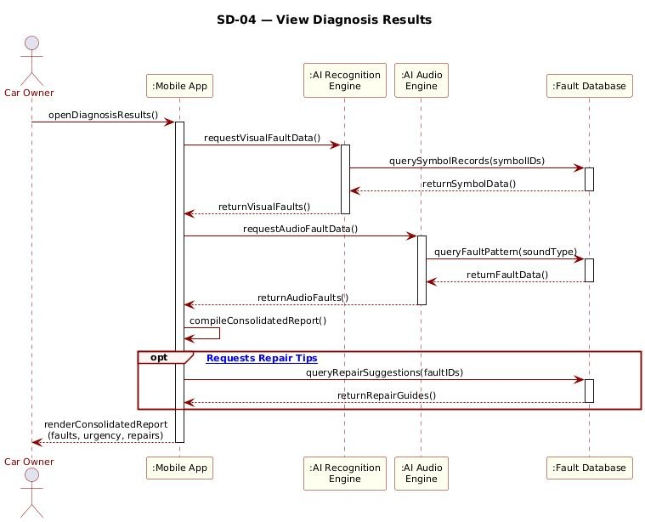

SD-05 — Watch Repair Tutorials
This diagram covers the tutorial retrieval flow. When the Car Owner taps Watch Tutorial, the Mobile App sends fault keywords to the Video Platform API. If matching videos are found, a list is returned and the user selects one for streaming through the embedded player. If no content is available, a no-content message is displayed. An optional offline path saves the video link for later access when connectivity is restored.
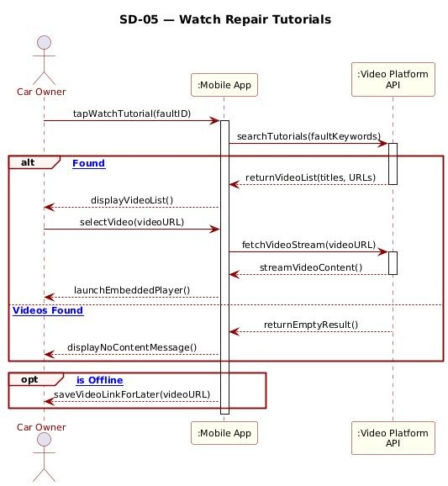

SD-06 — Offline Diagnosis
This diagram models the offline fallback scenario. When the Mobile App detects no network connection, it routes all processing to the Local AI Engine instead of the cloud APIs. Depending on the user's action, either the local CV model or the local audio model is invoked. Both models query the Local Fault Database for results and return a basic diagnosis report. The user is notified that video content remains unavailable until connectivity is restored.
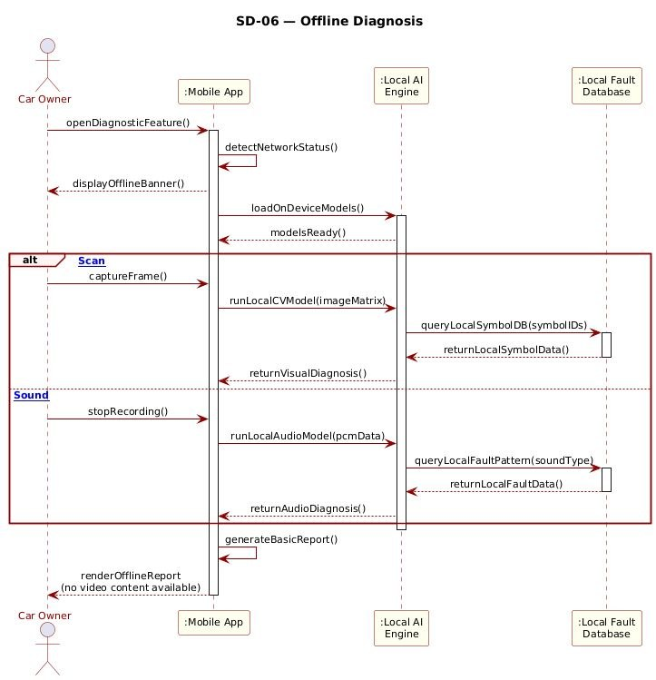

Class Diagram Description
CarDiag System — Static Structure Overview

The class diagram presented below illustrates the static structure of the CarDiag system, showing the five core entity classes, their attributes, their methods, and the relationships that exist between them.
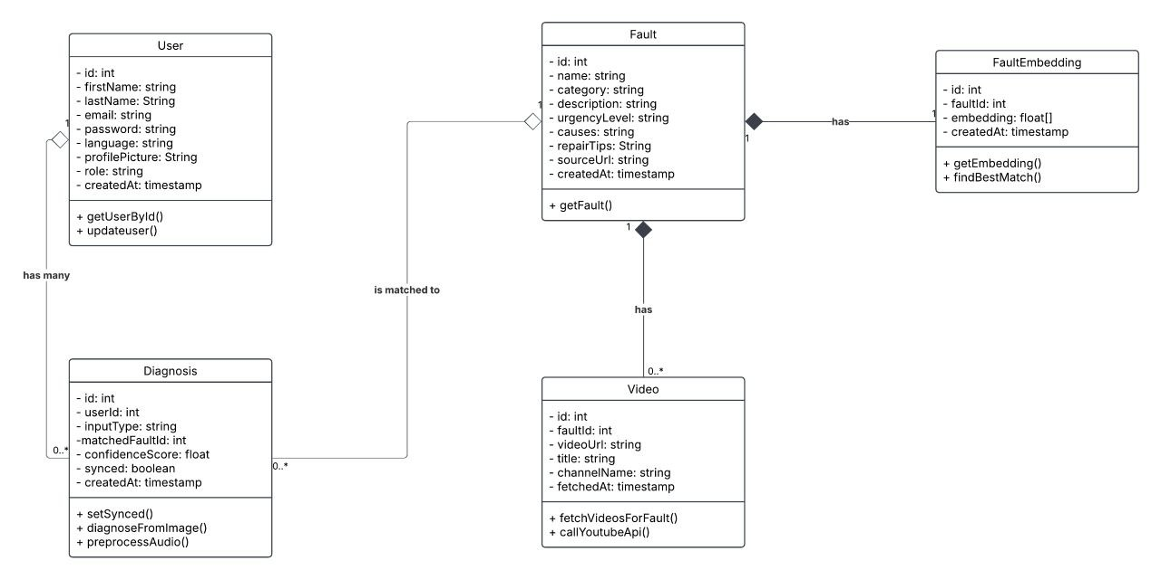

The Fault Class
The Fault class sits at the centre of the diagram and acts as the backbone of the entire system. It holds all the essential information about a vehicle fault including its name, category, urgency level, probable causes, repair tips, source URL, and the timestamp of when it was added. It exposes a single getFault() method used to retrieve its data. Three other classes — FaultEmbedding, Video, and Diagnosis — all maintain a direct relationship with Fault, reflecting its central role in the architecture.

The FaultEmbedding Class
The FaultEmbedding class is connected to Fault through a one-to-one composition relationship labelled "has". The filled diamond on the Fault side indicates that FaultEmbedding cannot exist independently — it is wholly owned by the Fault it belongs to. Each FaultEmbedding stores the 1408-dimensional vector representation of a fault generated by the Gemini multimodal embedding API, and exposes two methods:
- getEmbedding() — retrieves the stored vector.
- findBestMatch() — performs cosine similarity search against a user's input embedding.

The Video Class
The Video class is connected to Fault through a one-to-many composition relationship also labelled "has", with a multiplicity of 0..* on the Video side indicating that a fault may have zero or more associated videos. Like FaultEmbedding, the filled diamond confirms that Video records have no independent existence outside their parent Fault. The class stores the YouTube video URL, title, channel name, and the timestamp of when the video data was fetched. It provides two methods:
- fetchVideosForFault() — retrieves videos linked to a given fault.
- callYoutubeApi() — interacts with the YouTube Data API v3 when cached results are unavailable.

The User Class
The User class represents a registered user of the application. It stores personal information including first name, last name, email, password, preferred language, profile picture, role, and account creation timestamp. It provides two methods:
- getUserById() — for user retrieval.
- updateUser() — for modifying profile data.
User is connected to Diagnosis through a one-to-many aggregation relationship labelled "has many", represented by the hollow diamond on the User side. The hollow diamond distinguishes this from composition — a Diagnosis record can exist independently of a User, which accommodates guest users who receive diagnoses without creating an account. The multiplicity of 1 on the User side and 0..* on the Diagnosis side reflects that a single user may have many diagnoses or none at all.

The Diagnosis Class
The Diagnosis class represents a single diagnostic event performed by a user. It records the type of input submitted (image, audio, or text), the ID of the fault that was matched, the confidence score of that match, whether the record has been synced with the backend server, and the creation timestamp. It exposes three methods:
- setSynced() — updates the sync status when connectivity is restored.
- diagnoseFromImage() — triggers an image-based diagnosis flow.
- preprocessAudio() — prepares a raw audio recording for classification.
Diagnosis sits at the intersection of two relationships — it is aggregated by User on one side and associated with Fault on the other through the "is matched to" relationship, reflecting that every diagnosis event is both owned by a user and linked to the fault that was identified.

Overall Design Summary

The diagram cleanly separates data ownership from data reference. Composition relationships — Fault to FaultEmbedding and Fault to Video — enforce strict lifecycle dependency, ensuring that embedding vectors and video links are always tied to a specific fault record.
The aggregation between User and Diagnosis and the association between Fault and Diagnosis reflect looser coupling, allowing diagnoses to be created by guests and to persist independently. This design directly supports the system's offline-first strategy, its multimodal AI pipeline, and its requirement to maintain a complete diagnosis history per user.

Deployment Diagram Description
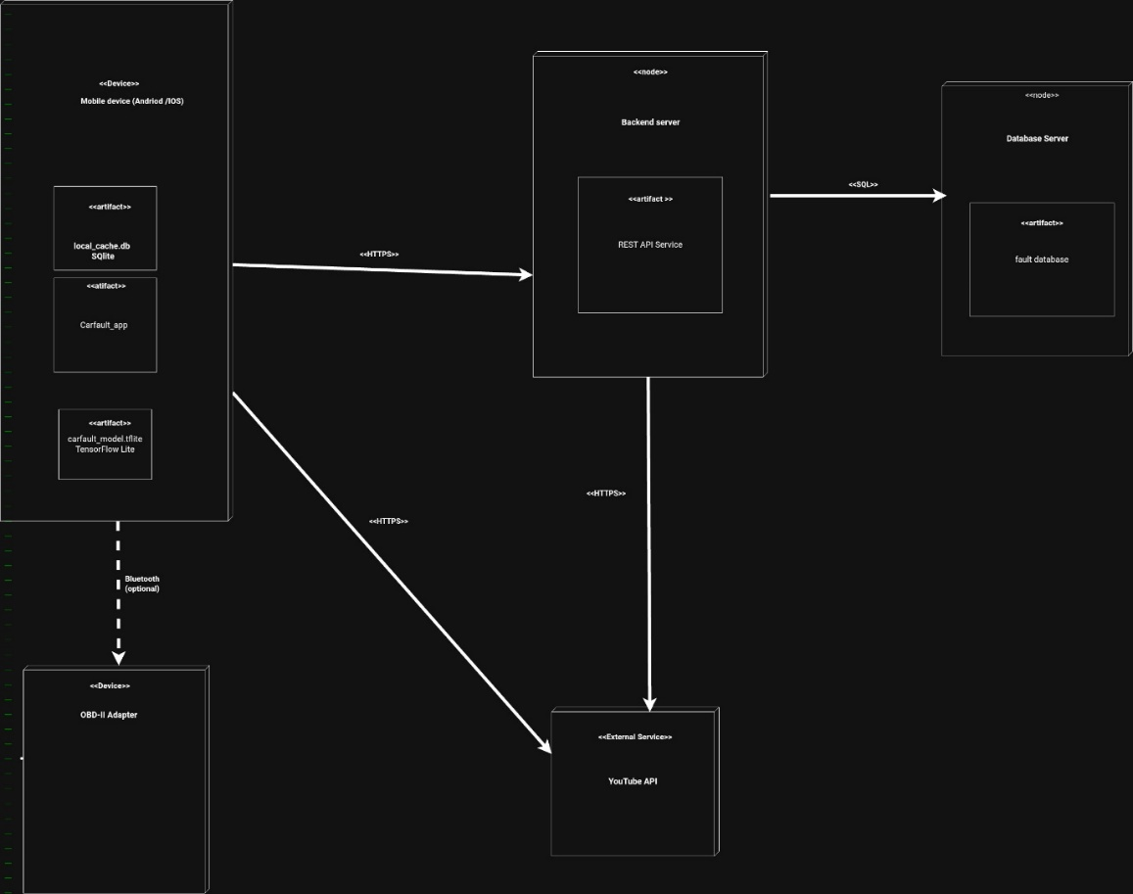

1. Introduction
The diagram presents the deployment architecture of an AI-based car fault diagnosis system. It shows how the mobile application is physically deployed on a smartphone and how it communicates with backend services, a database server, an external YouTube API service, and an optional OBD-II adapter. The design follows a hybrid approach where some processing is done locally on the device, while cloud services handle synchronization and external content delivery.

2. Overview of the Architecture
The system is centered on a mobile device (Android/iOS) that hosts the main car fault diagnosis application. The app uses three main local artifacts:
- Carfault_app: The main mobile application
- carfault_model.tflite: The on-device TensorFlow Lite model
- local_cache.db : The SQLite local cache database
These local artifacts support offline diagnosis, fast inference, and quick access to fault data.
The mobile device communicates with a Backend Server through HTTPS as well as with YouTube API external service through HTTPS and OBD-II Adapter through Bluetooth if enabled. The backend server communicates with the Database Server using SQL.

3. Description of the Nodes and Artifacts

3.1 Mobile Device Node
The mobile device is the main execution environment for the system. It contains the mobile application artifact,the local SQLite cache database and the TensorFlow Lite model

Purpose
This node performs:
- user interaction through the app interface
- local AI inference
- offline fault lookup
- optional communication with the vehicle via OBD-II
This design supports offline-first operation and reduces dependence on continuous internet access.

3.2 Backend Server Node
The backend server hosts the REST API Service artifact.

Purpose
This service receives requests from the mobile app, processes application-related queries, handles synchronization, communicates with the central database. It acts as the middleware between the mobile client and the central data storage.

3.3 Database Server Node
The database server contains the fault database artifact.

Purpose
It stores the master diagnostic information, such as fault descriptions, vehicle fault mappings, severity information, repair explanations and multilingual support data

3.4 External Service: YouTube API
The external service provides access to tutorial and educational content.

Purpose
The app can fetch repair tutorial links and demonstration videos. This is useful after diagnosis so the user can understand possible fixes visually.

3.5 OBD-II Adapter Node
The OBD-II adapter is shown as an optional device connected to the mobile app through Bluetooth.

Purpose
It allows the app to interface with the vehicle’s diagnostic system for read-only fault code access, complementary diagnosis, optional vehicle data retrieval. Because it is marked optional, the app can still function without it.

4. Communication Paths
The diagram includes several communication lines that define how the nodes interact:
- Mobile Device → Backend Server: HTTPS
Used for API requests and synchronization.
- Backend Server → Database Server: SQL
Used to query and update fault data.
- Mobile Device → YouTube API: HTTPS
Used to fetch tutorial content directly from the external service.
- Backend Server → YouTube API: HTTPS
Can be used if the backend mediates external content access.
- Mobile Device → OBD-II Adapter: Bluetooth
Used for optional vehicle communication.
These communication paths show a distributed architecture where the smartphone is the client, the backend provides services, and the database stores central knowledge.

5. Architectural Strengths

Offline Capability
The presence of local_cache.db and the TensorFlow Lite model makes the app functional even when internet access is unavailable.

Fast On-Device Processing
Using a .tflite model reduces inference time and supports mobile-friendly AI execution.

Cloud Synchronization
The backend and database server allow the app to update its fault knowledge and remain current.

Optional Vehicle Integration
The OBD-II adapter adds another diagnostic channel without making it mandatory.

6. Conclusion
The deployment diagram represents a practical and modern architecture for an AI-based car fault diagnosis mobile application. The smartphone performs the core diagnostic work using local artifacts, while the backend server and database server support data synchronization and central storage. External services such as YouTube enhance user knowledge and the optional OBD-II adapter provides additional vehicle diagnostic capability.

