Подготовил: Егор Кузьменков
Вариант 6, система «Кинорейтинг»

4)
SELECT film_rating
, film_default_title
, film_position
FROM film
WHERE (film_rating > 8) AND (film_year < 2000)
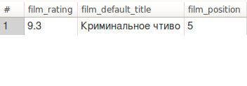
SELECT actor_name_EN, actor_surname_EN
FROM egor.actor
WHERE actor_name_EN LIKE ('Ja%')
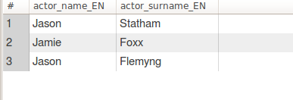
5)SELECT film_default_title
, film_rating
, film_year
FROM film
WHERE film_year < YEAR(CURDATE())
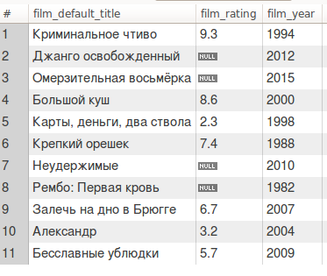
SELECT 'Average mark: '+CAST(AVG(film_rating) AS char(5)) AS Average_mark
FROM film;

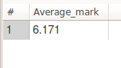
6)SELECT film.film_default_title,
GROUP_CONCAT(film_genre.film_genre) as genre
FROM film
INNER JOIN film_has_genre ON film.film_id = film_has_genre.film_id
INNER JOIN film_genre ON film_has_genre.genre_id = film_genre.idfilm_genre
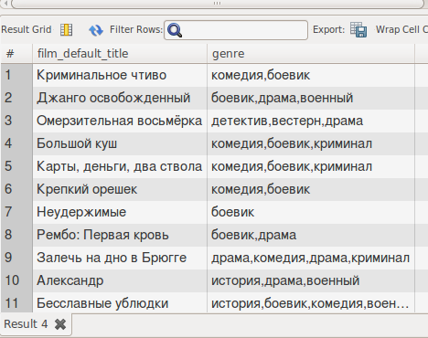
GROUP BY film.film_id
SELECT actor_name
, actor_surname
, CAST(AVG(film.film_rating) AS CHAR(5)) as average_rating
FROM actor
INNER JOIN actor_has_film ON actor_has_film.actor_id = actor.actor_id
LEFT JOIN film ON film.film_id = actor_has_film.film_id
GROUP BY actor_name, actor_surname
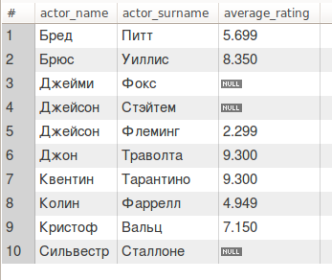
7)SELECT film_genre.film_genre
, CAST(AVG(film_rating) AS CHAR(5)) AS Average_rating
FROM film
INNER JOIN film_has_genre ON film.film_id = film_has_genre.film_id
INNER JOIN film_genre ON film_has_genre.genre_id = film_genre.idfilm_genre
GROUP BY film_genre
HAVING Average_rating > 6
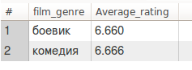
8)SELECT film_default_title
, film_rating
, film_year
FROM actor
INNER JOIN actor_has_film ON actor_has_film.actor_id = actor.actor_id
LEFT JOIN film ON film.film_id = actor_has_film.film_id
WHERE actor.actor_name_EN = 'Jason'
UNION
SELECT film_default_title
, film_rating, film_year
FROM director
INNER JOIN director_has_film ON director_has_film.director_id = director.director_id
LEFT JOIN film ON film.film_id = director_has_film.film_id
WHERE director_name_EN = 'Guy'
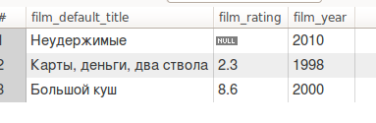
9)SELECT *
FROM film
WHERE film_rating = (SELECT MIN(film_rating) FROM film)
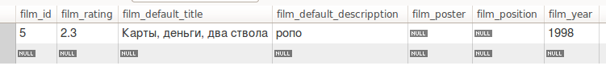
SELECT *
FROM director d1
WHERE 1<(SELECT COUNT(*)
FROM director_has_film d2
WHERE d1.director_id = d2.director_id)
