Exchange – Nettoyage de logs

Table des matières

1. IISLogsCleanup.ps1 2

a. How to Run IISLogsCleanup.ps1 2

b. Scheduling IISLogsCleanup.ps1 2

2. Purge-LogFiles.ps1 3

# IISLogsCleanup.ps1

## How to Run IISLogsCleanup.ps1

Please test the script on a non-production server first or at least make sure you have backed up your IIS log files before trying this script for the first time.

The script takes two parameters:

* **Logpath** – this is a mandatory parameter to specify the path to the IIS logs you want to clean up, such as “D:IIS LogsW3SVC1”
* **ArchivePath** – this is an optional parameter to specify the path to the central archive location, such as “\\nas01\archives\iislogs”

When you run IISLogsCleanup.ps1 it performs the following:

* Calculates the first day of the *previous* month (so there will always be at least 1 month of retained logs)
* Zips up log files from before the first day of the previous month into zip files per month
* Verifies the results of the zip action and removing the log files if safe to do so
* Optionally, moves the zip file to the central archive location
* Writes a log file of progress and actions taken

Examples :

.\IISLogsCleanup.ps1 -Logpath "D:\IIS Logs\W3SVC1"

.\IISLogsCleanup.ps1 -Logpath "D:\IIS Logs\W3SVC1" -ArchivePath "\\nas01\archives\iislogs"

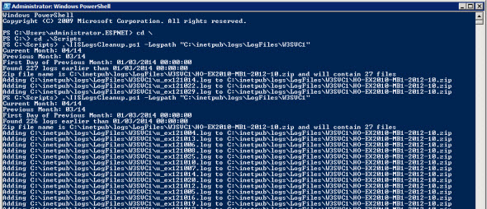

## Scheduling IISLogsCleanup.ps1

To run the script as a scheduled task use the following task settings (replace server names and file paths as necessary):

* Run whether user is logged on or not
* Triggers: I recommend the first day of each month
* Action: Start a program
* Program: powershell.exe
  + Arguments: -command “C:\Scripts\IISLogsCleanup.ps1 -LogPath ‘C:\inetpub\logs\LogFiles\W3SVC1' -ArchivePath ‘\\ho-mgt\iislogbackups'”

To run the task with a least privilege service account the account needs:

* Rights to “Log on as a batch job” for the local server
* Read/write access to the IIS logs directory
* Write access to the archive location
* Read/write/execute to the location where the script is running from

# Purge-LogFiles.ps1

**Note:**

This script requires the GlobalFunctions PowerShell module desribed here: https://gallery.technet.microsoft.com/Centralized-logging-64e20f97

The GlobalFunctions module must be implemented first. When using PowerShell 5.0 the easiest way is: Install-Module GlobalFunctions.

Find the script at GitHub: <https://github.com/Apoc70/Purge-LogFiles>

Find the most current release here: <https://github.com/Apoc70/Purge-LogFiles/releases>

Example

.\Purge-LogFiles.ps1 -DaysToKeep 7