LAB: Monitoring and Logging on the Bluemix Cloud Platform
Introduction:

IBM Bluemix offers platform based monitoring and logging capabilities. Metric and log data can be collected from compute instances running in the cloud and from other sources. Aggregated data from multiple sources both from in and out of the cloud, can then be visualized for analysis, insights, and action.
IBM’s platform logging and monitoring solution run on robust and popular open source offerings today. Logging is delivered from the Elasticsearch ELK stack. Monitoring is delivered from a Graphite/Grafana stack. Both are configured to use a common high speed Kafka bus. While these distinct services leverage a common Kafka bus, they are sometimes collectively referred to as ‘Logmet’ based on the strong affinity of logs and metrics to users needs and these microservices shared architecture.
The architectural graphic below provides a representation of data flowing into the logging and monitoring service. Data flows into the logging and monitoring service through an initial Logstash connection point. Once in the private network the data is processed then stored in Elastic Search or Graphite. Users gain access to the data through the Multitenant Proxy.
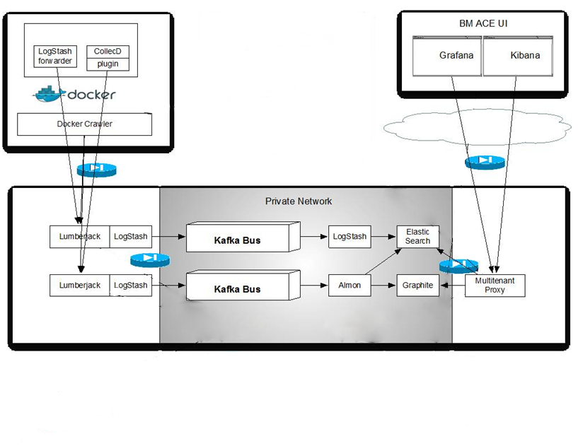
When data is collected from IBM hosted Docker containers, users additionally benefit from our use of a system crawler. The system crawler automatically collects select compute instance related logs and metrics. It can be additionally configured to collect more, all without agents or sidecar configurations.
This lab offers users the ability to experience some of the capabilities offered by the logging and monitoring microservices today. Specifically:
- Monitoring and logging from hosted Docker containers in Bluemix:
  - Configured through the Bluemix UI.
  - Configured through thr CLI
- Sending Liberty logs from a container hosted Liberty instance.
- Sending Websphere application logs from on-premise installations:
Additional scenarios possible with the monitoring and logging solutions, but not yet part of this lab include:
- Configuring VMs to send log and metrics data. Instructions for configuring this are included in the Bluemix documentation.
- Configuring CF Apps and runtimes to send log and metric data.

Lab Scenarios:

Automatic Logging and Monitoring from containers hosted in Bluemix by using the Bluemix user interface

In this scenario you will create a simple container by using the Bluemix user interface and include a log file location from which to send data to the Logmet service.
- Log into the London region of the new Bluemix user interface.
- Click Compute. Your Compute Dashboard opens. Cloud Foundry Applications, Containers, and Virtual Servers are all included in the Compute category and will be displayed in this Compute Dashboard when you create them.
- To create a container, click the + Add icon.
- Click Compute > Containers. The available images are displayed and this list includes images that are provided by IBM and images that are stored in your organization’s private Bluemix repository. Think of an image as a layered template for creating a container. When you create an image, you are adding a layer to that template with your own configurations, which are compiled in a Dockerfile. In this lesson, you use an image that is provided by IBM so that you do not have to create a Dockerfile yet.
- Select the ibmliberty image to build your container from.
- If you are creating a container for the first time, you are prompted to enter a namespace. The namespace is not the same as the Bluemix space. The namespace is used to generate a unique URL that you use to access your organization’s private Bluemix repository, which is the central repository within an organization where you store your trusted Docker images. Pick your namespace wisely; it cannot be changed later.
- The window opens to the Single Container creation tab by default, which is what is used for each lesson in this lab. Single containers are often used to run simple tests as you develop an app or service. To use your own networking front end, you can assign a public IP address to the container. A container group includes one or more single containers that require load balancing and automatic recovery. Use a container group for production workloads and testing at the required scale.
- In the Container name field, enter the name LogmetLab1_ibmliberty for the single container.
- In the Size field, select Pico.
- In the Public IP address field, select Request and Bind Public IP.
- In the Public ports field, the ports that are required for the container were included in this field for you because they were specified in the Dockerfile when the image was created.
- Expand the Advanced options section.
- Click Add a new environment variable to add log files to send to the logging and monitoring service. Adding this environment variable instructs the crawlers to pull data the log file you specify from the container and to push that data to the Logmet service so that you can view it in Kibana.
  - For the Key, enter the following name.
  - For the value, enter the following path. By default, Docker logs and messages that get stored in /var/log/messages are automatically pushed to the Logmet service for every container, so you do not have to add those. The dpkg.log file can be added since it is a standard Ubuntu log file that is commonly generated during the creation of a container, but is not pushed automatically to Kibana by the crawlers.
- Click CREATE. As the container is created, which might take a few moments, the container is also started in Bluemix and the Overview page for the container is displayed. Look at the container’s status as it is starting, which is displayed next to the container’s name. When the creation is complete, the status is Running.

Review your metrics and logs from the container.

- When the container is running, in the Overview page for the container that you created, click the Monitoring and Logs tab. This page shows a simple view of data that is specific to this container.
- From the Monitoring tab you will see the default metrics that are collected for your container. Click the ADVANCED VIEW. This will open a browser tab showing a Grafana dashboard of the same default metrics. From this dashboard, users are empowered to create and customize dashboards to fulfil their application and environment monitoring needs. Additional instructions for customizing Grafana dashboards can be found here.
- Click the Logging tab. This view includes a flat list of logs from the start-up of the container.
- Click the ADVANCED VIEW, which opens log information for all of the containers in the Bluemix space in a customizable Kibana dashboard. You can also access the same page from the URL https://logmet.eu-gb.bluemix.net.
- In the table, click a log entry to view the details. The path field shows you if the log entry came from /docker.log or /var/log/dpkg.log.
- Optional: To view only the logs from dpkg.log, in the path row for a log entry, in the Action column, click the magnifying glass icon. All of the docker.log entries are not displayed and the filter is displayed in a grey box below the header.
  - To remove the filter, click the Remove icon.
- Optional: To view everything except the logs from dpkg.log, in the path row for a log entry, in the Action column, click the circle icon. All of the docker.log entries are displayed.
  - To remove the filter, click the Remove icon.
- Additional instructions for customizing Kibana dashboards can be found here.

Logging and Monitoring from a Docker Hub image by using the IBM Containers CLI

In this scenario you will experience how docker containers initiated from a CLI are automatically registered to the logging and monitoring services. This goes one step further demonstrating that images imported into the IBM Cloud can be automatically configured.
- Install the IBM Containers CLI and its requirements. You can install them on your computer or on a VM.
Note: For this lab you only need to install the IBM Containers CF Plugin since the standard Docker and CF CLIs are already installed. cf install-plugin https://static-ice.ng.bluemix.net/ibm-containers-linux_x64

- Log in to the Cloud Foundry CLI. By default, you are logged into the Dallas region. Include the –a option to log in to a specific region in Bluemix.
Dallas region:
London region:
- Enter your Bluemix ID, password, organization, and space as you are prompted. This time, the space refers to your Bluemix space, not your namespace.
- Log into the IBM Containers CLI.
- From Option 2, copy and paste the environment variables to point the Docker host to the IBM Containers Docker daemon. This setting allows you to run native Docker commands as if you were using Docker locally, but you are using Docker in Bluemix. This setting is helpful if you are used to Docker commands and only want to use cf ic commands when necessary.
- Verify that the LogmetLab1_ibmliberty container you created earlier is still running by entering the following command:
Result:
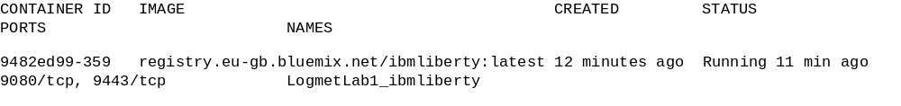
- Copy the mysql image from Docker Hub into your private Bluemix repository. Docker Hub is an image library maintained by Docker. You can copy any image from Docker Hub and use it in IBM Containers. The cpi command, which is used to copy images, is an IBM Containers command, so there is no Docker alternative. Therefore, use cf ic to run the command instead of docker. Include the name of the image you want to copy and the name you want to give the copied image. The copied image name must include the Bluemix registry path, your namespace, and the name of the image. You can include a tag or version, but latest is used by default.
Tip: Forget what your namespace is? Run the following command to get your namespace.
- Verify that the mysql image was copied into your private Bluemix repository and was named my_sql_image successfully by running the following command.
Result:
- Create a container from the image and include the LOG_LOCATIONS environment variable to include the var/log/dpkg.log logs in Kibana. This one command includes all of the same configuration information that you provided in the user interface when you created the LogmetLab1_ibmliberty container in the previous lesson.
- Wait for the container to start running. You can run docker ps to check the status of the container.
- When the container is running, check the Kibana dashboard to verify that the logs from this container are displayed.
  - Enter your Bluemix ID, password, organization, and space. This time, the space refers to your Bluemix space, not your namespace.
  - Select Kibana and click Login.
  - In the table, click a log entry to view the details. The path field shows you if the log entry came from /docker.log or /var/log/dpkg.log.

Send a message to the Logging service and view it in Kibana
Log into a container and send a message to the dpkg.log file. Then look in Kibana to see if your message was logged properly.

- Log into the container with a bash shell by running the following command. You can run docker exec instead of cf ic exec because you configured the CLI to do so.
- Type a message to create a log entry in dpkg.log.
- Alternatively, you can send a json string as the message, allowing you to further categorize your data in Kibana. The syntax is:
echo '{"key":"value"}' >> /var/log/dpkg.log'
Now let’s send the same message in json format.
- Exit the container’s bash session.
- Open the Kibana dashboard and look for the log entry that was created for your message.
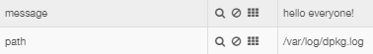

Send WebSphere Application Server logs through a container to view in Kibana
In this scenario we take logging another step further capturing liberty runtime logs from a container and loading them into logging and monitoring. You will additionally experience an example of a customized Kibana dashboard designed for WebSphere operations users.

Build your own image to use a container to send log data from an on-premise WebSphere Application Server and view that data from Kibana.
- Create your own image.
  - In your user home directory, create a directory to store the files for creating an image.
  - In the new directory, use a text editor to create a Dockerfile. Name this file Dockerfile and do not include a file extension.
  - In the Dockerfile, copy the following information.
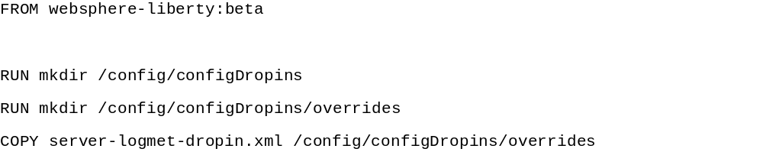
  - In the same directory, create a server-logmet-dropin.xml file and copy the following information into it.
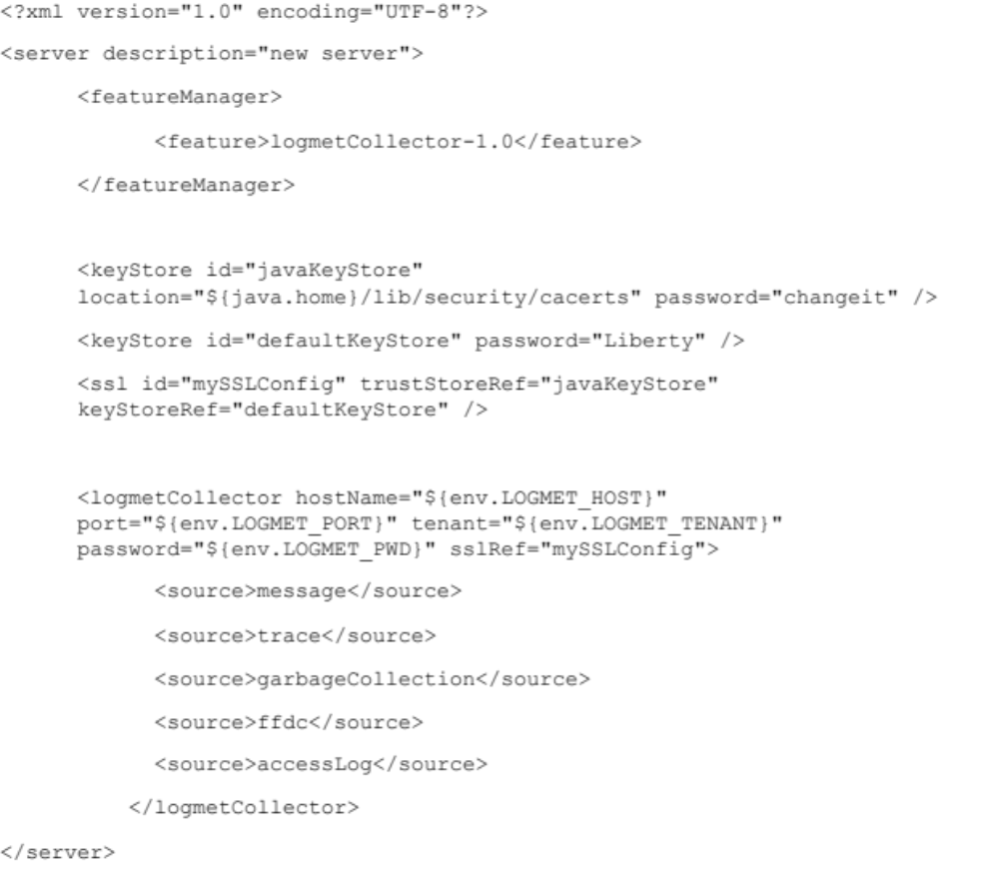
  - From a command line utility, navigate to the directory that contains the Dockerfile.
  - Build the image directly into your organization’s private Bluemix repository by running the following command. Make sure to include the period at the end. The period indicates that the Dockerfile exists in the directory that the command is being run from.
  - Verify that the image was created by running the following command.
Result:
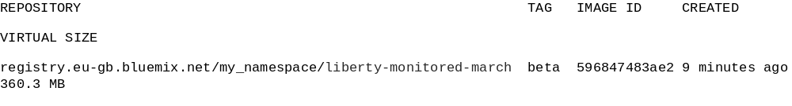
- Retrieve the space_id and logging_token for your Bluemix space by running the following command.
Tip: cURL is installed by default on many computers, but it is not installed on your computer, you can install it.
Result:
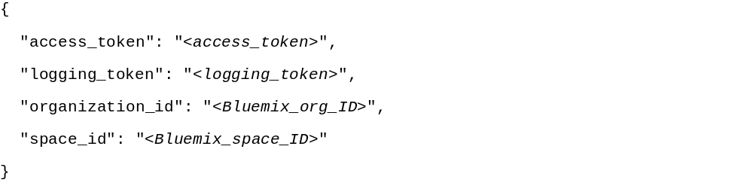
- Create a container from the image. With the following command, include environment variables that provide the details for sending log information from your Bluemix space to Logmet.
  - For the LOGMET_HOST, include one of the following values:
    - Bluemix Dallas region: logs.opvis.bluemix.net
    - Bluemix London region: logs.eu-gb.opvis.bluemix.net
  - For the LOGMET_PORT, specify 9091.
  - For the LOGMET_TENANT, enter your space ID.
  - For the LOGMET_PWD, enter the logging token.
Example:
- Log in to the Kibana dashboard and look for messages with the _type liberty_message to confirm that the log data was sent properly.
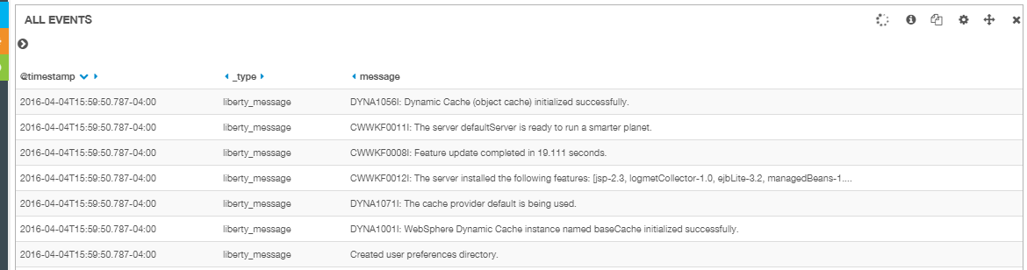
- Add a sample dashboard to your Kibana dashboard that is customized for viewing Liberty logs.
  - Save a copy of this .json dashboard locally. https://github.com/WASdev/sample.logmet.collector/blob/master/liberty-kibana3.json
  - Click the Load icon.
  - Hover the mouse over Advanced and then click Choose file.
  - Select the .json sample dashboard from your computer that you downloaded.
  - Click the Configure Dashboard icon and click the Index tab.
  - In the Index pattern field, type [logstash-<space_ID>-]YYYY.MM.DD and include the space_id that you retrieved earlier. Click Save.
  - Click the Save icon to save the sample dashboard as your own dashboard.
  - Enter a name for the dashboard, like Liberty, and click the Save icon.
- Explore the Liberty log data in the customized Kibana dashboard.
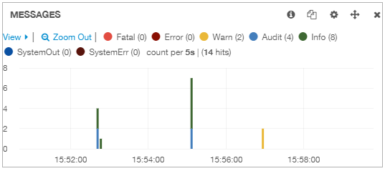
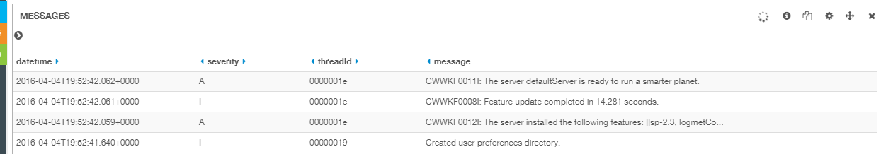

Send WebSphere Application Server logs from an on premise server to view in Kibana
In this final scenario you can discover how easy it is to set up your on premise Liberty servers to send your logs to Bluemix and view and analyze them in Kibana. Follow the step by step instructions available athttp://www.ibm.com/support/knowledgecenter/SS7K4U_9.0.0/com.ibm.websphere.wlp.nd.multiplatform.doc/ae/twlp_analytics_logmet.html.
Here's a link to a video (https://www.youtube.com/watch?v=ZcSp0Q19Tq4) showing on premise Liberty servers sending logs to Bluemix and using the Kibana dashboard for analysis.

