**χαρμολύπη (Charmolypi)**

***χαρμολύπη*** is an interactive artistic experience aiming to explore the beauty of closeness in the context of human relationships.

**Description and user experience:**

Distance is hereby understood as solitude: individuals are self-contained beings when apart but when they choose to start getting closer to one another, an exchange gradually happens. This exchange will inevitably translate into the opening of their respective boundaries, sharing parts of themselves to receive something valuable in exchange.

The intention behind this project, envisioned as an immersive video and audio interactive installation, is to explore and abstractly represent what humans possess and can choose to share of themselves, enhancing the value of the enriching effect closeness in relationships has on the individual. Closeness, sharing and openness are all choices that our installation wants to promote and encourage.

To achieve this, the installation exploits human-to-human interaction and both visual and audio implementations dynamically evolve contributing to make the users perceive closeness and connection as something valuable and energising.

Our vision is for the users to be able to freely move within the installation space and interact with others to actually perceive (visually and auditorily) the overall change in atmosphere that closeness against distance between people generates.

**Challenges, accomplishment and lessons learned**:

Challenges:

* Development and implementation of the Variable Length Markov Chain model:
  + finding a balance between how stochastic the chain is in generating sequences and its ability to produce results with harmonic and melodic meaning (when the order of the chain is increased, the generation ends up having one possible outcome only becoming, this way, deterministic)
* Hardware connection issues due to SDK of the Kinect technology being discontinued a long time ago

Lessons Learned and Achievements:

* Networking implementation via OSC (how the communication works, what kind of messages to send and receive)
* How to generate stochastic sequences and therefore, how to implement the model of a Variable Length Markov Chain
* Understading of the Paulstretch algorithm to perform abstract sound synthesis by stretching audio samples in time
* How to collaborate and work in a team where each member has its own specific role

**Hardware and Software Technology**:

Our testing and development setup involved:

* Xbox Kinect Techology
  + Motion and distance detection
* TouchDesigner by Derivative.ca
  + Motion and distance mapping
  + Visual and graphics
* Python
  + Variable Markov Chain algorithm implementation
  + Music sequence generation and composition
* SuperCollider
  + Sound synthesis
  + Audio output
* OSC – Open Sound Control
  + Networking and communication protocol

**Dependencies**

* Python
  + Mido – MIDI Objects for Python[1]
  + pyOSC3

**External Resources**

* Maestro-v3.0.0 dataset by Magenta[2]
  + midi files used to generate music sequences

**Students**:

* Emma Coletta: documentation, presentation material, python MIDO library understanding and employment, overall supervision of the project development
* Enrico Dalla Mora: TouchDesigner implementation, Python and SuperCollider optimisation and adjustments, hardware technology expert
* Federico Ferreri: Variable Length Markov Chain model development, Python code implementation (OSC connection, threading management, music sequences generation)
* Lorenzo Previati: project idea, concept and inspiration development, SuperCollider script management

**Links**:

* Github repo: <https://github.com/EnricoDallaMora/CPAC-23-24-GROUP-7.git>
* Video Demo – youtube: <https://youtu.be/q8xytoQ--RE?feature=shared>

**Project thumbnail:**

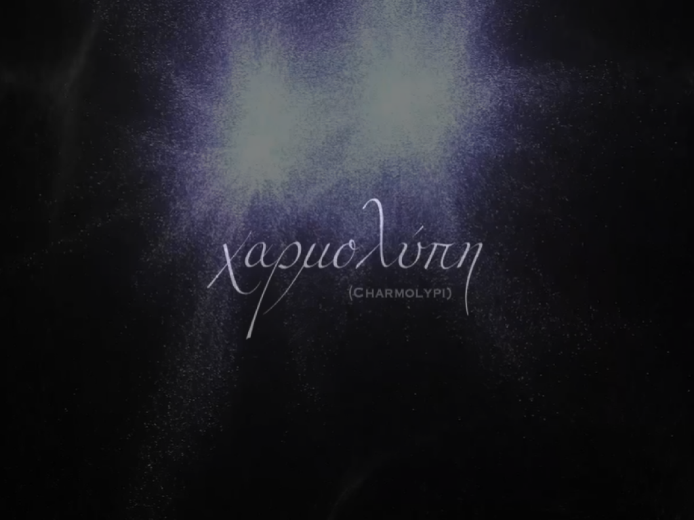

1. <https://mido.readthedocs.io/en/stable/>
2. Curtis Hawthorne, Andriy Stasyuk, Adam Roberts, Ian Simon, Cheng-Zhi Anna Huang, Sander Dieleman, Erich Elsen, Jesse Engel, and Douglas Eck. "Enabling Factorized Piano Music Modeling and Generation with the MAESTRO Dataset." In International Conference on Learning Representations, 2019.