ACCESSING AN ENTERPRISE BEAN
Assignment 4: implement a simple enterprise bean using WildFly

Date : 26.10.2017
Enrico Magnago 186957

Introduction:
This project is an implementation of a simple stateless java enterprise bean.
The Server module consists of a class TimestampBean which implements the Timestamp interface placed in the Common module. Such enterprise bean is deployed on WildFly so that a client is able to retrieve a remote instance and interact with such class.
The client once an instance of Timestamp has been acquired it asks 2 times for the current time.

Implementation:
The project is composed of 3 java modules: Client, Server and Common.

The Common module contains the definition of the shared interface between Client and Server : the Timestamp class. This interface extends Serializable. It provides the signature of a method that returns a String representation of the current time.

The Client module contains the Client class which first sets some parameters required to create the proper InitialContext. The client tries to connect to the server asking for an instance of an object implementing the Timestamp interface. The name used to get the instance is the one where WildFly places the enterprise beam defined by the Server module. In conclusion the Client call 2 times the getTimestamp() method on the retrieved object, between the 2 calls it waits 1 second.

The Server module contains the class TimestampBean which is a stateless implementation of the Timestamp interface. The annotations: Stateless and Remote(Timestamp.class) tell WildFly that this class provides a stateless implementation of the Timestamp interface, so that it can process in creating a binding between the bean and a name.

Deployment:
In oder to deploy the enterprise bean on WildFly I have used the facilities of the Intellij IDE which is able to take care of the creation of the java archive and starting WildFly in standalone mode, given the JBOSS_HOME path.

Note:

This image shows the log of the WildFly server. In particular the JNDI bindings can be seen.

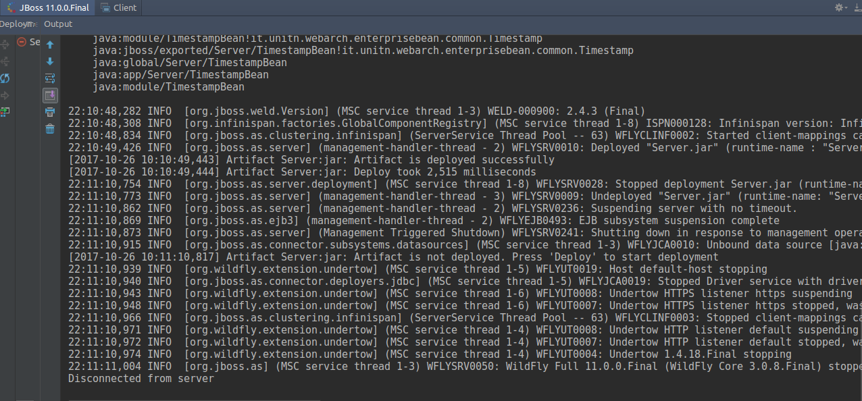

The following image shows a single run of the Client class. The last 2 lines show the log on standard output of the 2 timestaps acquired from the enterprise bean.

