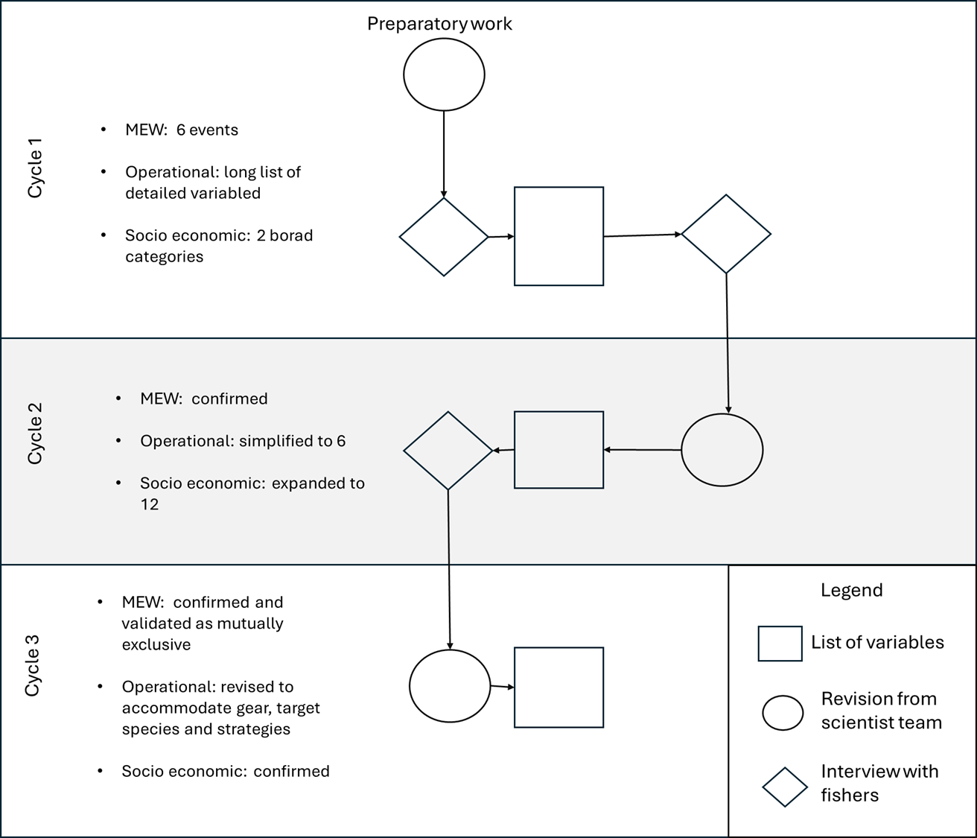
Figure 1: conceptual representation of the workflow used to turn stakeholder perspective into a Bayesian Risk Analysis. The workflow is divided into cycles, each associated to a list of variables and causal connections (squares). In each cycle the list of variables is revised by a team of scientists (circles) and/or enriched with expert elicitation (diamonds). The bullet point describes the main decision taken at each cycle.
Figure 2. Bayesian Network representing risks to Swedish fisheries posed by marine extreme weathers, at the conclusion of the third cycle of stakeholder dialogues. The probability distribution shown represents the example of how operations of fishing guides are affected by a summer heatwave, given current fish stock statuses.

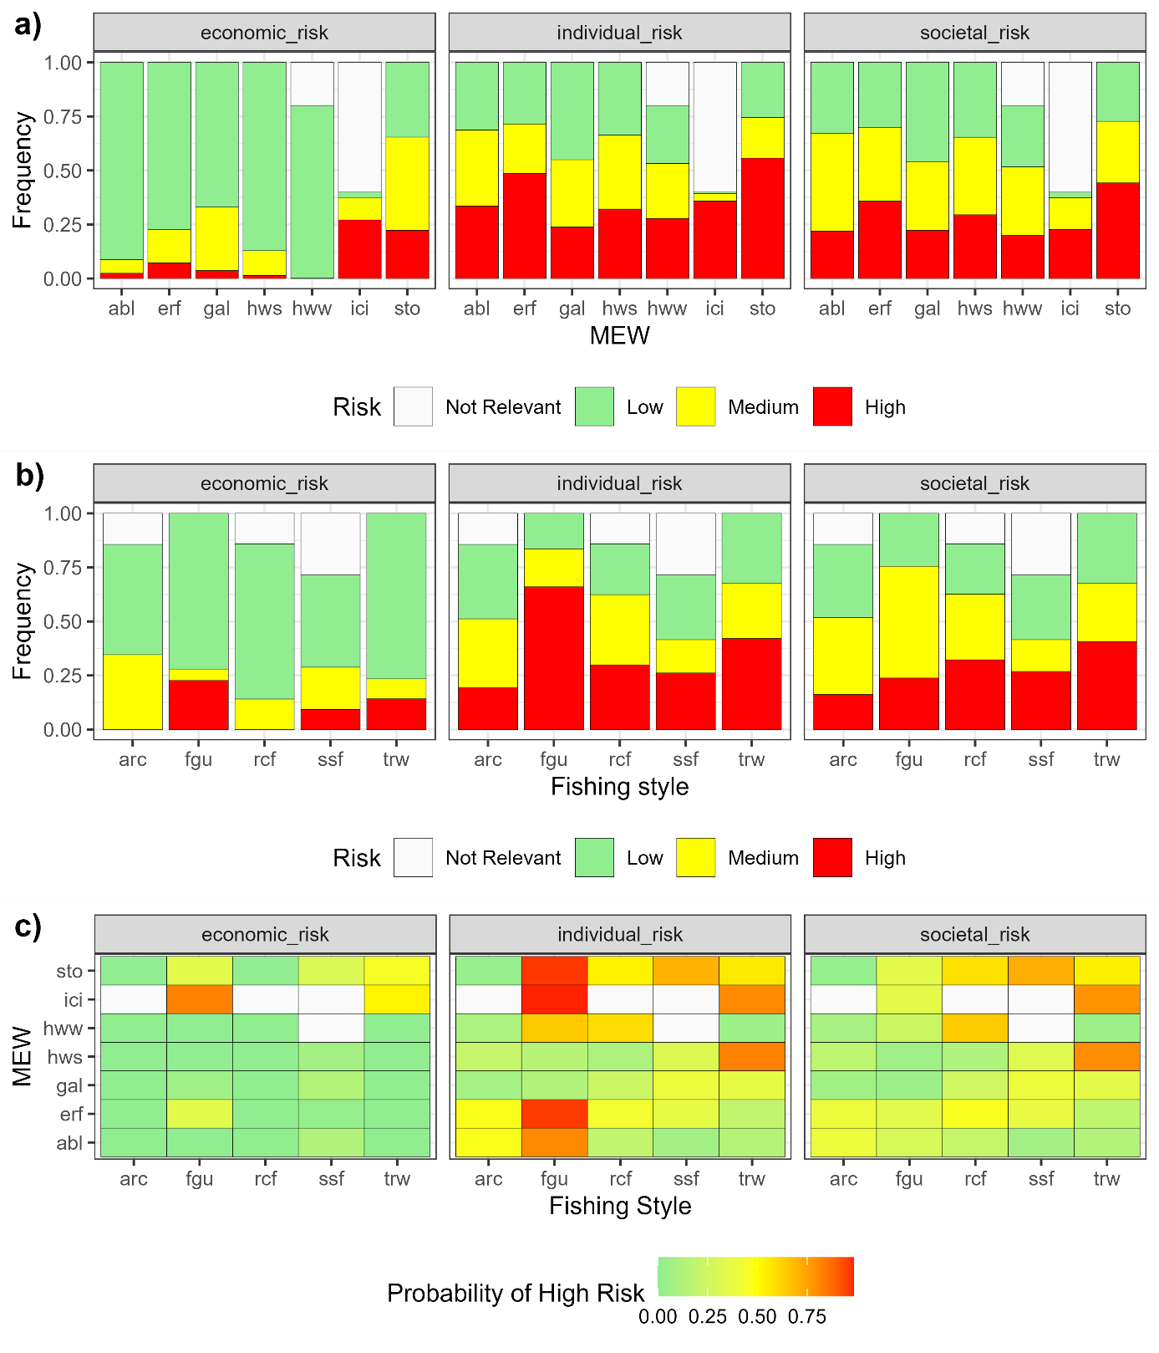
Figure 3. Risks posed to Swedish fisheries, varying with (a) type of marine extreme weather (MEW); (b) fishing style, c) each combination of MEW and fishing style resulting from scenario 1, 2, and 3 respectively. A) and b) are shown as probability distribution of the utility nodes “economic risk”, “societal risk” and “economic risk”; panel c) shows the probability that the utility nodes “economic risk”, “societal risk” and “economic risk” has state = High. MEWs are: algal bloom (abl), extreme rainfall (erf), gale (gal), summer heatwave (hws), storm (sto). Fishing styles are: Archipelago (arc), fishing guide (gui), recreational fisher (rcf), coastal small-scale fisher (ssf), pelagic trawler (trw).Risk equal to not relevant accounts for those combinations of fishers and fishing style not relevant for risk (white boxes in panel c).

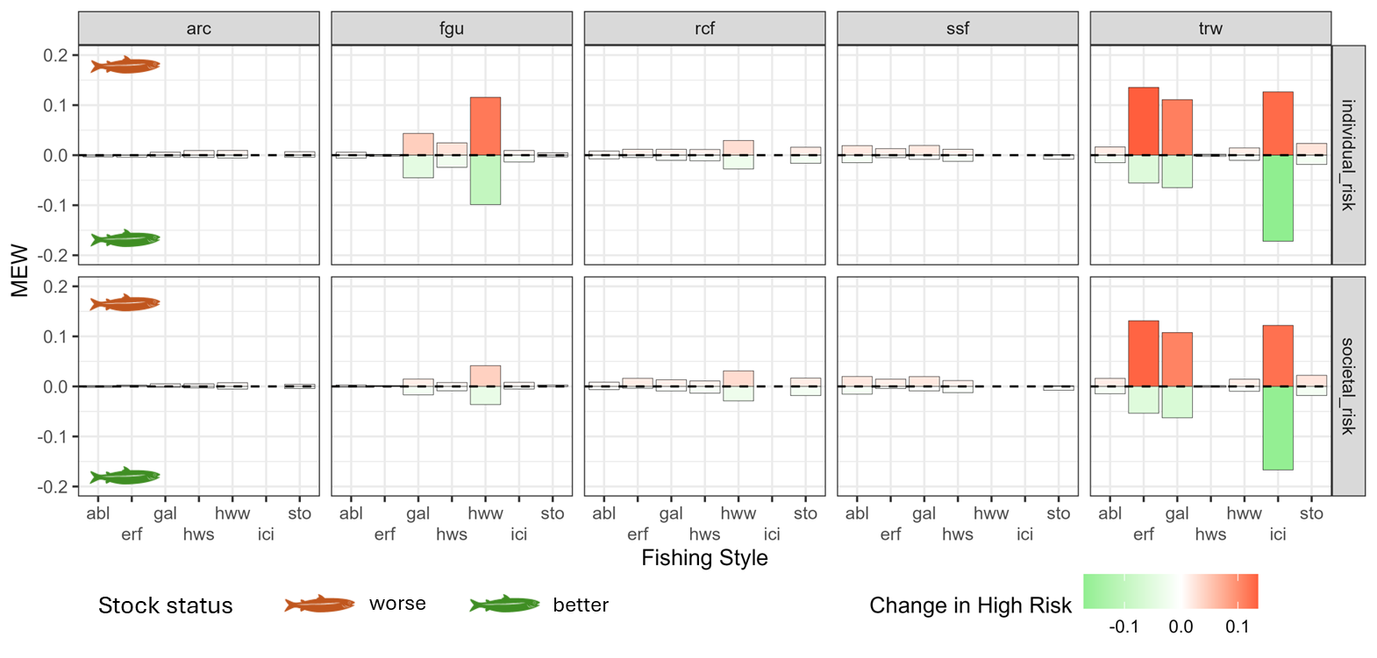
Figure 4: the effect of changes of stock status on economic and individual risk, resulting from scenario 4. Colored bars shows the difference in the probability of observing high risk compared to the baseline scenario reported in figure 3c. Red shades are used to report on the increased risk associated with worse stock status. Green shades indicate risk decrease due to improvement in stock status. The X axis represents the MEW algal bloom (abl), extreme rainfall (erf), gale (gal), summer heatwave (hws), storm (sto). The column panels represent the fishing styles Archipelago (arc), fishing guide (gui), recreational fisher (rcf; coastal small-scale fisher (ssf), pelagic trawler (trw). The row panels show individual and societal risk.

