Supplementary Materials - A2
Contents
Methods used to fill CPTs 1
Decision nodes 3
Operational subsystem 4
Ecological subsystem 10
User subsystem 11

Purpose of this document version is to provide interpretation for the part of the network shown in the figure here below. It is here described the meaning of each node along with the source of information and the data treatment to fill the conditional probability tables.

Methods used to fill CPTs
This section summarizes methods used to fill most of the CPTs, which generally base on the concept of ranked nodes (Fenton et al., 2007). Ranked nodes are discrete variables (e.g.: low/medium/high) which states can be mapped to a continuous numerical scale bounded to [0,1]. The continuous variable is distributed as $TNormal(μ, σ^{2},0,1)$ [Eq.1], and the states are mapped to the interval assuming equal intervals. For instance, in a node having three states (low, medium, high), the interval widths are 0.33 so that the “low” state takes the interval [0-0.33). Ranked nodes can also be used to map binary variables (yes/no) to nodes having two states and interval width = 0.5.
[M1] Single parent
The distribution depends on a single parent. The CPT can be defined based on priors for $μ$ and $σ^{2}$ obtained from the interviews. For example, node A represents the importance assigned to a certain feature by fisherman categories. Node A has three states (low, medium, high). Interview (Likert scale from 1 very low to 5 very high) says that fisherman X1 considers node A as “highly important” (= 4/5). Fisherman X2 says it is moderately important (3/5); X3 says = 5/5. $μ= \frac{\sum_{i=1}^{n}{X_{i}}}{n}$ = 0.8; $σ^{2}= \frac{\sum_{i=1}^{n}{{(X}_{i}}-μ)}{n}= 0.2.$
The continuous distribution of the node would be:
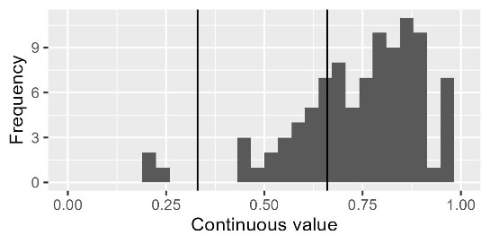
Figure 3
After discretisation, the CPT will be:
Table 5
Low | 0.02
Medium | 0.25
High | 0.73

[M1 - bis] Multiple parent with causal independence (Noisy OR)
Parent nodes can act independently. For example, node A has three parents (B, C and D). Node D is a binary node that act as an “activator”: when its state is 0, the state of A is 0 (or low) independently from the state of the nodes B and C. When the node D is activated (=1), nodes B and C produce their effect. But node B and node C are also independent. The Noisy-OR approach consists in modelling individual probabilities independently. The CPT can be implemented by applying the method M1 to each subsection of the CPT.

[M2] Multiple parents
When a child has multiple parents with multiple states (binary or more), the distribution of a child node can be calculated by implementing algorithms based on the state, direction (positive or negative) and weight of their parents (Fenton et al., 2007). There are different algorithms:
Weighted average gives a linear result depending on states and weights
$μ= \frac{\sum_{i=1}^{n}{w_{i}X_{i}}}{\sum_{i=1}^{n}{w_{i}}}$; [Eq. 1]
Weighted min assigns more contribution to small states
$μ=min\left[\frac{w_{i}X_{i}+ \sum_{i≠j}^{n}{X_{j}}}{w_{i}+(n-1)}\right]$; [Eq. 2]
Weighted max assigns more contribution to large states
$μ=max\left[\frac{w_{i}X_{i}+ \sum_{i≠j}^{n}{X_{j}}}{w_{i}+(n-1)}\right]$; [Eq. 3]
For example, here parent C has a weight = 2 and negative effect, parent B has weight = 1 and positive effect. The algorithm implemented is weighted min. The CPT for node A is:
 | C = Low |  |  | C = Medium |  |  | C = High
 | B = Low | B = Med | B = High | B = Low | B = Med | B = High | B = Low | B = Med | B = High
Low | 0.04 | 0 | 0 | 0.9 | 0.08 | 0 | 1 | 0.96 | 0.49
Medium | 0.93 | 0.35 | 0 | 0.1 | 0.87 | 0.52 | 0 | 0.04 | 0.51
High | 0.03 | 0.65 | 1 | 0 | 0.05 | 0.48 | 0 | 0 | 0

Decision nodes
Controls the climate and fishing management scenarios, those are defined a priori depending on the conditions to be explored in the scenario analyses.
Extreme weather events (node: event)
The node Event is used to wrap all the extreme weather events we are considering and some of their interactions. These events are storms (summer), or strong wind events, with intensity above 24.5 m/s; gales (summer), or moderately strong wind events, with intensity between 15 m/s and 24.5 m/s; Extreme precipitation – rainstorm (summer), or deviation from average precipitation regime; algal bloom (summer): intense algal bloom; Heatwaves (winter/summer): prolonged discrete anomalously warm water event (Hobday et al., 2016); Icing (winter): strong wind events associated to ice, which then forms icing pile up on gears and boats.

Fishing style
The node fishing style is used to wrap all the fishing styles and seasons. These are recreational fisher in winter season, a fishing style that primarily performs ice fishing and potentially can fish in open water from the shore; fishing guide in winter season, a fishing style that primarily performs ice fishing and potentially can fish in open water from the shore; fishing guide in the summer season, which primarily fish in coastal areas from shore or boat and can potentially move to inland fishing; artisanal fishers, a fishing style that happen mostly in summer using gillnets in coastal areas, and in some cases with traps (not for salmon) but can perform limited amount of ice fishing in winter; artisanal fishers specialised in salmon fishing which fish for salmon with fixed traps rigidly regulated; industrial fishers, represented by pelagic trawlers mostly active in winter and exclusively fishing for small pelagic; archipelago fishers, which is similar to an artisanal fishers but is by law prevented from selling their catches.

Fishing management
Fishing management scenario contribution can be crucial to understand what are the major limits that actual management has, and what can be possible solutions. We can leverage on degrees of:
- Flexibility: choosing different flexibility possibility to change fishing strategy (both gear and target). This can be linked to the node “strategy”.

- Infrastructure: availability of terrestrial infrastructures such as roads, ports and bridges. CPT is already filled with method M1 based on the answer to Q17 (infrastructure).

Operational subsystem
Pending: still have to adjust for “misinterpretation” like the trawler and heatwave; Math stuff: scale down uncertainty; adjust ranges properly (e.g.: 0-2 answers should work on both sides)
- Strategy
Fishers response is coded as Adapt (proactive planning); react (unplanned response); cope (accept passively) (Green et al., 2021). Cope is when fisher prefer to not go out fishing; React is when they apply small modification to their practice, such as fishing in deeper areas or in different time of the day; Adapt is when they take proactive response such as modify their strategy by changing fishing target and/or gear.
Each interviewee expressed their view regarding the strategy in different questions. For each event and fisherman, it is applied manual revision to assign one or more between react, cope and adapt. Then it is identified which answer is more appropriate to fill the CPT.
Case 1: single strategy. React use avoidance (or what has been labelled as such) to define the probability to cope or react. Adapt use avoidance (or what has been labelled as such) to define the probability to be cope or adapt. Cope or NA: then is 100% cope. When there is a single respondent use the self-declared uncertainty. When there are multiple respondents (which all agree on the strategy), calculate uncertainty from answers.
Case 2: single strategy but multiple options (i.e.: target species). Choose the highest value, the range of values would be used to describe the node target conditional on event and strategy.
Case 3: When multiple strategies occur within the same context, the probabilities are combined through a weighted noisy-OR mechanism, accounting for both response frequency and uncertainty. This means that first we separately calculate the probability distribution as if it was case 1, then the probabilities are combined as weighted average where the weight is the number of responses.

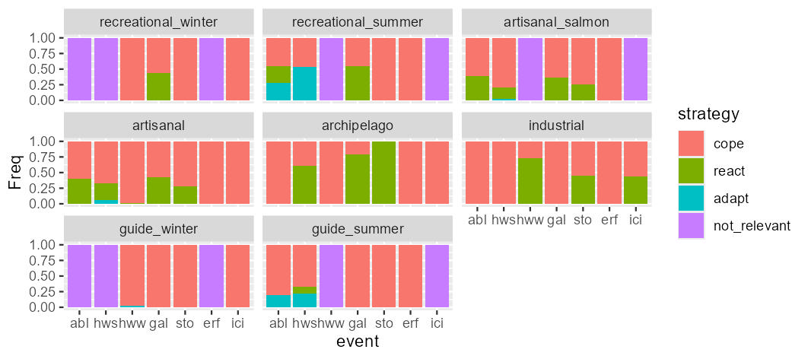
- Technical solutions
Describes the measures implemented in the case when the strategy is React. The different solutions work differently and have different cost: travel further implies fisherman change fishing location to seek a sheltered place or to find deeper waters; short sets mean that the fisher perform shorter sessions than average (i.e.: reduced soak time for gillnets); other technical includes strategies that are mentioned sporadically (i.e.: use of ice machines).
The CPT is compiled manually for each combination of event and fisherman based on what has been mentioned throughout the questionnaire. In case only one strategy is mentioned, this is assigned probability = 1. When two strategies are mentioned, they are 50% probable unless one strategy is explicitly adopted more often than the other (and so on for three strategies).

 | Strategy: cope | Strategy: react | Strategy: adapt | Strategy: not relevant
Tec. Sol: No | 1 | 0 | 1 | 1
Tec. Sol: travel further | 0 | Manually filled | 0 | 0
Tec. Sol: short sets | 0 | Manually filled | 0 | 0
Tec. Sol: travel further | 0 | Manually filled | 0 | 0

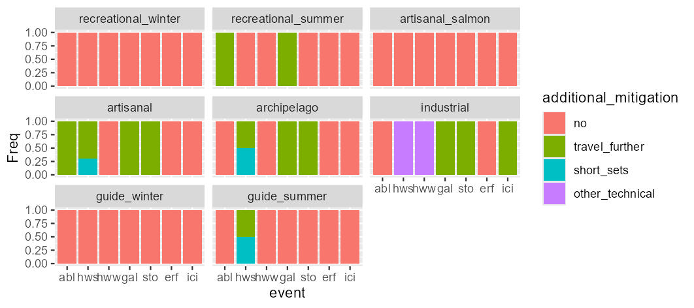

- Gear
Describes the most probable gear used by each fisherman. The CPT is compiled manually for each combination of event and fisherman. In the case when the strategy is cope or react, the CPT reflects what we do expect from the fisher in normal conditions (this can be one or more gears). When the strategy is Adapt, the CPT accounts for what has been mentioned throughout the questionnaire.
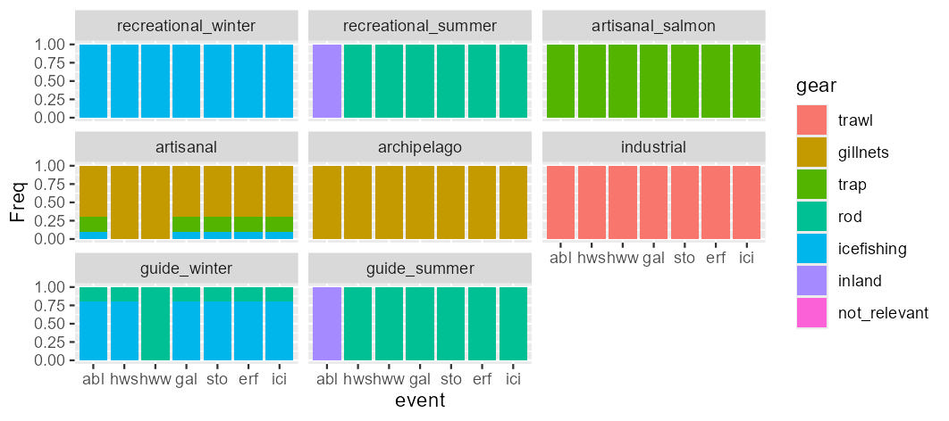

- Catchability: the ability to catch fish depending on gear-fish interactions. For example, a gillnet clogged in algae is more visible and less efficient (less catchability); a gillnet in murky waters is less visible and more efficient (more catchability); the necessity to go to haul the net sooner because of heatwave diminish the soaking time (less catchability). For each combination of species and even the CPT is filled with method M1-bis based on the answer to Q3 (catchability).

- Catch condition: the real or perceived quality of catches in terms of aspect/health status. Does NOT refer to species composition or distribution. When the technical solution is no, the CPT is filled with method M1-bis based on the answer to Q5 (catch_condition). The combination of species, events and technical solutions are inspected to identify which of those works. For these, the catch condition is same with probability = 1.

 | Tec. Sol: No | Tec. Sol: only when applies to the combination of event, target and solution
Condition: worse | p(Cond = w | Q5) | 0
Condition: same | p(Cond = s | Q5) | 1
Condition: better | p(Cond = b | Q5) | 0

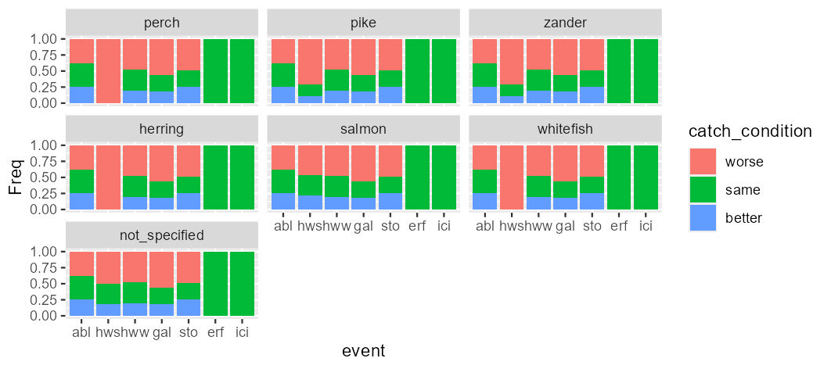

- Personal safety (or Safety concerns): any variation to ordinary working condition that can increase the potential physical damage for operators (i.e.: icing can require more time on the deck that translates in increased risk of slipping; a violent storm is life threatening). When the technical solution is no, the CPT is filled with method M1-bis based on the answer to Q9 (damage). When the technical solution is “travel further”, the personal safety is “no” with probability 1. With the available answers no other measure is implemented to deal with personal safety.

 | Tec. Sol: No, short sets, other | Tec. Sol: travel further
Pers. Safety: no | p(Safety = n | Q9) | 1
Pers. Safety: minor | p(Safety = min | Q9) | 0
Pers. Safety: major | p(Safety = maj | Q9) | 0

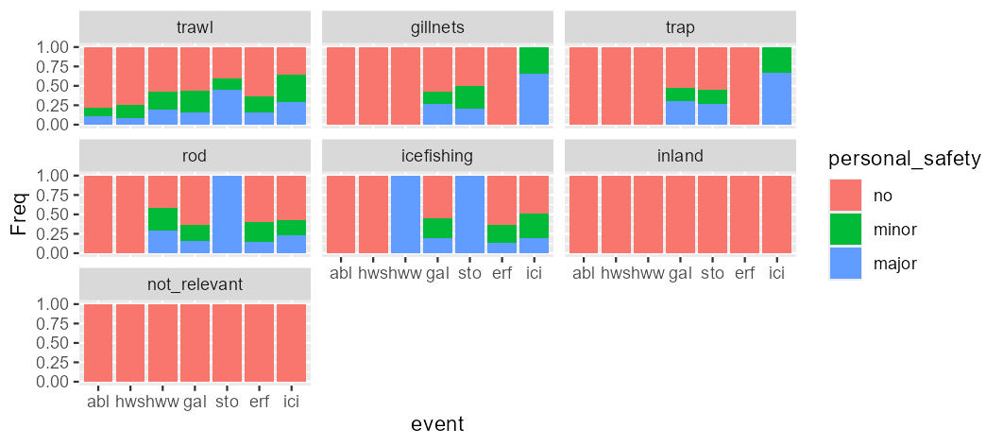

- Damage: damage to the fishing gear ranging from minor to completely losing the fishing gear or part of it because it was lost or irreparably damaged. When the technical solution is no, the CPT is filled with method M1-bis based on the answer to Q10 (damage). When the technical solution is “travel further”, the damage is “no” with probability 1. With the available answers no other measure is implemented to deal with damages.

 | Tec. Sol: No, short sets, other | Tec. Sol: travel further
Damage: no | p(Damage = no | Q10) | 1
Damage: minor | p(Damage = min | Q10) | 0
Damage: major | p(Damage = maj | Q10) | 0
Damage: destroy | p(Damage = dest | Q10) | 0

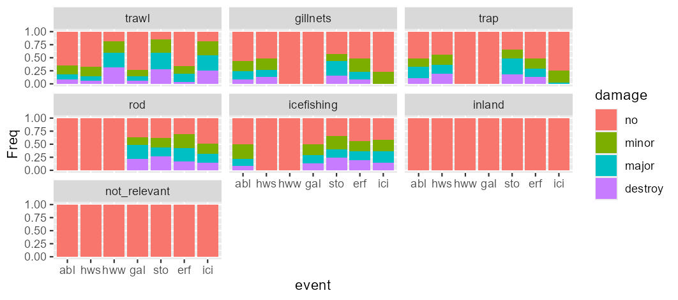

Ecological subsystem

- Target
Describes the most probable target species associated to each fishing gear. The CPT is compiled manually for each combination of event and gear. In the case when the strategy is cope or react, the CPT reflects what we expect from the fisher in normal conditions (this can be one or more combinations of gear/species). When the strategy is Adapt, the CPT accounts for what has been mentioned throughout the questionnaire. Example: gillnetters normally target a set of species (herring, whitefish, perch), but when there is an heatwave they switch primarily to perch.
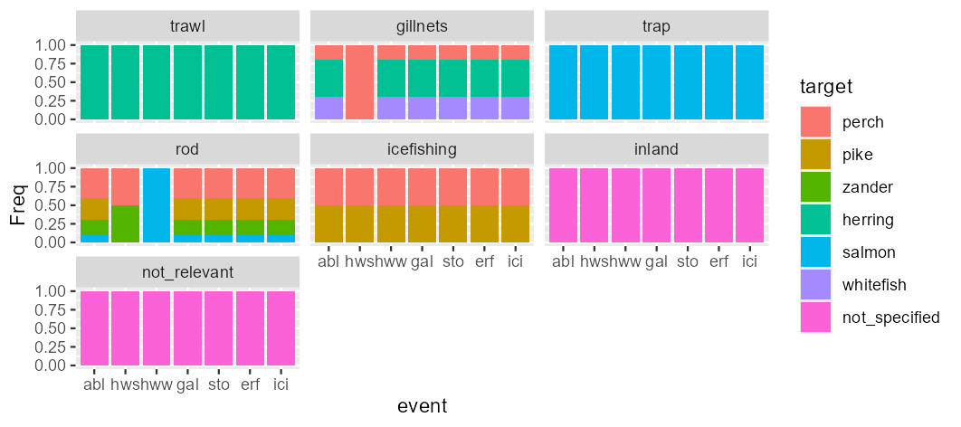

User subsystem

- Go fishing
Describes the probability to go out fishing. When the parent node strategy is “cope”, the CPT is filled with method M1 based on the answer to Q2 (go_out). In the case when the parent node strategy is “react” or “adapt”, the decision is always to go fishing.
 | Strategy: cope | Strategy: react | Strategy: adapt | Strategy: not relevant
Go fishing: Yes | p(Go fishing=Y|Q2) | 1 | 1 | 0
Go fishing: No | p(Go fishing=N|Q2) | 0 | 0 | 0
Go fishing: not relevant | 0 | 0 | 0 | 1

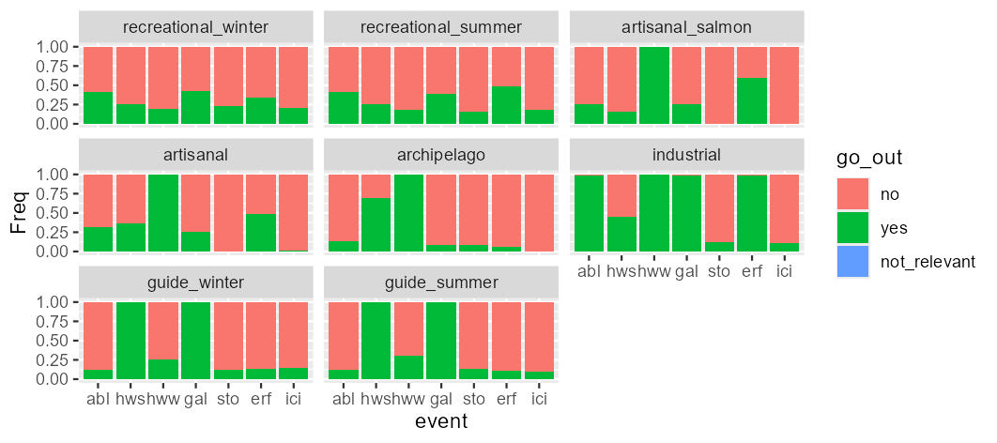

- Stress: psychological aspect, elements such as anxiety and sense of fatigue which can eventually drives motivation (Chatterjee and and Bolar, 2019). The stressful events considered are having damages to the gear, being injuried, being the catch in poor condition. The CPT is filled with strategy M2, where the answers to Q21 a, b and c (stress) are used as weights.

- Fishing cost: a summary of the extra expected costs to reach the fishing grounds, to implement maintenance (after or before the event to adapt to increased risk hazard), and/or to replace the fishing gear. This is under revision (looking for values in literature).

References
Boonstra, W. J., Birnbaum, S., and Björkvik, E. 2017. The quality of compliance: investigating fishers’ responses towards regulation and authorities. Fish and Fisheries, 18: 682–697. John Wiley & Sons, Ltd.
Chatterjee, D., and and Bolar, K. 2019. Determinants of Mobile Wallet Intentions to Use: The Mental Cost Perspective. International Journal of Human–Computer Interaction, 35: 859–869. Taylor & Francis.
Fenton, N. E., Neil, M., and Caballero, J. G. 2007. Using Ranked Nodes to Model Qualitative Judgments in Bayesian Networks. IEEE Transactions on Knowledge and Data Engineering, 19: 1420–1432.
Green, K. M., Selgrath, J. C., Frawley, T. H., Oestreich, W. K., Mansfield, E. J., Urteaga, J., Swanson, S. S., et al. 2021. How adaptive capacity shapes the Adapt, React, Cope response to climate impacts: insights from small-scale fisheries. Climatic Change, 164: 15.
Hobday, A. J., Alexander, L. V., Perkins, S. E., Smale, D. A., Straub, S. C., Oliver, E. C. J., Benthuysen, J. A., et al. 2016. A hierarchical approach to defining marine heatwaves. Progress in Oceanography, 141: 227–238.
ICES and WGBFAS. 2024. Baltic Fisheries Assessment Working Group (WGBFAS). ICES Scientific Reports. https://ices-library.figshare.com/articles/report/Baltic_Fisheries_Assessment_Working_Group_WGBFAS_/25764978 (Accessed 11 April 2025).

