Target Journal: People and Nature (https://besjournals.onlinelibrary.wiley.com/hub/journal/25758314/author_guidelines)

Research Article – empirical, conceptual and theoretical submissions are considered in this category. For empirical research qualitative, quantitative or mixed methodologies will be considered. Research articles should be no more than 7,000 words in length (not including the reference list); if a paper is longer than 7,000 words, authors should explain the rationale for that length in the cover letter.
https://besjournals.onlinelibrary.wiley.com/doi/10.1002/pan3.70143

Title: Causal pathways of risk: how extreme weather impacts the social-ecological performance of Swedish fisheries

New title proposal: How do extreme weather events affect fisheries? Exploring causal pathways of risk in Swedish fisheries operations.

Authors: Enrico Nicola Armelloni^{1, *}, Jens Olsson¹, Laura Uusitalo², Anna Gårdmark¹

¹ Department of Aquatic Resources, Swedish University of Agricultural Sciences, Uppsala, Sweden
² Fisheries and Fish Resources, Natural Resources Institute Finland (Luke), Helsinki, Finland
* Corresponding author

- Introduction – 700 words max

- Extreme weather events: brief overview of what they are
Climatic events characterised by out-of-average intensity and duration are defined as extreme weather events (REF).
Marine extreme weather events include heatwaves, heavy rains, and storms, and are likely to become more common due to ongoing climate change. Extreme events are scarcely predictable and are a challenge for management.

- Extreme weather events on fishery: direct and indirect via marine ecosystem
Marine extreme weather events are already recognized to have a high impact on marine ecosystems (Gomes et al., 2024; Guibourd de Luzinais et al., 2024; Marshall et al., 2013), as well as on the economic and cultural values of those societal sectors that have strong connections with the marine environment (Eurich et al., 2024; Free et al., 2023).
Fisheries are among those marine sectors where extreme weather events have a complex series of impacts, ranging from the indirect effects due to the alteration of the marine ecosystem to the direct impact on physical infrastructures and fisheries opportunities. A few examples here?

- Need to adapt. Diversity of people makes diversity of impacts

The potential danger that climate change, including extreme weather events, can pose on fisheries made many to re-think to the notion of sustainability (Harvey et al., 2025). Part of new sustainability paradigm also comprehend effort devoted the development of strategies to support climate adaptation (Harvey et al., 2025).
To start with, fisheries system resilience to extreme weather events depends on their ability to adapt or cope to novel conditions (Green et al., 2021).
Fisheries are complex interactions of dynamics from ecological (the fish), human (the fisher) and socio-economic (the society and economy where the fisher is included). All these spheres (economic, societal and individual attributes) contribute to shape vulnerabilities (Li et al., 2024), and have a key role in success or failure of adaptation strategies (Eurich et al., 2024; Free et al., 2023; Harvey et al., 2025).
These attributes can greatly vary among fishing styles, which are not only characterized by different behaviors and capacities but also by diverse priorities and scopes (Boonstra & Hentati-Sundberg, 2016; Wijermans et al., 2020).
Therefore, there is a need for a range of adaptation strategies that fit the different needs.
Small scale fisheries especially requires transdisciplinary (Jentoft & Chuenpagdee, 2019)

- Highlighting poor knowledge of the relation between weather events and fishing practice
The heatwaves in the pacific coast of the unites states triggered several studies on the effects of extreme events on fisheries systems (Eurich et al., 2024; Free et al., 2023). The knowledge is uneven: lots for heatwaves, large scale fisheries, coastal fisheries. Knowledge gaps in other events, recreational fisheries, fishing guides. . There is need to incorporate social and economic information to evaluate fishing management and to assess readiness (Harvey et al., 2025)

- Research question
The extreme weather events unpredictability and the fisheries systems complexity pose a challenge to understand what can happen in future. Creation of a conceptual framework to describe the causal pathways of the climatic impact on fisheries is helpful (de Carvalho et al., 2023).
Research question(s): how Are the direct effects of extreme weather events on Swedish fisheries an economic, or a non-monetary risk? Which fishing styles are mostly exposed to the direct effects of extreme weather events? Is implementing more flexible management helping to reduce the direct effects of extreme weather events? Extra: is it reducing the risks of the direct effect of a shortage of credits? Is any adaptation strategy meaningful if the stock status is not good?

We set out to explore how do extreme weather events affect fisheries operation in a comprehensive set of fishing styles. The
Are the economic, individual and societal values at risks? How is this influenced by management, credits and stock status?

- Theoretical framework – 1500 max

2.1 Decoding complexity: methods to describe the pathways of risk in fisheries systems

The response of fisheries to environmental variability is a typical risk assessment problem (Kruse et al., 2024; Stelzenmüller et al., 2018). Risk Assessment frameworks can handle causalities through a logic and conceptual description of the system of interest, or Risk Identification, and uncertainty through the subsequent implementation of quantitative methods to describe how it reacts to perturbations, Risk Analysis (Cormier et al., 2013; Hodgson et al., 2019; Roux et al., 2022).

The challenge of risk identification is to bridge social, economic, and ecological dynamics that characterize marine fisheries. This can be facilitated by dissecting complexity into a series of samller components (Collins et al., 2011; Schlüter et al., 2025). A logic way to translate fisheries into risk identification is to describe fisheries as social ecological systems (Li et al., 2024; Restrepo-Gómez et al., 2022). Social-Ecological System theory (Ostrom, 2009) identifies fisheries as subsystems, tipically (i) the ecological aspects of the exploited marine ecosystem, (ii) the behavioral and economic aspects of the fisherman, and (iii) the societal and governance priorities of the human community in which the fisherman is included (Harvey et al., 2025; Restrepo-Gómez et al., 2022). SES theory strength is in it flexibility, and possibility to adhere to diverse case studies with emphasis on different subsystems (Crosman et al., 2019; Dudley et al., 2021; Kruse et al., 2024; Pihlajamäki et al., 2020; Stelzenmüller et al., 2024). Nevertheless, it is a handy logic scheme to anchor descriptions.

Risk Analysis implies determining the probabilistic distribution behind the risk (Stelzenmüller et al., 2018). It is a task that requires including a layer of quantitative information over the system described in the risk identification. A common limitation is to have limited or no empirical information that needs to be supplemented by expert opinion (Stelzenmüller et al., 2018). Expert judgement comes with the problem of subjectivity and standardisation, as well as issues regarding uncertainty treatment and data integration. Bayesian Networks (BN) are probabilistic models that can be used to integrate heterogeneous information while providing support for risk analysis (Fenton & Neil, 2019). BN are made of a graph, that mimic the risk identification, and a conditional probability table. BN can propagate uncertainty easily and provide support for scenario implementation. Its use for this has been proven in several case studies (Kruse et al., 2024; Pihlajamäki et al., 2020; Uusitalo et al., 2023).

Implementing stakeholder perception adds up an extra layer of complexity to risk assessment. There are strategies to facilitate expert elicitation and interviews (Duespohl et al., 2012), however the chances to have a response that exactly matches expectations straight away are low. Instead of considering risk identification and risk analysis as two separate and sequential steps, these can be viewed as components of an incremental and iterative process (Korb & Nicholson, 2011). Korb & Nicholson (2011) describes the process of turning the stakeholder perspective into a Bayesian network as “Knowledge Engineering” (KEBN). KEBN guidelines include iterations, or cycles, where phases of design, implementation and validation are subsequently re-iterated to move from an initial prototype to a final product. Add theoretical frameworks for interviews here.

I MISS A CLOSING REMARK

2.2 Fishing styles in the central and northern Baltic Sea

Fishing in central and northern Baltic Sea implies adaptation to the unique conditions of the area, such as brackish water and ice coverage (REF). The implications are a mix of freshwater and marine species and strong seasonality in fishing methods (Salmi et al., 2023). In addition to the diversity of conditions, the productivity of the Sea and the attachment of Sweds to outdoor, set the ground for making fishing an important part of the culture that is performed with a diversity of fishing methodologies, or “fishing styles” (Boonstra & Hentati-Sundberg, 2016). The existing fishing styles are very different in terms of individual scopes, economic implication, regulatory system. This implies a diversity of risk pathways. In this paper we model five fishing styles, representing the large majority of fisher operating in the area:

Coastal fishing: fishers that operates passive gears from small boats (<12 m) associated with specific targets: herring gillnets, small-mesh gillnets targeting a mix of freshwater species, salmon traps. More specialised fisheries exist or existed for vendace roe and Eel fyke nets. Coastal fishers have a limited spatial mobility due to vessel size, and sometimes because of bond to specific places (Björkvik, Boonstra, & Hentati-Sundberg, 2020). They are regulated as . It is estimated that 500 people are actively included in this fishing style in the area, with a declining trend (Björkvik, Boonstra, Hentati-Sundberg, et al., 2020). The coastal fishing style has a relatively small economic impact on Sweden economy (5 million €; (Björkvik, Boonstra, Hentati-Sundberg, et al., 2020), however it has a much larger cultural value. Coastal fishing is a traditional activity and one of the main sources of income supporting permanent population living along the Swedish coast, including some remote areas (Salmi et al., 2023). Coastal fishermen are highly motivated by identity and traditional value, such as to maintain fisherman lifestyle and to transmit their critical ecological knowledge to future generations (Boonstra & Hentati-Sundberg, 2016; Norr et al., 2018; Rådberg et al., 2018; Wijermans et al., 2020). The major challenges that coastal fisher faces are low profit due to low fishing opportunities, exacerbated to a difficulty in making investment due to, also, limited access to public funding and loans (Garavito-Bermúdez & and Boonstra, 2023; Rådberg et al., 2018). Fisher nowadays tend to diversify their activity (fish processing, tourism related activities), or to quit.

Pelagic trawling: fishers that operates pelagic trawl nets from medium to large size vessels (24-40 m) targeting herring and sprat. Pelagic trawlers have an high spatial mobility and operate from the North Sea, where they fish for human consumption, to the Baltic Sea, where they fish for fishmeal. They are regulated as .
Pelagic trawling fishing capacity has been reduced over the last decades to meet sustainability target, and it is practiced by a handful of vessels that generates a significant individual revenue. The an overall worth value of XXX million. Pelagic trawling is a full-scale business with a non-negligible cultural value. They are family business and provide source of traditional food (Herring). While pelagic trawlers priority is profit, maintain fisherman lifestyle and to transmit their business ecological to future generations is important (Boonstra & Hentati-Sundberg, 2016; Norr et al., 2018; Rådberg et al., 2018; Wijermans et al., 2020). The major challenges that coastal fisher faces are low profit due to low fishing opportunities. Large scale vessels are large business supported by banks and have easy access to credits (Garavito-Bermúdez & and Boonstra, 2023; Rådberg et al., 2018).

Archipelago fishing style: identifies people living in close connection with land and water in the outer Swedish archipelago. This peculiar fishing style is operated by people that usually owns land and the surrounding stretch of water and that used to operate the same fishing gears that coastal fisherman does. For this paper, we include in the archipelago only people that are not allowed to sell their catches and that do not have access to commercial fishing licenses, such as that for salmon and eel. Therefore, the gear employed is mostly gillnets.

Recreational fishing: includes fishers without a commercial fishing license, which deploys hand-held gears such as angling and trolling. Recreational fishing in Sweden comes with large mobility opportunity considering the variety of coastline, archipelago, as well as lakes and rivers. In coastal areas and lakes, angling is practiced from the shore or from boats. The main targets of coastal fishers are pike, perch and zander, while fishing for sea trout and trolling for salmon is also popular. Most of the recreational fisher do catch and release. In the winter season, a popular activity is ice fishing. They are regulated as . Recreational fishing is a growing sector worldwide, and Sweden is no exception. It is estimated that XXX people are actively included in this fishing style in the area. Recreational fishing is not generating income for the fisher, but is is generates income for local communities (5 million €; (Björkvik, Boonstra, Hentati-Sundberg, et al., 2020). Recreational fishing is a leisure activity that is more linked to personal well-being thatn tradition. fish exclusively for fun. they tend to fish only when it is a pleasant experience. they can cope to some extent with extreme events by adapting their location if they want to fish on the coast

Fishing guides: professionals that aids recreational anglers at the scope of improving fishing experience (Farthing et al., 2022). The main contribution of fishing guides is to sharing local knowledge, giving access to angling concession and boat chartering. In Sweden fishing guides clients includes locals, national and international tourists. Fishing guides adopts the same fishing techniques and targets adopted by recreational fisher, and can also diversify between coastal, river and lakes. Although the flexibility is virtually high, it is always subordinated to client. They are regulated as. Fishing guides are freelancers or occasionally small companies, and no official public register is available. Based on a web scraping procedure we estimate that in late 2025 the number of fishing guide companies is in the order of few hundreds to a thousand. Fishing guides faces volatile market and revenues and high costs. With an increasing tourist market the business is good, but it is fragile because of limited access to credits.

- Material and methods – 1500 max

3.1 Turning the stakeholder perspective into a Bayesian Risk Analysis

The process of transforming the conceptual model identified in 3.1 into a socio-ecological Risk analysis follows protocols for creating Bayesian Network with stakeholders (Duespohl et al., 2012) and guidelines of Knowledge Engineering (Korb & Nicholson, 2011). Knowledge Engineering expects to have several iterations, or cycles, where phases of design, implementation and validation are subsequently re-iterated.

3.1.1 Cycle 1: stakeholder engagement and identification of the network structure

Design & Implementation
Structured dialogues with representative of all the target fishing styles took place during a joint workshop with fishermen and county administrative boards, and through subsequent individual dialogues with individual segments. The dialogues were based on six open-ended questions: (1) What is extreme weather for you; (2) How is your business affected by different types of extreme weather; (3) Are there other possible consequences of extreme weather that you consider important to monitor/understand better; (4) How vulnerable/sensitive is your business to the effects of extreme weather; (5) What consequences does extreme weather have for your business in general; (6) What values do you consider most important/value most highly and which are affected by extreme weather.

Evaluation

Researchers drafted an extended preliminary list of variables exclusively based on the narrative emerging from the interviews. The variables were assembled into a structured network that was shared with stakeholders to ask for agreement and to allow further suggestions.

3.1.2 Cycle 2: stakeholder follow up and estimation of the parameters

Design
The variables identified by stakeholders were labeled and regrouped according to their relevance for each of the four social ecological subsystems represented in Figure 1: operational subsystem, user, ecological, human. The list of variables in each subsystem was revised to tailor complexity to available information, to emphasize stakeholder divergence, and to the need of the research question.
The list of variables was trimmed to reduce the complexity on those subsystems extensively covered by the interviews (operational, user). Simplification procedure was done by grouping variables with similar effects and eliminating variables that are not relevant for the research question or too ambiguous. Stakeholder divergence was emphasized by attempting to retain variables that are only relevant to a subset of fishers (REF).
The list of variables was extended for the subsystems under-represented in the interviews (human community). A list of relevant variables was borrowed from literature, with emphasis on expressing how important is fishing for the community (Crosman et al., 2019; Ekstrom et al., 2015; Wabnitz et al., 2018), how the community is able to adapt (Cinner et al., 2012; Green et al., 2021; Kruse et al., 2024; Ritzman et al., 2018), how important is fishing for personal wellbeing (Crosman et al., 2019; Moore et al., 2024; Stelzenmüller et al., 2024).
The revised list of variables was used to build a conceptual map to be used as a first version (v1) of the Directed Acyclic Graph to feed the Bayesian Network, hereby identified as DAG_{v1}.
To simplify the construction of the Conditional Probability Table each variable is planned to be represented as a discrete nodes with three sequential ordinal levels (e.g: low, medium, high; worse, same, better) that can be translated into a continuous [0,1] scale (Fenton & Neil, 2019).

Implementation - eliciting conditional probabilities from literature

It is inspected what is available in literature about of economic and social statistics (i.e.: costs, revenues, job mobility). If there is a value published in the Annual Economic Reports or in other literature, we may use it. Describe here which sources are being consulted.

Implementation – eliciting conditional probabilities from stakeholders

The elicitation of the conditional probabilities regarding operational aspects and other socio-economic attributes base on one-to-one interviews with the engaged stakeholders. Interviews were conducted on zoom within three months from the agreement on the preliminary network described in section 3.1. The short time from the previous consultation was necessary to maintain the stakeholder engaged and updated on the state of the project. The aim of these interviews was both to obtain parameters to fill the CPT as well as to give stakeholder a further opportunity to express their perception of the effects of extreme weather events.
The interviews started by reiterating a short summary of the consequences of extreme weather events on fisher activity, where interviewee was asked to agree or otherwise to explain. The rest of the interviews followed a standardised plot based on 45 questions tailored on DAG_{v1} structure. The complete questionnaire along with answers and data treatment is reported in Supplementary Appendix A1. Questions were designed either to represent a section of the CPT, or to validate coherence of interviewee reasoning (e.g.: Q7 and Q13, Tables A1.22 and A1.29). The questionnaire included (i) requests to provide rating on the LIKERT 5-points scale; (ii) multiple options; (iii) open ended requests. The questionnaire was divided into topic sections, each of which included a self-assessment of variability in the category represented. This was used to inform uncertainty for the categories represented by a single interviewee. The interviewee was encouraged to argument whenever they considered it appropriate or needed, and their opinions were annotated.
Answers that failed to provide a scoring on the LIKERT scale where otherwise expected were revised following the structured protocol described in section Supplementary material A1. Answers are converted into quantities according to the LIKERT scale and aggregated by fishing style to calculate mean and standard deviation. In case when the respondent was alone, we used the self-assessment.

3.2.2 Cycle 3: adjusting the network structure and revising parameter

Design – adjusting the network structure and coding stakeholder perspective as Adapt-React-Cope

The interviews results from cycle 1 are used to revise the narrative enclosed in DAG_{v1}. The network structure is refined to account for novelties emerged in the revised narrative, especially regarding the strategies that fisherman adopt when extreme weather events happens. Strategies that fisher mentioned are labeled according to the Adapt-React-Cope framework (Green et al., 2021), where adapt implies proactive planning; react implies unplanned response; cope mean to accept passively.
This strategy allowed to code all the observed strategies, such as not go out fishing (Cope); apply small modification, such as fishing in different time of the day (React); or modify their strategy by changing fishing target and/or gear (Adapt). The revised DAG is labeled as DAG_{v2}.
Implementation – implementing conditional probabilities

Our BN includes categorical and ranked nodes. Ranked nodes have order-preserving meaning states (e.g.: low/medium/high) that can be mapped to a continuous numerical scale bounded to [0,1], assuming equal intervals (Fenton & Neil, 2019). For instance, in a node having three states (low, medium, high), the “low” state takes the interval [0-0.33). The probability distribution of a ranked node in the numerical scale is described as $TNormal(μ, σ^{2},0,1)$. The use of a numerical scale allow to use linear algebra to perform operations among variables, a technique that is particularly useful to build a CPT from a reduced number of questions (Fenton et al., 2007). When a child has multiple parents with multiple states (binary or more), the distribution of a child node can be calculated by implementing algorithms based on the state, direction (positive or negative) and weight of their parents. The algorithms most commonly applied to ranked nodes (Fenton et al., 2007; Laitila & and Virtanen, 2022) gives equal (Eq. 1) or unequal contribution to states. Weighted max (Eq. 2) assigns more contribution to large states, while Weighted min (Eq. 3) assigns more contribution to small states.
$μ= \frac{\sum_{i=1}^{n}{w_{i}X_{i}}}{\sum_{i=1}^{n}{w_{i}}}$; [Eq. 1]
$μ=min\left[\frac{w_{i}X_{i}+ \sum_{i≠j}^{n}{X_{j}}}{w_{i}+(n-1)}\right]$; [Eq. 2]
$μ=max\left[\frac{w_{i}X_{i}+ \sum_{i≠j}^{n}{X_{j}}}{w_{i}+(n-1)}\right]$; [Eq. 3]
The method used to convert stakeholder and literature values into probabilities was depending on the number and type of parents that the node has. Let $μ_{i,j}$ and $σ_{i,j}^{2}$ be the mean and the standard deviation of the response i for the fishing style j. We implemented three kinds of strategies described in Table 1. A detailed explanation of all the conditional probabilities implemented in the DAG_{v2} is provided as Annex B.

Table 1: strategies used to fill the CPT based on interviews
Case | Example | Description
C1: one categorical parent | Entrepreneurship (Fig. 5) | A continuous probability distribution of the i^{th} child node conditional on the j^{th} fishing style was set as $TNormal(μ, σ^{2},0,1)$. The continuous distribution was discretised assuming equal intervals.
C2: two or more ordinal parents | Stress (Fig. 4) | Use algorithms for ranked nodes (Fenton et al., 2007; Laitila & and Virtanen, 2022).
C3: combination of ordinal and categorical parents hybrid |  | Parent nodes can act independently. For example, node A has three parents (B, C and D). Node D is a binary node that act as an “activator”: when its state is 0, the state of A is 0 (or low) independently from the state of the nodes B and C. When the node D is activated (=1), nodes B and C produce their effect. But node B and node C are also independent. The Noisy-OR approach consists in modelling individual probabilities independently. The CPT can be implemented by applying the method M1 to each subsection of the CPT.

3.2 Scenario Testing / Risk Analysis

Decision nodes

Fishing style: it offers the possibility to visualise the results for one or more fishing styles. We treat fishing style node in two configurations. In configuration 1 (explicit: EPL) results are explicitly visualised for each fishing style, by setting the conditional probability table with 100% probability over that fishing style. In configuration 2 (integrated: ITG) results are integrated across all fishing styles by setting the conditional probability table giving equal probabilities to all fishing styles.

Marine Extreme Weather (MEW): it offers the possibility to visualise the results for one or more MEW. We treat MEW node in two configurations. In configuration 1 (explicit: EPL) results are explicitly visualised for each MEW, by setting the conditional probability table with 100% probability over that MEW. In configuration 2 (integrated: ITG) results are integrated across all MEW by setting the conditional probability table giving equal probabilities to all MEW.

Management: it controls how much fishing regulations allows fishers to implement adaptation strategies (e.g.: changing target species and gear). Scenarios implemented are Business as Usual (BAU) and flexible management (FLEX). In the BAU scenarios each fishing style adopts strategies and behaviour according to interviews results. In the FLEX scenario each fishing style is allowed for more flexibility. However, FLEX scenarios do not grant automatically grant more adaptive strategies. In fact, the selection of strategies depends on both flexibility and infrastructure availability, with the latter remaining unchanged across scenarios. Point to appendix. Wording: more flex regarding changing gear, strategy etc.

Stock status: changing the stock status and therefore altering catch opportunities. Scenarios implemented are status quo (BAU), improved stock status (IMP) and worsened stock status (WOR). The realised catches are a linear combination of the stock status and of the catchability nodes. Therefore, the beneficial effect of improving stock status on the final utilities is linear and conditional on catchability.

Scenario Implementation

Scenarios are implemented as conditional probability queries, or CPQs (Scutari & Denis, 2021). In a CPQ the probability distribution of one (or more) decision node is conditioned, or updated, according to the scenario description. When the local distribution of the decision node is updated, the changes are propagated through the Bayesian Network. Scenarios are evaluated by tracking changes in the distribution of the utility nodes, or the economic, social and individual risk. Any other distribution can be tracked to provide further insights in the causes of the changes in the utilities. RQ1 is “How do extreme weather events affect fisheries operations and influence economic, individual and societal risks to Swedish fisheries?”. RQ2 is “How are these economic, individual and societal risks influenced by (a) management and (b) stock status?”.
To answer our two research questions RQ1 and RQ2 we query the BN according to the scenarios summarised in Table X.
In scenario 1 we seek to describe the risk associated to each MEW, integrating across all the fishing styles and considering BAU conditions for management and stock status. In scenario 2 we seek to identify which are the more and the less exposed fishing styles, integrating across all MEW and considering BAU conditions for management and stock status. In scenario 3 we investigate which combination of fishing style and MEW can benefit the most when implementing more flexible management, under BAU stock status. In scenario 4 we test all the combinations of management and stock status to give insights on their contribution to the risks integrated over MEW and fishing style.

Table 2: summary of the scenarios implemented
 | RQ | MEW | F. style | Management | Stock status
Scenario 1: the most dangerous event | RQ1 | EPL | ITG | BAU | BAU
Scenario 2: the most exposed fishing style | RQ1 | ITG | EPL | BAU | BAU
Scenario 3: describing responsiveness | RQ2 | EPL | EPL | BAU + FLEX | BAU + IMP + WOR
Scenario 4: management priorities | RQ2 | ITG | ITG | BAU + FLEX | BAU + IMP + WOR

- Results – 1000 max

4.1 Bayesian Risk analysis based on Stakeholder perspective

4.1.1 Cycle 1: stakeholder engagement and identification of the network structure

The consequences mentioned included economic and non-existential values, such as stress and well-being. Fisherman mentioned that fishing in heavy weather is a source of stress. Other on problem of succession. Provide a summary of relevant facts. Variables are reported in Table 3.
Table 3
Variables | Type of Response
Heatwave; storm; extreme precipitation | MEW
Algae; Icing; Ice coverage | Fishing style
Personal safety; damage; accessibility | Hazards
Stress | Non-monetary values

4.1.2 Cycle 2: stakeholder follow up and estimation of the parameters

Brief description of which subsystem needed more support from literature review (e.g.: on the human community we included variables for two different types of communities).
Interview results: average duration, % of responses, % of answers that required interpolation, some other statistics.

3.2.2 Cycle 3: adjusting the network structure and revising parameter

Mention to main differences to be implemented (multi species, multi gear).
Description of the main changes and strategies.
Final product. Figure 3 is an example of where I get so far

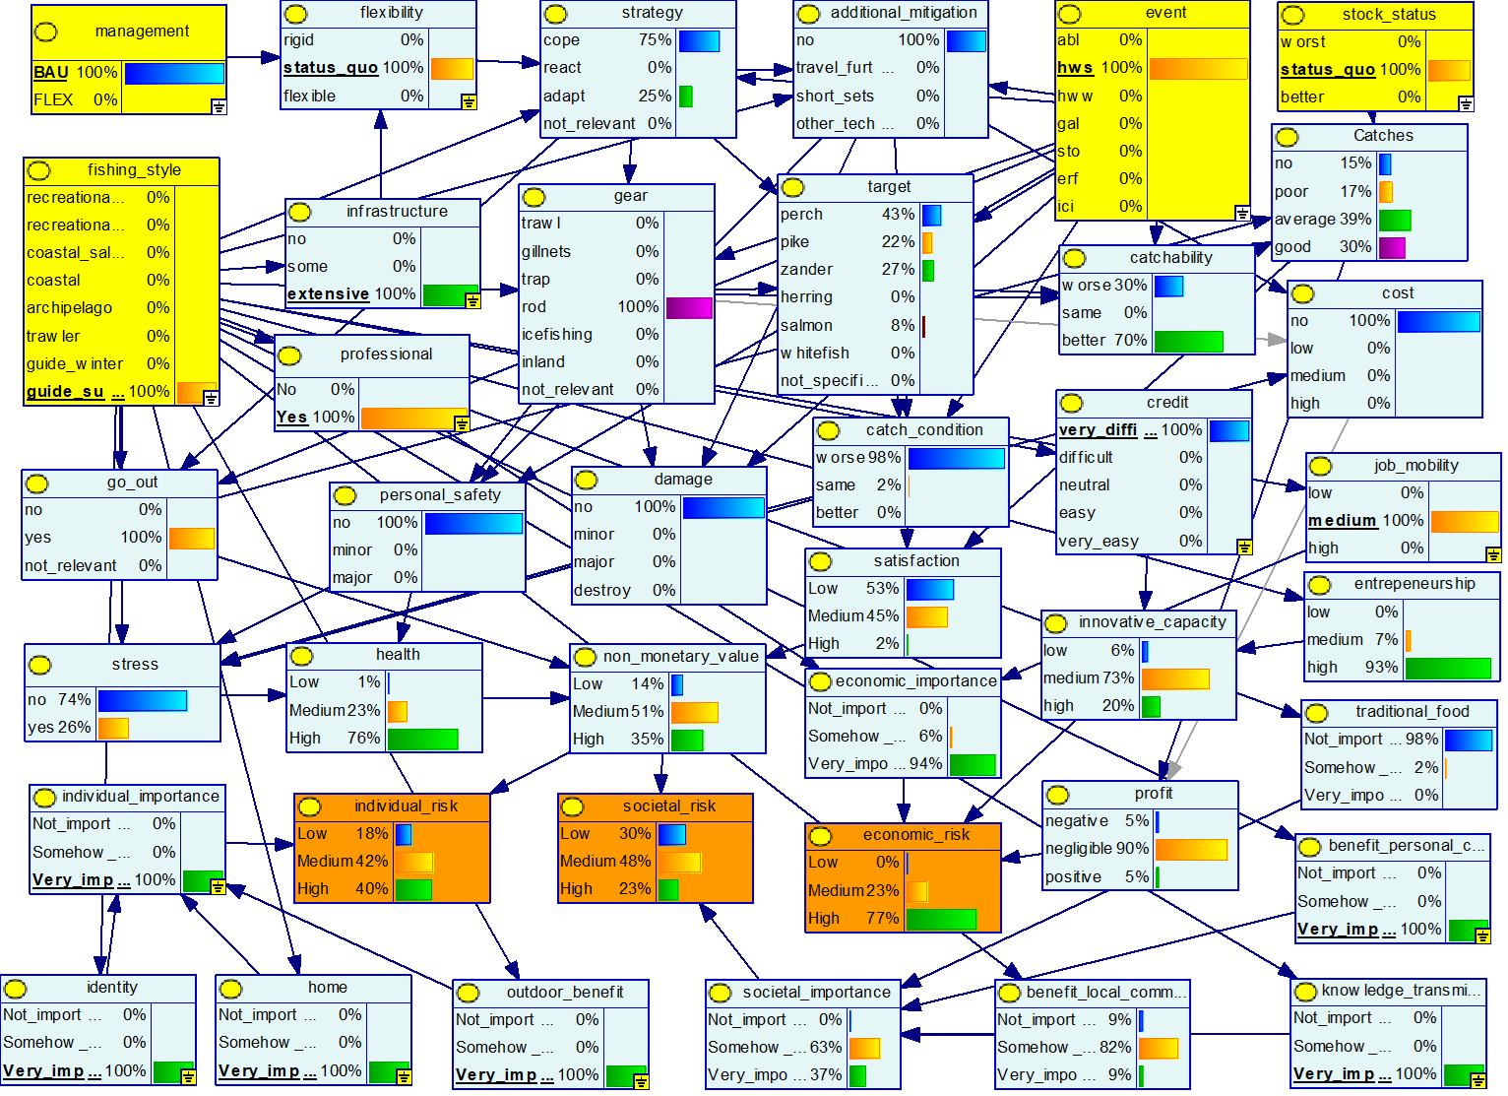
Figure 4: Bayesian Network after cycle 3. The probability distribution shown represents the evidences of fishing guide, summer heatwave, BAU management and status_quo stock status.

4.3 Scenario Testing

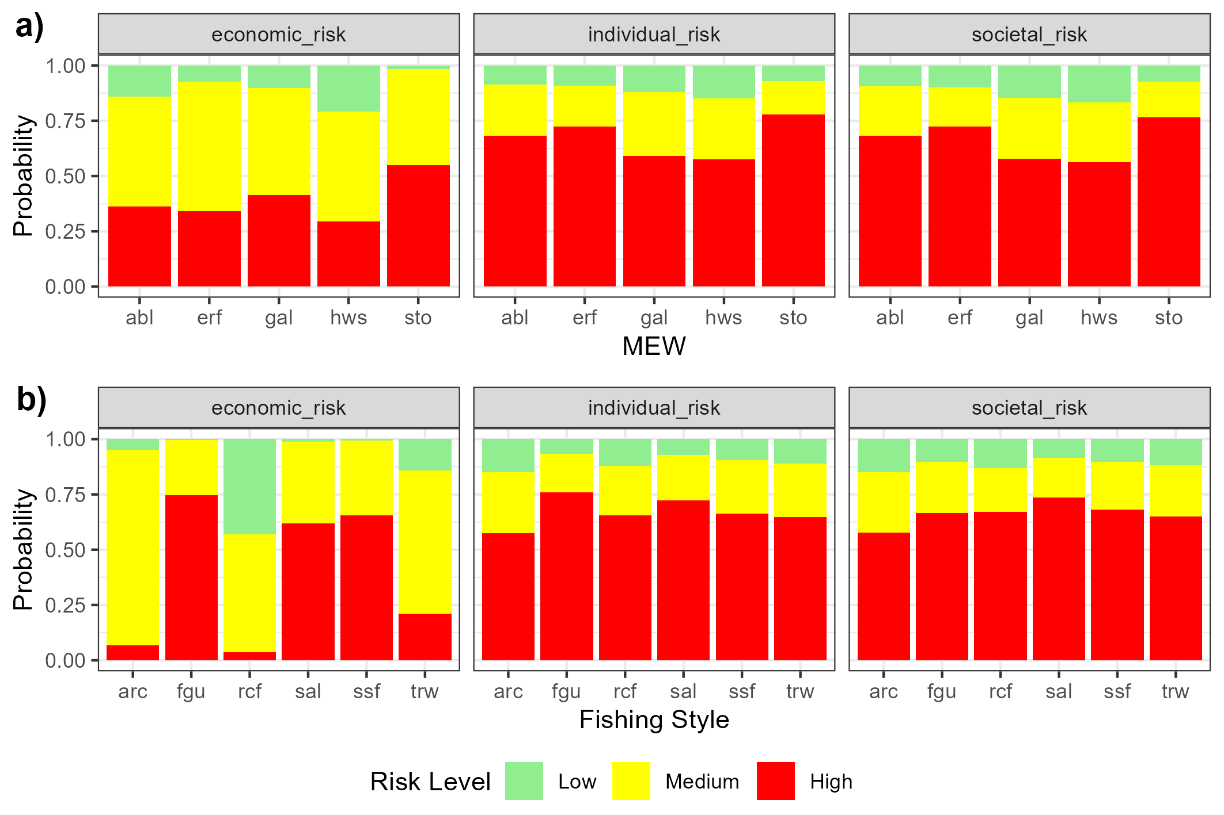
Figure 1: results of scenarios 1 and 2 showing the probability distribution of the utility nodes “economic risk”, “societal risk” and “economic risk”. Columns in a) represents the MEW algal bloom (abl), extreme rainfall (erf), gale (gal), summer heatwave (hws), storm (sto). Columns in b) represents the fishing styles Archipelago (arc), fishing guide (gui), recreational fisher (rcf), coastal salmon fisher (sal); coastal small-scale fisher (ssf), pelagic trawler (trw).
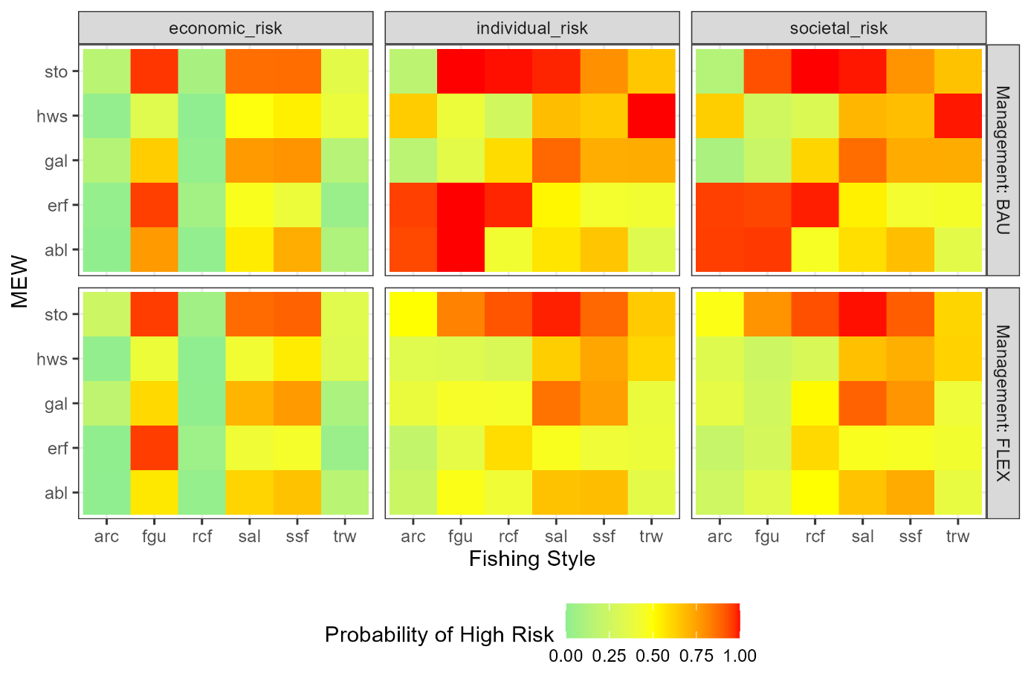
Figure 2: results of scenario 3 showing the probability that the utility nodes “economic risk”, “societal risk” and “economic risk” has state = High. The Y axis represents the MEW algal bloom (abl), extreme rainfall (erf), gale (gal), summer heatwave (hws), storm (sto). The X axis represents the fishing styles Archipelago (arc), fishing guide (gui), recreational fisher (rcf), coastal salmon fisher (sal); coastal small-scale fisher (ssf), pelagic trawler (trw). The panels represent the utility nodes and management options business as usual (BAU) and increased flexibility (FLEX).

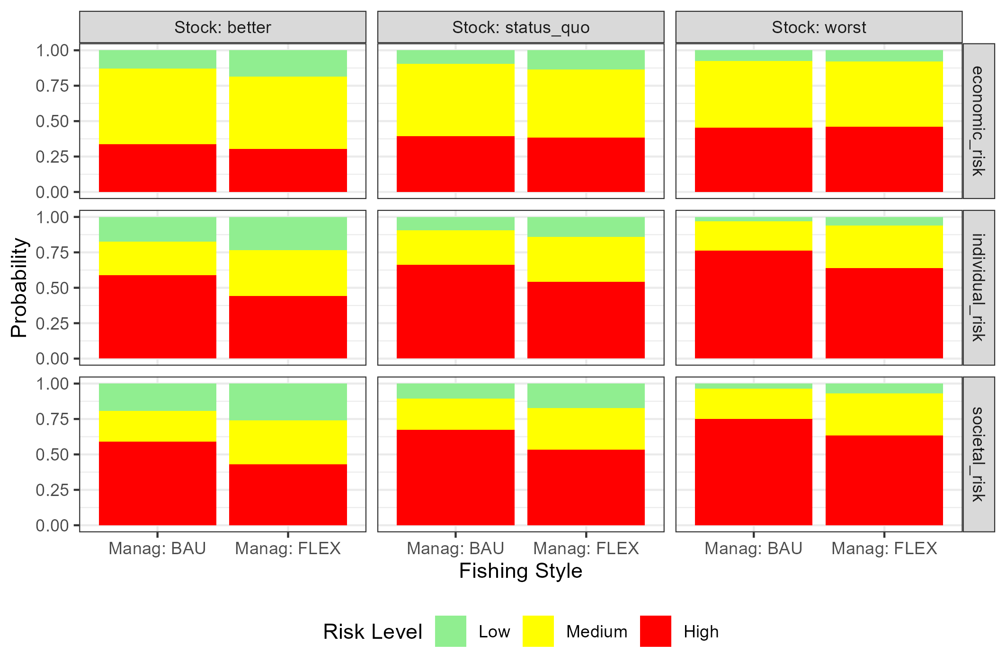
Figure 3: results of scenario 4 showing the probability distribution of the utility nodes “economic risk”, “societal risk” and “economic risk”. Columns represents management options business as usual (BAU) and increased flexibility (FLEX). The panels represent the utility nodes and stock status options improved conditions (better), business as usual (status quo) and worsened condition (worse).

- Discussion – 1500 max

Social complexity and capabilities of diverse fishing systems can shape their adaptive capacity (Harvey et al., 2025).
Drafting a social ecological risk assessment can give the foundation to base decision making on sience

- General: highlight the diversity in the results and eventual surprising things

- Technicalities: he second run of interview serve to express many more details;

- Limitations: there is no loop (Harvey et al., 2025)

- Novelties:

- Uses:

- Conclusion – 500 max

It is not surprising that the values at risk from extreme weather differ between sectors, as the drivers and motives behind the different forms of fishing are quite diverse. For commercial operators (pelagic and small-scale coastal fishermen and fishing guides), it is economic values that are at risk from extreme weather. Whereas pelagic fishing seems to focus solely on economic values, both small-scale coastal fishermen and fishing guides highlight lifestyle, experience and cultural values as the most significant aspects of their activities and thus the values that are possibly most affected by extreme weather. For recreational and subsistence fishermen, the focus is exclusively on non-monetary values linked to experiences and the opportunity to spend time and work in the archipelago. The most shared non-monetary value was regarding the stressful condition that extreme event can pose. It is possible that fishing operators can invest in their activities to reduce the economic losses that extreme weather can cause, but it is likely much more difficult, if not impossible, to invest away the risks to non-monetary values associated with fishing, especially if they are deeply rooted in traditions and experiences.
In summary, the dialogues with the various sectors of the fishing industry have shown that the impact of extreme weather on their activities can vary considerably, but that the impact is not particularly significant under current weather conditions. What is more crucial for fishing today is the current management and status of ecosystems and fish stocks, i.e. whether there are fish available to catch. However, if the frequency of extreme weather events increases and the various forms of extreme weather occur simultaneously to a greater extent, the impact on fishing as an activity may become greater. A key to the resilience of the fishing sector to extreme weather is flexible and diversified operations where fishermen have the opportunity to move freely between and utilise different fishing grounds, and where there are opportunities and conditions to supplement their income from secondary activities. It is also crucial that without functioning ecosystems with strong fish stocks and responsive and adaptive management of marine ecosystem services, the prospects for fisheries to withstand and adapt to extreme weather at sea are slim.

References
Björkvik, E., Boonstra, W., & Hentati-Sundberg, J. (2020). Why fishers end up in social-ecological traps: A case study of Swedish eel fisheries in the Baltic Sea. Ecology and Society, 25(1). https://doi.org/10.5751/ES-11405-250121
Björkvik, E., Boonstra, W. J., Hentati-Sundberg, J., & Österblom, H. (2020). Swedish Small-Scale Fisheries in the Baltic Sea: Decline, Diversity and Development. In Small-Scale Fisheries in Europe: Status, Resilience and Governance (Vol. 23, pp. 559–580).
Boonstra, W. J., & Hentati-Sundberg, J. (2016). Classifying fishers’ behaviour. An invitation to fishing styles. Fish and Fisheries, 17(1), 78–100. https://doi.org/10.1111/faf.12092
Cinner, J. E., McClanahan, T. R., Graham, N. A. J., Daw, T. M., Maina, J., Stead, S. M., Wamukota, A., Brown, K., & Bodin, Ö. (2012). Vulnerability of coastal communities to key impacts of climate change on coral reef fisheries. Global Environmental Change, 22(1), 12–20. https://doi.org/10.1016/j.gloenvcha.2011.09.018
Collins, S. L., Carpenter, S. R., Swinton, S. M., Orenstein, D. E., Childers, D. L., Gragson, T. L., Grimm, N. B., Grove, J. M., Harlan, S. L., Kaye, J. P., Knapp, A. K., Kofinas, G. P., Magnuson, J. J., McDowell, W. H., Melack, J. M., Ogden, L. A., Robertson, G. P., Smith, M. D., & Whitmer, A. C. (2011). An integrated conceptual framework for long-term social–ecological research. Frontiers in Ecology and the Environment, 9(6), 351–357. https://doi.org/10.1890/100068
Cormier, R., Kannen, A., Elliott, M., Hall, P., & Davies, I. M. (2013). Marine and coastal ecosystem-based risk management handbook [Report]. ICES Cooperative Research Reports (CRR). https://doi.org/10.17895/ices.pub.5486
Crosman, K. M., Petrou, E. L., Rudd, M. B., & Tillotson, M. D. (2019). Clam hunger and the changing ocean: Characterizing social and ecological risks to the Quinault razor clam fishery using participatory modeling. Ecology and Society, 24(2), art16. https://doi.org/10.5751/ES-10928-240216
de Carvalho, D. A., Amaral, S., & Alves, L. M. (2023). Climate change adaptation frameworks in fishing communities: A systematic review. Ocean & Coastal Management, 243, 106754. https://doi.org/10.1016/j.ocecoaman.2023.106754
Dudley, P. N., Rogers, T. L., Morales, M. M., Stoltz, A. D., Sheridan, C. J., Beulke, A. K., Pomeroy, C., & Carr, M. H. (2021). A More Comprehensive Climate Vulnerability Assessment Framework for Fisheries Social-Ecological Systems. Frontiers in Marine Science, 8. https://doi.org/10.3389/fmars.2021.678099
Duespohl, M., Frank, S., & Doell, P. (2012). A Review of Bayesian Networks as a Participatory Modeling Approach in Support of Sustainable Environmental Management. Journal of Sustainable Development, 5(12), p1. https://doi.org/10.5539/jsd.v5n12p1
Ekstrom, J. A., Suatoni, L., Cooley, S. R., Pendleton, L. H., Waldbusser, G. G., Cinner, J. E., Ritter, J., Langdon, C., van Hooidonk, R., Gledhill, D., Wellman, K., Beck, M. W., Brander, L. M., Rittschof, D., Doherty, C., Edwards, P. E. T., & Portela, R. (2015). Vulnerability and adaptation of US shellfisheries to ocean acidification. Nature Climate Change, 5(3), 207–214. https://doi.org/10.1038/nclimate2508
Eurich, J. G., Friedman, W. R., Kleisner, K. M., Zhao, L. Z., Free, C. M., Fletcher, M., Mason, J. G., Tokunaga, K., Aguion, A., Dell’Apa, A., Dickey-Collas, M., Fujita, R., Golden, C. D., Hollowed, A. B., Ishimura, G., Karr, K. A., Kasperski, S., Kisara, Y., Lau, J. D., … Mills, K. E. (2024). Diverse pathways for climate resilience in marine fishery systems. Fish and Fisheries, 25(1), 38–59. https://doi.org/10.1111/faf.12790
Farthing, M. W., Mann-Lang, J., Childs, A. R., Bova, C. S., Bower, S. D., Pinder, A. C., Ferter, K., Winkler, A. C., Butler, E. C., Brownscombe, J. W., Danylchuk, A. J., & Potts, W. M. (2022). Assessment of fishing guide knowledge, attitudes, and behaviours in global recreational fisheries. Fisheries Research, 255, 106453. https://doi.org/10.1016/j.fishres.2022.106453
Fenton, N. E., & Neil, M. (2019). Risk assessment and decision analysis with Bayesian networks (Second edition). CRC Press, Taylor & Francis Group.
Fenton, N. E., Neil, M., & Caballero, J. G. (2007). Using Ranked Nodes to Model Qualitative Judgments in Bayesian Networks. IEEE Transactions on Knowledge and Data Engineering, 19(10), 1420–1432. https://doi.org/10.1109/TKDE.2007.1073
Free, C. M., Anderson, S. C., Hellmers, E. A., Muhling, B. A., Navarro, M. O., Richerson, K., Rogers, L. A., Satterthwaite, W. H., Thompson, A. R., Burt, J. M., Gaines, S. D., Marshall, K. N., White, J. W., & Bellquist, L. F. (2023). Impact of the 2014–2016 marine heatwave on US and Canada West Coast fisheries: Surprises and lessons from key case studies. Fish and Fisheries, 24(4), 652–674. https://doi.org/10.1111/faf.12753
Garavito-Bermúdez, D., & and Boonstra, W. J. (2023). Knowing through fishing: Exploring the connection between fishers’ ecological knowledge and fishing styles. Journal of Environmental Planning and Management, 66(9), 1841–1860. https://doi.org/10.1080/09640568.2022.2043257
Gomes, D. G. E., Ruzicka, J. J., Crozier, L. G., Huff, D. D., Brodeur, R. D., & Stewart, J. D. (2024). Marine heatwaves disrupt ecosystem structure and function via altered food webs and energy flux. Nature Communications, 15(1), 1988. https://doi.org/10.1038/s41467-024-46263-2
Green, K. M., Selgrath, J. C., Frawley, T. H., Oestreich, W. K., Mansfield, E. J., Urteaga, J., Swanson, S. S., Santana, F. N., Green, S. J., Naggea, J., & Crowder, L. B. (2021). How adaptive capacity shapes the Adapt, React, Cope response to climate impacts: Insights from small-scale fisheries. Climatic Change, 164(1), 15. https://doi.org/10.1007/s10584-021-02965-w
Guibourd de Luzinais, V., Gascuel, D., Reygondeau, G., & Cheung, W. W. L. (2024). Large potential impacts of marine heatwaves on ecosystem functioning. Global Change Biology, 30(7), e17437. https://doi.org/10.1111/gcb.17437
Harvey, C. J., Clay, P. M., Selden, R., Moore, S. K., Andrews, K. S., deReynier, Y. L., Beaudreau, A. H., Liu, O. R., Norman, K. C., Samhouri, J. F., Bellquist, L., Burden, M., Colburn, L. L., Haltuch, M. A., Harley, A., Kaplan, I. C., Kasperski, S., Klajbor, W., Lewis-Smith, C., … Wise, S. (2025). Embracing social-ecological system complexity to promote climate-ready fisheries. Reviews in Fish Biology and Fisheries, 35(2), 633–658. https://doi.org/10.1007/s11160-025-09926-x
Hodgson, E. E., Essington, T. E., Samhouri, J. F., Allison, E. H., Bennett, N. J., Bostrom, A., Cullen, A. C., Kasperski, S., Levin, P. S., & Poe, M. R. (2019). Integrated Risk Assessment for the Blue Economy. Frontiers in Marine Science, 6. https://doi.org/10.3389/fmars.2019.00609
Jentoft, S., & Chuenpagdee, R. (2019). The Quest for Transdisciplinarity in Small-Scale Fisheries Governance. In R. Chuenpagdee & S. Jentoft (Eds), Transdisciplinarity for Small-Scale Fisheries Governance: Analysis and Practice (pp. 3–14). Springer International Publishing. https://doi.org/10.1007/978-3-319-94938-3_1
Korb, K. B., & Nicholson, A. E. (2011). Bayesian Artificial Intelligence.
Kruse, M., Letschert, J., Cormier, R., Rambo, H., Gee, K., Kannen, A., Schaper, J., Möllmann, C., & Stelzenmüller, V. (2024). Operationalizing a fisheries social-ecological system through a Bayesian belief network reveals hotspots for its adaptive capacity in the southern North sea. Journal of Environmental Management, 357, 120685. https://doi.org/10.1016/j.jenvman.2024.120685
Laitila, P., & and Virtanen, K. (2022). Advancing construction of conditional probability tables of Bayesian networks with ranked nodes method. International Journal of General Systems, 51(8), 758–790. https://doi.org/10.1080/03081079.2022.2086541
Li, Y., Sun, M., Yang, X., Yang, M., Kleisner, K. M., Mills, K. E., Tang, Y., Du, F., Qiu, Y., Ren, Y., & Chen, Y. (2024). Social–ecological vulnerability and risk of China’s marine capture fisheries to climate change. Proceedings of the National Academy of Sciences, 121(1), e2313773120. https://doi.org/10.1073/pnas.2313773120
Marshall, N. A., Tobin, R. C., Marshall, P. A., Gooch, M., & Hobday, A. J. (2013). Social Vulnerability of Marine Resource Users to Extreme Weather Events. Ecosystems, 16(5), 797–809. https://doi.org/10.1007/s10021-013-9651-6
Moore, S. K., Broadwater, M., Cha, C., Dortch, Q., Harvey, C. J., Norman, K. C., Pearce, J., Pomeroy, C., & Samhouri, J. F. (2024). Exploring the human dimensions of harmful algal blooms through a well-being framework to increase resilience in a changing world. PLOS Climate, 3(5), e0000411. https://doi.org/10.1371/journal.pclm.0000411
Norr, H., Olsson, E., Lovén, E., & Rohlin, L. (2018). Fiskeförvaltning och mervärden i S:t Annas, Gryts och Tjusts skärgård. In Det småskaliga kustfiskets förändrade förutsättningar och mervärden.
Pihlajamäki, M., Helle, I., Haapasaari, P., Sarkki, S., Kuikka, S., & Lehikoinen, A. (2020). Catching the future: Applying Bayesian belief networks to exploratory scenario storylines to assess long-term changes in Baltic herring (Clupea harengus membras, Clupeidae) and salmon (Salmo salar, Salmonidae) fisheries. Fish and Fisheries, 21(4), 797–812. https://doi.org/10.1111/faf.12461
Rådberg, B., Karlsson, L., & Lindberg, M. (2018). Det kustnära fisket i Hållnäs – utmaningar och mervärden. In Det småskaliga kustfiskets förändrade förutsättningar och mervärden (pp. 31–40). SLU. https://pub.epsilon.slu.se/15885/7/sandstrom_e_190208.pdf
Restrepo-Gómez, D. C., Zetina-Rejón, M. J., & Zepeda-Domínguez, J. A. (2022). Trends in marine fisheries social-ecological systems studies. Ocean & Coastal Management, 220, 106076. https://doi.org/10.1016/j.ocecoaman.2022.106076
Ritzman, J., Brodbeck, A., Brostrom, S., McGrew, S., Dreyer, S., Klinger, T., & Moore, S. K. (2018). Economic and sociocultural impacts of fisheries closures in two fishing-dependent communities following the massive 2015 U.S. West Coast harmful algal bloom. Harmful Algae, 80, 35–45. https://doi.org/10.1016/j.hal.2018.09.002
Roux, M.-J., Duplisea, D. E., Hunter, K. L., & Rice, J. (2022). Consistent Risk Management in a Changing World: Risk Equivalence in Fisheries and Other Human Activities Affecting Marine Resources and Ecosystems. Frontiers in Climate, 3. https://doi.org/10.3389/fclim.2021.781559
Salmi, P., Arias-Schreiber, M., & Svels, K. (2023). Societal Transformations and Governance Challenges of Coastal Small-Scale Fisheries in the Northern Baltic Sea. In S. Partelow, M. Hadjimichael, & A.-K. Hornidge (Eds), Ocean Governance: Knowledge Systems, Policy Foundations and Thematic Analyses (pp. 295–317). Springer International Publishing. https://doi.org/10.1007/978-3-031-20740-2_13
Schlüter, M., Wijermans, N., González-Mon, B., Lindkvist, E., Orach, K., Prawitz, H., Martin, R., Martínez-Peña, R., Pellowe, K. E., & Sanga, U. (2025). Navigating the space between empirics and theory – Empirically stylized modelling for theorising social-ecological phenomena. Environmental Modelling & Software, 189, 106444. https://doi.org/10.1016/j.envsoft.2025.106444
Scutari, M., & Denis, J.-B. (2021). Bayesian Networks: With Examples in R (2nd edn). Chapman and Hall/CRC. https://doi.org/10.1201/9780429347436
Stelzenmüller, V., Coll, M., Mazaris, A. D., Giakoumi, S., Katsanevakis, S., Portman, M. E., Degen, R., Mackelworth, P., Gimpel, A., Albano, P. G., Almpanidou, V., Claudet, J., Essl, F., Evagelopoulos, T., Heymans, J. J., Genov, T., Kark, S., Micheli, F., Pennino, M. G., … Ojaveer, H. (2018). A risk-based approach to cumulative effect assessments for marine management. Science of The Total Environment, 612, 1132–1140. https://doi.org/10.1016/j.scitotenv.2017.08.289
Stelzenmüller, V., Letschert, J., Blanz, B., Blöcker, A. M., Claudet, J., Cormier, R., Gee, K., Held, H., Kannen, A., Kruse, M., Rambo, H., Schaper, J., Sguotti, C., Stollberg, N., Quiroga, E., & Möllmann, C. (2024). Exploring the adaptive capacity of a fisheries social-ecological system to global change. Ocean & Coastal Management, 258, 107391. https://doi.org/10.1016/j.ocecoaman.2024.107391
Uusitalo, L., Puntila-Dodd, R., Artell, J., & Jernberg, S. (2023). Modelling framework to evaluate societal effects of ecosystem management. Science of The Total Environment, 898, 165508. https://doi.org/10.1016/j.scitotenv.2023.165508
Wabnitz, C. C. C., Lam, V. W. Y., Reygondeau, G., Teh, L. C. L., Al-Abdulrazzak, D., Khalfallah, M., Pauly, D., Palomares, M. L. D., Zeller, D., & Cheung, W. W. L. (2018). Climate change impacts on marine biodiversity, fisheries and society in the Arabian Gulf. PLOS ONE, 13(5), e0194537. https://doi.org/10.1371/journal.pone.0194537
Wijermans, N., Boonstra, W. J., Orach, K., Hentati-Sundberg, J., & Schlüter, M. (2020). Behavioural diversity in fishing—Towards a next generation of fishery models. Fish and Fisheries, 21(5), 872–890. https://doi.org/10.1111/faf.12466

