Disclaimer
I strongly invite you not to use LLMS (chatGPT or so) for this task. Please do not make me read code generated, or even just polished by a bot, it would be a missed opportunity for you to learn how to approach a problem and how to code it (that means, to be really able to solve it). I look forward to seeing how much you learn in the class, what has been clear and what has not been clear.

Assignment 4 (Deadline 10. December 23:59)
TOPIC 1: Unsupervised learning: Clustering the Milky Way
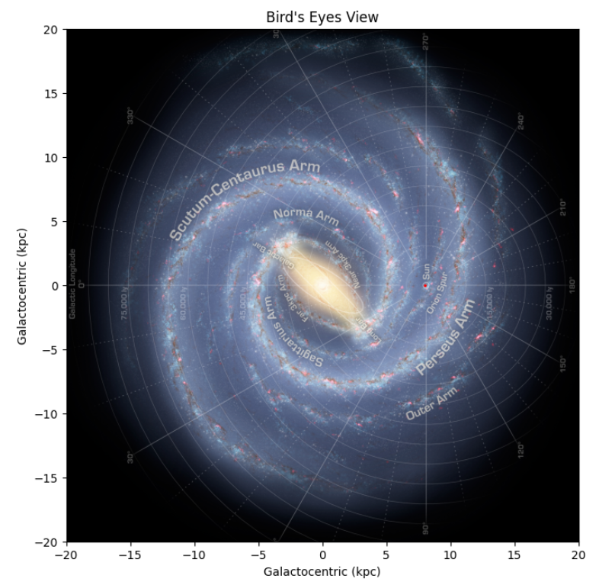
Task 1: Reproduce the image of the milky way via MWSkyMap (see attached code). [5]
Task 2: Generate a visualization of the milky way sector starting in center "M31" with radius=(8000, 8000) * lightyear . [5]
Task 3: Convert the image generated into a rgb np.array (each pixes will be a list of 3 number, Red, Green, Blue (rbg). [5]
Task 4: Generate some category from the task 3 data [5]
Task 5: Use K-NN (Nearest neighbor, not discussed in class but extremely simple) or K-means to cluster the data [5]
Task 6: over-impose your cluster to the image generate in task 2
Task 7: try different category (task 4), repeating tasks 5 and 6, and provide an explanation of your results. What can we learn from a unsupervised model of our galaxy?

TOPIC 2: Supervised learning: Machines versus human models to predict epidemics?!?
Task 1: Reproduce the project 2 exercise 5 plots for Ebola epidemic in West Africa (data points and model). If you are not confident from previous results, ask the TAs for the correct solution [5]
Task 2: Train a line with linear regression on the data for the three countries. [5]
Task 3: Train a better fitting function than a single line with linear regression on the data for the three countries. [5]
Task 4: Train a NN (LSTM) network and predict the epidemic evolution. [10]
Task 5: Discuss the results. Can we ignore modeling and let Machine Leaning make prediction? What are your conclusions? [20]

Deliverable:
Please put all the functions (and classes) you have generated in a .py file.
In a jupyter notebook, instead, import and use your functions (and classes) to calculate the desired results.
In the notebook, provide a short introduction in which you outline the nature of the problem(s) to be investigated.
End your notebook with a brief summary of what you feel you learned from the project (if anything). Also, if you have any general comments or suggestions for what could be improved in future assignments, this is the place to do it.
Your notebook has to be working.
Any figures you include should be easily understandable. You should label axes appropriately, and depending on the problem, include other legends etc. Also, you should discuss your figures in the main text.
It is always good if you can reflect a little bit around why you see what you see.

Delivery method:
Git: you should already have your repo. Make a new folder for project 4 and push it.
In the jupyter notebook, use TOPIC 1: task 1, task 2, etc to give the answer to each point using Markdown syntax. Please use, for each task, one cell to help us going over your work.

How will this project be graded:
x points available. Each question has a number of points available indicated in [].
Your final score = total points accumulated + quality_factor * bonus points
quality_factor = total points accumulated/max point available
If AI is used the quality factor will be equal to zero. If AI is used and not stated, it is considered cheating and the project will be given 0 points.
A grade for the assignment between A and F will be given.

Bonus points:
Use pylint on your function file. Pylint gives a score from 0 to 10. That will be your bonus points that will be applied.
Up to 5 extra points for proper use of assert statements in your code.
1 extra point for each function that tests if your code works correctly (max 5 points).
The shorter the jupyter notebook in terms of number of lines, the more bonus points you will get (Up to 5 points). Comments and assert statements do not count in the line numbers.
For each day earlier that you deliver, you will get one extra points. For each day of delay, -10. Be strategic about this.

Group work:
Groups of 3 are suggested. If you do not have a group, you will be assigned one. If you are unsatisfied with your group, we can help you to find another one, but we need to be informed within 48hrs from the start of the present project.

Other Requirements
A statement on the eventual usage of AI has to be included.
A statement reporting the Individual contributions has to be written.

