A Meta-Review of Meta-Analyses on Cognitive Performance in ADHD and Developmental Dyslexia

Enrico Toffalini¹, Laura Sità¹, Sayedeh Mohaddeseh Badri¹, Valentina Tobia2
¹ Department of General Psychology, University of Padua, Italy
² University Vita-Salute San Raffaele, Milan, Italy

Author Note
Whis work was supported by Project 2022KBW99S “Tails or types? Testing the dimensional hypothesis in neurodevelopmental disorders”, funded by Next Generation EU, Mission 4, Component 1, CUP C53D23004210006
The preregistered protocol is available at: https://osf.io/fxzgy/
Data, code, and materials used in this meta-review are available in the GitHub repository: https://github.com/EnricoToffalini/Meta-review-cognitive-profiles-ADHD-Dyslexia , and are publicly archived on OSF: https://doi.org/10.17605/OSF.IO/QEWCH
Correspondence concerning this article should be addressed to Enrico Toffalini, Department of General Psychology, University of Padua, Via Venezia, 8, 35131, Padua, Italy. Email: enrico.toffalini@unipd.it

Abstract
Attention-deficit/hyperactivity disorder (ADHD) and developmental dyslexia are often discussed in terms of disorder-specific cognitive deficits, yet both conditions can be more parsimoniously interpreted as extremes on continuous, correlated traits. We conducted a meta-review of published quantitative meta-analyses to map cognitive performance differences in ADHD and dyslexia across broad cognitive domains within a dimensional and transdiagnostic framework. Searches of PubMed, PsycINFO, Scopus, and Web of Science identified 1,457 records; 49 additional records were assembled from supplementary methods. After screening, 87 meta-analyses met inclusion criteria (1998–2025). From these, 591 pooled estimates were extracted and coded using a consistent direction (negative values indicate worse performance in the clinical group); 523 pooled estimates were retained after prespecified effect-level exclusions. Results were organised into domain-based evidence maps, with domain-level overlays obtained using multilevel summaries to reduce over-representation of meta-analyses reporting many closely related outcomes; these overlays are treated as descriptive, not as higher-order pooled estimates, given overlap of primary studies and construct heterogeneity. Across both disorders, cognitive differences were predominantly negative and broadly distributed. In ADHD, small-to-moderate negative differences were observed across attention, executive functions, working memory, processing speed, and related domains (including timing/decision-related measures), with no single domain or executive subcomponent emerging as uniquely dominant. In dyslexia, larger negative differences were most prominent in reading-proximal domains, particularly phonological processing and rapid automatized naming, embedded within broader negative differences across working memory, attention-related measures, processing speed, and general cognition. Overall, the meta-analytic literature is more compatible with graded, multivariate shifts with relative prominences than with sharply selective, disorder-specific cognitive signatures.
Keywords: attention-deficit/hyperactivity disorder; developmental dyslexia; cognition; meta-review; dimensional model

A Meta-Review of Meta-Analyses on Cognitive Performance in ADHD and Developmental Dyslexia
ADHD and developmental dyslexia are among the most frequently studied neurodevelopmental conditions, and both are associated, on average, with measurable differences in cognitive performance across development. At the same time, categorical diagnostic practice is well known to face scientific challenges, including high co-occurrence, substantial within-diagnosis heterogeneity, and boundaries that are partly conventional rather than biologically privileged (Coghill & Sonuga-Barke, 2012; Astle et al., 2022). These features make it difficult to interpret case-control differences as evidence for disorder-specific cognitive mechanisms, especially when effects are modest, and measurement is noisy.
The cognitive literature has therefore produced many partially overlapping narratives, often organized around “core deficit” proposals, for example executive dysfunction in ADHD or phonological deficits in dyslexia. While these hypotheses have been empirically productive, they have also encouraged a construct-by-construct research culture, where conceptual conclusions are sometimes broader than what any single task family or meta-analysis can sustain (Pennington, 2006). The practical result is a meta-analytic landscape that is increasingly extensive but compartmentalized, with many domain-specific syntheses and relatively limited integration across domains and disorders.
A Dimensional and Transdiagnostic Framework
This report adopts a dimensional and transdiagnostic framework. Under this view, ADHD and dyslexia are treated as extremes of continuous, correlated traits, rather than as natural categories with qualitatively distinct cognitive signatures (Coghill & Sonuga-Barke, 2012; Astle et al., 2022). Two background constraints make this stance theoretically plausible and methodologically useful.
First, polygenicity suggests that behavioral and cognitive traits are influenced by many genetic variants of very small effect, which makes single-cause explanations unlikely in most typical samples (Chabris et al., 2015). Second, pleiotropy and “generalist genes” arguments imply that many genetic influences are shared across cognitive domains and learning-related outcomes, limiting the extent to which sharp cognitive specificity should be expected (Kovas & Plomin, 2006; Plomin & Deary, 2015). Within this framework, the absence of a single dominant deficit is not treated as a failure of theory, but as an anticipated pattern when outcomes reflect broad, correlated liabilities rather than modular impairments.
Consistent with this reasoning, classic psychometric and epidemiological arguments in reading have long suggested that dyslexia reflect the lower tail of a continuous distribution of reading skill, with diagnostic cutoffs functioning primarily as pragmatic thresholds (Rodgers, 1983; Shaywitz et al., 1992; Peterson & Pennington, 2015). Analogous dimensional arguments have also been advanced for childhood psychiatric phenotypes more broadly, including ADHD, and have motivated proposals to soften strict adherence to categorical nosology in favor of dimensional descriptions (Coghill & Sonuga-Barke, 2012; Astle et al., 2022).
Throughout this report, latent cognitive constructs such as executive functions, working memory, or general cognitive ability are treated pragmatically, as useful summaries of performance covariance rather than as ontological entities. This is important because task impurity and construct overlap can make apparent “specificity” contingent on measurement choices, selection rules, and covariate adjustments (Pennington, 2006).
A Meta-Review of Meta-Analyses
Quantitative meta-analyses are central to this literature because they synthesize large corpora of case-control findings and quantify heterogeneity. However, individual meta-analyses typically target specific task families or narrow constructs. The volume of published meta-analyses is now large enough that a second-order synthesis is warranted, not to re-estimate population parameters, but to clarify broad regularities, relative magnitudes across domains, and the degree of convergence versus dispersion in reported effects.

A meta-review can address questions that are difficult to answer from single-domain meta-analyses, including: whether cognitive differences appear broad or sharply concentrated, how similar the overall profiles are across ADHD and dyslexia, and whether prominent effects align more with diagnostic definitions and selection practices than with uniquely informative mechanisms (Pennington, 2006). This is especially relevant in dyslexia research, where many meta-analyses implement IQ-based selection or covariate control, a practice that can, by design, accentuate apparent domain specificity by removing shared variance with general cognition (Peterson & Pennington, 2015).
The present meta-review synthesizes published quantitative meta-analyses on cognitive characteristics associated with ADHD and developmental dyslexia. The project was preregistered, and the original protocol framed the meta-review as one component of a broader program oriented toward dimensional versus categorical interpretations. During the review process, the number of eligible meta-analyses substantially exceeded expectations, motivating a reorientation toward reporting the meta-review as a standalone contribution, with an explicit emphasis on structured description and cautious interpretation.
Accordingly, the report has three objectives: i) to summarize the direction and approximate magnitude of cognitive differences reported across published meta-analyses for ADHD and dyslexia; ii) to characterize breadth versus relative prominence across cognitive domains, without assuming singular or “core” deficits unless consistently supported; iii) to interpret the overall pattern under a dimensional and transdiagnostic framework, explicitly considering heterogeneity, construct overlap, and dependence between evidence streams.
Where cross-meta-analytic summaries or displays combine results across meta-analyses, these are used descriptively and heuristically, to make broad patterns visible. They are not treated as formal higher-order meta-analytic inference, because assumptions such as statistical independence and construct homogeneity are frequently violated when multiple meta-analyses draw on overlapping primary studies and partially overlapping constructs.

Method
Protocol and Reporting
The protocol for this meta-review was preregistered prior to data extraction (see preregistration document). The preregistration specified the conceptual framework, eligibility criteria, search strategy, screening procedures, and data extraction plan. Reporting was guided by the PRISMA 2020 statement, adapted where necessary to the specific context of a meta-review of published quantitative meta-analyses (Page et al., 2021).
The preregistered project originally framed the meta-review as part of a broader program aimed at evaluating dimensional versus categorical interpretations using taxometric-like reasoning. During the review process, the number of eligible meta-analyses substantially exceeded expectations. For this reason, the meta-review is reported here as a standalone synthesis. This shift affected the organization and emphasis of the report, but did not change the preregistered eligibility criteria, screening criteria, or data extraction rules.
Eligibility Criteria
Eligible articles were quantitative meta-analyses, or systematic reviews including at least one quantitative meta-analysis, that examined cognitive characteristics associated with ADHD and/or developmental dyslexia. Studies were included if they met all of the following criteria: i) Study type: quantitative meta-analysis (pooled effect sizes synthesizing multiple primary studies); ii) Target condition: ADHD and/or developmental dyslexia (explicitly analyzed); iii) Outcomes: at least one cognitive or neuropsychological domain (e.g., attention, executive functions, working memory, processing speed, phonological processing, rapid automatized naming, reading-related cognition, or related constructs); iv) Analytical framework: either (a) a categorical case-control contrast comparing ADHD/dyslexia groups to neurotypical controls, or (b) a dimensional synthesis relating continuous ADHD or reading-related traits to cognitive outcomes in broadly sampled datasets.
Studies were excluded if they: i) Focused on intervention or treatment effects (e.g., medication, training, rehabilitation, therapy); ii) Focused only on prevalence, diagnostic criteria, or symptoms without cognitive outcomes; iii) Used exclusively non-neurotypical comparators or clinical-only contrasts (unless separable eligible neurotypical comparisons were reported); iv) Relied exclusively on reading-level matched comparisons in a way that removed the neurotypical contrast relevant to the target inference.
Although dimensional associations were eligible in principle, the final corpus of extracted pooled effects consisted exclusively of categorical case-control comparisons, as no dimensional meta-analytic associations emerged among eligible effects.

Search Strategy and Study Identification
A broad database search was conducted in PubMed, PsycINFO, Scopus, and Web of Science. No publication date restrictions were applied. The preregistered search string combined disorder terms, cognitive-domain terms, and meta-analytic methodology terms, and it excluded intervention-related terms. The search string was refined iteratively to balance coverage and specificity, consistent with the preregistration. The full search syntax is provided in the preregistration and supplementary materials.
Records were imported into a reference management system (Zotero was used in practice) to manage references and remove duplicates. In addition to database searching, reference lists of relevant reviews were inspected to identify additional eligible meta-analyses. Although the preregistered framing emphasized children, the preregistered search strategy was not age-restricted. Therefore, eligible meta-analyses across the lifespan were retained, and age group was coded descriptively rather than used as an exclusion criterion.
Another series of targeted searches were conducted (both before and after the main search) involving Google Scholar, citation searches, database searches, and personal knowledge of relevant articles, in an unsystematic way. These results were assembled and reused under the “identification of studies via supplementary search and other methods” branch of the PRISMA flowchart. Some of them were found to be redundant with the main analysis or were excluded for other reasons upon careful full-text eligibility check (e.g., did not actually contain meta-analytic estimates); the remaining were merged in the final review.
Screening and Selection Procedure
Screening proceeded in two stages, consistent with the preregistered plan and PRISMA logic: (1) title and abstract screening, followed by (2) full-text screening. At the title and abstract stage, records were excluded when clearly ineligible (e.g., not a meta-analysis, not ADHD/dyslexia, not cognitive outcomes, intervention-focused). Full-text screening assessed eligibility against the predefined inclusion and exclusion criteria, including confirmation that at least one quantitative pooled effect was reported.
Screening was supported by AI-assisted tools using protocol-bound prompts, under close human supervision. AI outputs were used to increase throughput and enforce consistency with preregistered decision rules, but final inclusion and exclusion decisions were reviewed and validated by the researchers. Reasons for exclusion at full text were recorded. A PRISMA flow diagram summarizes identification, screening, exclusions (with reasons), and inclusion.
AI-assisted screening was not specified in the preregistered workflow. It was introduced as a procedural aid under human oversight and without changing any eligibility rules.

Data Extraction and Coding
Data extraction followed a standardized coding scheme specified in the preregistration. The unit of extraction was one pooled meta-analytic estimate per row. When a meta-analysis reported multiple pooled effects (e.g., multiple domains, subdomains, tasks, or subgroup-specific estimates), each eligible pooled estimate was extracted as a separate row.
For each included meta-analysis, we extracted:
- bibliographic information (authors, year, journal),
- target disorder (ADHD, dyslexia, or both),
- age range and age group,
- cognitive outcome labels and their mapping to harmonized cognitive domains,
- effect size metric and pooled effect estimate,
- uncertainty information (standard error and/or confidence interval),
- number of primary studies contributing to each pooled effect (k) where available,
- heterogeneity indices where reported,
- publication-bias assessments and any adjusted estimates where reported,
- selected methodological features as per preregistration.
To facilitate cross-meta-analytic synthesis, cognitive outcomes were mapped into a hierarchical domain structure (broad domain, specific subdomain). Effect sizes were stored using a consistent sign convention so that negative values indicate worse performance in the clinical group relative to controls. When standard errors were not reported but 95% confidence intervals were reported on an approximately normal scale, standard errors were derived deterministically from the interval width, and flagged accordingly in the dataset.
In addition, we coded some objective methodological indicators from each included meta-analysis: whether a protocol was preregistered, whether search databases and search dates were reported, whether inclusion and exclusion criteria were explicit, the meta-analytic model type (random-effects, fixed-effect, or both), whether heterogeneity was reported and which metrics were provided, whether publication bias was assessed and which methods were used, and whether dependence handling was reported. These indicators were used descriptively to characterize the corpus and motivate caution in interpretation. They were not used to exclude studies post hoc or to weight results quantitatively.
Deviation from preregistration: Data extraction was supported by AI-assisted tools using protocol-bound prompts, with repeated checks and final human validation. As for the screening, this was not specified in the preregistered workflow. It was introduced as a procedural aid under human oversight without modifying the extraction criteria.
Synthesis Strategy
Synthesis was designed to summarize what the existing quantitative meta-analytic literature reports across disorders and cognitive domains, without conducting new meta-analyses of primary studies. The unit of evidence in this review is the pooled estimate reported by each included meta-analysis (e.g., standardized mean differences for case–control contrasts, or pooled associations where relevant), not the underlying primary-study effects. Results are organized by disorder and by a hierarchically coded domain structure (broad domains and, where relevant, subdomains), with an emphasis on direction and approximate magnitude, dispersion across meta-analyses, and the extent to which effects appear broadly distributed versus relatively more prominent in some domains.
All extracted pooled estimates were stored using a consistent sign convention such that negative values indicate worse performance in the clinical group relative to neurotypical controls (or an association compatible with higher symptom burden and poorer performance, where applicable). When standard errors were not directly reported but confidence intervals were available on an approximately normal scale, standard errors were derived deterministically from the interval width and flagged in the dataset. These steps were intended to standardize reporting and enable coherent cross-study visualization, not to re-estimate primary-study parameters.
To make cross-meta-analytic patterns visible, we used descriptive evidence maps that plot the full set of extracted pooled estimates by domain, alongside compact domain summaries. Because many meta-analyses report multiple pooled estimates within the same domain (often for closely related tasks or outcomes), and because those estimates are not statistically independent, domain summaries were generated using multilevel models applied to the extracted pooled estimates within each domain. Specifically, for each domain we fit a three-level random-effects model with effects nested within meta-analysis, so that clustering of multiple estimates from the same meta-analysis is represented in the model structure. In addition, we specified a working dependence structure for sampling errors within meta-analysis (i.e., allowing correlated sampling error among multiple pooled estimates reported by the same meta-analysis). These modeling choices were used to reduce the risk that domains dominated by a few meta-analyses reporting many closely related estimates would visually and numerically overwhelm the broader pattern.
Crucially, these multilevel summaries do not “solve” the broader dependence and construct-overlap problems inherent to a meta-review. Meta-analyses may include overlapping sets of primary studies, may target partially overlapping but non-identical constructs, and may differ in subgroup handling (e.g., children vs adults, mixed samples, different inclusion criteria, or different operationalizations of outcomes). Such features violate key assumptions required for valid higher-order meta-analytic inference, particularly statistical independence and construct homogeneity. The dependence specification used for within–meta-analysis clustering is therefore best interpreted as a pragmatic adjustment to support clearer descriptive summaries, not as a basis for confirmatory inference. Accordingly, all cross-meta-analytic summaries (including model-based overlays) must be treated as merely descriptive and heuristic, and we avoid language implying valid pooled population estimates at the level of meta-analyses.
Deviation from preregistration: The preregistration stated that no new meta-analyses would be conducted. Consistent with that constraint, we did not meta-analyze primary-study effect sizes. However, to facilitate compact visualization and to reduce over-representation of meta-analyses that reported many related pooled estimates, we generated domain-level descriptive summaries using multilevel models fitted to the extracted meta-analytic pooled estimates. These summaries are explicitly treated as descriptive evidence maps rather than higher-order pooled estimates, given likely study overlap and construct heterogeneity.

Results
Study Selection and Characteristics
Following deduplication, 1,094 unique records from the main database search entered title/abstract screening. From this stream, 92 reports were sought for retrieval; 5 could not be retrieved, leaving 77 full texts assessed for eligibility. In addition, 49 reports assembled from supplementary sources (previous targeted searches and other methods) were retrieved and assessed in full text. Overall, 126 full-text reports were assessed for eligibility, and 87 quantitative meta-analyses met inclusion criteria and were included in the meta-review (Figure 1). The most frequent reasons for full-text exclusion were the absence of a quantitative meta-analysis (e.g., narrative reviews or systematic reviews without pooled estimates), ineligible outcomes or contrasts/associations, or other eligibility mismatches identified at full text.
Included meta-analyses were published between 1998 and 2025, with most appearing since 2010. At the meta-analysis level, 43 contributed eligible pooled estimates for ADHD, 45 for dyslexia, and one contributed eligible pooled estimate to both disorders (hence disorder-specific counts exceed 87 when summed).
Age coverage was predominantly developmental. Using a meta-analysis–level classification, 37 meta-analyses focused on children/adolescents, 9 on adults, and 39 included mixed-age samples; for 2 meta-analyses, age group could not be coded with confidence from available reporting. These groupings were used descriptively to contextualize the evidence base rather than as eligibility restrictions.
Across the 87 included meta-analyses, 591 pooled estimates were extracted (258 from ADHD contrasts and 333 from dyslexia contrasts). After applying prespecified effect-level inclusion rules, 523 pooled estimates were retained for synthesis displays; exclusions were due to predefined reasons recorded in the dataset (e.g., non-comparable control definitions or other effect-level constraints). Nearly all retained effects could be mapped to the prespecified domain framework; a small number of extracted estimates could not be meaningfully assigned to a domain and were not included in domain-specific summaries. Effects were coded using a consistent sign convention such that negative values indicate worse performance in the clinical group relative to neurotypical controls; all summaries in this section are descriptive.
Methodological and reporting features were coded descriptively to contextualize the corpus. Most meta-analyses reported heterogeneity (82/87), and random-effects models were the most common analytic choice (67/87; a further 6/87 reported both fixed- and random-effects), with model type unclear or otherwise not classifiable in 14/87. Publication-bias assessments were reported in 65/87 meta-analyses, whereas preregistered protocols were explicitly reported in 9/87 (often unclear from reporting). Explicit handling of dependence among multiple outcomes/effects within a meta-analysis was reported in 46/87, unclear in 34/87, and absent/not applicable in the remainder. A condensed overview of included meta-analyses (disorder, age group, domains covered, and key reporting indicators) is provided in Table S1.
Overview of Results
Effect sizes are reported using a sign convention such that negative values indicate worse performance in the clinical group relative to neurotypical controls. The evidence maps (Figures 2–4) plot one point per extracted pooled estimate from each included quantitative meta-analysis. To aid readability, domain-level overlays summarize central tendency within each domain using multilevel random-effects models that account for clustering of multiple estimates within the same meta-analysis; these overlays are intended as heuristic, descriptive summaries rather than higher-order meta-analytic inference. A summary of the central tendencies for all SMDs and the number of articles and meta-analytic estimates on which they are based is reported in Table 1.
Across the extracted corpus, effects were predominantly negative, indicating broadly lower cognitive performance in both ADHD and dyslexia across many domains. Dispersion across pooled estimates was substantial in most domains, consistent with heterogeneity in tasks, operationalizations, samples, and meta-analytic inclusion rules. Domain patterns are therefore best read as broad shifts with relative peaks, rather than as evidence for sharply selective preservation or impairment.
For ADHD (Figure 2), the profile was broadly distributed across partially correlated domains, with domain summaries typically in the small-to-moderate negative range. Domains supported by the largest number of contributing meta-analyses included executive functions (central tendency around SMD = −0.46), attention (SMD = −0.45), processing speed (SMD = −0.36), and working memory (SMD = −0.44 to −0.63 depending on working-memory subtype). Additional domains such as time perception (SMD = −0.51) and decision-making / reinforcement learning (SMD = −0.35) were represented by fewer meta-analyses but showed similarly negative central tendencies. Some domains were sparsely covered (e.g., language and social cognition, each largely driven by single meta-analyses), and learning and memory showed a comparatively small and imprecise average difference (central tendency close to −0.17 with confidence intervals spanning zero), highlighting variability rather than consistent selectivity.
For developmental dyslexia (Figure 3), the pattern combined broad negative differences with pronounced peaks in reading-proximal cognitive domains. The largest negative summaries were observed for phonological processing (central tendency around SMD = −1.12) and rapid automatized naming (SMD = −1.11). Beyond these peaks, negative differences extended to language (SMD = −0.92), attention (SMD = −0.83), processing speed (SMD = −0.73), and working memory (notably verbal working memory, SMD = −0.79). More moderate negative summaries were also observed for executive functions (SMD = −0.54), learning and memory (SMD = −0.42), and general cognition/intelligence (SMD = −0.39). Several domains (e.g., oculomotor/motor control, social cognition, and some narrower working-memory subtypes) were supported by relatively few meta-analyses and showed wider uncertainty.
Viewed together, the two disorders showed substantial overlap in domains with negative differences (e.g., attention, executive functions, processing speed, and working memory), alongside differences in relative prominence: dyslexia showed much larger peaks in phonological processing and rapid automatized naming, whereas ADHD included additional domains emphasized in that literature such as time perception, delay gratification, and decision-making / reinforcement learning (Figure 2).
Given the prominence of executive-function accounts in ADHD, executive outcomes were additionally summarized at the subdomain level (Figure 4). Across executive subdomains, negative differences were again common, with the most robust evidence for response inhibition (central tendency around SMD = −0.54, based on the largest number of contributing meta-analyses). Other subdomains (e.g., planning/organization and fluency) showed moderate negative summaries but were supported by few meta-analyses. In contrast, set shifting/cognitive flexibility, problem solving, and error monitoring showed smaller and/or less precise summaries, with confidence intervals often including zero. Overall, the subdomain pattern suggests broad executive involvement with substantial heterogeneity, rather than a single executive subcomponent consistently standing out.

Discussion
Our present meta-review summarised published quantitative meta-analyses on cognitive performance in ADHD and developmental dyslexia, grouping outcomes into broad cognitive domains. Because meta-analyses may include overlapping primary studies, may focus on partly different constructs, and may differ in subgroup handling and analytic choices, we treated the cross-meta-analytic summaries as descriptive. The updated figures include domain overlays derived from multilevel models that partially account for clustering of multiple extracted estimates within the same meta-analysis, but these overlays remain best interpreted as heuristic summaries: they are useful to show convergence and relative magnitude, not as higher-order pooled estimates. With this in mind, the overall picture remains clear: cognitive differences are mostly negative and spread across many domains, while the largest deviations tend to appear in domains that are close to how the conditions are defined or that are operationally proximal to the defining phenotype (Figures 2–4).
This pattern fits well with a dimensional and transdiagnostic perspective. If ADHD traits and reading ability are continuously distributed and correlated, and if cognitive tasks also overlap in what they measure, then it is not surprising that the evidence does not point to one single, sharply specific deficit. A similar conclusion is also compatible with what we know from behavioral genetics. Polygenicity and pleiotropy make broad, partly shared influences plausible, rather than one-to-one links between a diagnosis and a single cognitive mechanism (Kovas & Plomin, 2006; Plomin & Deary, 2015; Plomin & Kovas, 2005).
Across domains, ADHD is associated with small-to-moderate negative differences in attention, executive functions, working memory, processing speed, and general cognition, with additional coverage in domains that are frequently discussed in contemporary ADHD accounts such as time perception and decision-making/reinforcement-learning outcomes (Figure 2). When we summarise results at the domain level, no single cognitive domain clearly stands out as consistently larger than the others; rather, central tendencies cluster in a relatively narrow band across multiple correlated domains. This also applies to executive functions, which often receive special emphasis. When executive functions are broken down into subcomponents, the updated evidence still does not suggest that one subcomponent is clearly and consistently more impaired than the others (Figure 4). Response inhibition is among the most robustly supported subdomains, but other executive subdomains show broadly comparable magnitudes when evidence is available, and several subdomains remain relatively uncertain due to sparse coverage. Overall, the most parsimonious interpretation is that ADHD is linked to a general shift across several correlated domains, rather than to one dominant cognitive deficit.
This conclusion is also coherent with basic measurement considerations. Executive-function tasks are well known to be “impure”, because they mix executive control with other demands such as processing speed, attention, and basic task performance. This makes it difficult to isolate clean, specific effects, and makes comparisons sensitive to task selection and scoring choices (Miyake et al., 2000; Miyake & Friedman, 2012). The updated synthesis also highlights that apparent “peaks” in sparsely represented domains should be interpreted cautiously, because a small number of meta-analyses can dominate those regions of the evidence map, and domain labels may compress heterogeneous tasks into a single bin.
For dyslexia, the evidence map continues to show stronger negative differences in domains that are closely linked to reading, particularly phonological processing and rapid automatized naming (Figure 3). This is consistent with the defining phenotype, and it is also expected because these constructs are operationally close to reading skill. Therefore, these peaks are best read as relative prominence, not as proof of strict mechanistic specificity. At the same time, dyslexia is not limited to reading-proximal outcomes. Moderate negative differences also appear in broader domains, including working memory, attention-related measures, processing speed, and general cognition (Figure 3). This suggests that the dyslexia profile is not simply “specific” versus “non-specific”. It looks more like a pattern of stronger peaks within a broader network of correlated cognitive differences.
Another important point is methodological. In the dyslexia literature, there is a long tradition of trying to separate reading difficulty from generalized low ability, using exclusion rules, matching, or statistical adjustment involving intelligence measures. These practices can reduce group differences in general cognition by design, while leaving reading-proximal differences comparatively large. In this way, part of the shape of the cognitive profile can be influenced by methodological conventions about what variance is allowed to remain in the dyslexia group. This does not mean that the reading-proximal peaks are trivial artifacts. It means that the contrast across domains can be partly structured by design choices. In this corpus, general cognition still tends to show a negative difference on average, which suggests that such controls are heterogeneous and not applied uniformly across studies and meta-analyses.
Across both disorders, the literature does not strongly support sharply selective cognitive signatures. This is understandable when considering measurement, sampling, and etiological constraints together. Many cognitive measures are heterogeneous and share variance with general performance. This limits interpretability of domain specificity, especially for executive functions (Miyake et al., 2000; Miyake & Friedman, 2012). Clinical sampling is also important. Referral pathways, thresholds, impairment criteria, and comorbidity can concentrate multiple correlated liabilities in the clinical group. Under these conditions, group contrasts will often look broad, even when some processes are more strongly related to the defining phenotype.
This pattern is consistent with multiple-deficit accounts, where developmental outcomes reflect probabilistic combinations of partially shared and partially specific risk factors, rather than a single necessary cause (Pennington, 2006). It is also compatible with genetic expectations. Polygenicity and pleiotropy make it plausible that influences are shared across cognitive systems and learning outcomes, which reduces the plausibility of sharply modular mappings between diagnoses and single cognitive mechanisms as the default explanation (Kovas & Plomin, 2006; Plomin & Deary, 2015; Plomin & Kovas, 2005).
Several domains show negative differences in both disorders, including working memory, attention-related measures, and some aspects of processing speed. Within a dimensional and transdiagnostic framework, this overlap does not require assuming a single shared “deficit”. It can reflect shared measurement demands, correlated liabilities, and broad developmental covariance. The strongest contrasts between disorders are expected where the domain is close to diagnostic operationalisation or closely aligned with defining criteria: reading-proximal domains for dyslexia (Figure 3), and a more evenly distributed profile across attention, executive, and timing/decision-related domains for ADHD (Figure 2). This also suggests caution when interpreting large effects in domains that are definitional, very close to selection criteria, or strongly downstream of multiple influences.
This view is aligned with broader transdiagnostic perspectives, where diagnostic categories are useful but imperfect summaries of heterogeneous and overlapping developmental liabilities, and where progress may come from models that cut across diagnostic boundaries (Astle et al., 2022; Coghill & Sonuga-Barke, 2012). Two implications follow for future synthesis. First, meta-analyses should report selection and adjustment practices more explicitly, especially intelligence-related exclusion, matching, or covariate control in dyslexia, because these choices can influence cross-domain contrasts and the apparent degree of specificity. Second, more synthesis work that fits dimensional theory is needed, including meta-analyses of continuous associations in representative samples and designs that reduce circularity between selection criteria and outcomes. More generally, the evidence map suggests that future work may benefit from moving beyond single-domain narratives, and instead examining how multiple correlated risks, across cognitive and contextual domains, combine to predict functional outcomes.
To conclude, within the limits of a meta-review of meta-analyses, the updated evidence remains consistent with a dimensional interpretation where ADHD and dyslexia reflect extremes on continuous, correlated traits. ADHD shows broadly distributed cognitive differences without a uniquely dominant cognitive domain, including across executive subcomponents. Dyslexia shows stronger peaks in reading-proximal domains, embedded within broader cognitive covariance, and the contrast across domains is plausibly influenced in part by common intelligence-related selection and control practices. Overall, the meta-analytic literature does not support discrete cognitive signatures. Instead, it supports an interpretation in terms of graded shifts with relative prominences, rather than disorder-specific, single-mechanism deficits.

References
*a full list of references of articles included in the meta-review is available as Supplementary online materials.
American Psychiatric Association. (2013). Diagnostic and statistical manual of mental disorders (5th ed.).
Astle, D. E., Holmes, J., Kievit, R. A., & Gathercole, S. E. (2022). Annual Research Review: The transdiagnostic revolution in neurodevelopmental disorders. Journal of Child Psychology and Psychiatry. https://doi.org/10.1111/jcpp.13481
Chabris, C. F., Lee, J. J., Cesarini, D., Benjamin, D. J., & Laibson, D. I. (2015). The fourth law of behavior genetics. Current Directions in Psychological Science. https://doi.org/10.1177/0963721415580430
Coghill, D., & Sonuga-Barke, E. J. S. (2012). Annual Research Review: Categories versus dimensions in the classification and conceptualization of child and adolescent mental disorders, implications of recent empirical study. Journal of Child Psychology and Psychiatry, 53(5), 469-489.
Kovas, Y., & Plomin, R. (2006). Generalist genes: Implications for the cognitive sciences. Trends in Cognitive Sciences, 10(5), 198-203.
Martinussen, R., Hayden, J., Hogg-Johnson, S., & Tannock, R. (2005). A meta-analysis of working memory impairments in children with attention-deficit/hyperactivity disorder. Journal of the American Academy of Child & Adolescent Psychiatry, 44(4), 377-384.
Melby-Lervåg, M., Lyster, S.-A. H., & Hulme, C. (2012). Phonological skills and their role in learning to read: A meta-analytic review. Psychological Bulletin, 138(2), 322-352. https://doi.org/10.1037/a0026744
Miyake, A., & Friedman, N. P. (2012). The nature and organization of individual differences in executive functions: Four general conclusions. Current Directions in Psychological Science, 21(1), 8-14. https://doi.org/10.1177/0963721411429458
Miyake, A., Friedman, N. P., Emerson, M. J., Witzki, A. H., Howerter, A., & Wager, T. D. (2000). The unity and diversity of executive functions and their contributions to complex “frontal lobe” tasks: A latent variable analysis. Cognitive Psychology, 41(1), 49-100. https://doi.org/10.1006/cogp.1999.0734
Page, M. J., McKenzie, J. E., Bossuyt, P. M., Boutron, I., Hoffmann, T. C., Mulrow, C. D., et al. (2021). The PRISMA 2020 statement: An updated guideline for reporting systematic reviews. BMJ, 372, n71
Pennington, B. F. (2006). From single to multiple deficit models of developmental disorders. Cognition, 101(2), 385-413.
Peterson, R. L., & Pennington, B. F. (2015). Developmental dyslexia. Annual Review of Clinical Psychology, 11, 283-307. https://doi.org/10.1146/annurev-clinpsy-032814-112842
Plomin, R., & Deary, I. J. (2015). Genetics and intelligence differences: Five special findings. Molecular Psychiatry, 20, 98-108. https://doi.org/10.1038/mp.2014.105
Rodgers, B. (1983). The identification and prevalence of specific reading retardation. British Journal of Educational Psychology. https://doi.org/10.1111/j.2044-8279.1983.tb02570.x
Shaywitz, S. E., Shaywitz, B. A., Fletcher, J. M., & Escobar, M. D. (1992). Evidence that dyslexia may represent the lower tail of a normal distribution of reading ability. The New England Journal of Medicine, 326(3), 145-150. https://doi.org/10.1056/NEJM199201163260301
Willcutt, E. G., Doyle, A. E., Nigg, J. T., Faraone, S. V., & Pennington, B. F. (2005). Validity of the executive function theory of attention-deficit/hyperactivity disorder: A meta-analytic review. Biological Psychiatry, 57(11), 1336-1346. https://doi.org/10.1016/j.biopsych.2005.02.006

Table 1
Domain-level central tendencies corresponding to the model-based overlays in the figures.
Values are standardized mean differences (SMD; negative = lower performance in the clinical group). “Central tendency” and 95% CIs come from the multilevel summaries computed in the R output (with clustering of multiple pooled estimates within meta-analysis). k_effects = number of extracted pooled estimates contributing to that domain; k_meta = number of contributing meta-analyses.
Group | Domain / subdomain | SMD | ci_lb | ci_ub | k_effects | k_meta
ADHD
 | Attention | -0.45 | -0.57 | -0.34 | 23 | 10
 | Decision-making / reinforcement learning | -0.35 | -0.48 | -0.21 | 14 | 4
 | Delay gratification | -0.44 | -0.58 | -0.30 | 3 | 1
 | Executive functions | -0.46 | -0.56 | -0.36 | 46 | 20
 | Intelligence / general cognition | -0.26 | -0.36 | -0.16 | 2 | 2
 | Language | -1.07 | -1.22 | -0.93 | 5 | 1
 | Learning and memory | -0.17 | -0.51 | 0.18 | 10 | 3
 | Processing speed | -0.36 | -0.47 | -0.24 | 27 | 12
 | Social cognition | -0.74 | -1.05 | -0.42 | 5 | 1
 | Time perception | -0.51 | -0.64 | -0.37 | 15 | 4
 | Working memory (general) | -0.44 | -0.57 | -0.32 | 6 | 5
 | Working memory Verbal | -0.46 | -0.58 | -0.34 | 8 | 7
 | Working memory Visual-spatial | -0.63 | -0.87 | -0.40 | 5 | 4
Dyslexia
 | Attention | -0.83 | -0.99 | -0.68 | 20 | 4
 | Executive functions | -0.54 | -0.66 | -0.42 | 4 | 3
 | Intelligence / general cognition | -0.39 | -0.69 | -0.08 | 6 | 3
 | Language | -0.92 | -1.21 | -0.63 | 4 | 4
 | Learning and memory | -0.42 | -0.60 | -0.24 | 13 | 5
 | Oculomotor / motor control | -0.47 | -0.73 | -0.20 | 5 | 3
 | Perception | -0.65 | -0.73 | -0.58 | 60 | 11
 | Phonological processing | -1.12 | -1.30 | -0.94 | 7 | 4
 | Processing speed | -0.73 | -0.82 | -0.64 | 2 | 2
 | Rapid automatized naming | -1.11 | -1.28 | -0.94 | 8 | 4
 | Social cognition | -0.46 | -0.57 | -0.34 | 4 | 1
 | Working memory (general) | -0.75 | -0.99 | -0.50 | 5 | 2
 | Working memory Numerical | -0.42 | -0.64 | -0.20 | 1 | 1
 | Working memory Verbal | -0.79 | -0.98 | -0.60 | 6 | 5
 | Working memory Visual-spatial | -0.44 | -0.71 | -0.17 | 3 | 2
ADHD - executive functions subdomains
 | Error monitoring | -0.40 | -0.81 | 0.00 | 3 | 2
 | Fluency | -0.57 | -0.79 | -0.34 | 2 | 2
 | Planning / organization | -0.53 | -0.74 | -0.33 | 4 | 2
 | Problem solving | -0.23 | -0.67 | 0.20 | 4 | 2
 | Response inhibition | -0.54 | -0.65 | -0.42 | 25 | 15
 | Set shifting / cognitive flexibility | -0.26 | -0.52 | 0.01 | 4 | 3

Figure 1
Diagram of records identified, screened, assessed for eligibility, and included in the meta-review of quantitative meta-analyses on cognitive characteristics in ADHD and developmental dyslexia. Reasons for exclusion at the full-text stage are reported. The diagram follows PRISMA 2020 guidelines.
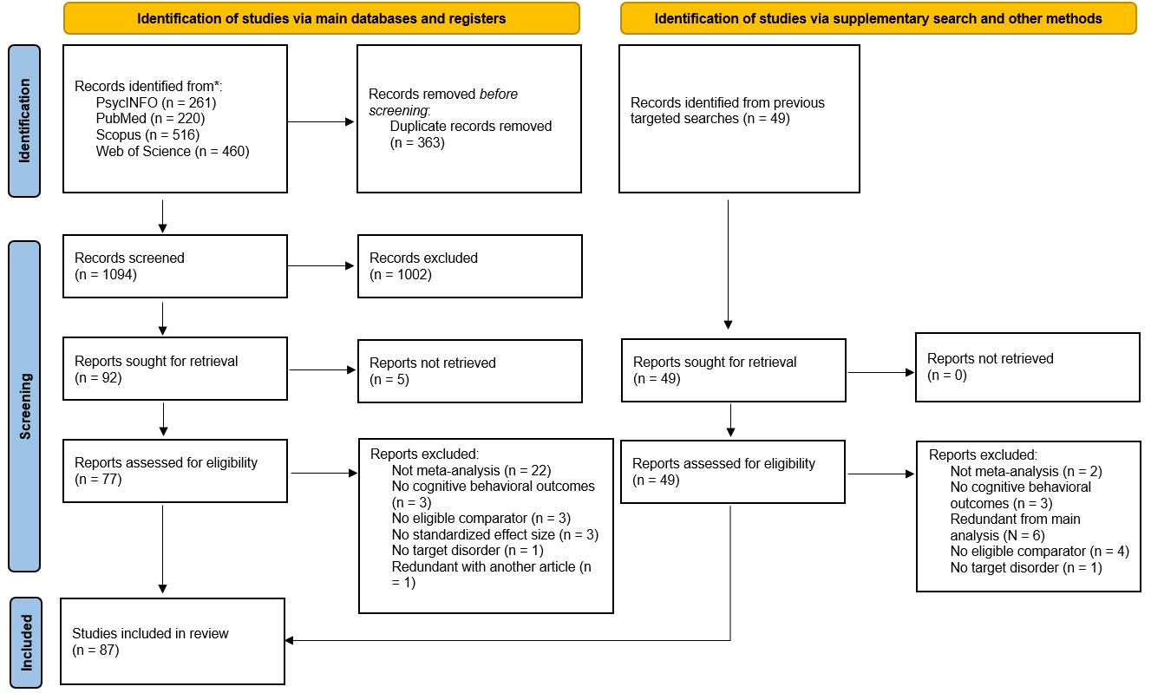
Figure 2.
Cognitive effect sizes (expressed as standardized mean differences) across domains in individuals described as having ADHD. Each point represents a single pooled effect size from a published quantitative meta-analysis comparing individuals with the condition to neurotypical controls (negative values indicate lower performance in the condition group). Point size reflects precision (inverse standard error); color and shape indicate age group (child, mixed, adult). Black points with horizontal bars show descriptive meta–meta-analytic summaries (95% CIs) for each domain. These overlays are heuristic only and do not support higher-order inferential claims, as primary studies and constructs may overlap across meta-analyses.
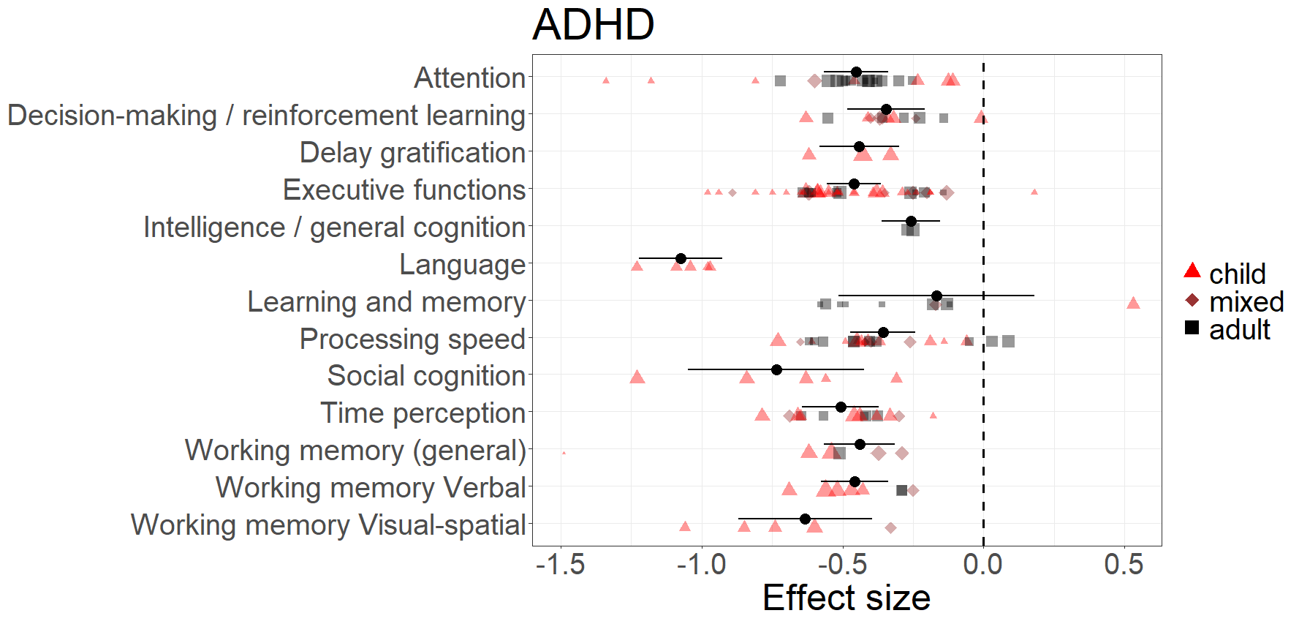
Figure 3.
Cognitive effect sizes (expressed as standardized mean differences) across domains in individual described as having dyslexia / reading disorder. Each point represents a single pooled effect size from a published quantitative meta-analysis comparing individuals with the condition to neurotypical controls (negative values indicate lower performance in the condition group). Point size reflects precision (inverse standard error); color and shape indicate age group (child, mixed, adult). Black points with horizontal bars show descriptive meta–meta-analytic summaries (95% CIs) for each domain. These overlays are heuristic only and do not support higher-order inferential claims, as primary studies and constructs may overlap across meta-analyses.
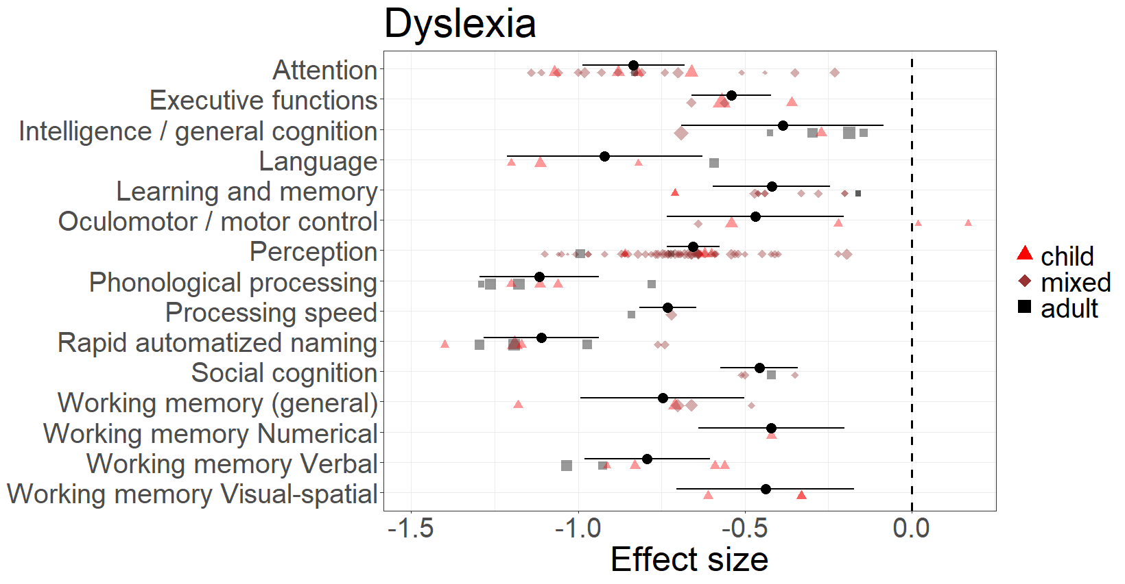
Figure 4.
Effect sizes (expressed as standardized mean differences) across executive function subdomains in ADHD.
