#### Data Collection

Crawled 1244 Weibos that contain keyword '贸易战' from July 25, 2019 to July 29, 2019. Considering that some netizens don't like to send Weibo post with accurate keyword, we also crawled Weibos that contain keyword '毛衣战'.

#### Sentiment Analysis

For each Weibo post, we use the sentiment analysis service, which is provided by a natural language process (NLP) platform on 'Tencent Cloud', to evaluate the sentiment of this post. The sentiment analysis would evaluate the sentiment of given post, and provide a score between 0 and 1 representing the sentiment of post, with 0 indicating a strongly negative and 1 a strongly positive mood. After that, each weibo post can be grouped into "positive" or "negative" class by the sentiment score, i.e. a Weibo post is said to be "positive" if its sentiment score is greater then 0.5, otherwise it's a "negative" post.

All 1244 weibo posts, 757 (60.9%) of them are classified as negative posts, 487 (39.1%) of them are positive posts. The average of sentiment score is at 0.487, which is slightly lower than 0.5.

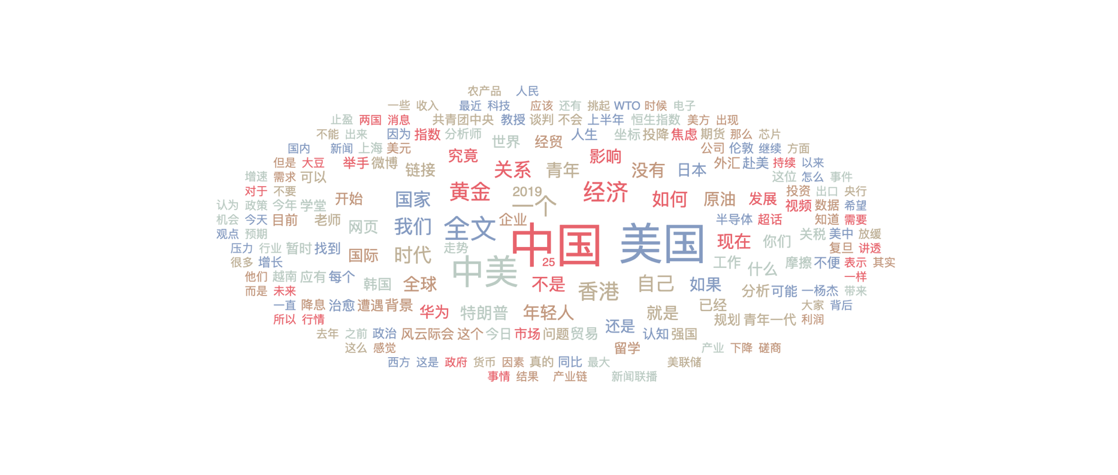

For Weibo posts contain the keyword '毛衣战', we have crawled 1052 posts among a month. 66.9% negative posts.

