**java.lang.reflect.InvocationTargetException**

**Error:** Exception thrown in Intellij idea at the moment to generate Json web token using spring boot, the exception generated was this:

public.java.lang.String.com.jalasoft.jfc.controller.UserController.loginUser(java.lang.String,java.lang.String)

Specifically this exception:

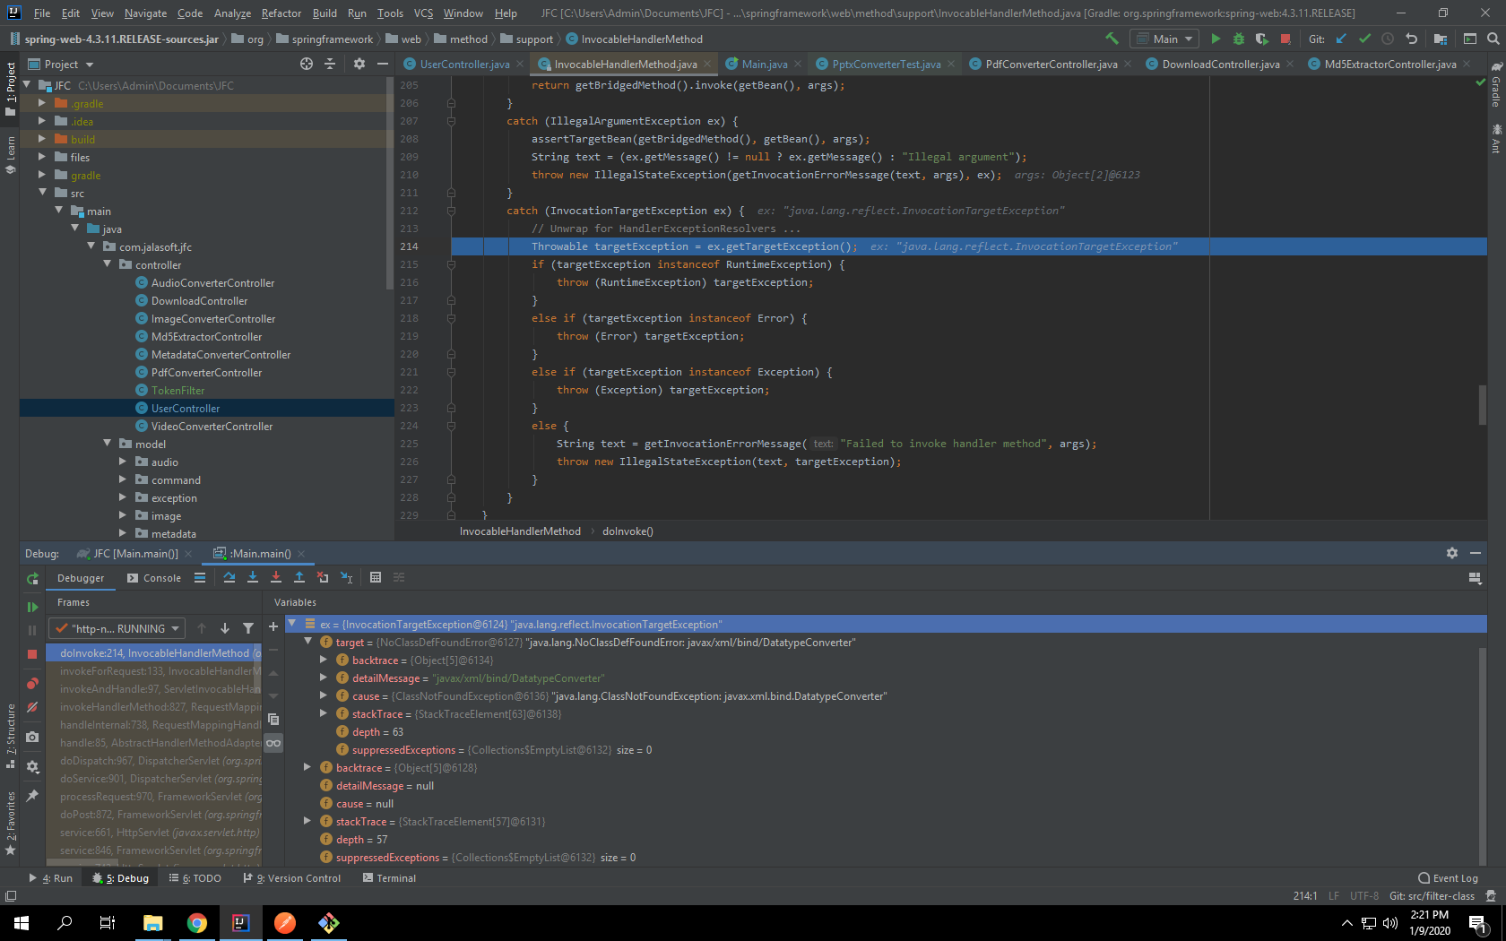java.lang.reflect.InvocationTargetException

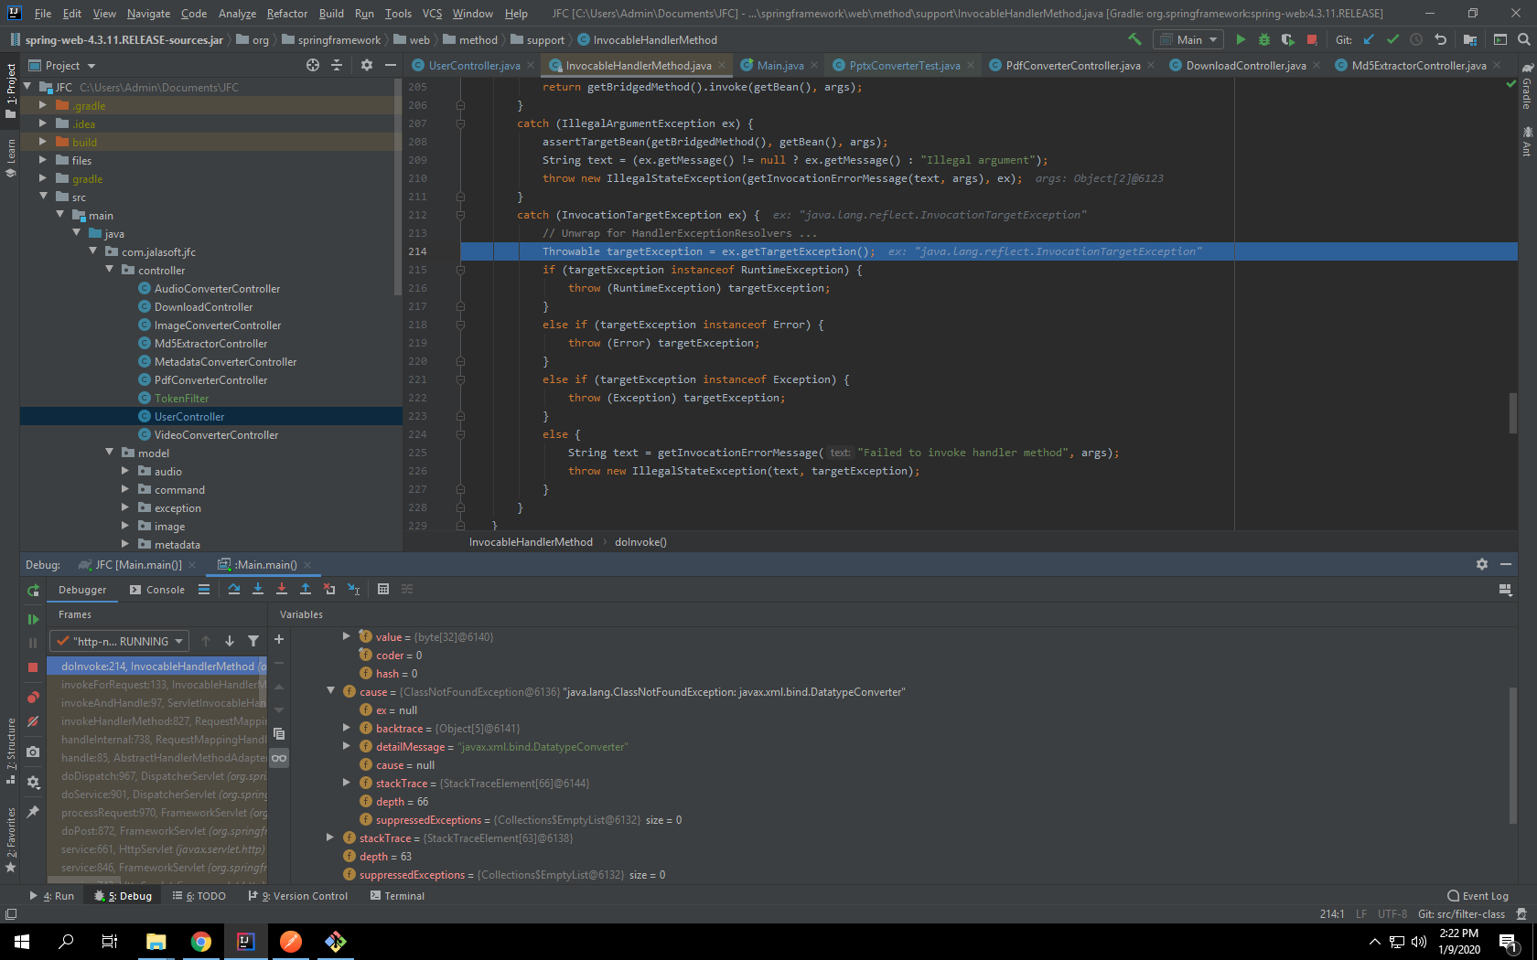

**Fix:** In order to fixing this error was uninstalling Intellij idea, clean temp files and reboot the virtual machine, After that install again Intellij idea. That was the solution.