Date of publication xxxx 00, 0000, date of current version xxxx 00, 0000.

Digital Object Identifier 10.1109/ACCESS.2017.Doi Number

Preparation of Papers for IEEE Access (February 2022)

First A. Author1, Fellow, IEEE, Second B. Author2, and Third C. Author, Jr.3, Member, IEEE

1National Institute of Standards and Technology, Boulder, CO 80305 USA

2Department of Physics, Colorado State University, Fort Collins, CO 80523 USA

3Electrical Engineering Department, University of Colorado, Boulder, CO 80309 USA

Corresponding author: First A. Author (e-mail: author@ boulder.nist.gov).

This paragraph of the first footnote will contain support information, including sponsor and financial support acknowledgment. For example, “This work was supported in part by the U.S. Depart­ment of Com­merce under Grant BS123456.”

ABSTRACT These The countries are in a process of energy transition, where the use of renewable energies is intensifying, in a centralized as well as distributed manner, since as much as large companies, small consumers seek to be prosumers[1].

The countries seek to contribute to the reduction of CO2 emissions, making a change from non-renewable energies[2], to clean energies such as solar energy, which has suffered considerable price reductions in recent years, thus stimulating the adoption of this type of energy in a much broader market, which ranges from large companies to independent households, where the now new prosumers are increasingly seeking to reduce the consumption of the traditional network; Additionally, energy markets require an estimate of energy demand by consumers, since short and long-term prices need to be determined[3]; To achieve an adequate estimate, it is also necessary to know the generation of energy that will be available at a given moment, an issue that is crucial for photovoltaic energy, given its variable nature[4].

These energy estimates also provide the necessary tools for the management and management planning of an electrical network, such as a microgrid, which has nodes that consume and/or generate energy; Microgrids are small systems that share energy with each other, but for which they need a management system that allows them to distribute energy more efficiently and precisely, prioritizing the consumption of energy generated by the microgrid itself. For these reasons, in this research, a methodology based on artificial intelligence tools, simulation systems, and user interfaces is carried out, in order to provide a system that allows contributing to the planning of energy management within a microgrid, where the results obtained with it were satisfactory, since the data provided by the system allows planning of energy distribution much more efficiently than traditional methods and contributes to the calculation of economic and environmental benefits.

INDEX TERMS microgrid-energy management-neural network-artificial intelligence-user interface-simulation.

1. INTRODUCTION

The rapid adoption of decentralized generation systems in transmission[1] and distribution system coupled with recent developments in storage technologies, microgrids have become one of the key domains in smart grid when we talk about resiliency and system reliability. With increased participation from various market players, the concept of microgrids has become an opportunity, but also a challenge for some traditional and regulated utilities. It all depends on the business strategy and future sustainability of any utility as to how they take it.

The energy sector is in a process of change, where adaptation has been progressive and increasing on the part of both generators and consumers, since trends change, consumption patterns adapt to the increase in technology and increasingly seeks efficiency in new ways, such as solar energy, so the planning problem is visible, since the inclusion of microgrids and distributed generation systems changes the dynamics of the traditional network, the tools used until now to planning, lower their performance, thus providing a space for other new technologies to fill that place and allow the identification of new trends with sufficient precision to be implemented in current systems.

With the advancement of computer systems and programming, a great deal of knowledge has been generated in terms of prediction and forecasting systems, through mathematical tools and artificial intelligence, where they are being used in all areas of the industry. measure that is being adopted massively.

The current whitepaper addresses many of these aspects of microgrids, components and characteristics, their operation, control and management, and pays special attention to the opportunities of microgrids for utilities and isolated microgrids as such through Management models and prediction of energy consumption and generation, thus seeking a more efficient management of energy, thus presenting a tool that allows simulating energy microgrids, analyzing their results and developing management strategies based on these data.

1. PROBLEM DESCRIPTION

With the arrival of the 4th industrial revolution, technological and regulatory changes, new business models emerge to transform the way in which companies and people carry out their productive activity. The electricity sector is proof of this, with the adoption of non-conventional sources of renewable energy to ensure reliable supply in an environmentally friendly manner[5].

In this sense, for the incorporation of renewable energy into the electricity sector, some technical, economic and regulatory mechanisms have been developed derived from Law 1715 of 2014 and today more recently, Law 2099 of 2021 on Energy Transition, refer to a concept key for this research, such as the microgrid.

A microgrid can be understood as “The Micro-Grid is an interconnection system with the capacity to be self-sufficient and operate in isolation if necessary. It includes both generation, storage and electricity transport, as well as equipment to optimize intelligent energy management by the end user"[6] A clear example of a microgrid is a group of houses, where each one has its own solar system installed to supply their consumption and they all connect to share their surplus energy.

With the rapid development of the Internet of Things (IOT) for energy networks and the implementation of Smart-Grids, the challenge of maintaining proper control and balance between supply and demand has grown significantly.

The inclusion in microgrids of more complex systems, such as monitoring stations, storage systems, self-generation systems and demand response capacity integrated into the electrical system, present new challenges when it comes to guaranteeing supply efficiently. technically and economically.

A clear example of this is the pilot projects that are being carried out in Colombia in the city of Medellín, where models of certain segments of the city are being generated and applied to microgrid simulation to understand how the passage of a standard energy structure affects to a microgrid structure[7].

The object of this research is the development of a support system for energy management in microgrids through a simulation of a microgrid and its behavior, as well as the prediction of generation and consumption patterns, for efficient energy management. in a microgrid, which requires adequate calculation and estimation of supply and demand, to reach a balance and obtain economic and environmental benefits.

This balance between supply and demand seeks to minimize energy losses, such as excess supply, where the additional energy generated cannot be used, causing additional costs due to oversizing and opportunity costs if said excess energy is not sold. On the other hand, problems such as blackouts and deficiencies in the energy supply service can arise when there is excess demand, since the supply is not capable of fully supplying the demand at any instant of time. This problem of imbalance between supply and demand usually also appears in microgrids as a result of an intermittent supply of energy from solar and wind systems, since there is no sun and wind all day, nor is it of the same intensity at the hours of their presence. .

The growth of the economy is associated with a growth in the demand for energy, due to the fact that the different economic activities require energy consumption for their development, in this sense, the impacts of health events such as COVID-19 and climate events such as El Niño and la Niña, generate changes in the load profiles of consumers[8], as well as in the availability and price of the energy supply, which puts at risk the supply of energy to end users at reasonable prices.

Self-generation plants are normally based on renewable energies based on non-conventional sources (FNCER) such as photovoltaic solar energy, wind power and small hydroelectric plants. The availability of energy that these generation plants can deliver depends on various climatic factors, such as such as cloudiness, precipitation, temperature, wind speed, hours of sunshine during the day and its intensity per unit area, among other factors, which determine a variable and intermittent generation, thus causing uncertainty in the amount of energy available to meet demand in the short, medium and long term[9].

Similarly, the energy demand of households and companies is variable [10], either due to the incorporation of new efficient technologies that reduce consumption, due to the entry of new equipment and machinery to support growth, due to reduction or increase in industrial and commercial production as a result of economic and commercial changes, due to restrictions on mobility due to the effect of a pandemic, among many other factors that explain why the energy demanded by a home or by a company varies over time.

PRELIMINARIES

The necessary backgrounds, including the entry dynamic equations, multiple trajectory constraints, and threats detected during the entry process, for HGVs are described in this section

1. MICROGRID

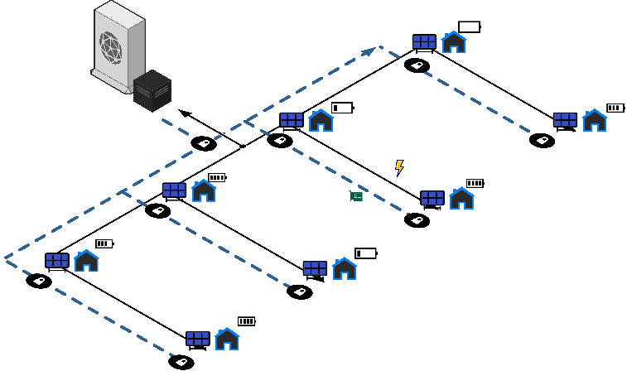

1. Microgrid illustration.

Microgrids are small systems or networks capable of generating energy and that, in addition, also have the ability to function autonomously[6].

The traditional electrical network connects homes, companies, among other infrastructures, to the central network, which is supplied with energy by large power plants, whether they are coal-fired, hydroelectric, or fuel plants, among others. Thanks to this network, electricity travels from where it is produced to where it is consumed.

On many occasions, microgrids are also connected to the traditional electricity grid, but this does not mean that they cannot function on their own.

Microgrids are generally made up of self-generating systems, which means that they can become self-sufficient and can operate in isolation from the electrical grid.

Mainly this means that when the electrical network fails, these microgrids can continue to function and generate electricity autonomously.

Microgrids are generally connected to the traditional electrical network, through a point that maintains the voltage at the same level. But if problems are detected, it goes offline and can continue to function normally[7].

The operation of a microgrid depends on how it is powered, since they can receive energy from solar panels, batteries, wind generators, distributed generators, small hydroelectric plants, among other energy sources. Depending on how it is managed, a microgrid can run indefinitely and cleanly, for example if it is powered by renewable energy.

Microgrids can be defined in the following categories:

• Commercial and industrial microgrids are installed with the objective of reducing demand and costs, during normal operation of construction operations, or other activities, such as data centers, supply of RGD operations, among others.

• Business and service microgrids are generally designed to improve reliability and also promote community participation.

• In the field of campus and institutional microgrids, it is understood that today, most institutions and campuses already have distributed generation systems installed due to its boom and the trend towards green energy.

• In military networks, they focus on physical security and cybersecurity, both for fixed bases and forward operating bases.

It is also worth clarifying the modes of operation of microgrids, which are systems connected to the traditional network and the island mode.

Remote microgrids are permanently disconnected from other power grids and operate in island mode.

In the figure above you can see an example of a microgrid connected to the traditional network.

As defined in [8], for a microgrid disconnected from the network, the example is the same, only that the part of the main network is not included in the connection scheme, since it works completely isolated in island mode.

The traditional grid connection mode is the normal operating mode of a microgrid, without disturbing the energy quality of the traditional grid. In this mode, the microgrid can take over its entire supply, or, depending on the total generation of energy from the local distribution network, in the traditional network environment, it can export or import energy.

In island mode, the microgrid operates isolated from the traditional grid, producing and consuming its own energy. In this mode of operation, the continuity of the service to the connected loads is guaranteed in case of failures in the traditional network. Its autonomy will depend on the generation capacity vs. KWh consumption of the connected loads.

In addition to the modes of operation, the types of microgrids must be taken into account, which are alternating current, direct current and hybrid microgrids.

AC microgrids have a common AC bus to which loads running on AC/DC, renewable energy sources, and energy storage systems are connected. They are easily integrated into the conventional electrical network, but they present a decrease in their energy efficiency, due to the direct/alternating current conversion of their resources, synchronization problems of distributed generators and three-phase imbalance.

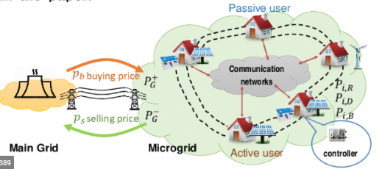

1. Illustration of a microgrid connected to the traditional network[9].

As can be seen in Fig. 2, direct current microgrids use a DC bus to connect to their local network with an AC/DC converter. Compared to the AC microgrid, the DC microgrid is more efficient by reducing power conversion losses. In this type of microgrids, household appliances, lighting, computers, electric vehicles, photovoltaic panels, batteries, flywheels, etc., work with high-efficiency DC/DC converters [10].

Hybrid microgrids are a combination of AC and DC microgrids in the same network segment, facilitating the integration of AC and DC distributed generation resources, energy storage systems and loads. With the advantages of both types of microgrids, RGD integration is facilitated, and energy conversion stages and energy losses are reduced.

1. MANAGEMENT SYSTEMS

A management system is the way an organization manages and manages all the interrelated parts of its business in order to achieve its objectives.

The objectives can be related to many different topics, such as service quality, operational efficiency, health, performance, among others.

The level of complexity of a system depends entirely on the organization of the company.

There are different types of management systems, such as process control, inventory control, sales and marketing, human resources, accounts and finance, decision support systems, expert systems, transaction processing and database[11].

In the field of management support software, there are three types of management support systems: executive information systems, expert systems and DSS decision support systems.

Then there are the executive information systems, which focus more on the management of packages and deliveries, since this level is different from the administrative level, it needs its own approach, since the need for fast and updated information on packages, status of warehouses, deliveries and other logistics issues is something required in the management of a company or projects if efficiency and improvement are sought in them.

The information systems developed for the management of Logistics and status reports, whether of materials or personnel, are the executive information systems or EIS for its acronym in English; The EIS act as an electronic instruction system, offering great flexibility in its use, using internal and external information on the status of the company's logistics processes.

In addition to the EIS, there are also expert systems, which were created to meet the exponential increase in complexity of the processes of some companies, since a greater flow of information and faster decision-making are required, which can become a problem if you only work with the human factor, which is why expert systems were implemented, since they can interact with several variables at the same time in a faster and more effective way than a human.

The EIS work, simulating human activity taken from human experts in a certain specific subject, recreating the inputs of information, whether qualitative or quantitative, identification of requirements and analysis of information regarding decision-making rules; Delivering a solution to the problem in a way that explains to the user the reasoning used to arrive at that solution and how to execute it.

On the other hand, there are decision support systems, they are designed to support decision making in a company or project, making the process of administrators improve in effectiveness and efficiency, since they are based on the premise that the judgment of the administrator cannot be replaced by a computer-based solution. However, by offering the support of models and data, it is possible to improve the decision-making process.

The basic purpose of decision support systems or DSS for its acronym in English, is to extend the decision capacity of the manager by supporting him with tools and data available under his control. The DSS do not presuppose specific information requirements or predefined analysis tools for different types of information, nor do they impose solutions on the administrator.

The flexibility mentioned in the previous paragraph, then, implies that these DSS systems are flexible and allow plasticity to the administrator when entering data, depth of analysis and dependence on the result of an analysis for making a specific decision. DSSs offer an interactive environment for the user, thus allowing the administrator to experiment with the data and models to develop an optimal decision-making strategy for a specific situation.

DSS systems can be used in operations management and other planning departments within an organization to synthesize executable solutions from information and data from the same operations[11].

For example, a DSS system can be used to project a company's profit into a future time interval, based on assumptions about the sales of a specific product. Given the large number of factors that surround a profit projection figure, these calculations are not easy to perform manually, therefore, this task is offloaded in a system of this class.



1. Illustration of a microgrid connected to the traditional network[9].

The operation of a microgrid depends on how it is powered, since they can receive energy from solar panels, batteries, wind generators, distributed generators, small hydroelectric plants, among other energy sources. Depending on how it is managed, a microgrid can run indefinitely and cleanly, for example if it is powered by renewable energy.

1. NEURAL NETWORKS

Artificial intelligence copies nature's behavior of learning and adapting to an environment[12].

AI makes it possible for machines or programs to learn from experience, adjust to new ideas or problems, and perform increasingly efficient tasks[13].

Artificial intelligence is based on the behavior of neurons, which adapt as needed for a specific task, where each neuron has defined values ​​for each connection and these values ​​change as it adapts, thus reinforcing the connections that are needed and discard those that are not needed.

Artificial intelligence presents different ways of performing learning, where among the best known are deep learning, machine learning and natural language processing[14].

Artificial neural networks were the first way to approach the idea of ​​thinking machines, where they seek to imitate the behavior of neurons in the brain, strengthening and weakening connections as needed.

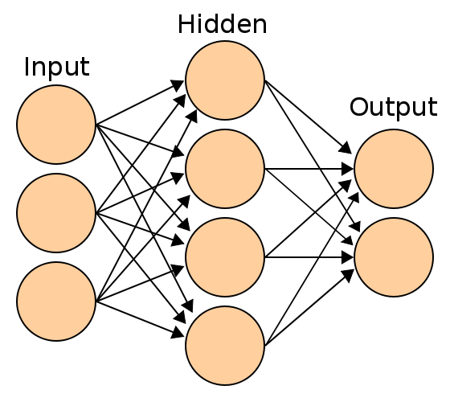

1. Illustration of a neural network internal connection diagram[15].

In the figure 4 you can see a scheme of a simple neural network, where there are 3 layers, one input, where the information is fed to the network, the hidden layer, where the information is processed and the output where it is delivered. an answer.

Automatic or machine learning is an implementation of these neural networks on a large scale[14], since large collections of these are implemented to learn about a specific task automatically and without human intervention, where the system is left to find answers on its own as it progresses in “understanding” a specific problem.

To complement, a formal definition of machine learning is a discipline in the field of artificial intelligence that, through algorithms, gives computers the ability to identify patterns in massive data and make predictions. This learning allows computers to perform specific tasks autonomously, that is, without the need to be programmed.

In addition to the definition of machine learning, there are definitions of the different types of machine learning, such as supervised, unsupervised, semi-supervised and reinforcement learning[16].

Supervised learning needs labeled data sets. That is, you tell the model what you want it to learn.

On the other hand, unsupervised learning is the opposite, since it works with data that has not been labeled. You don't have a label to predict. These algorithms are mainly used in tasks where it is necessary to analyze the data to extract new knowledge or group entities by affinity.

Semi-supervised learning is used on occasions where it is difficult to obtain a completely labeled data set, this means that only a portion of the data is marked, which is solved with this type of learning, since it is delivered to the model a sample of the data to be learned and another part of the data, which the system must analyze according to what was learned in the initial labeled sample[14].

Deep learning or Deep learning (DL) is an additional layer that is added to the collections of neurons implemented in machine learning (ML), with multiple layers connected to each other, where each layer is assigned a specific function in a problem[17]; It should be clarified that functions or tasks are not always assigned to a specific layer, but it is also possible to let the same program find and divide the problem into simpler subproblems, thus achieving a greater abstraction of the problem and possibly a better solution to the same problem.

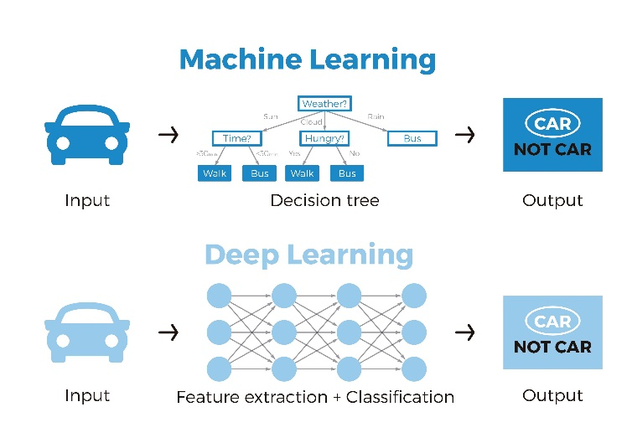

1. Illustration of a neural network in ML and DL[18].

Figure 5 shows the difference between machine learning and deep learning, where deep learning finds different parameters such as characteristics of a particular object as it is trained, using filters applied to each of the layers, where each of them will be adjusted to a specific feature of the information being analyzed, among others. While machine learning does not select characteristics of the object, but the information is passed through the layers of the network, which are adjusted until they deliver the desired output.

Neural networks as an emerging and widely accepted tool worldwide, have been implemented in more and more areas with the emergence of new needs in the world in constant growth, globalization and search for more efficient solutions; As is the case of the inherent need to forecast data in the future, since the search for greater efficiency, both in energy and in the very processes that are carried out in the industry, has triggered a search to predict data, either for system control , economy, stock market, weather forecast, among others[16].

Neural networks with their ability to adapt and infer the behavior of all kinds of dynamic systems, are presented as a useful tool for this purpose, since by inferring the behavior of a system at a given instant of time, they can be used to determine the response of a system in the future, since its behavior has already been determined by a neural network, can be used to deliver an approximate future response to what the real system would deliver in a future horizon[19].

These applications of prediction and forecasting of the response of any measurable system with respect to a time axis, have gained greater strength since they allow actions to be taken prior to the event and to anticipate with an adequate response to it, resulting in resource savings, either of personnel, energetic and economic, as for example in control systems, where a respective response can result in energy savings and avoid excessive wear and tear on the system, since the behavior can be given more smoothly if it is known with certainty. anticipate the action to be taken.

On the other hand, in energy distribution systems, the energy demand can be known in advance, thus achieving the respective preventive actions that allow a response to the adequate demand to result; These preventive actions can trigger a more efficient distribution system.

Taking into consideration the scope of decision making mentioned above, neural networks are of great help to meet this objective, since the ability to estimate the behavior of a system or situation in the future allows decisions to be made that result in better management. power of a microgrid. With neural networks, an identification of the behavior of the entities that make up the micronetwork can then be achieved, in order to make a forecast of generation and consumption, where this information is used to distribute the energy in the most appropriate way possible, achieving efficient management. as balanced as possible and thus provide a balanced response to the demand of the microgrid itself, since the predictions of patterns allow anticipating the facts and taking the necessary actions before the events occur; In this case, energy generation and consumption events.

1. METHODOLOGY

The methodology for this project will be made up of 4 stages, starting with previous theoretical research that allows supporting the entire development, and then going through a breakdown and definition of components where a synthesis of all the necessary elements will be made.

The following stages are composed of the implementation of the synthesized components in an algorithmic way, since it was sought to carry out a simulation assembly where various tests and tests of different microgrid topologies can be carried out, in order to carry out a parameter adjustment and analyze results.

1. METHODOLOGY STAGES

* STAGE 1: Characterization of Micro-Grid systems.
* STAGE 2: System design and model development.
* STAGE 3: Model implementation and simulation.
* STAGE 4: Implementation, testing and validation.

1. STAGE 1:

It was then sought to characterize a microgrid under study according to the first specific objective.

* The different types of existing microgrids were analyzed and the type of microgrid to be used in this application case will be defined.
* The node was defined as a representative element of a consumer or prosumer or distributed generator component of the microgrid.
* A set of relationships between the nodes of the microgrid was defined and specified.
* The form of relationship of the microgrid with the external network or distribution system was defined.
* The behavior of the determining components or variables of the node, consumption and generation curves were identified and specified.

A model was developed, which allowed characterizing a microgrid object of the study, its components and representative variables. Thus, for example, it was possible to define consumer-type nodes with their type of load curve or prosumer-type nodes, which have energy consumption and production. The consumption of energy from different types of loads or consumption in the unit of time and generation from different sources of energy such as solar photovoltaic, wind, etc.

As a result of this stage, we obtain a complete microgrid model.

1. STAGE 2:

In this stage, the support system for energy management in the microgrid was designed considering the microgrid model defined in the previous stage. For this, models of the components of the microgrid must be developed, including the following:

* A model that allows defining the load curve or energy demand of the node
* A model that allows defining the node generation curve
* A model that allows forecasting the energy demand for the next day
* A model that allows forecasting the generation of the node for the following day.
* An energy management model for the microgrid.

After the models per node, it is necessary to define the aggregator models for the microgrid.

* A network model of the microgrid that allows interaction with the traditional distribution network.
* A model for estimating the energy benefits of the microgrid
* A model for estimating the economic benefits of the microgrid
* A model for estimating the environmental benefits of the microgrid

For the development of the forecast models, several machine learning algorithms were tested that were adjusted to the specified case study, using the node variables defined in the previous step, that is, to the micronetwork under study. Then the set of algorithms that best represent the expected future behavior was selected.

Finally, the needs that the final interface must meet were defined, what it must have, such as the interaction with the user, what platform to use to implement the interface, how the variables should be configured, the implementation mode of all the components and communication between them.

1. STAGE 3:

With the components, models defined and algorithms established, it was implemented in a software that allows the simulation of the interaction of the components of the microgrid and of this as a whole with the distribution network.

For the simulation, the literature was analyzed and the appropriate tools were defined for this case that allowed the fulfillment of the objectives.

In the simulation platform, a graphical interface was developed, where the user can parameterize the microgrid, such as the behavior of each node in terms of generation and consumption, as well as the capacities of the energy networks that connect the nodes of the microgrid and It is with the distribution network.

1. STAGE 4:

Functional and operational tests were carried out on the support system developed with its integrated models in such a way that it was possible to identify errors and other aspects of improvement.

With results obtained from multiple successful tests in different operating situations, the management system was tested with different models of microgrids.

1. METHODOLOGY PROCESS
2. STAGE 1:

EXISTING MICROGRID ANALYSIS

For the analysis of the existing microgrids, a previous investigation was carried out in the background section where the types of existing microgrids were identified, which are found in the theoretical framework. Solar energy was determined as a non-conventional source of renewable energy in this case due to its technical and economic benefits, that is, widely used commercial technology of low cost and easy appropriation by users.

With the types of existing microgrids, we proceed to define the topology to be used for this project, which is a microgrid, connected in alternating current to the national interconnected system with the possibility of selling surpluses.

The diagram of the type of microgrid to be used is illustrated in figure 6 below.

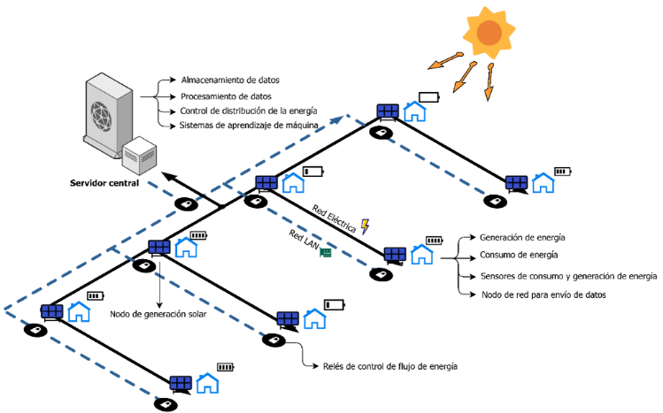

1. Illustration of the microgrid topology to use.

With the types of existing microgrids, we proceed to define the topology to be used for this project, which is a microgrid, connected in alternating current to the national interconnected system with the possibility of selling surpluses.

The diagram of the type of microgrid to be used is illustrated in figure 6 below.

MICROGRID NODE DEFINITION

With the topology defined and the energy source defined, we proceed to develop a definition of the components of a node that make up the microgrid.

The synthesis performed for the components of each node and its operation is described in figure 7.

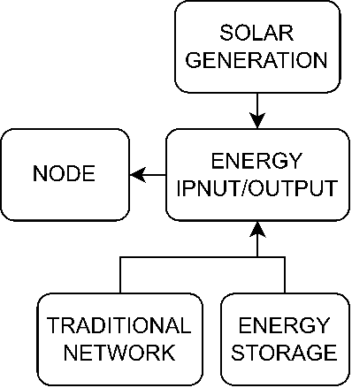

1. Illustration of microgrid node components.

Figure 7 shows the 4 general components that define the node, which can be described as follows:

* SOLAR GENERATION: The node has the option of having a solar generation point (photovoltaic system), where you can configure the hours of the day that the system receives depending on the area where it is installed, as well as the installed power, in order to be able to calculate the energy self-generation curve of the node.
* TRADITIONAL NETWORK: The node has the option of connecting to the traditional network to be able to supply its own energy consumption when the micro-network cannot supply it. This with the purpose of modeling the real situation. At present and in general terms, consumers receive their energy supply from a distribution network, so the development of microgrids for the most part would be carried out with this type of existing topology, users connected to the distribution network that make up a microgrid connected to the grid.
* ENERGY INPUT/OUTPUT: The node is managed by this element, which will receive orders from the central management system, to enter or remove energy from the node at a given time. Said input/output system is defined by a bidirectional meter that allows accounting for energy consumption or the delivery of surpluses to the internal network and an intelligent control system that, working as a "slave", implements the orders of the centralized master management system of the microgrid. In some cases, such as in those nodes where there is storage, the storage management system would be used, in other cases where there is only self-generation in the node without storage, inverter control is used, in other cases, a intelligent control system. For this work it is assumed that the node has said intelligent control system.
* ENERGY STORAGE: The node can be configured with a storage system with a certain capacity.

NODE INTERACTION DEFINITION

Once the node is defined, we proceed to make a scheme and interactions between the nodes as shown in figure 27.

1. Illustration of node interactions.

Figure 8 illustrates the interaction between nodes, which has been taken up to now, without a management system, since it is necessary to define the basic structure of the microgrid first, in order to then implement a management layer to the system.

The nodes are connected to a connection system that is general for the entire microgrid, through which energy can flow in all directions to any node at a given time. This system corresponds to an internal electrical network that physically connects the nodes, similar to the internal distribution network of a subdivision, building or free zone.

The component of each node that connects to the connection system would be the ENERGY INPUT/OUTPUT component, mentioned above in figure 7, which will function as a kind of gate to enter or extract energy from the node as needed.

For the connection of the microgrid with the external energy network, it is carried out via the connection of the internal electrical system with the local distribution system, that is, it would have the equipment of a self-generation commercial frontier such as the advanced measurement system bidirectional, and intelligent energy management system. To cite an example, in a subdivision or in a building or in a free zone there is an electrical substation that supplies energy to users, the connection of this substation with the external electrical network of the local distributor would be modified so that under compliance of current regulations can consume and deliver surpluses to the network operator's distribution network.

ENERGY DEMAND CURVE DEFINITION

For the consumption curves, an extensive investigation of load profiles was carried out for different types of users, which are:

* Residential
* Commercial
* Industry

information taken directly from the public information system of the operator of the national interconnected system (XM), for a minimum analysis horizon of one year, in hourly resolution. On the other hand, the technical information provided by the Energy Mining Planning Unit (UPME) corresponding to the xxx study was used, where load curves were determined by users, this being the validation mechanism of the load profile obtained for the type of user used. in this case study.

The curves were made for an interval of 24 hours divided by hour, where there are 24 data per node, whether in a residential, commercial or industrial curve.

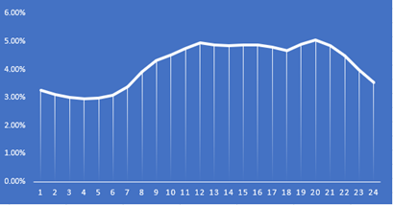

1. Residential curve.

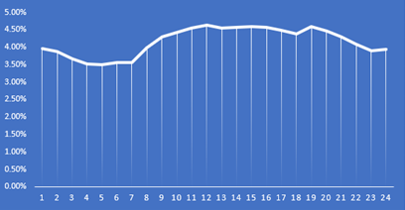

1. Industrial curve.

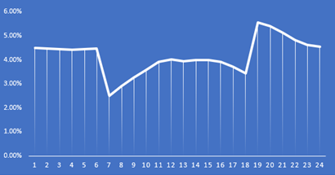

1. Commercial curve.

Figures 9, 10 and 11 show the synthesized percentile graphs of the residential, commercial and industrial sectors, respectively. These curves allow defining the load profile of each node and distributing the specified average consumption for each user at each hour of the day.

OPERATING VARIABLE DEFINITION

With the consumption data defined, we proceed to define the variables that will be taken into account for the operation of the microgrid:

* Node consumption.
* Node generation or node self-generation.
* Node storage.
* Prediction of node consumption.
* Prediction of node generation or node self-generation.

MICROGRID DIAGRAM AND DECISION SUPPORT SYSTEM DEFINITION

With the components of the microgrid and the variables defined, we proceed to define the missing components necessary for the management of the microgrid, which are:

* Microgrid energy management system.
* Consumption and generation prediction system.

The management system is the one that will make decisions about who and when energy will be delivered, based on the information that the prediction system will deliver.

The prediction system will be constantly training itself with the consumption and generation information of each node in order to deliver a response to the management system.

The diagram of the complete microgrid can be seen in figure 12 and an example of the functional design of the microgrid in figure 6.

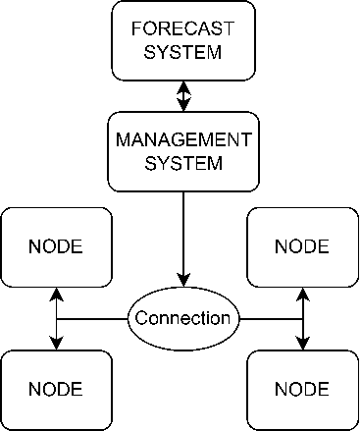

1. Complete microgrid diagram.

Figure 12 shows how the microgrid is arranged, where the management system is directly connected to each node through the connection system to the ENERGY INPUT/OUTPUT components of each node, where this component will fulfill certain functions described below:

* Energy “gate” operation to enter and extract energy from the node.
* Collection of generation and consumption data of each node.
* Delivery of information from each node to the management system.

The management system receives the information from each node and delivers it to the prediction system, which will perform the necessary calculations and return the results, where it will already make the decisions for energy distribution applied through the INPUT/OUTPUT component of each node.

For the storage issue, the system takes into account the total installed power in the microgrid and uses the batteries that each node has installed as global for the entire microgrid and thus distributes as needed.

1. STAGE 2:

NODE MODEO DESIGN

With all the components and interactions defined, we proceed to develop the models of the components of the node.

DEMAND COMPONENT DESIGN

For the design of the demand component of a node, the curves found for the residential, commercial and industrial sectors were taken as a reference, where an average daily energy consumption is taken and multiplied by the percentile values ​​contained in the curve, in order to generate an hourly power consumed by that node at a given time.

The curves are defined using the data shown in figures 9, 10 and 11, where there are 24 data points for every hour in a day.

GENERATION COMPONENT DESIGN

For the design of the generation component, values ​​were taken from curves already established for the solar energy sector by the industry and companies in the energy sector.

This generation curve was taken in percentage values ​​of a total of 100% daily, for each instant of time.

The data used is shown on figure 13.

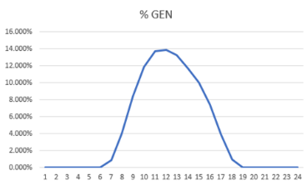

1. Solar generation curve.

As can be seen, the percentage of generation is distributed in the mid-day hours, as expected due to the nature of the solar resource.

With these data, we proceed to implement the curve in the next stage.

FORECAST MODEL DESIGN

For the forecast model, the AI ​​route was chosen, using artificial intelligence tools for time series forecasting, to determine the consumption or generation of a node at a given future instant and thus achieve more efficient energy management.

For this model, something light and fast was sought, but at the same time robust and efficient, so a previous investigation of neural models applied to this type of problem was carried out and it was concluded that the most suitable model for this type of systems is a regression system, since it manages to successfully determine any type of time series in an approximate way.

For the portability and weight section of the algorithm, it was determined that a gradient tree is the best network structure to use because it is lightweight and robust, so for the final model, it was determined to use a regressor from the XGBoost library in Python.

Once the model is defined, we proceed to determine the structure of the data that will be entered into the system, opting for the time series model for their partitioning.

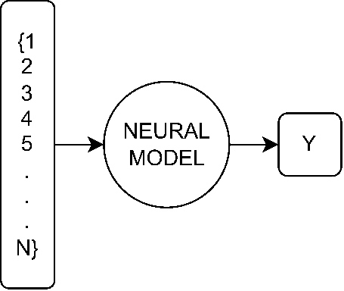

1. Data format for neural model.

For the neural model, a data vector is entered, with an adjustable window size, to process a future value, either generation or consumption.

FORECAST ALGORITHM SELECTION

For the neural model, a data vector is entered, with an adjustable window size, to process a future value, either generation or consumption.

TABLE I

Units for Magnetic Properties

|  |  |  |
| --- | --- | --- |
| Symbol | Quantity | Conversion from Gaussian and  CGS EMU to SI a |
| Φ | magnetic flux | 1 Mx → 10−8 Wb = 10−8 V·s |
| *B* | magnetic flux density,  magnetic induction | 1 G → 10−4 T = 10−4 Wb/m2 |
| *H* | magnetic field strength | 1 Oe → 103/(4π) A/m |
| *m* | magnetic moment | 1 erg/G = 1 emu  → 10−3 A·m2 = 10−3 J/T |
| *M* | magnetization | 1 erg/(G·cm3) = 1 emu/cm3  → 103 A/m |
| 4π*M* | magnetization | 1 G → 103/(4π) A/m |
| σ | specific magnetization | 1 erg/(G·g) = 1 emu/g → 1 A·m2/kg |
| *j* | magnetic dipole  moment | 1 erg/G = 1 emu  → 4π × 10−10 Wb·m |
| *J* | magnetic polarization | 1 erg/(G·cm3) = 1 emu/cm3  → 4π × 10−4 T |
| χ*,* κ | susceptibility | 1 → 4π |
| χρ | mass susceptibility | 1 cm3/g → 4π × 10−3 m3/kg |
| μ | permeability | 1 → 4π × 10−7 H/m  = 4π × 10−7 Wb/(A·m) |
| μr | relative permeability | μ → μr |
| *w, W* | energy density | 1 erg/cm3 → 10−1 J/m3 |
| *N, D* | demagnetizing factor | 1 → 1/(4π) |

Vertical lines are optional in tables. Statements that serve as captions for the entire table do not need footnote letters.

aGaussian units are the same as cg emu for magnetostatics; Mx = maxwell, G = gauss, Oe = oersted; Wb = weber, V = volt, s = second, T = tesla, m = meter, A = ampere, J = joule, kg = kilogram, H = henry.

1. MULTIPART FIGURES

Figures compiled of more than one sub-figure presented side-by-side, or stacked. If a multipart figure is made up of multiple figure types (one part is lineart, and another is grayscale or color) the figure should meet the stricter guidelines.

1. FILE FORMATS FOR GRAPHICS

Format and save your graphics using a suitable graphics processing program that will allow you to create the images as PostScript (PS), Encapsulated PostScript (.EPS), Tagged Image File Format (.TIFF), Portable Document Format (.PDF), or Portable Network Graphics (.PNG) sizes them, and adjusts the resolution settings. If you created your source files in one of the following programs you will be able to submit the graphics without converting to a PS, EPS, TIFF, PDF, or PNG file: Microsoft Word, Microsoft PowerPoint, or Microsoft Excel. Though it is not required, it is strongly recommended that these files be saved in PDF format rather than DOC, XLS, or PPT. Doing so will protect your figures from common font and arrow stroke issues that occur when working on the files across multiple platforms. When submitting your final paper, your graphics should all be submitted individually in one of these formats along with the manuscript.

1. SIZING OF GRAPHICS

Most charts, graphs, and tables are one column wide (3.5 inches / 88 millimeters / 21 picas) or page wide (7.16 inches / 181 millimeters / 43 picas). The maximum depth a graphic can be is 8.5 inches (216 millimeters / 54 picas). When choosing the depth of a graphic, please allow space for a caption. Figures can be sized between column and page widths if the author chooses, however it is recommended that figures are not sized less than column width unless when necessary.

There is currently one publication with column measurements that do not coincide with those listed above. Proceedings of the IEEE has a column measurement of 3.25 inches (82.5 millimeters / 19.5 picas).

The final printed size of author photographs is exactly   
1 inch wide by 1.25 inches tall (25.4 millimeters x 31.75 millimeters / 6 picas x 7.5 picas). Author photos printed in editorials measure 1.59 inches wide by 2 inches tall (40 millimeters x 50 millimeters / 9.5 picas x 12 picas).

1. RESOLUTION

The proper resolution of your figures will depend on the type of figure it is as defined in the “Types of Figures” section. Author photographs, color, and grayscale figures should be at least 300dpi. Line art, including tables should be a minimum of 600dpi.

1. VECTOR ART

In order to preserve the figures’ integrity across multiple computer platforms, we accept files in the following formats: .EPS/.PDF/.PS. All fonts must be embedded or text converted to outlines in order to achieve the best-quality results.

1. COLOR SPACE

The term color space refers to the entire sum of colors that can be represented within the said medium. For our purposes, the three main color spaces are Grayscale, RGB (red/green/blue) and CMYK (cyan/magenta/yellow/black). RGB is generally used with on-screen graphics, whereas CMYK is used for printing purposes.

All color figures should be generated in RGB or CMYK color space. Grayscale images should be submitted in Grayscale color space. Line art may be provided in grayscale OR bitmap colorspace. Note that “bitmap colorspace” and “bitmap file format” are not the same thing. When bitmap color space is selected, .TIF/.TIFF/.PNG are the recommended file formats.

1. ACCEPTED FONTS WITHIN FIGURES

When preparing your graphics IEEE suggests that you use of one of the following Open Type fonts: Times New Roman, Helvetica, Arial, Cambria, and Symbol. If you are supplying EPS, PS, or PDF files all fonts must be embedded. Some fonts may only be native to your operating system; without the fonts embedded, parts of the graphic may be distorted or missing.

A safe option when finalizing your figures is to strip out the fonts before you save the files, creating “outline” type. This converts fonts to artwork what will appear uniformly on any screen.

1. USING LABELS WITHIN FIGURES
2. Figure Axis labels

Figure axis labels are often a source of confusion. Use words rather than symbols. As an example, write the quantity “Magnetization,” or “Magnetization M,” not just “M.” Put units in parentheses. Do not label axes only with units. As in Fig. 1, for example, write “Magnetization (A/m)” or “Magnetization (Am−1),” not just “A/m.” Do not label axes with a ratio of quantities and units. For example, write “Temperature (K),” not “Temperature/K.”

Multipliers can be especially confusing. Write “Magnetization (kA/m)” or “Magnetization (103 A/m).” Do not write “Magnetization (A/m) × 1000” because the reader would not know whether the top axis label in Fig. 1 meant 16000 A/m or 0.016 A/m. Figure labels should be legible, approximately 8 to 10 point type.

1. Subfigure Labels in Multipart Figures and Tables

Multipart figures should be combined and labeled before final submission. Labels should appear centered below each subfigure in 8 point Times New Roman font in the format of (a) (b) (c).

1. FILE NAMING

Figures (line artwork or photographs) should be named starting with the first 5 letters of the author’s last name. The next characters in the filename should be the number that represents the sequential location of this image in your article. For example, in author “Anderson’s” paper, the first three figures would be named ander1.tif, ander2.tif, and ander3.ps.

Tables should contain only the body of the table (not the caption) and should be named similarly to figures, except that ‘.t’ is inserted in-between the author’s name and the table number. For example, author Anderson’s first three tables would be named ander.t1.tif, ander.t2.ps, ander.t3.eps.

Author photographs should be named using the first five characters of the pictured author’s last name. For example, four author photographs for a paper may be named: oppen.ps, moshc.tif, chen.eps, and duran.pdf.

If two authors or more have the same last name, their first initial(s) can be substituted for the fifth, fourth, third... letters of their surname until the degree where there is differentiation. For example, two authors Michael and Monica Oppenheimer’s photos would be named oppmi.tif, and oppmo.eps.

1. REFERENCING A FIGURE OR TABLE WITHIN YOUR PAPER

When referencing your figures and tables within your paper, use the abbreviation “Fig.” even at the beginning of a sentence. Do not abbreviate “Table.” Tables should be numbered with Roman Numerals.

1. CHECKING YOUR FIGURES: THE IEEE GRAPHICS ANALYZER

The IEEE Graphics Analyzer enables authors to pre-screen their graphics for compliance with IEEE Access standards before submission. The online tool, located at <http://graphicsqc.ieee.org/>, allows authors to upload their graphics in order to check that each file is the correct file format, resolution, size and colorspace; that no fonts are missing or corrupt; that figures are not compiled in layers or have transparency, and that they are named according to the IEEE Access naming convention. At the end of this automated process, authors are provided with a detailed report on each graphic within the web applet, as well as by email.

For more information on using the Graphics Analyzer   
or any other graphics related topic, contact the IEEE Graphics Help Desk by e-mail at [graphics@ieee.org](mailto:graphics@ieee.org).

1. SUBMITTING YOUR GRAPHICS

Because IEEE will do the final formatting of your paper,

you do not need to position figures and tables at the top and bottom of each column. In fact, all figures, figure captions, and tables can be placed at the end of your paper. In addition to, or even in lieu of submitting figures within your final manuscript, figures should be submitted individually, separate from the manuscript in one of the file formats listed above in section VI-J. Place figure captions below the figures; place table titles above the tables. Please do not include captions as part of the figures, or put them in “text boxes” linked to the figures. Also, do not place borders around the outside of your figures.

1. COLOR PROCESSING / PRINTING IN IEEE JOURNALS

All IEEE Transactions, Journals, and Letters allow an author to publish color figures on IEEE Xplore® at no charge, and automatically convert them to grayscale for print versions. In most journals, figures and tables may alternatively be printed in color if an author chooses to do so. Please note that this service comes at an extra expense to the author. If you intend to have print color graphics, include a note with your final paper indicating which figures or tables you would like to be handled that way, and stating that you are willing to pay the additional fee.

CONCLUSION

A conclusion section is not required. Although a conclusion may review the main points of the paper, do not replicate the abstract as the conclusion. A conclusion might elaborate on the importance of the work or suggest applications and extensions.

APPENDIX

Appendixes, if needed, appear before the acknowledgment.

ACKNOWLEDGMENT

The preferred spelling of the word “acknowledgment” in American English is without an “e” after the “g.” Use the singular heading even if you have many acknowledgments. Avoid expressions such as “One of us (S.B.A.) would like to thank ... .” Instead, write “F. A. Author thanks ... .” In most cases, sponsor and financial support acknowledgments are placed in the unnumbered footnote on the first page, not here.

REFERENCES AND FOOTNOTES

1. REFERENCES

References need not be cited in text. When they are, they appear on the line, in square brackets, inside the punctuation. Multiple references are each numbered with separate brackets. When citing a section in a book, please give the relevant page numbers. In text, refer simply to the reference number. Do not use “Ref.” or “reference” except at the beginning of a sentence: “Reference [3] shows ... .” Please do not use automatic endnotes in Word, rather, type the reference list at the end of the paper using the “References” style.

Reference numbers are set flush left and form a column of their own, hanging out beyond the body of the reference. The reference numbers are on the line, enclosed in square brackets. In all references, the given name of the author or editor is abbreviated to the initial only and precedes the last name. Use them all; use et al. only if names are not given. Use commas around Jr., Sr., and III in names. Abbreviate conference titles. When citing IEEE transactions, provide the issue number, page range, volume number, year, and/or month if available. When referencing a patent, provide the day and the month of issue, or application. References may not include all information; please obtain and include relevant information. Do not combine references. There must be only one reference with each number. If there is a URL included with the print reference, it can be included at the end of the reference.

Other than books, capitalize only the first word in a paper title, except for proper nouns and element symbols. For papers published in translation journals, please give the English citation first, followed by the original foreign-language citation See the end of this document for formats and examples of common references. For a complete discussion of references and their formats, see the IEEE style manual at www.ieee.org/authortools.

1. FOOTNOTES

Number footnotes separately in superscripts (Insert| Footnote).[1] Place the actual footnote at the bottom of the column in which it is cited; do not put footnotes in the reference list (endnotes). Use letters for table footnotes (see Table I).

SUBMITTING YOUR PAPER FOR REVIEW

1. REVIEW STAGE USING WORD 6.0 OR HIGHER

If you want to submit your file with one column electronically, please do the following:

--First, click on the View menu and choose Print Layout.

--Second, place your cursor in the first paragraph. Go to the Format menu, choose Columns, choose one column Layout, and choose “apply to whole document” from the dropdown menu.

--Third, click and drag the right margin bar to just over 4 inches in width.

The graphics will stay in the “second” column, but you can drag them to the first column. Make the graphic wider to push out any text that may try to fill in next to the graphic.

1. FINAL STAGE USING WORD 6.0

When you submit your final version (after your paper has been accepted), print it in two-column format, including figures and tables. You must also send your final manuscript on a disk, via e-mail, or through a Web manuscript submission system as directed by the society contact. You may use Zip for large files, or compress files using Compress, Pkzip, Stuffit, or Gzip.

Also, send a sheet of paper or PDF with complete contact information for all authors. Include full mailing addresses, telephone numbers, fax numbers, and e-mail addresses. This information will be used to send each author a complimentary copy of the journal in which the paper appears. In addition, designate one author as the “corresponding author.” This is the author to whom proofs of the paper will be sent. Proofs are sent to the corresponding author only.

1. REVIEW STAGE USING SCHOLARONE® MANUSCRIPTS

Contributions to the Transactions, Journals, and Letters may be submitted electronically on IEEE’s on-line manuscript submission and peer-review system, ScholarOne® Manuscripts. You can get a listing of the publications that participate in ScholarOneat http://www.ieee.org/  
publications_standards/publications/authors/authors_submission.html First check if you have an existing account. If there is none, please create a new account. After logging in, go to your Author Center and click “Submit First Draft of a New Manuscript.”

Along with other information, you will be asked to select the subject from a pull-down list. Depending on the journal, there are various steps to the submission process; you must complete all steps for a complete submission. At the end of each step you must click “Save and Continue”; just uploading the paper is not sufficient. After the last step, you should see a confirmation that the submission is complete. You should also receive an e-mail confirmation. For inquiries regarding the submission of your paper on ScholarOne Manuscripts, please contact oprs-support@ieee.org or call +1 732 465 5861.

ScholarOne Manuscripts will accept files for review in various formats. Please check the guidelines of the specific journal for which you plan to submit.

You will be asked to file an electronic copyright form immediately upon completing the submission process (authors are responsible for obtaining any security clearances). Failure to submit the electronic copyright could result in publishing delays later. You will also have the opportunity to designate your article as “open access” if you agree to pay the IEEE open access fee.

1. FINAL STAGE USING SCHOLARONE MANUSCRIPTS

Upon acceptance, you will receive an email with specific instructions regarding the submission of your final files. To avoid any delays in publication, please be sure to follow these instructions. Most journals require that final submissions be uploaded through ScholarOne Manuscripts, although some may still accept final submissions via email. Final submissions should include source files of your accepted manuscript, high quality graphic files, and a formatted pdf file. If you have any questions regarding the final submission process, please contact the administrative contact for the journal.

In addition to this, upload a file with complete contact information for all authors. Include full mailing addresses, telephone numbers, fax numbers, and e-mail addresses. Designate the author who submitted the manuscript on ScholarOne Manuscripts as the “corresponding author.” This is the only author to whom proofs of the paper will be sent.

1. COPYRIGHT FORM

Authors must submit an electronic IEEE Copyright Form (eCF) upon submitting their final manuscript files. You can access the eCF system through your manuscript submission system or through the Author Gateway. You are responsible for obtaining any necessary approvals and/or security clearances. For additional information on intellectual property rights, visit the IEEE Intellectual Property Rights department web page at http://www.ieee.org/publications_  
standards/publications/rights/index.html.

IEEE PUBLISHING POLICY

The general IEEE policy requires that authors should only submit original work that has neither appeared elsewhere for

Department strongly discourages courtesy authorship; it is the obligation of the authors to cite only relevant prior work.

The IEEE Access Department does not publish conference records or proceedings, but can publish articles related to conferences that have undergone rigorous peer review. Minimally, two reviews are required for every article submitted for peer review.

PUBLICATION PRINCIPLES

The two types of contents of that are published are; 1) peer-reviewed and 2) archival. The Transactions and Journals Department publishes scholarly articles of archival value as well as tutorial expositions and critical reviews of classical subjects and topics of current interest.

Authors should consider the following points:

1. Technical papers submitted for publication must advance the state of knowledge and must cite relevant prior work.
2. The length of a submitted paper should be commensurate with the importance, or appropriate to the complexity, of the work. For example, an obvious extension of previously published work might not be appropriate for publication or might be adequately treated in just a few pages.
3. Authors must convince both peer reviewers and the editors of the scientific and technical merit of a paper; the standards of proof are higher when extraordinary or unexpected results are reported.
4. Because replication is required for scientific progress, papers submitted for publication must provide sufficient information to allow readers to perform similar experiments or calculations and use the reported results. Although not everything need be disclosed, a paper must contain new, useable, and fully described information. For example, a specimen’s chemical composition need not be reported if the main purpose of a paper is to introduce a new measurement technique. Authors should expect to be challenged by reviewers if the results are not supported by adequate data and critical details.
5. Papers that describe ongoing work or announce the latest technical achievement, which are suitable for presentation at a professional conference, may not be appropriate for publication.

REFERENCES

[1] C. R. Binder, C. Knoeri, and M. Hecher, “Modeling transition paths towards decentralized regional energy autonomy: the role of legislation, technology adoption, and resource availability,” *Raumforsch. und Raumordnung | Spat. Res. Plan.*, vol. 74, no. 3, 2016, doi: 10.1007/s13147-016-0396-5.

[2] I. Iskin, R. A. Taha, and T. U. Daim, “Exploring the adoption of alternative energy technologies: A literature review,” *Int. J. Sustain. Soc.*, vol. 5, no. 1, pp. 43–61, 2013, doi: 10.1504/IJSSOC.2013.050534.

[3] T. Hong, P. Pinson, Y. Wang, R. Weron, D. Yang, and H. Zareipour, “Energy Forecasting: A Review and Outlook,” *IEEE Open Access J. Power Energy*, vol. 7, no. October, pp. 376–388, 2020, doi: 10.1109/OAJPE.2020.3029979.

[4] Vikas Pratap Singh, Vivek Vijay, Gaurishankar S. H., D. K. Chaturvedi, and N. Rajkumar, “Analysis of solar power variability due to seasonal variation and its forecasting for Jodhpur region using Artificial Neural Network,” *J. CPRI*, vol. 09, no. 03, pp. 110–118, 2013.

[5] L. Dogaru, “The main goals of the fourth industrial revolution. Renewable energy perspectives,” *Procedia Manuf.*, vol. 46, pp. 397–401, 2020, doi: 10.1016/j.promfg.2020.03.058.

[6] Villar Mir, “Qué son las micro redes,” *Enérgya VM*, 2021. https://www.energyavm.es/que-son-las-micro-redes-y-por-que-seran-importantes/.

[7] Q. Tang, N. Liu, and J. Zhang, “Optimal operation method for microgrid with wind/PV/diesel generator/battery and desalination,” *J. Appl. Math.*, vol. 2014, 2014, doi: 10.1155/2014/857541.

[8] E. Hossain, E. Kabalci, R. Bayindir, and R. Perez, “A comprehensive study on microgrid technology,” *Int. J. Renew. Energy Res.*, vol. 4, no. 4, pp. 1094–1104, 2014.

[9] “Connected Microgrid,” *Research Gate*, 2020. https://www.researchgate.net/figure/Grid-connected-microgrid-system_fig1_332082946.

[10] S. Saponara, R. Saletti, and L. Mihet-Popa, “Hybrid micro-grids exploiting renewables sources, battery energy storages, and bi-directional converters,” *Appl. Sci.*, vol. 9, no. 22, 2019, doi: 10.3390/APP9224973.

[11] S. French and M. Turoff, “Decision support systems,” *Commun. ACM*, vol. 50, no. 3, pp. 39–40, 2007, doi: 10.1145/1226736.1226762.

[12] E. S. Brunette, R. C. Flemmer, and C. L. Flemmer, “A review of artificial intelligence,” *ICARA 2009 - Proc. 4th Int. Conf. Auton. Robot. Agents*, no. March, pp. 385–392, 2009, doi: 10.1109/ICARA.2000.4804025.

[13] W. is artificial Inteligence, “https://www.sas.com/es_co/insights/analytics/what-is-artificial-intelligence.html,” 2020. .

[14] S. Sah, “Machine Learning: A Review of Learning Types,” *ResearchGate*, no. July, 2020, doi: 10.20944/preprints202007.0230.v1.

[15] “Que son las redes neuronales,” *ATRIA Innovation*, 2020. https://www.atriainnovation.com/que-son-las-redes-neuronales-y-sus-funciones/.

[16] T. Oladipupo, “Machine Learning Overview,” *New Adv. Mach. Learn.*, no. February 2010, pp. 8–18, 2010, doi: 10.5772/9374.

[17] N. F. Hordri, S. S. Yuhaniz, and S. M. Shamsuddin, “Deep Learning and Its Applications: A Review,” *Conf. Postgrad. Annu. Res. Informatics*, no. October, pp. 1–5, 2016.

[18] “Deep Learning,” *Cyberclick*, 2020. https://www.cyberclick.es/numerical-blog/como-puede-el-deep-learning-mejorar-tu-estrategia-de-marketing.

[19] N. Adams, “How Artificial Intelligence Works How Artificial Intelligence < Currently > Works [ Working Paper ] For this paper , a basic introduction to how AI works is most apt . The writer follows tradition by introducing AI by comparing it to a human . In particul,” no. October, 2019.

*Basic format for books:*

J. K. Author, “Title of chapter in the book,” in *Title of His Published Book, x*th ed. City of Publisher, (only U.S. State), Country: Abbrev. of Publisher, year, ch. *x*, sec. *x*, pp. *xxx–xxx.*

*Examples:*

1. G. O. Young, “Synthetic structure of industrial plastics,” in *Plastics,* 2nd ed., vol. 3, J. Peters, Ed. New York, NY, USA: McGraw-Hill, 1964, pp. 15–64.
2. W.-K. Chen, *Linear Networks and Systems.* Belmont, CA, USA: Wadsworth, 1993, pp. 123–135.

*Basic format for periodicals:*

J. K. Author, “Name of paper,” *Abbrev. Title of Periodical*, vol. *x, no*. *x,* pp*. xxx-xxx,* Abbrev. Month, year, DOI. 10.1109.*XXX*.123456.

*Examples:*

1. J. U. Duncombe, “Infrared navigation—Part I: An assessment of feasibility,” *IEEE Trans. Electron Devices*, vol. ED-11, no. 1, pp. 34–39, Jan. 1959, 10.1109/TED.2016.2628402.
2. E. P. Wigner, “Theory of traveling-wave optical laser,”   
   *Phys. Rev*.,   
   vol. 134, pp. A635–A646, Dec. 1965.
3. E. H. Miller, “A note on reflector arrays,” *IEEE Trans. Antennas Propagat*., to be published.

*Basic format for reports:*

J. K. Author, “Title of report,” Abbrev. Name of Co., City of Co., Abbrev. State, Country, Rep. *xxx*, year.

*Examples:*

1. E. E. Reber, R. L. Michell, and C. J. Carter, “Oxygen absorption in the earth’s atmosphere,” Aerospace Corp., Los Angeles, CA, USA, Tech. Rep. TR-0200 (4230-46)-3, Nov. 1988.
2. J. H. Davis and J. R. Cogdell, “Calibration program for the 16-foot antenna,” Elect. Eng. Res. Lab., Univ. Texas, Austin, TX, USA, Tech. Memo. NGL-006-69-3, Nov. 15, 1987.

*Basic format for handbooks:*

*Name of Manual/Handbook, x* ed., Abbrev. Name of Co., City of Co., Abbrev. State, Country, year, pp. *xxx-xxx.*

*Examples:*

1. *Transmission Systems for Communications*, 3rd ed., Western Electric Co., Winston-Salem, NC, USA, 1985, pp. 44–60.
2. *Motorola Semiconductor Data Manual*, Motorola Semiconductor Products Inc., Phoenix, AZ, USA, 1989.

*Basic format for books (when available online):*

J. K. Author, “Title of chapter in the book,” in *Title of Published Book*, *x*th ed. City of Publisher, State, Country: Abbrev. of Publisher, year, ch.*x*, sec. *x*, pp. *xxx–xxx*. [Online]. Available: http://www.web.com

*Examples:*

1. G. O. Young, “Synthetic structure of industrial plastics,” in Plastics, vol. 3, Polymers of Hexadromicon, J. Peters, Ed., 2nd ed. New York, NY, USA: McGraw-Hill, 1964, pp. 15-64. [Online]. Available: http://www.bookref.com.
2. *The Founders’ Constitution*, Philip B. Kurland and Ralph Lerner, eds., Chicago, IL, USA: Univ. Chicago Press, 1987. [Online]. Available: http://press-pubs.uchicago.edu/founders/
3. The Terahertz Wave eBook. ZOmega Terahertz Corp., 2014. [Online]. Available: http://dl.z-thz.com/eBook/zomega_ebook_pdf_1206_sr.pdf. Accessed on: May 19, 2014.
4. Philip B. Kurland and Ralph Lerner, eds., *The Founders’ Constitution.* Chicago, IL, USA: Univ. of Chicago Press, 1987, Accessed on: Feb. 28, 2010, [Online] Available: http://press-pubs.uchicago.edu/founders/

*Basic format for journals (when available online):*

J. K. Author, “Name of paper,” *Abbrev. Title of Periodical*, vol. *x*, no. *x*, pp. *xxx-xxx*, Abbrev. Month, year. Accessed on: Month, Day, year, DOI: 10.1109.*XXX*.123456, [Online].

*Examples:*

1. J. S. Turner, “New directions in communications,” *IEEE J. Sel. Areas Commun*., vol. 13, no. 1, pp. 11-23, Jan. 1995.
2. W. P. Risk, G. S. Kino, and H. J. Shaw, “Fiber-optic frequency shifter using a surface acoustic wave incident at an oblique angle,” *Opt. Lett.*, vol. 11, no. 2, pp. 115–117, Feb. 1986.
3. P. Kopyt *et al., “*Electric properties of graphene-based conductive layers from DC up to terahertz range,” *IEEE THz Sci. Technol.,* to be published. DOI: 10.1109/TTHZ.2016.2544142.

*Basic format for papers presented at conferences (when available online):*

J.K. Author. (year, month). Title. presented at abbrev. conference title. [Type of Medium]. Available: site/path/file

*Example:*

1. PROCESS Corporation, Boston, MA, USA. Intranets: Internet technologies deployed behind the firewall for corporate productivity. Presented at INET96 Annual Meeting. [Online]. Available: http://home.process.com/Intranets/wp2.htp

*Basic format for reports and handbooks (when available online):*

J. K. Author. “Title of report,” Company. City, State, Country. Rep. no., (optional: vol./issue), Date. [Online] Available: site/path/file

*Examples:*

1. R. J. Hijmans and J. van Etten, “Raster: Geographic analysis and modeling with raster data,” R Package Version 2.0-12, Jan. 12, 2012. [Online]. Available: http://CRAN.R-project.org/package=raster
2. Teralyzer. Lytera UG, Kirchhain, Germany [Online]. Available: http://www.lytera.de/Terahertz_THz_Spectroscopy.php?id=home, Accessed on: Jun. 5, 2014

*Basic format for computer programs and electronic documents (when available online):*

Legislative body. Number of Congress, Session. (year, month day). *Number of bill or resolution*, *Title*. [Type of medium]. Available: site/path/file

***NOTE:*** ISO recommends that capitalization follow the accepted practice for the language or script in which the information is given.

*Example:*

1. U.S. House. 102nd Congress, 1st Session. (1991, Jan. 11). *H. Con. Res. 1, Sense of the Congress on Approval of Military Action*. [Online]. Available: LEXIS Library: GENFED File: BILLS

*Basic format for patents (when available online):*

Name of the invention, by inventor’s name. (year, month day). Patent Number[Type of medium]. Available: site/path/file

*Example:*

1. Musical toothbrush with mirror, by L.M.R. Brooks. (1992, May 19). Patent D 326 189

[Online]. Available: NEXIS Library: LEXPAT File: DES

*Basic format for conference proceedings (published):*

J. K. Author, “Title of paper,” in *Abbreviated Name of Conf.*, City of Conf., Abbrev. State (if given), Country, year, pp. *xxxxxx.*

*Example:*

1. D. B. Payne and J. R. Stern, “Wavelength-switched pas- sively coupled single-mode optical network,” in *Proc. IOOC-ECOC,* Boston, MA, USA,1985,   
   pp. 585–590.

*Example for papers presented at conferences (unpublished):*

1. D. Ebehard and E. Voges, “Digital single sideband detection for interferometric sensors,” presented at the *2nd Int. Conf. Optical Fiber Sensors,* Stuttgart, Germany, Jan. 2-5, 1984.

*Basic format for patents:*

J. K. Author, “Title of patent,” U.S. Patent *x xxx xxx*, Abbrev. Month, day, year.

*Example:*

1. G. Brandli and M. Dick, “Alternating current fed power supply,” U.S. Patent 4 084 217, Nov. 4, 1978.

*Basic format**for theses (M.S.) and dissertations (Ph.D.):*

a) J. K. Author, “Title of thesis,” M.S. thesis, Abbrev. Dept., Abbrev. Univ., City of Univ., Abbrev. State, year.

b) J. K. Author, “Title of dissertation,” Ph.D. dissertation, Abbrev. Dept., Abbrev. Univ., City of Univ., Abbrev. State, year.

*Examples:*

1. J. O. Williams, “Narrow-band analyzer,” Ph.D. dissertation, Dept. Elect. Eng., Harvard Univ., Cambridge, MA, USA, 1993.
2. N. Kawasaki, “Parametric study of thermal and chemical nonequilibrium nozzle flow,” M.S. thesis, Dept. Electron. Eng., Osaka Univ., Osaka, Japan, 1993.

*Basic format for the most common types of unpublished references:*

a) J. K. Author, private communication, Abbrev. Month, year.

b) J. K. Author, “Title of paper,” unpublished.

c) J. K. Author, “Title of paper,” to be published.

*Examples:*

1. A. Harrison, private communication, May 1995.
2. B. Smith, “An approach to graphs of linear forms,” unpublished.
3. A. Brahms, “Representation error for real numbers in binary computer arithmetic,” IEEE Computer Group Repository, Paper R-67-85.

*Basic formats for standards:*

a) *Title of Standard*, Standard number, date.

b) *Title of Standard*, Standard number, Corporate author, location, date.

*Examples:*

1. IEEE Criteria for Class IE Electric Systems, IEEE Standard 308, 1969.
2. Letter Symbols for Quantities, ANSI Standard Y10.5-1968.

*Article number in reference examples:*

1. R. Fardel, M. Nagel, F. Nuesch, T. Lippert, and A. Wokaun, “Fabrication of organic light emitting diode pixels by laser-assisted forward transfer,” *Appl. Phys. Lett.*, vol. 91, no. 6, Aug. 2007, Art. no. 061103.
2. J. Zhang and N. Tansu, “Optical gain and laser characteristics of InGaN quantum wells on ternary InGaN substrates,” *IEEE Photon. J.*, vol. 5, no. 2, Apr. 2013, Art. no. 2600111.

*Example when using et al.:*

1. S. Azodolmolky *et al.*, Experimental demonstration of an impairment aware network planning and operation tool for transparent/translucent optical networks,” *J. Lightw. Technol.*, vol. 29, no. 4, pp. 439–448, Sep. 2011.

FIRST A. AUTHOR (M’76–SM’81–F’87) and all authors may include biographies. Biographies are often not included in conference-related papers. This author became a Member (M) of IEEE in 1976, a Senior Member (SM) in 1981, and a Fellow (F) in 1987. The first paragraph may contain a place and/or date of birth (list place, then date). Next, the author’s educational background is listed. The degrees should be listed with type of degree in what field, which institution, city, state, and country, and year the degree was earned. The author’s major field of study should be lower-cased.

The second paragraph uses the pronoun of the person (he or she) and not the author’s last name. It lists military and work experience, including summer and fellowship jobs. Job titles are capitalized. The current job must have a location; previous positions may be listed without one. Information concerning previous publications may be included. Try not to list more than three books or published articles. The format for listing publishers of a book within the biography is: title of book (publisher name, year) similar to a reference. Current and previous research interests end the paragraph.

The third paragraph begins with the author’s title and last name (e.g., Dr. Smith, Prof. Jones, Mr. Kajor, Ms. Hunter). List any memberships in professional societies other than the IEEE. Finally, list any awards and work for IEEE committees and publications. If a photograph is provided, it should be of good quality, and professional-looking. Following are two examples of an author’s biography.

**SECOND B. AUTHOR** was born in Greenwich Village, New York, NY, USA in 1977. He received the B.S. and M.S. degrees in aerospace engineering from the University of Virginia, Charlottesville, in 2001 and the Ph.D. degree in mechanical engineering from Drexel University, Philadelphia, PA, in 2008.

From 2001 to 2004, he was a Research Assistant with the Princeton Plasma Physics Laboratory. Since 2009, he has been an Assistant Professor with the Mechanical Engineering Department, Texas A&M University, College Station. He is the author of three books, more than 150 articles, and more than 70 inventions. His research interests include high-pressure and high-density nonthermal plasma discharge processes and applications, microscale plasma discharges, discharges in liquids, spectroscopic diagnostics, plasma propulsion, and innovation plasma applications. He is an Associate Editor of the journal *Earth*, *Moon*, *Planets*, and holds two patents.

Dr. Author was a recipient of the International Association of Geomagnetism and Aeronomy Young Scientist Award for Excellence in 2008, and the IEEE Electromagnetic Compatibility Society Best Symposium Paper Award in 2011.

**THIRD C. AUTHOR, JR.** (M’87) received the B.S. degree in mechanical engineering from National Chung Cheng University, Chiayi, Taiwan, in 2004 and the M.S. degree in mechanical engineering from National Tsing Hua University, Hsinchu, Taiwan, in 2006. He is currently pursuing the Ph.D. degree in mechanical engineering at Texas A&M University, College Station, TX, USA.

From 2008 to 2009, he was a Research Assistant with the Institute of Physics, Academia Sinica, Tapei, Taiwan. His research interest includes the development of surface processing and biological/medical treatment techniques using nonthermal atmospheric pressure plasmas, fundamental study of plasma sources, and fabrication of micro- or nanostructured surfaces.

Mr. Author’s awards and honors include the Frew Fellowship (Australian Academy of Science), the I. I. Rabi Prize (APS), the European Frequency and Time Forum Award, the Carl Zeiss Research Award, the William F. Meggers Award and the Adolph Lomb Medal (OSA).

1. It is recommended that footnotes be avoided (except for the unnumbered footnote with the receipt date on the first page). Instead, try to integrate the footnote information into the text.