INDIA

Dhakan et al., 2019. PRJNA397112:

- Reference: Dhakan, D. B., Maji, A., Sharma, A. K., Saxena, R., Pulikkan, J., Grace, T., ... & Sharma, V. K. (2019). The unique composition of Indian gut microbiome, gene catalogue, and associated fecal metabolome deciphered using multi-omics approaches. Gigascience, 8(3), giz004. https://doi.org/10.1093/gigascience/giz004

- Description:
  - Tipo Dataset: Poblacional.
  - Estado Individuos: Healthy
  - Antes Filtros:
    - N.º Muestras=Nº Individuos: Si (219 muestras/110 individuos).
    - N.º FASTQs=N.º SampleAccessions: Si (219 PAIRED/ 110 SampleAccessions).
  - Después Filtros (habría que filtrar en library_strategy por WGS y por los Infant):
    - N.º Muestras=Nº Individuos: Si (106 muestras/ 106 individuos).
    - N.º FASTQs=N.º SampleAccessions: Si (106 PAIRED/106 SampleAccessions).
  - Particularidades Procesado: No.

The study cohort consisted of 110 healthy individuals including infants, adults and aged individuals from two different locations across India i.e., Bhopal (LOC1, n=53) and Kerala (LOC2, n=57), which are separated by ~2,000 kilometers. LOC1 is dominated by vegetarians, whereas the population of LOC2 has dietary habits mostly consisting of rice, seafoods and red meat. The sample were collected from three regions in LOC2 including Kanhangad, Neeleswar and Trichur, which were upto ~250 kilometers apart from each other. Las 4 localizaciones son ciudades, por lo que se pueden asumir como urban.

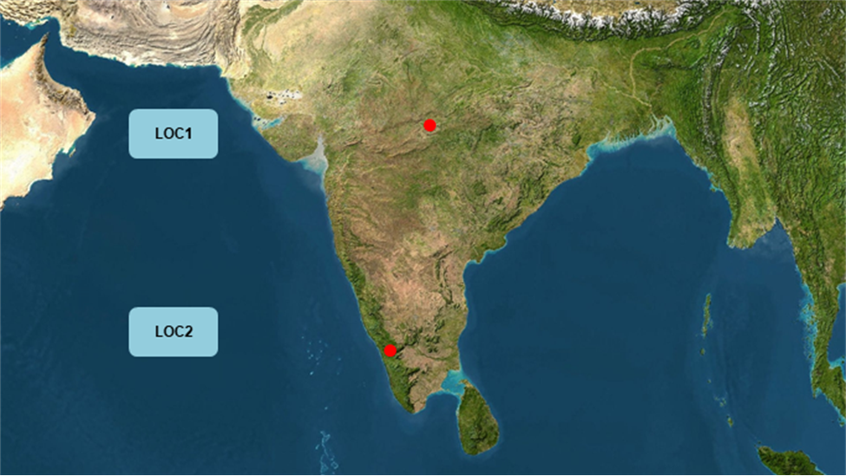

Se filtraron los niños que tenían menos de 3 años (Infantes).

NO HABRÍA QUE JUNTAR LOS FASTQS.

Script CHECK:

Run Stats Pre-filter:

1) Number of run_accessions: 219
2) Number of unique sample_accessions: 110
3) Number of unique sample_aliases: 110
4) Appearances per scientific_name(tax_id):
unique_values counts
human gut metagenome(408170) 219
5) Appearances per instrument_model(instrument_platform):
unique_values counts
NextSeq 500(ILLUMINA) 219
6) Appearances per library_layout:
unique_values counts
PAIRED 219
7) Appearances per library_strategy+library_source:
unique_values counts
WGS+METAGENOMIC 110
AMPLICON+METAGENOMIC 109

Run Stats Post-filter:

1) Number of run_accessions: 106
2) Number of unique sample_accessions: 106
3) Number of unique sample_aliases: 106
4) Appearances per scientific_name(tax_id):
unique_values counts
human gut metagenome(408170) 106
5) Appearances per instrument_model(instrument_platform):
unique_values counts
NextSeq 500(ILLUMINA) 106
6) Appearances per library_layout:
unique_values counts
PAIRED 106
7) Appearances per library_strategy+library_source:
unique_values counts
WGS+METAGENOMIC 106

