How to deploy Machine Learning models on Android and IOS with Telegram Bots

[](https://medium.com/@kevindegila?source=post_page-----a6fb16922741--------------------------------)

[Kevin Degila](https://medium.com/@kevindegila?source=post_page-----a6fb16922741--------------------------------)

Follow

[Oct 16](https://medium.com/analytics-vidhya/how-to-deploy-machine-learning-models-on-android-and-ios-with-telegram-bots-a6fb16922741?source=post_page-----a6fb16922741--------------------------------) · 7 min read

In this blog post, I’ll show you how to bring your Machine Learning model to mobile phones, both Android and IOS with Telegram Bots and host it on heroku for free.

Image for post



I’m sure, you have seen a demo of my Mask Detection Bot. If you haven’t, [**click here**](https://youtu.be/i1-vxmxwqGA). I will describe step by step how you can do the same in a matter of minutes. But First why did I do this and how can this Mask detection bot be useful ?

Inspiration for this project

I had the idea for this when I saw this tweet by Uber, introducing their mask verification feature for both drivers and riders:

Uber’s Tweet

Well, I wanted to do the same and reproduce the user experience, meaning, taking a photo in an app and have a mask detection response.

Unfortunately, like most Data Scientists and Machine Learning Engineer, I don’t have Mobile apps creation skills. I thought about learning Flutter so i can deploy on both IOS and Android, but hey, I already have a list of skills to learn on my backlog.

I’ve discovered later that you can create bots on Telegram for free and since Telegram is available on all mobile platforms and on windows, mac and linux as well, then it could be used to serve deep learning models.

So, what do we need for this project:

* Data : Images of people wearing masks and people not wearing masks
* Model: We will use Fastai v2 to train a model leveraging Transfert Learning
* Telegram account : obviously
* An Heroku account: For hosting

Let’s start.

Data

I didn’t have to build a Dataset from scratch. I found this [repo](https://github.com/prajnasb/observations) by [Prajna Bhandary](https://www.linkedin.com/in/prajna-bhandary-0b03a416a/). She has already done the work. You can find the data in the experiments folder. 690 Images of people wearing mask are in a folder named “with_mask” and 686 Images of people not wearing mask in a folder named “without_mask”. That’s all we need. Let’s train a model

Model Training with Fastai v2

I’ve recently started learning fastai with the [**Deep Learning for coders**](https://www.amazon.fr/Deep-Learning-Coders-Fastai-Pytorch/dp/1492045527) book. So, this was an opportunity to practice my skills. Plus, Transfert Learning with fastai v2 is just 5 or 6 lines of code. But I could have done it with Tensorflow 2.0 too and get the same results.

Let’s install [fastai](https://github.com/fastai/fastai). It’s recommended to do it a conda environment. Install fastbook as well to get some utils files:

conda install -c fastai -c pytorch fastai  
pip install -Uqq fastbook

Open a notebook and let’s import everything needed:

import fastbook  
fastbook.setup_book()  
from fastbook import *  
from fastai.vision.all import *

Path to the data directory :

path = Path("../data")

Time to create a Dataloader. It’s just as simple as this. The datablock will get the images, use 20% of them for validation, get the labels just by taking the parent directory name and resize all images to 128*128*3

mask = DataBlock(  
 blocks=(ImageBlock, CategoryBlock),   
 get_items=get_image_files,   
 splitter=RandomSplitter(valid_pct=0.2, seed=42),  
 get_y=parent_label,  
 item_tfms=Resize(128))

Let’s look at some of the images in the validation set:

dls = mask.dataloaders(path)  
dls.valid.show_batch(max_n=10, nrows=2)

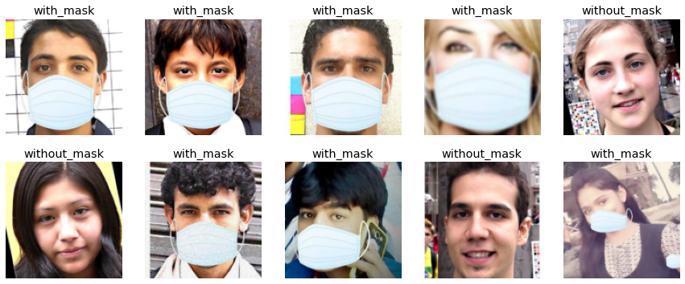

Some images for our mask detection dataset

We can already see that some images where created by simply adding a mask to people’s faces. Good to know.

We can now add some data augmentation steps and train our model with Transfert learning using a resnet18:

mask = mask.new(  
 item_tfms=RandomResizedCrop(224, min_scale=0.5),  
 batch_tfms=aug_transforms())  
dls = mask.dataloaders(path)learn = cnn_learner(dls, resnet18, metrics=error_rate)  
learn.fine_tune(4)

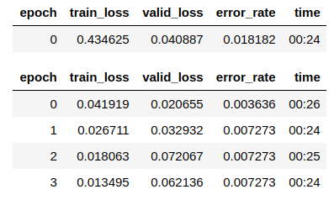

training

And just like that, in just 2 min on my local machine, we have a 99 % accuracy. How amazing is that! Let’s look at the confusion matrix:

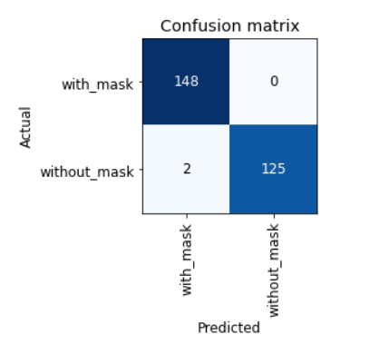

confusion matrix

Only 2 instances of people without mask misclassified as wearing mask. We can export this model and start writing code for our bot.

learn.export("model.pkl")

Telegram Bot for our model

This is the fun part, and it is surprisingly so simple. To create a bot on Telegram, search **BotFather** on Telegram, sent this command : **/newbot**and it will ask your bot’s name and his username. Once you finish those steps, you will get a **link** to access your bot and a **token** which will be used in the code to interact with the it.

Something like this :

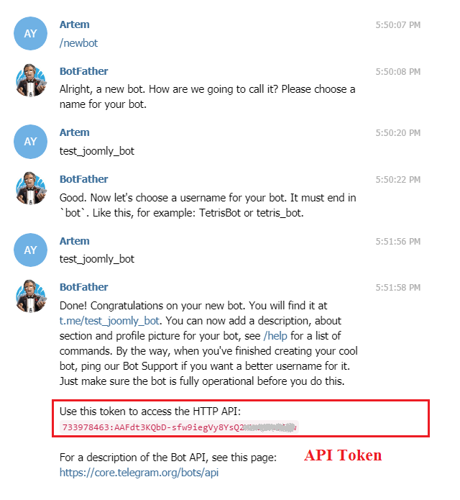

BotFather

Go to your favorite code editor, Pycharm in my case, and let’s write the script for the bot.

We will be using the [**python-telegram-bot library**](https://github.com/python-telegram-bot/python-telegram-bot). Install with :

pip install python-telegram-bot

Imports of libraries as usual with fastai for model loading:

import logging  
from telegram.ext import Updater, CommandHandler, MessageHandler, Filters  
from fastai.vision.all import load_learner

All telegram bots must define a function for specials commands **/start**and **/help**.

def start(update, context):  
 update.message.reply_text(  
 "Bot by @kevindegila on Twitter \n\n "  
 "EN : Just send me a photo of you and I will tell you if you're wearing a mask 😏 \n"  
 "FR : Envoie moi une photo de toi et je te dirai si tu portes un masque 😏"  
 )  
  
  
def help_command(update, context):  
 update.message.reply_text('My only purpose is to tell you if you are wearing a mask. Send a photo')

As you can see, these functions take an update and a context as input and send text to the bot using the **update.message.reply_text()** function.

An instance of the Updater class receive the commands and messages entered by users, forward them to a dispatcher which gives the messages to different handlers:

def main():  
 updater = Updater(token="token", use_context=True)  
 dp = updater.dispatcher dp.add_handler(CommandHandler("start", start))  
 dp.add_handler(CommandHandler("help", help_command)) updater.start_polling()  
 updater.idle()if __name__ == '__main__':  
 main()

At this step, you can run your bot by running the script and send message for the special commands.

Let’s add the mask detection feature. We will define a function to load our model, another function for when we receive images from users, and pass thi function to a Message handler with filters for images:

def load_model():  
 global model  
 model = load_learner('model/model.pkl')  
 print('Model loaded')def detect_mask(update, context):  
 user = update.message.from_user  
 photo_file = update.message.photo[-1].get_file()  
 photo_file.download('user_photo.jpg')  
   
 label = model.predict('user_photo.jpg')[0]  
 if label == "with_mask":  
 update.message.reply_text(  
 "EN: Looks like you are wearing a mask 😷. I hope you don't forget it when going out!😉 \n\n"  
 "FR: On dirait que tu portes un masque 😷, J'espère que tu ne l'oublies pas quand tu sors! 😉"  
 )  
 else:  
 update.message.reply_text(  
 "EN: Looks like you are not wearing a mask 😷. Please wear one and stay safe 🙄\n\n"  
 "FR: On dirait que tu ne portes pas un masque 😷. S'il te plait, va en porter un. Fais attention 🙄"  
 )

You can see how we download images and pass it our model and get the label with **label = model.predict(‘user_photo.jpg’)[0]**. We just send different messages based on which label is predicted.

Our main function now look like this:

def main():  
 load_model()  
 updater = Updater(token="token", use_context=True)  
 dp = updater.dispatcher  
 dp.add_handler(CommandHandler("start", start))  
 dp.add_handler(CommandHandler("help", help_command))  
  
 dp.add_handler(MessageHandler(Filters.photo, detect_mask))  
  
 updater.start_polling()  
 updater.idle()

That’s it for our bot. Everything is ready and it should work on your laptop.

Now, let’s deploy it on heroku for free.

Deploying Telegram Bot on Heroku

Go to <https://www.heroku.com/> and sign up if you don’t already have an account. Second step is to go to your <https://dashboard.heroku.com/> to create a new app by clicking on the **new** button:

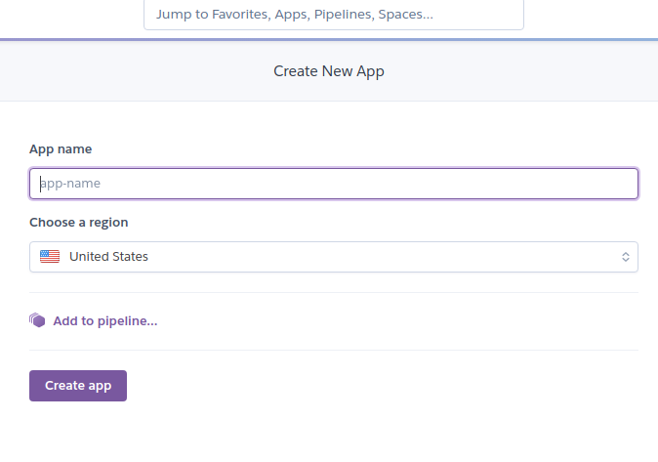

App creation on heroku

Once your app is created, you need to create 3 special files is your project folder:

* A file named **Procfile** to tell Heroku how to run your code:

worker: python main.py

* A file named runtime.txt to tell Heroku which version of Python to install:

python-3.7.0

* A file named requirements.txt to tell heroku to install some libraries. Here we install the cpu version of Pytorch to avoid exceeding the slug size of 500Mb on Heroku. Make sure to set fastai to the same version you trained your model with:

python-telegram-bot  
-f https://download.pytorch.org/whl/torch_stable.html  
fastai==2.0.13  
torch==1.6.0+cpu  
torchvision==0.7.0+cpu

Now you just need to do this next steps to have your bot hosted and available at all time:

* Create a repo and commit all your files to master
* Write the **heroku login** command to connect to your Heroku account
* Add heroku as a distant repo with **heroku git:remote -a app_name** with app_name being your app name on heroku
* Deploy by pushing your code to Heroku with : **git push heroku master**

That’s it. You can check if everything is working by testing on telegram and seeing the logs with **heroku logs — tail** .

Few considerations about Ethics

Here are few things worth considering when creating a project like this one :

* **About the model** : Does it recognize mask on all colors of skin, on all genders ? You mush check for biases before deploying this kind of model.
* **About the bot** : Should it saved user images ? Have they accepted the collection of their data? In my case I don’t keep images for this bot. If I did I would exceed the slug size anyway.