**Date Submitted: 11-25-2018**

**Task 1+2: Building and loading the collector example and the sensor example.**

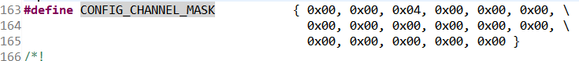

Channel mask config for both collector and sensor.

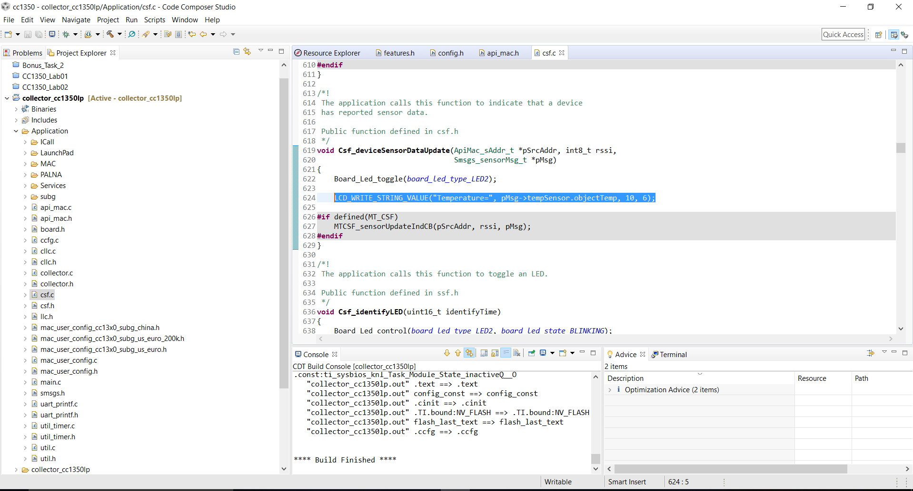

Modified line from csf.c on collector to print out temperature. (highlighted blue)

Youtube Link: No video required for this part.

**Modified Code:** highlighted in image above.

**------------------------------------------------------------------------------------**

**Task 03: Using the Collector and Sensor**

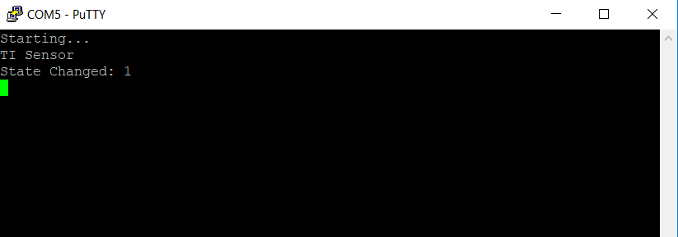

Sensor UART. Successfully starting.

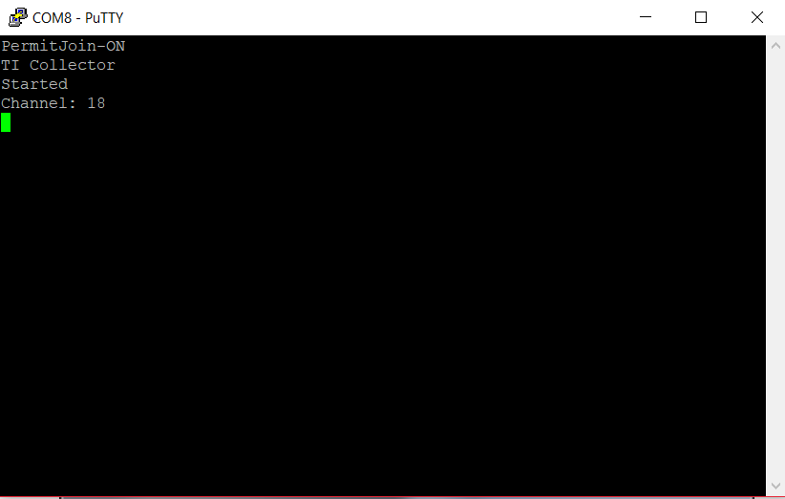

Collector UART. Successfully starting.

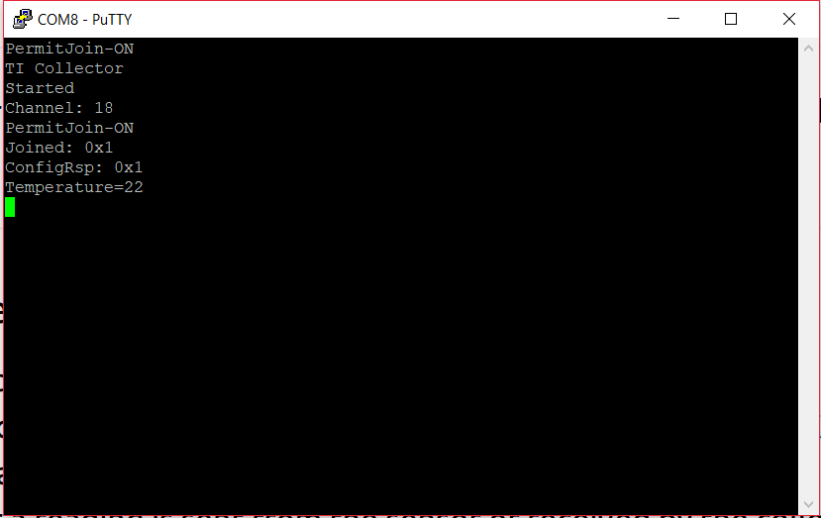

Collector UART. Sensor has joined and sent over temperature.

Youtube Link: <https://youtu.be/EeSAvy8vkXU>

**Modified Code:** No code was modified.

**------------------------------------------------------------------------------------**

**Task 04: Updating the sensor's reporting rate**

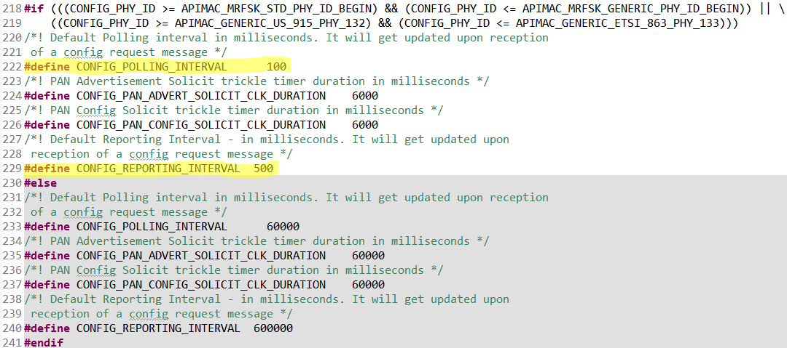

Reporting and Polling intervals changed on sensor config. (highlighted in yellow)

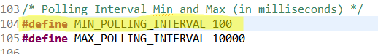

Minimum polling interval changed in sensor sensor.c. (highlighted in yellow)

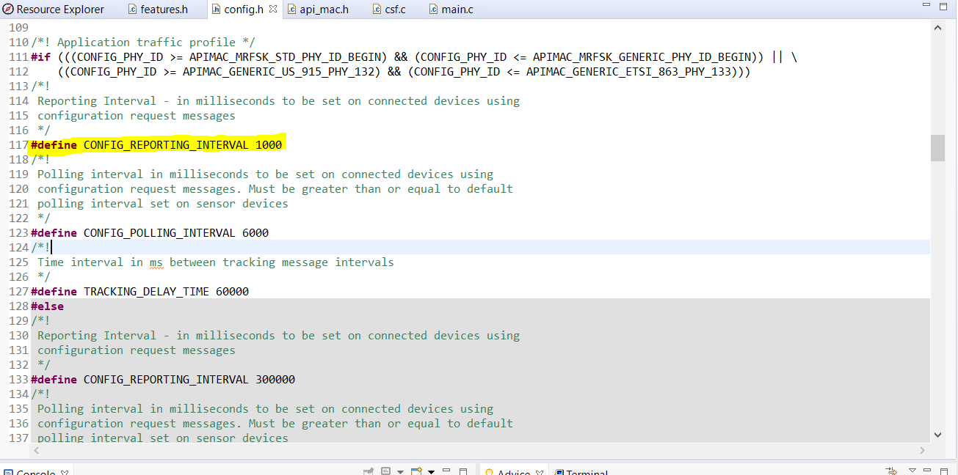

Reporting interval change for collector config. (highlighted in yellow)

Youtube Link: <https://youtu.be/XFslj5QEuDs>

**Modified Code:** Highlighted in yellow on images above.