Enrique Saldana

CPE 403 ADV EMB SYS DES FALL 2018

Title: TIVAC MIDTERM

Goals:

* Read lux values using TSL 2591 Lux Sensor
* Communicate lux valuse to ESP using UART
* Send lux values to Thinkspeak Server using the ESP
* Hibernate program to send values every 45 seconds

Deliverables:

The project is intended to collect lux values for an extended period of time and write these values to the Thinkspeak server which will display these values in a graph.

Schematics:

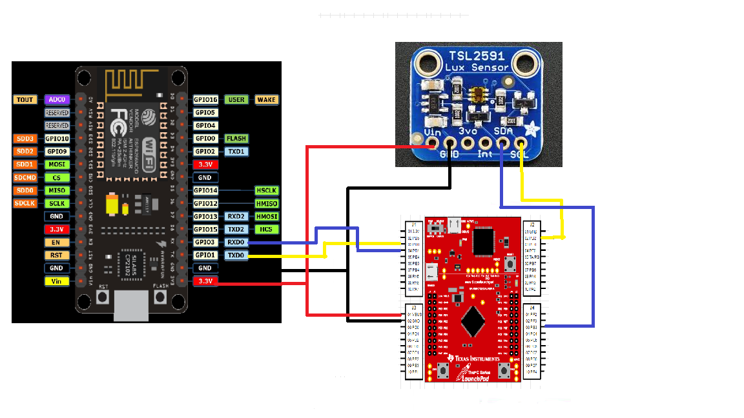

Implementation:

* Initialize integer variables
* Initialize UART, I2C, and TSL2591(lux sensor)
* Using a 40MHz clock configure system to hibernate for 45 seconds
* Take 20 samples of the lux value and use the average as the sample to send throught UART
* Send commands throught UART in order to have the ESP upload data to Thinkspeak server
* Hibernate for 45 seconds and then repeat sending lux data

Code:

**#include** <stdarg.h>

**#include** <stdbool.h>

**#include** <stdint.h>

**#include** "inc/tm4c123gh6pm.h"

**#include** "inc/hw_i2c.h"

**#include** "inc/hw_memmap.h"

**#include** "inc/hw_types.h"

**#include** "inc/hw_gpio.h"

**#include** "driverlib/i2c.h"

**#include** "driverlib/sysctl.h"

**#include** "driverlib/gpio.h"

**#include** "driverlib/pin_map.h"

**#include** "driverlib/uart.h"

**#include** "utils/uartstdio.h"

**#include** "driverlib/interrupt.h"

**#include** "driverlib/hibernate.h"

**#include** "TSL2591_def.h"

**#include** "utils/ustdlib.h"

**void** **ConfigureUART**(**void**)

//Configures the UART to run at 19200 baud rate

{

**SysCtlPeripheralEnable**(SYSCTL_PERIPH_UART1); //enables UART module 1

**SysCtlPeripheralEnable**(SYSCTL_PERIPH_GPIOB); //enables GPIO port b

**GPIOPinConfigure**(GPIO_PB1_U1TX); //configures PB1 as TX pin

**GPIOPinConfigure**(GPIO_PB0_U1RX); //configures PB0 as RX pin

**GPIOPinTypeUART**(GPIO_PORTB_BASE, GPIO_PIN_0 | GPIO_PIN_1); //sets the UART pin type

**UARTClockSourceSet**(UART1_BASE, UART_CLOCK_PIOSC); //sets the clock source

**UARTStdioConfig**(1, 115200, 16000000); //enables UARTstdio baud rate, clock, and which UART to use

}

**void** **I2C0_Init** ()

//Configure/initialize the I2C0

{

**SysCtlPeripheralEnable** (SYSCTL_PERIPH_I2C0); //enables I2C0

**SysCtlPeripheralEnable** (SYSCTL_PERIPH_GPIOB); //enable PORTB as peripheral

**GPIOPinTypeI2C** (GPIO_PORTB_BASE, GPIO_PIN_3); //set I2C PB3 as SDA

**GPIOPinConfigure** (GPIO_PB3_I2C0SDA);

**GPIOPinTypeI2CSCL** (GPIO_PORTB_BASE, GPIO_PIN_2); //set I2C PB2 as SCLK

**GPIOPinConfigure** (GPIO_PB2_I2C0SCL);

**I2CMasterInitExpClk** (I2C0_BASE, **SysCtlClockGet**(), false); //Set the clock of the I2C to ensure proper connection

**while** (**I2CMasterBusy** (I2C0_BASE)); //wait while the master SDA is busy

}

**void** **I2C0_Write** (uint8_t addr, uint8_t N, ...)

//Writes data from master to slave

//Takes the address of the device, the number of arguments, and a variable amount of register addresses to write to

{

**I2CMasterSlaveAddrSet** (I2C0_BASE, addr, false); //Find the device based on the address given

**while** (**I2CMasterBusy** (I2C0_BASE));

va_list vargs; //variable list to hold the register addresses passed

va_start (vargs, N); //initialize the variable list with the number of arguments

**I2CMasterDataPut** (I2C0_BASE, va_arg(vargs, uint8_t)); //put the first argument in the list in to the I2C bus

**while** (**I2CMasterBusy** (I2C0_BASE));

**if** (N == 1) //if only 1 argument is passed, send that register command then stop

{

**I2CMasterControl** (I2C0_BASE, I2C_MASTER_CMD_SINGLE_SEND);

**while** (**I2CMasterBusy** (I2C0_BASE));

va_end (vargs);

}

**else**

//if more than 1, loop through all the commands until they are all sent

{

**I2CMasterControl** (I2C0_BASE, I2C_MASTER_CMD_BURST_SEND_START);

**while** (**I2CMasterBusy** (I2C0_BASE));

uint8_t i;

**for** (i = 1; i < N - 1; i++)

{

**I2CMasterDataPut** (I2C0_BASE, va_arg(vargs, uint8_t)); //send the next register address to the bus

**while** (**I2CMasterBusy** (I2C0_BASE));

**I2CMasterControl** (I2C0_BASE, I2C_MASTER_CMD_BURST_SEND_CONT); //burst send, keeps receiving until the stop signal is received

**while** (**I2CMasterBusy** (I2C0_BASE));

}

**I2CMasterDataPut** (I2C0_BASE, va_arg(vargs, uint8_t)); //puts the last argument on the SDA bus

**while** (**I2CMasterBusy** (I2C0_BASE));

**I2CMasterControl** (I2C0_BASE, I2C_MASTER_CMD_BURST_SEND_FINISH); //send the finish signal to stop transmission

**while** (**I2CMasterBusy** (I2C0_BASE));

va_end (vargs);

}

}

uint32_t **I2C0_Read** (uint8_t addr, uint8_t reg)

//Read data from slave to master

//Takes in the address of the device and the register to read from

{

**I2CMasterSlaveAddrSet** (I2C0_BASE, addr, false); //find the device based on the address given

**while** (**I2CMasterBusy** (I2C0_BASE));

**I2CMasterDataPut** (I2C0_BASE, reg); //send the register to be read on to the I2C bus

**while** (**I2CMasterBusy** (I2C0_BASE));

**I2CMasterControl** (I2C0_BASE, I2C_MASTER_CMD_SINGLE_SEND); //send the send signal to send the register value

**while** (**I2CMasterBusy** (I2C0_BASE));

**I2CMasterSlaveAddrSet** (I2C0_BASE, addr, true); //set the master to read from the device

**while** (**I2CMasterBusy** (I2C0_BASE));

**I2CMasterControl** (I2C0_BASE, I2C_MASTER_CMD_SINGLE_RECEIVE); //send the receive signal to the device

**while** (**I2CMasterBusy** (I2C0_BASE));

**return** **I2CMasterDataGet** (I2C0_BASE); //return the data read from the bus

}

**void** **TSL2591_init** ()

//Initializes the TSL2591 to have a medium gain,

{

uint32_t x;

x = I2C0_Read (TSL2591_ADDR, (TSL2591_COMMAND_BIT | TSL2591_ID)); //read the device ID

**if** (x == 0x50)

{

// UARTprintf ("GOT IT! %i\n", x); //used during debuging to make sure correct ID is received

}

**else**

{

**while** (1){}; //loop here if the dev ID is not correct

}

I2C0_Write (TSL2591_ADDR, 2, (TSL2591_COMMAND_BIT | TSL2591_CONFIG), 0x10); //configures the TSL2591 to have medium gain adn integration time of 100ms

I2C0_Write (TSL2591_ADDR, 2, (TSL2591_COMMAND_BIT | TSL2591_ENABLE), (TSL2591_ENABLE_POWERON | TSL2591_ENABLE_AEN | TSL2591_ENABLE_AIEN | TSL2591_ENABLE_NPIEN)); //enables proper interrupts and power to work with TSL2591

}

uint32_t **GetLuminosity** ()

//This function will read the channels of the TSL and returns the calculated value to the caller

{

**float** atime = 100.0f, again = 25.0f; //the variables to be used to calculate proper lux value

uint16_t ch0, ch1; //variable to hold the channels of the TSL2591

uint32_t cp1, lux1, lux2, lux;

uint32_t x = 1;

x = I2C0_Read (TSL2591_ADDR, (TSL2591_COMMAND_BIT | TSL2591_C0DATAH));

x <<= 16;

x |= I2C0_Read (TSL2591_ADDR, (TSL2591_COMMAND_BIT | TSL2591_C0DATAL));

ch1 = x>>16;

ch0 = x & 0xFFFF;

cp1 = (uint32_t) (atime * again) / TSL2591_LUX_DF;

lux1 = (uint32_t) ((**float**) ch0 - (TSL2591_LUX_COEFB * (**float**) ch1)) / cp1;

lux2 = (uint32_t) ((TSL2591_LUX_COEFC * (**float**) ch0) - (TSL2591_LUX_COEFD * (**float**) ch1)) / cp1;

lux = (lux1 > lux2) ? lux1: lux2;

**return** lux;

}

**void** **main** (**void**)

{

**char** HTTP_POST[300]; //string buffer to hold the HTTP command

**SysCtlClockSet**(SYSCTL_SYSDIV_5|SYSCTL_USE_PLL|SYSCTL_XTAL_16MHZ|SYSCTL_OSC_MAIN); //set the main clock to runat 40MHz

uint32_t lux = 0, i;

uint32_t luxAvg = 0;

ConfigureUART (); //configure the UART of Tiva C

I2C0_Init (); //initialize the I2C0 of Tiva C

TSL2591_init (); //initialize the TSL2591

**SysCtlPeripheralEnable** (SYSCTL_PERIPH_HIBERNATE); //enable button 2 to be used during hibernation

**HibernateEnableExpClk** (**SysCtlClockGet**()); //Get the system clock to set to the hibernation clock

**HibernateGPIORetentionEnable** (); //Retain the pin function during hibernation

**HibernateRTCEnable** (); //enable RTC hibernation

**HibernateRTCSet** (0); //Set RTC hibernation

**HibernateRTCMatchSet** (0, **HibernateRTCGet**()+45); //hibernate for 30 minutes

**HibernateWakeSet** (HIBERNATE_WAKE_PIN | HIBERNATE_WAKE_RTC); //allow hibernation wake up from RTC time or button 2

**for** (i = 0; i < 20; i++)

//finds the average of the lux channel to send through uart

{

lux = GetLuminosity ();

luxAvg += lux;

}

luxAvg = luxAvg/20;

**UARTprintf** ("AT+RST\r\n"); //reset the esp8266 before pushing data

**SysCtlDelay** (100000000);

**UARTprintf** ("AT+CIPMUX=1\r\n"); //enable multiple send ability

**SysCtlDelay** (20000000);

**UARTprintf** ("AT+CIPSTART=4,\"TCP\",\"184.106.153.149\",80\r\n"); //Establish a connection with the thingspeak servers

**SysCtlDelay** (50000000);

//The following lines of code puts the TEXT with the data from the lux in to a string to be sent through UART

**usprintf** (HTTP_POST, "GET /update?key=AJSGNO2JLU6Y93LZ&field1=%d&headers=falseHTTP/1.1\nHostapi.thingspeak.com\nConnection:close\Accept*\*\r\n\r\n", luxAvg);

**UARTprintf** ("AT+CIPSEND=4,%d\r\n", strlen(HTTP_POST)); //command the ESP8266 to allow sending of information

**SysCtlDelay** (50000000);

**UARTprintf** (HTTP_POST); //send the string of the HTTP GET to the ESP8266

**SysCtlDelay** (50000000);

**HibernateRequest** (); //Hibernate

**while** (1)

{};

}