Lab 06 – Methods

Enrique Saracho Felix

100406980

CPSC 1150

26/06/2023

# Exercise 1

A. Running ScopeOfVariables.java…



After removing comments:

B. The value of *x* after calling update method while in the main method is still 10. It only changes to 15 inside the update method block. This is because *x* in main is a local variable.

C. Modified update method to return new value of *x* to main method.

Now the update method returns a new value to main where is set in *x*.

D. Commented out line 14 and removed comment from line 4.

This change removed the *ADD* constant from the update method and created an *ADD* constant in the main method. The error is because the constant is local to the main method. So, when the update method tries to use it, it doesn’t recognize it and creates a compile error.

E. Commented out line 4 and removed comment from line 2.

This change eliminated the *ADD* constant from the update method, and created a global constant *ADD* outside the methods (in the class block). So now the update method can access its value and add it to *x*. Changing the value from 10 to 25.

F. Removed comment from line 14.

This change brought back the local *ADD* constant to the update method. The update method now has access to two different *ADD* constants, the local one and the global one, but gives preference to the local one and adds its value to *x*. Making it 15.

G. The modifiers in line 2 are *final* and *static*. In line 14 is *final*.

H. Removed *static* modifier in line 2 and commented out line 14.

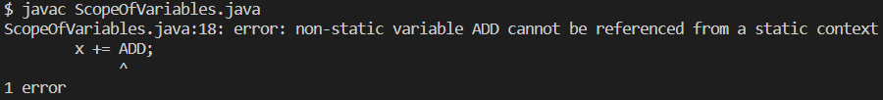

This change made the *ADD* constant an instance variable and can’t be accessed by static methods. Also, it eliminated the *ADD* local constant from the update method, so when this method tries to use the constant’s value it creates a compile error.

# Exercise 2

## Program SumDigits.java

**File name:** lab06\SumDigits.java

**Purpose:** To take two positive integers as input and check whether the sum of even digits of both numbers are equal.

**Packages:** (list of imported packages)

**Limitations:** (input it can’t handle, list of possible error messages, round-off error)

**Bugs:** (list of unfixed bugs)

**Input:** Two positive integer numbers (*a* and *b*).

**Output:** A boolean value, displaying true if both sum of even digits of *a* and *b* are equal. Displaying false if otherwise.

**Pseudocode:**

Algorithm SumDigits

START

(main)

Set *a* and *b* as integer variables

a = getData()

b = getData()

Print isSumEqual(*a*, *b*)

(getData)

Set *flag* = false

Set *num* as integer variable

Do

{

If (*flag*)

{

Display error message

}

Display prompt message

Read *num*

*flag* = true

} While (*num* < 0)

Return *num*

(isSumEqual(*a*, *b*))

Return (sumOfEven(*a*) = sumOfEven(*b*))

(sumOfEven(*num*))

Set *sum* = 0

Set *digit* as an integer variable

{

*digit* = *num* % 10

If *digit* % 2 = 0

{

*sum* += *digit*

}

*num* /= 10

}

Return *sum*

END SumDigits

**Test run(s):**

