**Smart River-Monitoring System**

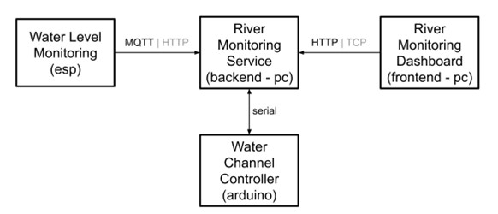This embedded project is based on 4 subsystems.  
  
Figure 1 – System outline

The system is composed of 4 subsystems:

* **Water Level Monitoring** subsystem (running on ESP32 SoC):
  + embedded system to monitor the water level of a river
  + it interacts with the *River Monitoring Service* subsystem (via MQTT)
* **Water Channel Controller** subsystem (running on Arduino microcontroller):
  + embedded system controlling the gate/valve of a water channel
  + it interacts via serial line with the *River Monitoring Service* subsystem
* **River Monitoring Service** subsystem (backend - running on a PC server):
  + service functioning as the main unit governing the management of the Smart River-Monitoring System
  + it interacts through the serial line with the *Water Channel Controller* subsystem
  + it interacts via MQTT with the *Water Level Monitoring* subsystem
  + it interacts via TCP with the *River Monitoring Dashboard* subsystem
* **River Monitoring Dashboard** subsystem (frontend/web app - running on the PC):
  + frontend to visualize and track the state of the *River Monitoring Service* subsystem
  + it interacts with the R*iver Monitoring Service* subsystem via TCP

1. **Water Level Monitoring**

It runs on ESP32-S3 [devkitC-1 n16r8v](https://github.com/EnryMarch10/SmartRiverMonitoringSystem/blob/develop/water-level-monitoring/boards/esp32-s3-devkitc-1-n16r8v.json" \o "esp32-s3-devkitc-1-n16r8v.json).

Manages the water level sampling and is coordinated by the River Monitoring Service.

At first, it connects to WIFI through given credentials. Credentials must be correct for the system to work, so they must be set “location dependently”. If WIFI disconnects the SoC tries to reconnect to it. If the connection can’t be established for any reason the ESP32 is unable to communicate with the River Monitoring Service, so the System does not work properly.

If the WIFI connection is established correctly than the SoC can connect with the MQTT broker, particularly [broker.emqx.io](https://www.emqx.com/en/mqtt/public-mqtt5-broker). The connection is secured by attacks because TLS is used to identify the correct server thanks to a certificate (source <https://github.com/emqx/MQTT-Client-Examples>).  
In this case two topics are considered:

* *“SmartRiverMonitoringSystem/WaterLevelMonitoring/Period”*, where this subsystem listens for a new sampling period sent from the River Monitoring Service
* *“SmartRiverMonitoringSystem/WaterLevelMonitoring/WaterLevel”*, where this subsystem publishes the water levels sampled at the specified period

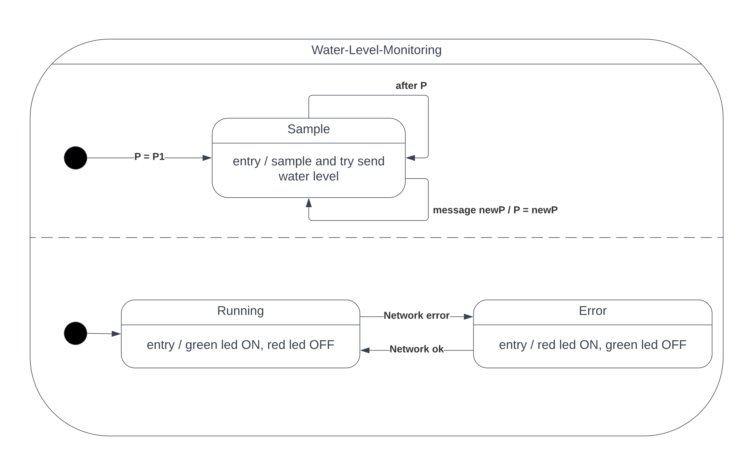For what concerns the connection with the internet: when the system works correctly, the network is OK, a green led is on, while when the connection cannot be maintained, a red led is turned on instead.

Figure 2 - Water Level Monitoring FSMs

1. **Water Channel Controller**

It runs on ARDUINO UNO.

Manages the valve opening level in AUTOMATIC or MANUAL modalities.

It does not need the network because it communicates with the River Monitoring Service via serial line.

It manages the modality of the system that can be:

* LOCAL - it is toggled by a button
  + “AUTOMATIC” – it is coordinated by the River Monitoring Service in whatever modality it wants
    - WHATEVER – the River Monitoring Service decides the valve opening level from remote (via serial communication)
  + “MANUAL” – it reads the value of a potentiometer and sets the valve opening level according to the read value
* REMOTE - it is toggled by the communication with the River Monitoring Service and is triggered by the River Monitoring Dashboard (“AUTOMATIC” or “REMOTE_MANUAL”)

LOCAL modality rules over the REMOTE one. The “REMOTE_MANUAL” text was chosen to differentiate it from the “MANUAL” mode set interacting directly with the Water Channel Controller.

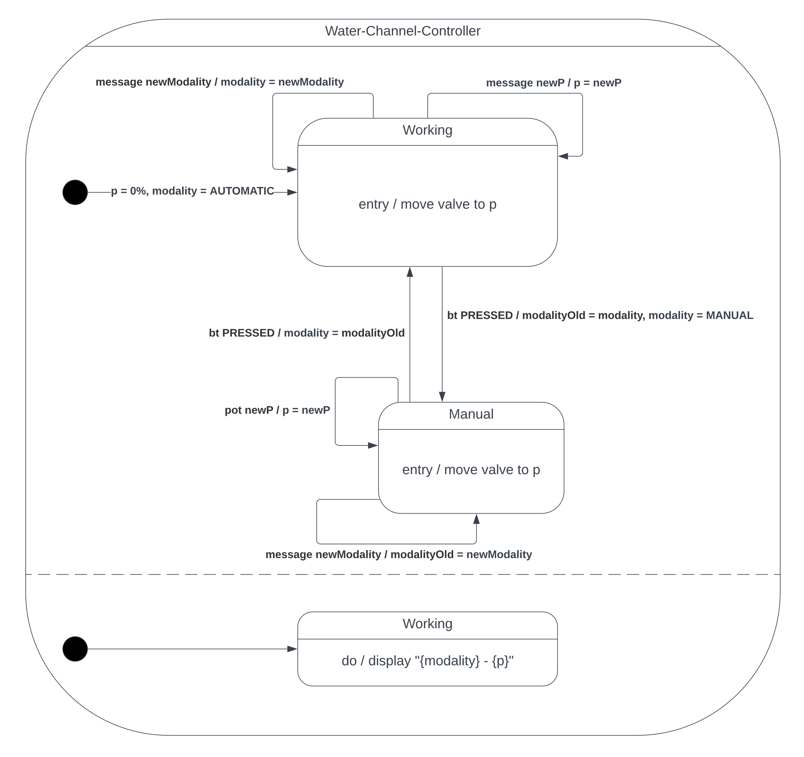Modality (in the three quoted texts listed) and valve opening level are shown in a display.

Figure 3 - Water Channel Controller FSMs

1. **River Monitoring Service**

It runs on the PC. I chose a Python application.

Manages the system policy as requested. This service can be considered the core of the system.  
The chosen states trigger a change in the behaviors of the two previously described subsystems:

|  |  |  |
| --- | --- | --- |
| STATE | WATER LEVEL SAMPLING PERIOD (s) | VALVE LEVEL (%) |
| ALARM-TOO-LOW | 10 | 0 |
| NORMAL | 10 | 25 |
| PRE-ALARM-TOO-HIGH | 2 | 25 |
| ALARM-TOO-HIGH | 2 | 50 |
| ALARM-TOO-HIGH-CRITIC | 2 | 100 |

This subsystem decides the overall policy and behavior of the Smart River-Monitoring System, depending on the water level as measured by the Water Level Monitoring subsystem, policy:

* When the water-level is < WL1, the system is in an ALARM-TOO-LOW state:
  + in this state, the valve opening level should be 0%
* When the water-level is in the range [WL1, WL2], then the system is considered in a NORMAL state. In the NORMAL state:
  + the period to be used for monitoring the water level is T1
  + the valve opening level should be 25%
* When the water-level is > WL2, there are three further cases:
  + WL2 < water-level <= WL3 → the system is in a PRE-ALARM-TOO-HIGH state:
    - In this state, the period to be used for monitoring the water-level should be increased to T2 (where T2 < T1)
  + WL3 < water-level <= WL4 → ALARM-TOO-HIGH state:
    - In this state the period is still T2, but the valve opening level must be 50%
  + water-level > WL4 → ALARM-TOO-HIGH-CRITIC state:
    - In this state, the period is still T2, but the valve opening level should be 100%

I chose the following data:

* periods: T1 = 10 s and T2 = 2 s (to replace F1 and F2)
* water levels: WL1 = 5, WL2 = 10, WL3 = 15, WL4 = 20 from lowest to highest water levels, only for testing purposes (they are the centimeters measured by the Waster Level Monitoring sonar)

The modality of the Water Channel Controller could also be managed by the River Monitoring Dashboard that can set it as “REMOTE_MANUAL”. In this case if the Water Channel Controller accepts the valve opening level can be set directly by an operator from remote, independently from the described policy of this subsystem.  
It is also managed a time set a TIMEOUT that resets the modality to “AUTOMATIC” if the “REMOTE_MANUAL” operator doesn’t interact with the valve level for a time of 20 s (so low only for test purposes).

This service communicates via MQTT with the Water Level Monitoring signing to the described topics in the specular way. Even here the same MQTT broker and TLS system is used (source <https://github.com/emqx/MQTT-Client-Examples>). In particular:

* *“SmartRiverMonitoringSystem/WaterLevelMonitoring/Period”*, in this case the subsystem sends the period
* *“SmartRiverMonitoringSystem/WaterLevelMonitoring/WaterLevel”*, in this case the subsystem listens for the water level

This subsystem uses threads to communicate with other subsystems.

1. **River Monitoring Dashboard**

It runs on the PC. I chose a Flask (Python) web application.

Shows System data by communicating with the River Monitoring Service.

Its main components are:

* A web server
* A persistent TCP Client that listens with the River Monitoring Service (server 1) to fetch updated data
* A non-persistent TCP Client that communicates with the River Monitoring Service (server 2) to toggle the modality from “AUTOMATIC” to “REMOTE_MANUAL”
* A non-persistent TCP Client that communicates with the River Monitoring Service (server 3) to send new valve level when in “REMOTE_MANUAL” mode

It appears as an HTML file. The browser side uses JavaScript with AJAX to fetch data from this web server.

The server uses daemon threads to communicate with the River Monitoring Service via TCP.

Shows if the River Monitoring Service is unreachable, otherwise considers the connection ok.  
Shows also:

* Current System State
* Current valve level (%)
* Measured water levels in a graph (10 to simplify) with approximative measurements River Monitoring Service times (considering that the Water Level Monitoring subsystem runs on ESP32 that does not have a notion of time synchronized with the external environment this solution was adopted)

The web dashboard enables also to have a MANUAL (remote) control on the Water Channel Controller.

Figure 4 - embedded systems (Arduino + ESP32) components