Blixem User Manual

Written by Gemma Barson
<gb10@sanger.ac.uk>

Wellcome Trust Sanger Institute
17 January 2011

Revision History

Revision | Date | Author
First revision (Blixem v4.1.5) | 17/01/11 | Gemma Barson
Updated for Blixem v4.1.9 | 14/02/11 | Gemma Barson
Updated for Blixem v4.1.13 | 25/03/11 | Gemma Barson
Updated for Blixem v4.1.14 | 05/04/11 | Gemma Barson
Updated for Blixem v4.1.17 | 09/05/11 | Gemma Barson
Updated for Blixem v4.2 | 17/06/11 | Gemma Barson
Updated for Blixem v4.7 | 02/12/11 | Gemma Barson

Contents
Revision History 2
Introduction 5
An aside about the name “Blixem” 5
Getting Started 6
Running Blixem 6
Input files 6
GFF file: 6
FASTA file: 8
Combined GFF and FASTA file: 8
Configuration file 8
Colour key file 9
The Blixem Window 10
Active Strand 11
Big Picture 12
Bumping the transcript view 12
Detail View 13
Match colours 13
Alignment lists 13
Nucleotide mode 14
Protein mode 14
Exons 16
Coverage view 16
The toolbar 17
The main menu 19
Hiding sections of the window 19
Operation 21
Navigation 21
Scrolling 21
Zooming 22
Selections 22
Selecting sequences 22
Selecting coordinates 22
Finding sequences 23
Copy and paste 24
Sorting alignments 25
Fetching sequences 26
Grouping sequences 26
Creating a group from a selection: 26
26
Creating a group from a search: 26
Creating a temporary 'match-set' group from the current selection: 27
Editing groups: 27
Running dotter 28
Reference sequence versus itself 29
Dotter HSPs only 29
Settings 30
Features 30
Highlight variations 30
Show polyA tails 30
Display options 30
Show Unaligned Sequence 30
Show Splice Sites 30
Highlight Differences 31
Squash Matches 31
General settings 31
Font 31
Fetch mode 31
Columns 31
Load optional data 31
Column visibility 31
Grid properties 31
%ID per cell 31
Max %ID 32
Min %ID 32
Coverate view properties 32
Depth per cell 32
Appearance 32
Use print colours 32
Display colours 32
Key 33
Keyboard shortcuts 34

Introduction
This manual explains how to configure, run and use Blixem. Blixem is an interactive browser of pairwise matches displayed as multiple alignments. It is not strictly a multiple alignment tool, rather a 'one-to-many' alignment. It is used to check the alignments of nucleotide and amino acid sequences against a reference sequence.

Blixem is maintained by the Wellcome Trust Sanger Institute and is available as part of the SeqTools package. The software can be downloaded from the Sanger Institute’s website: http://www.sanger.ac.uk.

An aside about the name “Blixem”
“BLIXEM" was originally an acronym for "BLast matches In an X-windows Embedded Multiple alignment", although this is a bit of a misnomer now because Blixem can handle any kind of alignment, not just BLAST matches. We have dropped the acronym, and the capital letters, so the correct name is just “Blixem”.

Getting Started

Running Blixem
As a minimum, Blixem takes the following required arguments:

blixem –-display-type N|P <features_file>

Where <features_file> is the path name of a GFF version 3 file containing the alignments and any other features.

The ‘--display-type‘ or ‘-t‘ argument is the only mandatory argument. It defines the display mode: ‘N‘ for nucleotide or ‘P‘ for protein. .

Run ‘blixem‘ without any arguments to see further usage information.

Input files
Blixem takes one or two files as input: a mandatory GFF version 3 file containing the features and, optionally, a separate file containing the reference sequence in FASTA format.

blixem –t N|P [<reference_sequence_file>] <features_file>

If the reference sequence file is not provided, the reference sequence must be supplied in FASTA format at the end of the GFF file, following a comment line that reads ‘##FASTA‘.

Note that the reference sequence must always be a nucleotide sequence and match sequences must be the correct type for the mode, i.e. nucleotide sequences for nucleotide mode or protein sequences for protein mode.

GFF file:
Blixem uses the GFF version 3 file format. In this section we give a very brief description of this file format; see http://www.sequenceontology.org/gff3.shtml for a full description.

The GFF file should start with the following two comment lines. (Additional comments can be included but may be ignored.)

##gff-version 3
##sequence-region chr4-04 44144 154265

Each subsequent line defines a feature. A feature line must have the following 8 tab-separated columns:

reference_sequence_name source type start end score strand phase

An optional 9th column defines any tags (separated by semi-colons). Blixem supports the following GFF tags. (Additional tags can be supplied but may be ignored.)
Target (required for alignments)
Gap (required for gapped alignments)
ID (required for parent features)
Name (required for transcripts and SNPs)
Parent (required for child features)

In addition, Blixem supports the following custom tags.
percentId (only applicable to alignments; populates the %ID column)
sequence (only applicable to alignments; supplies the sequence data)
variant_sequence (only applicable to variations; supplies the variation data)
url (only used by variations; GFF3 special characters must be escaped)

Transcripts
Note that exons should have a Parent transcript defined, and the Name tag should be set in the parent rather than the child exons. Note that Blixem will recognise exons that do not have a Parent tag if they have a Name tag instead, but they may not get grouped correctly with other exons from the same transcript.

Typically, one defines the parent transcript, the exons, and the CDS regions; Blixem will then calculate the missing components (in this case, the UTR regions and the introns). Blixem will recognise other combinations of inputs, and will always calculate the missing components as long as enough information is provided.

Variations
SNPs, insertions and deletions are supported, as well as combined variations. One may use the generic ‘sequence_alteration‘ type for these but it is good practice to use more specific types such as ‘SNP‘ or ‘deletion‘ where applicable.

Sample GFF file
A sample GFF file may look like this (‘…‘ denotes that text has been omitted).

##gff-version 3
##sequence-region chr4-04 44144 154265
chr4-04 EST_Human nucleotide_match 79195 79311 95.000000 - . Target=DA692754.1 287 403 +;percentID=90.6;sequence=GATCTGGC...
chr4-04 EST_Human nucleotide_match 79195 79323 121.000000 + . Target=AI095103.1 326 454 +;percentID=96.9;sequence=TTTAAATT...
chr4-04 ensembl_variation deletion 80798 80799 . + . Name=rs60725655;url=http%3A%2F%2Fwww.ensembl.org%2FHomo_sapiens%2FVariation%2FSummary%3Fv%3Drs60725655;variant_sequence=AA/-;
chr4-04 ensembl_variation sequence_alteration 80799 80799 . + . Name=rs57681246;url=http%3A%2F%2Fwww.ensembl.org%2FHomo_sapiens%2FVariation%2FSummary%3Fv%3Drs57681246;variant_sequence=A/-/C;
chr4-04 ensembl_variation SNP 81040 81040 . + . Name=rs2352935;url=http%3A%2F%2Fwww.ensembl.org%2FHomo_sapiens%2FVariation%2FSummary%3Fv%3Drs2352935;variant_sequence=T/C;
chr4-04 ensembl_variation insertion 82229 82230 . + . Name=rs35105663;url=http%3A%2F%2Fwww.ensembl.org%2FHomo_sapiens%2FVariation%2FSummary%3Fv%3Drs35105663;variant_sequence=-/G;
chr4-04 Augustus mRNA 119534 119941 . - . ID=transcript21;Name=AUGUSTUS00000051712
chr4-04 Augustus exon 119534 119941 . - . Parent=transcript21
chr4-04 Augustus CDS 119534 119941 . - 0 Parent=transcript21

FASTA file:
A FASTA file has a header line that starts with ‘>’. We use a custom FASTA header format that contains the sequence name followed by the start and end coordinates, separated by spaces. Note that the FASTA sequence range may be different to the GFF file range.
The next line contains the start of the sequence data. The sequence data can be on a single line or separated by newlines; it is usually separated by newlines every 50 characters to aid readability.

>chr4-04 44144 154265
tcttgtttctgtaggagaggccatctccatcagctataaccaaaaaaaaa
acaaaaaactcctctttttgacaagtttgtaaagcctgtccatctgggtc
tataataatcctccaggccctatgccactcctctttattcagccagttca
...

Combined GFF and FASTA file:
##gff-version 3
##sequence-region chr4-04 44144 154265
chr4-04_210623-364887 EST_Human nucleotide_match 79195 79311 95.000000 - . Target=DA692754.1 287 403 +;percentID=90.6
chr4-04_210623-364887 EST_Human nucleotide_match 79195 79323 121.000000 + . Target=AI095103.1 326 454 +;percentID=96.9
...
##FASTA
>chr4-04 44144 154265
tcttgtttctgtaggagaggccatctccatcagctataaccaaaaaaaaa
acaaaaaactcctctttttgacaagtttgtaaagcctgtccatctgggtc
tataataatcctccaggccctatgccactcctctttattcagccagttca
...

Configuration file
Default column widths can be specified in a “.ini” style configuration file, which is passed to Blixem using the '-c' command line argument. Columns should be specified in the [column-widths] group. Note that the column name should be exactly the same as that column's display name in Blixem and is case sensitive. A column can be disabled by default by setting its width to zero, e.g.

[column-widths]
Source=0
Organism=25
Gene Name=60
%Id=40

The pfetch server can also be specified in the configuration file; if the sequence data for the match sequences is not supplied via the ‘sequence’ tag in the GFF file then Blixem will try to fetch the data from a server using a program called ‘pfetch’. Currently this is only supported for internal users at the Sanger Institute.

Colour key file
A “.ini”-style key file can be supplied via the --styles-file argument in order to tell Blixem what colour to draw certain features in, e.g.

[EST_Human]
fill_color=#ff0000
line_color=#bb0000

The group name (in square brackets) denotes a source, and the colours will apply to any features from the GFF file with the same source name. As many groups as required can be defined. Any features whose source does not have a group in the key file will use default colours.

The key-value pairs give the identifier of the colour and the colour string in hexadecimal format (“#RRGGBB”). Valid colour identifiers recognized by Blixem are:

fill_color
line_color
fill_color_selected
line_color_selected
fill_color_utr
line_color_utr
fill_color_utr_selected
line_color_utr_selected

Only fill_color and line_color are mandatory; the selection colors will be calculated automatically if not specified explicitly (a darker shade of the default color will be used when the feature is selected). For transcripts, the fill_color/line_color/etc items are used for CDS regions and different colors can be specified for UTR regions using fill_color_utr, line_color_utr etc.

The Blixem Window
The Blixem window consists of two main sections: an overview section called the “big picture”, and a detail section showing the actual sequence data. These sections are separated by a splitter bar, so you can maximise the space for the area you are interested in. You can also hide sections of the window using the ‘View’ menu.

Blixem can show sequences in nucleotide or protein mode.

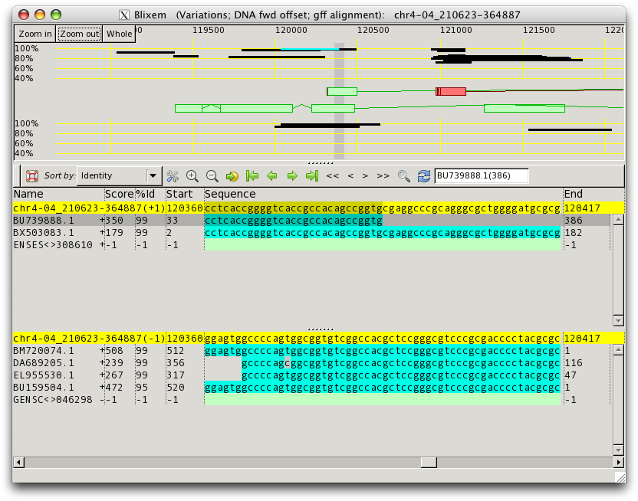Figure 1: Nucleotide mode. There are two panes in the detail-view, one for each strand. The active strand is shown at the top. The active strand can be changed by hitting the ’Toggle’ button or the ‘t’ shortcut key.

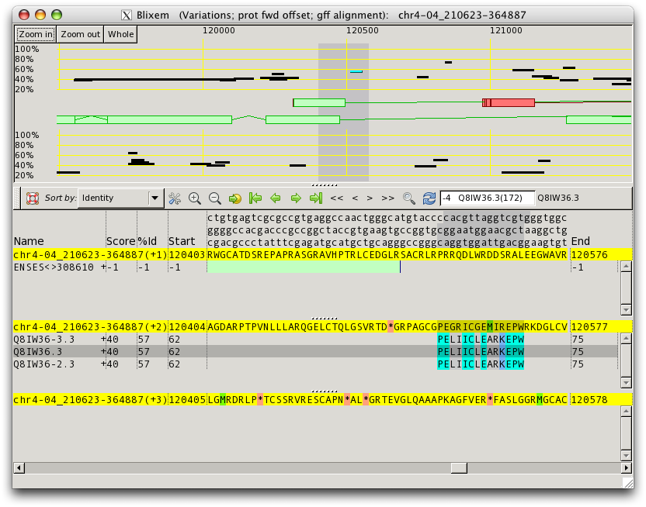Figure 2: Protein mode. There are three panes in the detail-view; one for each reading frame of the active strand. The other strand can be activated by hitting the ‘Toggle’ button or the ‘t’ shortcut key.

Active Strand
The “active” reference sequence strand in Blixem controls the orientation of the display – coordinates are shown increasing from left-to-right for the forward strand and decreasing for the reverse strand. The active strand is always shown at the top – i.e. the top grid and top transcript view in the big picture and the top pane in the detail view.

In protein mode, only the active strand is shown in the detail view. One must toggle the strand to view the other strand.

Toggle which strand is active by:
- pressing the ‘Toggle’ button on the toolbar; or
- pressing the ‘t’ key.

By default, Blixem assumes that the reference sequence passed to it is the forward strand, unless otherwise specified by the ‘--reverse-strand’ command line argument.

Big Picture
The ‘Big Picture’ section shows an overview of the reference sequence. The reference sequence coordinates are shown along the top. You can zoom in to view a shorter range by using the 'Zoom in' button at the top left of the screen. Use 'Zoom out' or 'Whole' to zoom out – 'Whole' zooms out to view the full length of the reference sequence.

The big picture consists of two grids showing the alignments for each strand, and two sections between these grids showing the transcripts for each strand. The grids have a scale on the left-hand side showing the percent-ID, and alignments are plotted against this scale. The scale and extents of the grids can both be edited - see the Grid properties section in the Settings dialog.

The active strand alignments and transcripts are shown at the top and the other strand at the bottom. The direction of the coordinates is determined by the active strand. The active strand can be toggled using the 't' shortcut key or the 'Toggle strand' button on the toolbar.

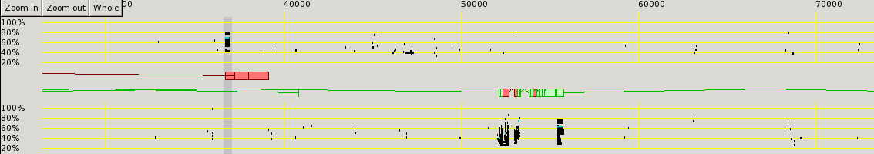Figure 3: The Big Picture section
Red shaded areas in the big picture indicate assembly gaps (gaps in the reference sequence). Assembly gaps are represented by dashes in the FASTA input file.

Bumping the transcript view
By default, exons and introns for the same strand are drawn overlapping each other. They can be expanded (or 'bumped') by pressing the 'b' shortcut key or by enabling the relevant option in the View dialog (see Hiding sections of the window).

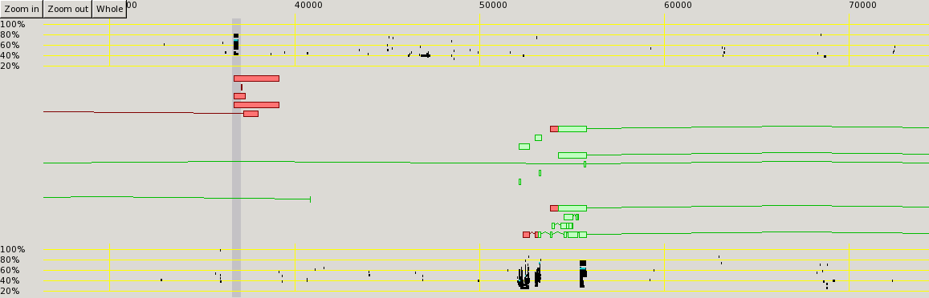Figure 4: Expanded transcript view

Detail View
The ‘Detail View’ shows the actual sequence data for the match sequences. Match sequences are lined up underneath the relevant section of reference sequence, and individual bases are highlighted in different colours to indicate how well they match.

Match colours

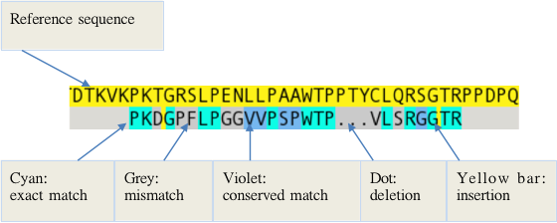Figure 5: Alignment colour key

Alignment lists
There are separate lists of alignments for each strand and reading frame of the reference sequence. Each list has a yellow header bar containing the reference sequence. At the left, the yellow bar shows the reference sequence name and which strand/frame it is, e.g. (+1) means forward strand, reading frame 1; (-2) means reverse strand, reading frame 2.

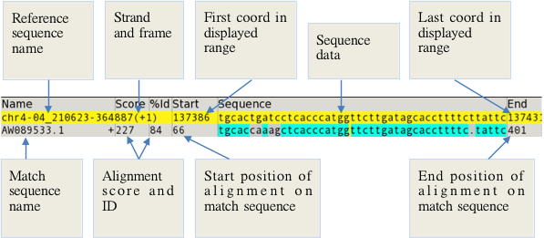Figure 6: Alignment list details

Nucleotide mode
There are two sections to the detail view in nucleotide mode: one for each strand. The active strand is shown at the top and defines the coordinate direction (increasing if the forward strand is active, decreasing if the reverse is active).

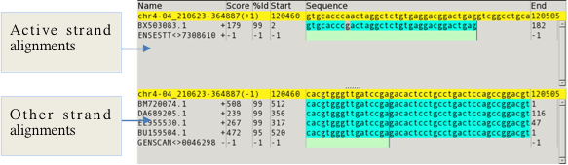Figure 7: Alignment lists: nucleotide mode

Protein mode
There are three sections in the detail view in protein mode: one for each of the three reading frames for the active strand. Only the active strand is shown. To view the other strand, toggle the display using the ‘Toggle strand’ button or the ‘t’ shortcut key.

In protein mode, the yellow header bars show the translated reference sequence for that reading frame. STOP and MET codons in the reference sequence are highlighted in red and green. There is also an additional header section at the top showing the nucleotide sequence.

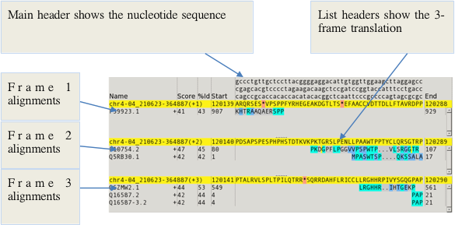Figure 8: Alignment lists: protein mode

In the nucleotide-sequence header, codons are read from top-to-bottom and then left-to-right, starting at row 1 for frame 1, row 2 for frame 2 etc. Middle-clicking on a coordinate will highlight the three nucleotides for the selected codon and the currently-active reading frame (by default, frame 1). Left-clicking in an alignment list sets the active reading frame.

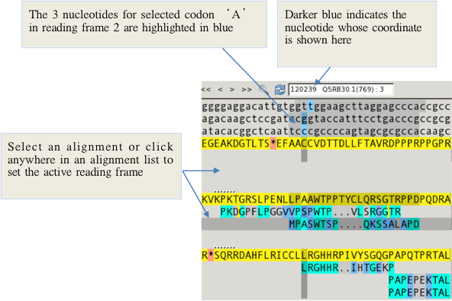Figure 9: Selected reading frame and codon

Exons
Exons are displayed as solid-colour blocks in the detail-view, coloured green for CDS, red for UTR. Vertical blue lines are drawn at the start and end of the blocks so that it is easy to see whether alignments line up with the exon boundaries.
In protein mode, an exon may not start or end exactly at a codon boundary. A “partial” or “split” codon like this is indicated in the detail-view by cross-hatch highlighting, and by drawing a dotted blue line rather than a solid line. (Note that dotted lines may be obscured by solid lines at the same position.)
The true boundary for split codons would really be either a third or two-thirds of the way through the character width, but Blixem does not draw boundaries through the middle of characters to avoid too cluttered a display.

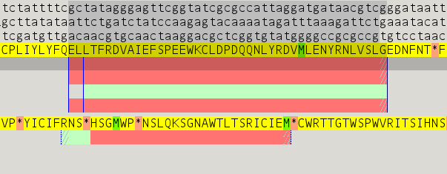Figure 10: Exons in the detail-view. Split codons are indicated with cross-hatching, e.g. the last codon in the selected exon is a split codon because it does not include all three bases for that codon, as you can see from the highlighting in the DNA header.

Coverage view
The coverage view shows a plot of how many alignments there are at each coordinate along the reference sequence. It can give an indication of where the regions of interest are.

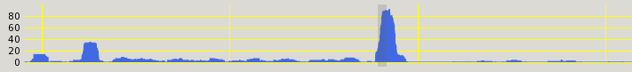Figure 11: Coverage view
The coverage view can be shown/hidden by ticking/unticking the 'Show coverage view' check box on the View dialog (which can be accessed from the right-click menu or by hitting the 'v' shortcut key).

The scale of the coverage view is the same as that of the big-picture and it can be navigated in the same manner, i.e.
- use the horizontal scroll-bar or middle-click to scroll; and
- use the zoom buttons at the top or the Ctrl-=/Ctrl-- keys to zoom.

The toolbar
The detail-view toolbar contains the following functions. Note that the Help and Settings buttons are included in the detail-view toolbar even though they apply to Blixem as a whole.

Figure 12: Detail-view toolbar

Help: | Show help about how to use Blixem
About: | Show program information
Settings: | Show the Settings dialog
Sort: | Show the Sort dialog
Zoom in: | Increase the font size in the detail-view
Zoom out: | Decrease the font size in the detail-view
Go to: | Go to a particular coordinate
First match: | Go to the first coordinate of the first alignment
Previous match: | Go to the start of the current alignment or the end of the previous alignment1
Next match: | Go to the end of the current alignment or the start of the next alignment1
Last match: | Go to the end of the last alignment1
Back one page: | Scroll the detail-view range to the left by one page
Back one index: | Scroll the detail-view range to the left by one base
Forward one index: | Scroll the detail-view range to the right by one base
Forward one page: | Scroll the detail-view range to the right by one page
Find: | Scrolls to the start of the first alignment from that sequence if any are found.
Toggle strand: | Toggle which strand is the active strand

Feedback box
The feedback box contains information about the currently selected sequence and/or coordinate, if either is selected. Click on a row in the detail-view to select a sequence. Middle-click on a base in the detail-view to select that coordinate. Text in the feedback box can be selected and copied.

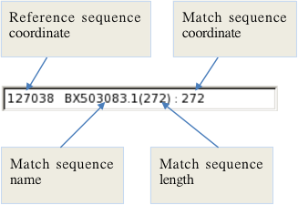Figure 13: Feedback box

Moused-over item feedback area
The area to the right of the toolbar contains information about the currently moused-over item (e.g. a match sequence in the alignment list or a variation in the variations track). For a match sequence, this information includes the sequence name and optional data such as organism and tissue type that can be parsed from EMBL files (currently only available to authorised users). To load optional data, see the Settings dialog. Note that the optional data may be incomplete due to the inconsistent information available from the EMBL files.

Figure 14: Moused-over item feedback area

The main menu
Right-click anywhere in the Blixem window to pop up the main menu.

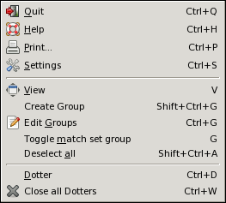Figure 15: Main menu
The options are:

Quit | Ctrl-Q | Close Blixem and any spawned processes
Help | Ctrl-H | Display the user help
Print | Ctrl-P | Printing options
Settings | Ctrl-S | Edit settings
View | v | Show/hide parts of the display
Create Group | Shift-Ctrl-G | Create a group of sequences
Edit Groups | Ctrl-G | Edit properties for groups
Toggle match set group | G | Toggle the special “match set” group on and off. This is a quick way of creating a group from the current selection buffer, which should contain match sequence names.
Deselect all | Shift-Ctrl-A | Deselect all sequences
Dotter | Ctrl-D | Run Dotter on the currently selected sequence
Close all Dotters |  | Close all Dotters that have been opened from this Blixem

Hiding sections of the window
Use to ‘View’ dialog to show/hide sections of the window.

- Right-click and select the View option, or hit the ’v’ shortcut key.
- Toggle check marks on or off to show/hide sections.
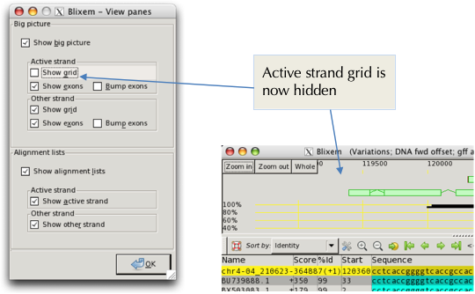Figure 16: The View dialog

Alternatively, use the following keyboard shortcuts to toggle visibility of a component:

1 | Hide top pane in detail view
2 | Hide second pane in detail view
3 | Hide third pane in detail view (protein mode only)
Ctrl-1 | Hide top grid in big picture (active strand)
Ctrl-2 | Hide bottom grid in big picture (other strand)
Shift-Ctrl-1 | Hide top exon view (active strand)
Shift-Ctrl-2 | Hide bottom exon view (other strand)

Operation

Navigation

Scrolling
Middle-click/double-click and then drag in big picture | Jump to a particular region. Dragging moves the highlight box.
Click on the highlight box and drag | Move the highlight box.
Middle-click/drag in detail view | Select a base. Releasing the mouse button scrolls the display to centre on the selected base (hold down Ctrl to avoid scrolling.)
Click a feature in the big picture | Selects that feature and scrolls the detail-view vertically so that it is visible (if it is in the current detail view range).
Horizontal scrollbar | Scroll the detail-view range.
Vertical scrollbars | Scroll up/down in the detail view or the big picture.
Horizontal mouse-wheel | Scroll the detail-view range (if your mouse has a horizontal scroll-wheel).
Vertical mouse-wheel | Scroll up/down the currently moused-over alignment list in the detail view, or the big picture.
Ctrl-left  Ctrl-right | Scroll to the start/end of the previous/next match (limited to currently-selected sequences, if any are selected; includes all sequences otherwise).
Home  End | Scroll to the start/end of the display.
Ctrl-Home  Ctrl-End | Scroll to the start/end of the currently-selected alignments (or to the first/last alignment if none are selected).
‘,’ (comma)  ‘.’ (full-stop) | Scroll the detail-view range one nucleotide to the left/right.
Ctrl-,  Ctrl-. | Scroll the detail-view range one page to the left/right.
Go-to button or  ‘p’ key | Scroll to a specific coordinate position.

Zooming
= - keys and | Zoom in/out of the detail-view
Ctrl-= or Ctrl-- keys and | Zoom in/out of the big-picture
Shift-Ctrl-- and | Zoom the big picture out to view the full length of the reference sequence.

Selections

Selecting sequences
- You can select a sequence by clicking on its row in the alignment list. Selected sequences are highlighted in cyan in the big picture.
- You can select a sequence by clicking on it in the big picture.
- The name of the sequence you selected is displayed in the feedback box on the toolbar. If there are multiple alignments for the same sequence, all of them will be selected.
- You can select multiple sequences by holding down the Ctrl or Shift keys while selecting rows.
- You can deselect a single sequence by Ctrl-clicking on its row.
- You can deselect all sequences by right-clicking and selecting 'Deselect all', or with the Shift-Ctrl-A keyboard shortcut.
- You can move the selection up/down a row using the up/down arrow keys.

Selecting coordinates
- You can select a nucleotide/peptide by middle-clicking on it in the detail view. This selects the entire column at that index, and the coordinate number on the reference sequence is shown in the feedback box. (The coordinate on the match sequence is also shown if a match sequence is selected.)
- By default the display will centre on the selected base when you middle click. To select a base without scrolling, hold down Ctrl when you middle click.
- For protein matches, when a peptide is selected, the three nucleotides for that peptide (for the active reading frame) are highlighted in the header in blue. (The active reading frame is whichever alignment list currently has the focus - click in a different list to change the reading frame.) Darker blue highlighting indicates the specific nucleotide that is currently selected (i.e. whose coordinate is displayed in the feedback box).

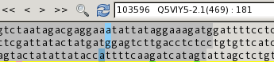Figure 17: The 3 nucleotides for the currently-selected amino acid in reading-frame 3. Selected nucleotide 103596 is shaded in darker blue.

- You can move the selection to the previous/next index using the left and right arrow keys.
- In protein mode, you can move the selected nucleotide by a single base (rather than an entire codon) holding Shift while using the left and right arrow keys.
- You can move the selection to the start/end of the previous/next match by holding Ctrl while using the left and right arrow keys (limited to just the selected sequences if any are selected; includes all sequences otherwise).

Finding sequences
The Find dialog allows the user to search for sequences by name. Press the Find button on the toolbar or hit the ‘Ctrl-F’ shortcut key to open the Find dialog.

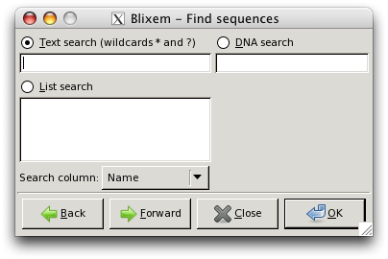Figure 18: Find dialog
There are three search modes:
- Text search: Search for match sequences by name (or another column from the 'Search column' drop-down box). The wild-card ‘*’ means any number (or zero) of any character and ‘?’ means 1 character (which can be any character). Any sequences whose relevant column data matches the search string will be selected and the display will scroll to the start of the selection.
- List search: the same as text-search, but you can enter multiple search strings by placing them on separate lines in the text box.
- DNA search: This searches for a given sub-sequence of nucleotides in the reference sequence. If the sub-sequence is found, the display will scroll to the start of the sub-sequence and the first base in the sub-sequence will be selected.

Enter your search text in the appropriate box and click the OK button to perform the search. By default, Blixem will start searching from the beginning of the reference sequence range. To start the search from the current position instead, click the Forward or Back button instead of OK. This will start searching from the currently-selected base, if there is one selected; if not, it will start from the beginning of the current detail-view display range when searching forwards or from the end of the display range if searching backwards.

Repeat a Find
After clicking OK on the Find dialog, press F3 to repeat the search in a forwards direction or Shift-F3 to repeat in a backwards direction. Alternatively, if you had selected the Forward or Back button in the Find dialog then click the Forward or Back buttons again to jump to the next result in that direction.

Copy and paste
- When sequence(s) are selected, their names are copied to the selection buffer and can be pasted to another program by middle-clicking in that program.
- Sequence names can be pasted from the selection buffer into Blixem by hitting the 'f' keyboard shortcut. If the selection buffer contains valid sequence names, those sequences will be selected and the display will jump to the start of the selection.
- Sequence names can also be pasted from the selection buffer into text boxes in dialog boxes such as the Groups dialog or Find dialog.
- To copy sequence name(s) to the default clipboard, select the sequence(s) and hit Ctrl-C. Sequence names can then be pasted into other applications using Ctrl-V.
- The default clipboard can be pasted into Blixem using Ctrl-V. If the clipboard contains valid sequence names, those sequences will be selected and the display will jump to the start of the selection.
- Note that text from the feedback box and some text labels (e.g. the reference sequence start/end coords) can be copied to the selection buffer by selecting the required text with the mouse (or copied to the default clipboard by selecting it and then hitting ‘Ctrl-C’).
- Text can be pasted from the default clipboard into text entry boxes on dialogs such as the Groups or Find dialog by using Ctrl-V.

Sorting alignments
- Click the sort button on the toolbar to open the Sort dialog.
- Select the column you wish to sort by from the top drop-down box on the dialog.
- You may optionally sort by further columns. You can sort by as many columns as you wish by adding further drop-down boxes using the Add button.

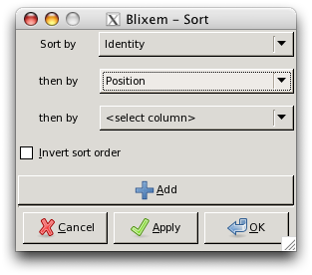Figure 19: Sort dialog
- The default sort order may be ascending or descending depending on what makes most sense for the selected column: e.g. sorting by position is ascending by default, but sorting by score or ID is descending.
- To get the inverse of the default sort order, select the ‘Invert sort order’ option on the Sort dialog.
- Alignments can also be sorted by group. Alignments that are part of a group will then be listed first (before any that are not in a group), and ordered according to the group’s order number. See the Groups section for more details.

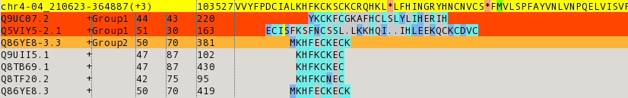Figure 20: Alignment list sorted by group

Fetching sequences
Currently only available to authorised users at the Sanger Institute.
- Double-click a row to fetch a match sequence’s EMBL file.

Grouping sequences
Alignments can be grouped together so that they can be sorted/highlighted/hidden etc.

Creating a group from a selection:
- Select the sequences you wish to include in the group by left-clicking their rows in the detail view. Multiple rows can be selected by holding the Ctrl or Shift keys while clicking.
- Right-click and select 'Create Group', or use the Shift-Ctrl-G shortcut key. (Note that Ctrl-G will also shortcut to here if no groups currently exist.)
- Ensure that the 'From selection' radio button is selected, and click 'OK' or ‘Apply’. If you click ‘Apply’, you will be shown the group you just created so that you can edit it. If you click ‘OK’ the group will be created with the default properties.
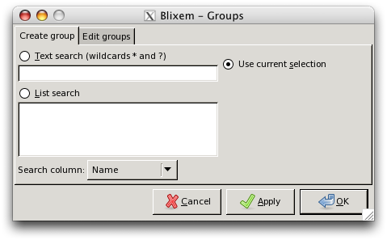Figure 21: Groups dialog - create group

Creating a group from a search:
- Right-click and select 'Create Group', or use the Shift-Ctrl-G shortcut key. (Or Ctrl-G if no groups currently exist.)
- Select the 'Text search' or 'List search' radio button and enter some text to search for.
- Select the column that you wish to search in the drop-down box at the bottom.
- Click OK or Apply.

Notes
- 'List search' allows you to enter multiple search strings; place each string on a separate line.
- You can use the following wild-cards in the search text: an asterisk (*) represents any number of characters; a question mark (?) represents any single character.
- You can paste text into the search boxes from the selection buffer by middle-clicking or from the clipboard using Ctrl-V.
- You may paste sequence names directly from another compatible program (e.g. ZMap): click on the feature in ZMap and then middle-click in the text box on the Groups dialog. (Grouping in Blixem works on the sequence name alone, so the feature coords output by ZMap will be ignored.)

Creating a temporary 'match-set' group from the current selection:
- You can quickly create a group from a current selection (e.g. selected features in ZMap or just the current selection in Blixem) using the 'Toggle match set' option.
- To create a match-set group, select the required items and then select 'Toggle match set' from the right-click menu in Blixem, or hit the 'g' shortcut key.
- To clear the match-set group, choose the 'Toggle match set' option again, or hit the 'g' shortcut key again.
- While it is enabled (i.e. toggled on), the match-set group can be edited like any other group, via the 'Edit Groups' dialog. Any settings you change (e.g. highlight colour) will be saved even if the match-set group is toggled off and then on again.
- If you delete the match-set group using the 'Edit Groups' dialog, all of its settings will be lost; you will get the default settings again the next time you enable the match-set group. To avoid this, disable it by toggling it off using the 'Toggle match set' menu option (or 'g' shortcut key) rather than by deleting it in the Groups dialog.

Editing groups:
To edit a group, right-click and select 'Edit Groups', or use the Ctrl-G shortcut key.
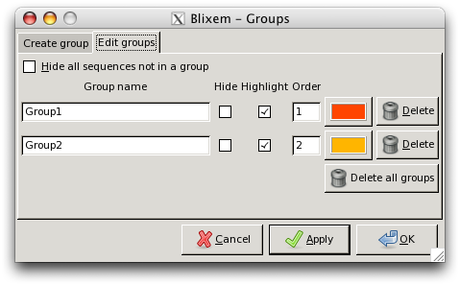Figure 22: Groups dialog – edit groups
You can change the following properties for a group. Click on Apply or OK to apply the changes.

Name | You can specify a more meaningful name to help you identify the group.
Hide | Tick this box to hide the alignments in the alignment lists.
Highlight | Tick this box to highlight the alignments.
Colour | The colour the group will be highlighted in, if 'Highlight' is enabled. The default colour for all groups is orange, so you may wish to change this if you want different groups to be highlighted in different colours.
Order | When sorting by Group, alignments in a group with a lower order number will appear before those with a higher order number (or vice versa if sort order is inverted). Alignments in a group will appear before alignments that are not in a group.

You can also hide all sequences that are not part of a group by ticking the 'Hide all sequences not in a group' option. This is a quick way of filtering sequences to show only those that you are interested in; any sequences that are not part of a group will be hidden. Note that any sequences in a hidden group will also still be hidden.

To delete a group, click one of the following buttons. This will have an immediate effect (i.e. you don’t have to click ‘Apply’).
- To delete a single group, click on the 'Delete' button next to the group you wish to delete.
- To delete all groups, click on the 'Delete all groups' button.

Running dotter
- To start Dotter from within Blixem, or to edit the parameters for running Dotter, right-click and select 'Dotter' or use the Ctrl-D keyboard shortcut. The Dotter dialog will pop up.

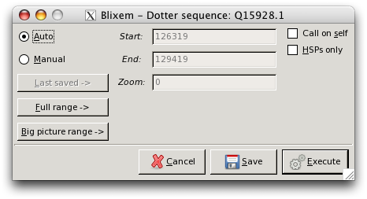
Figure 23: Dotter dialog
- Select the sequence you wish to run Dotter on before or after opening the dialog. The selected sequence name will be shown at the top of the dialog.
- Alternatively, if you just wish to edit the settings, you do not need to select a sequence.
- To run Dotter with the default (automatic) parameters, just hit RETURN, or click the 'Execute' button.
- To enter custom parameters, select the 'Manual' radio button and enter the values in the 'Start' and 'End' boxes.
- To save the parameters without running Dotter, click Save and then Cancel'.
- To save the parameters and run Dotter, click 'Execute'.
- To revert to the last-saved manual parameters, click the 'Last saved' button.
- To revert back to automatic parameters, click the 'Auto' radio button. The coordinates in the Start and End box will be recalculated for the currently-selected sequence.

Reference sequence versus itself
To run Dotter on the reference sequence versus itself, select the ‘Call on self’ tick box in the Dotter dialog and then click ‘Execute’. This can be useful to analyse internal repeats etc. (see the Dotter manual for more information).

Dotter HSPs only
This starts Dotter in HSP (High-Scoring Pair) mode (see the Dotter manual).

Settings
The settings menu can be accessed by right-clicking and selecting Settings, or by the shortcut Ctrl-S.

Features

Highlight variations
When this option is enabled, bases in the reference sequence that have know variations (such as SNPs, insertions, deletions etc., loaded from the GFF file) are highlighted in the reference sequence (nucleotide) header.
If the ‘Show variations track’ sub-option is also enabled, then an additional line is shown above the nucleotide header showing the alternative bases for each variation. Note that the Variations track can be quickly enabled or disabled by double-clicking the nucleotide header.
You can double-click a variation to open its URL.

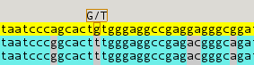Figure 24: Variations track

Show polyA tails
When this option is enabled, polyA tails are shown and highlighted in the alignment lists and polyA signals are highlighted in the reference sequence (nucleotide) header. If the sub-option ‘Selected sequences only’ is enabled, polyA features will only be shown for the currently selected sequences.

Display options

Show Unaligned Sequence
When this option is enabled, any additional, unaligned portions of the match sequences are displayed at the start and end of the alignments. If the ‘Limit to’ sub-option is also enabled, you can specify the maximum number of additional bases to display. If the ‘Selected sequences only’ sub-option is enabled, only the currently selected sequence(s) will display unaligned portions of sequence.

Show Splice Sites
When this option is enabled, splice sites are highlighted in the reference sequence (nucleotide) header for the currently-selected sequence(s). The two bases from the adjacent introns are highlighted in green if they are canonical or red if they are non-canonical.

Highlight Differences
When this option is enabled, matching bases are blanked out and mismatches are highlighted, making it easier to see where alignments differ from the reference sequence.

Squash Matches
This groups multiple alignments from the same sequence together into the same row in the detail view, rather than showing them on separate rows.

General settings

Font
Allows you to change the font that is used to display alignments in the detail-view. Note that you must select a monospace font; otherwise matches will not be shown aligned correctly. Blixem will warn you if the font you have selected is not monospace.

Fetch mode
Allows you to change the program used to fetch sequence EMBL entries. (Currently only available to authorised users within the Sanger Institute).

Columns

Load optional data
Click this button to load optional data from EMBL entries (currently only applicable to authorised users within the Sanger Institute). Note that this operation can take a long time if there are many sequences. The button will be greyed out once optional data has been loaded.

Column visibility
Tick/un-tick the check-marks to show/hide individual columns. Adjust the column width by entering the new width in the text box in pixels. Note that if you enter a zero width then the column will be hidden, regardless of whether the check-mark is ticked or not. Greyed-out columns are optional-data columns, and will only become available once optional data has been loaded.

Grid properties

%ID per cell
Use this to change the vertical scale of the grid; a smaller value means the grid will be more spaced out, a larger value means the grid will be more compact.

Max %ID
Defines the maximum cut-off value for the %ID scale.

Min %ID
Defines the minimum cut-off value for the %ID scale.

Coverate view properties

Depth per cell
Use this to change the vertical scale of the grid for the Coverage View (see the View menu to turn on the Coverage View); a smaller value means the grid will be more spaced out, a larger value means the grid will be more compact.

Appearance

Use print colours
Select this option to make Blixem use grey-scale colours, suitable for printing.

Display colours
Change any of Blixem’s custom display colours, such as the colour aligned bases are shown in or the colour stop codons are highlighted in etc. There are four colours for each item:
- Normal: this is the standard display colour;
- Normal (selected): this is the colour used when the item is selected (if applicable). Typically one would use a slightly darker or lighter shade of the Normal colour for this, so that the item does not look radically different when it is selected;
- Print: this is the standard colour used when the ‘Use print colours’ option is enabled;
- Print (selected): this is the colour used when ‘Use print colours’ is enabled and the item is selected.

Key
In the detail view, the following colours and symbols have the following meanings:

Alignment list header | Yellow background | Reference sequence
Alignment list | Cyan background | Identical residues
Alignment list | Violet background | Conserved residues
Alignment list | Grey background | Mismatch
Alignment list | ‘.’ with grey background | Deletion
Alignment list | Yellow vertical line | Insertion
Alignment list | Thin blue vertical line | Boundary of an exon
Nucleotide header (protein mode) | Sky-blue background | The three nucleotides for the currently-selected codon; darker blue indicates the nucleotide whose coordinate is displayed in the feedback box
Alignment list header (protein mode) | Pale red background | STOP codon
Alignment list header (protein mode) | Green background | MET codon

Keyboard shortcuts

Ctrl-Q | Quit
Ctrl-H | Help
Ctrl-P | Print
Ctrl-S | Edit settings
V | Show/hide sections of the display
Shift-Ctrl-G | Create group
Ctrl-G | Edit groups (or create a group if none currently exist)
Ctrl-A | Select all sequences in the current list
Shift-Ctrl-A | Deselect all sequences
Ctrl-D | Dotter
Left-arrow | Move coordinate section one index to the left
Right-arrow | Move coordinate section one index to the right2
Shift-Left | Same as Left, but in protein mode it scrolls by a single nucleotide
Shift-Right | Same as Right, but in protein mode it scrolls by a single nucleotide
Ctrl-Left | Scroll to the start/end of the previous alignment
Ctrl-Right | Scroll to the start/end of the next alignment3
Up-arrow | Move row selection up
Down-arrow | Move row selection down
Home | Scroll to the start of the display
End | Scroll to the end of the display
Ctrl-Home | Scroll to the start of the first alignment3
Ctrl-End | Scroll to the end of the last alignment3
= | Zoom in detail view
- | Zoom out detail view
Ctrl-= | Zoom in big picture
Ctrl-- | Zoom out big picture
Shift-Ctrl-- | Zoom out big picture to view the whole reference sequence
, | Scroll left one coordinate
. | Scroll right one coordinate
P | Go to position
T | Toggle the active strand
G | Toggle the 'match set' Group
1 | Toggles visibility of the 1st alignment list
2 | Toggles visibility of the 2nd alignment list
3 | Toggles visibility of the 3rd alignment list (protein mode only)
Ctrl-1 | Toggles visibility of the 1st big picture grid
Ctrl-2 | Toggles visibility of the 2nd big picture grid
Shift-Ctrl-1 | Toggles visibility of the 1st exon view
Shift-Ctrl-2 | Toggles visibility of the 2nd exon view

Acts only on selected sequences, if there is currently a selection; if no sequences are currently selected, then this operation acts on all sequences.
Only applicable if a coordinate is currently selected; middle-click a coordinate to select it.
Limited to just the selected sequences, if any are selected; otherwise, acts on all sequences.

