# Brief for graphic design services

Date of request: 31 Oct 2016

Approval:

Consult:

Notify:

Due date:

Delivery: Send as [file type] via [Confluence/We Transfer/DropBox]

## Project goals:

* Develop a logo for the website as a recognisable identity reflecting the work we do.

## Our audience

* Biologists/bioinformaticians working in genomics who are more or less regularly using a genome browser (e.g. UCSC, Ensembl) for their analyses and studies.

## Concepts to consider

* Tree of life
* Linking different types of data together
* Genome
* (For future: it might be helpful for Ensembl to make an Infographic to highlight our data and code - this might help us to highlight the parts of Ensembl that are most important to our users eg. this is pretty <http://ec.europa.eu/maritimeaffairs/policy/blue_growth/infographics/> )

## Use cases

* Ensembl websites incl. rest.ensembl.org
* EMBl-EBI website
* External website GitHub
* Twitter
* Facebook
* Scientific posters
* Powerpoint presentations to a range of audiences eg. Wellcome Trust, scientists

## Formats:

* Colour: blue and red are the main colours in our current logo
* We currently don’t use a black-and-white logo ?

**How we want to be perceived**

* Comprehensive
* High-quality
* Trusted
* User friendly
* Useful
* Easy to understand
* Stable
* Reference resource
* Enabling
* Consistent
* Reliable
* Infrastructure
* Informatics / Data Science
* Experts

## Our message

* We are a reliable resource of genome information
* We are the go-to team for expertise in genomic data management and exploration
* We anticipate and respond to the needs of the genomics community
* We provide infrastructure and information for you to do your science

## Sub-brands

* TreeFam ([http://www.treefam.org](http://www.treefam.org/))
* Ensembl-Genomes
* GENCODE ([http://www.gencodegenes.org](http://www.gencodegenes.org/))
* Ensembl VEP (<http://www.ensembl.org/info/docs/tools/vep/index.html>)
* Ensembl Preview site (http://pre.ensembl.org/index.html)

## Visual associations

* http://evogeneao.s3.amazonaws.com/assets/tree_of_life/tree-of-life_2000.jpg

## Colour scheme

What is your colour scheme now?

* Blue and red

What are the colour schemes of your partner sites?

* Ensembl genomes has a variety of colour schemes: grey, purple, minty green, midnight blue, teal, mushroom (these may be changed, not required).

What are the colour schemes of sites you would like your users to navigate to and from?

* These are likely to be the UCSC site (genome.ucsc.edu - navy blue) and the EBI site.

Are there colours that are particularly meaningful to Ensembl?

* No, not particularly. Aside from the red and blue in our current logo, our website is predominantly a white background with dark blue, pale blue, grey and yellow (but this may change if we re-design aspects of our website).   
    
  The main area where we use colour for a special meaning is: eg. we colour genes differently depending on their function and quality eg. gold for the more confidently annotated genes.   
    
  We colour DNA mutations differently depending on their severity, we colour regulatory regions different depending on their function. No one colour has particular significance over another.

Are there any colors we should avoid?

* Muted colours

## 

## Examples of good logos we like - from anywhere not just bioinformatics

### Logos that are visually appealing and clear

* “nice and clean but with an obvious DNA thing going on” - <https://www.ebi.ac.uk/metagenomics/> logo
* “again, it's clean but the link to different bugs is nice and obvious” - <http://justcreative.com/wp-content/uploads/2009/07/wwflogo.gif>

### Logos that are “simple and to the point”

* New York Genome Center: [http://www.nygenome.org](http://www.nygenome.org/)
* JGI: [http://jgi.doe.gov](http://jgi.doe.gov/)

### A logo that we just think is exciting and tied to genomics

* SMBE meeting 2017 in Austin Texas

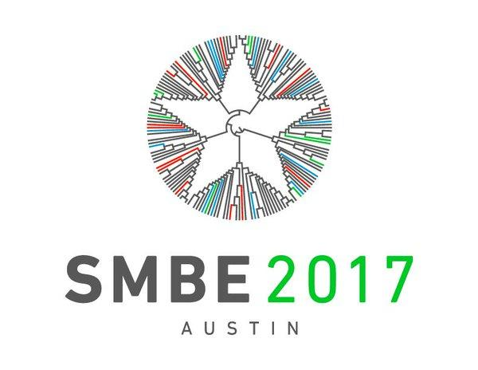

### Logos that feature a letter

* Queens’ Awards for Enterprise: A logo that feels inspirational with the wings. In fact it looks like the Ensembl font.



* Thomson logo: If you know that the brand is about booking holidays to make you happy, then the logo ties in well with using both a letter ‘T’ and a smiley face



* Holiday Inn: An example of a simple, single-letter logo where the colour and font are distinctive enough to make it recognisable even without the words ‘holiday inn’



* Quicktime logo is another example of a simple, single-letter logo that is recognisable. The logo has both a ‘Q’ for the brand name and looks a bit like a clock.



## Examples of good logos we do not like

### Too busy

* UCSC project <https://cbse.soe.ucsc.edu/news/article/1780/picture/387>
* EVA (sorry!) <http://www.ebi.ac.uk/eva/img/eva_logo.png>

### 

### 

### 

### Aim is unclear

* MuG (an EC project) logo:



“Dislike. Uses the helix, does wind around the nucleosome correctly. Though it's very unclear what the aim of the project is.”

### Too ‘blurry’ or vague

* McDonnell Genome Institute: [http://genome.wustl.edu](http://genome.wustl.edu/)
* Riken Institute: [www.riken.jp/en/](http://www.riken.jp/en/)
* Roslin Institute: [http://www.roslin.ed.ac.uk](http://www.roslin.ed.ac.uk/)
* Baylor Human Genomes Sequencing Center: [https://www.hgsc.bcm.edu](https://www.hgsc.bcm.edu/)

### Too complicated

* Virtual Physiological Human: Logo has a lot of good things - human, DNA, EU stars - but is too complicated



### 

### 

### Too heavy

* The grey ‘C’ logo is too heavy and industrial-looking



* Again, this ‘G’ logo is too heavy. Might work for an archive but ensembl is a value-add service and we want to appear more nimble

