ENSF: 607- Assignment 2

Ziad Chemali

# Exercise:1

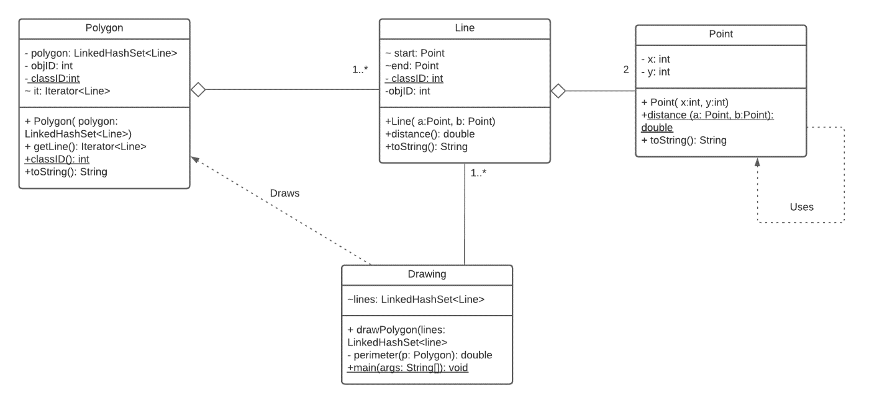

# Exercise 3

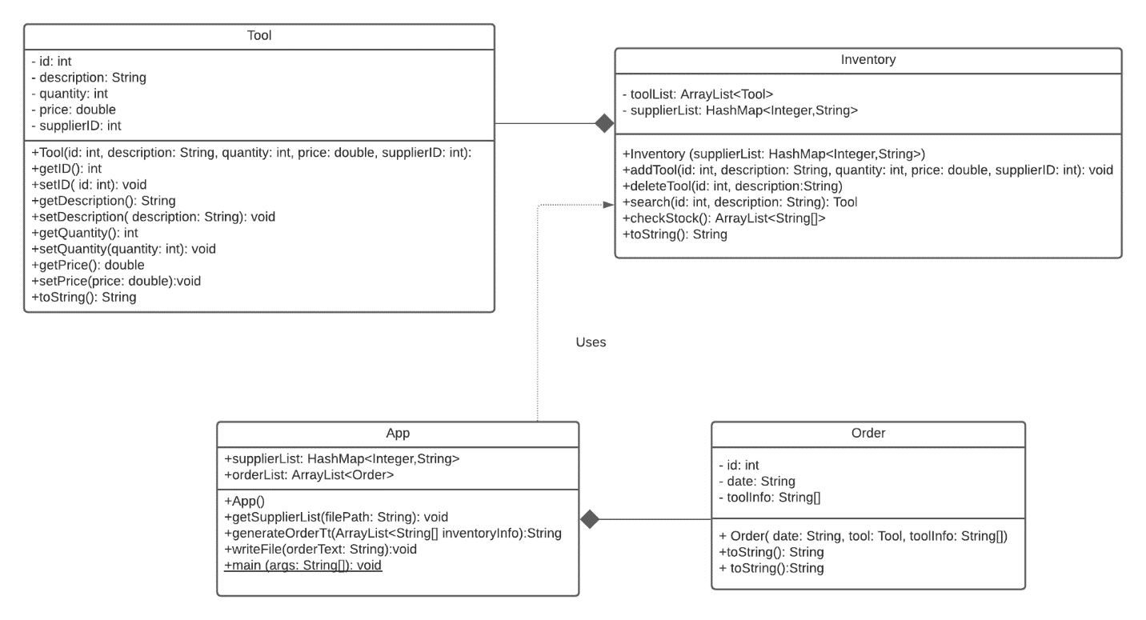

# Exercise: 4

Please enter the name of the 'X' player: Mike

Please enter the name of the 'O' player: Judy

|col 0|col 1|col 2

+-----+-----+-----+

| | | |

row 0 | | | |

| | | |

+-----+-----+-----+

| | | |

row 1 | | | |

| | | |

+-----+-----+-----+

| | | |

row 2 | | | |

| | | |

+-----+-----+-----+

Mike, what row should your next X be placed in ?

0

Mike, what column should your next X be placed in ?

0

|col 0|col 1|col 2

+-----+-----+-----+

| | | |

row 0 | X | | |

| | | |

+-----+-----+-----+

| | | |

row 1 | | | |

| | | |

+-----+-----+-----+

| | | |

row 2 | | | |

| | | |

+-----+-----+-----+

Judy, what row should your next O be placed in ?

1

Judy, what column should your next O be placed in ?

3

Out of bounds please try again!!

Judy, what row should your next O be placed in ?

1

Judy, what column should your next O be placed in ?

1

|col 0|col 1|col 2

+-----+-----+-----+

| | | |

row 0 | X | | |

| | | |

+-----+-----+-----+

| | | |

row 1 | | O | |

| | | |

+-----+-----+-----+

| | | |

row 2 | | | |

| | | |

+-----+-----+-----+

Mike, what row should your next X be placed in ?

00

Mike, what column should your next X be placed in ?

0

There is a mark there, choose another location

Mike, what row should your next X be placed in ?

0

Mike, what column should your next X be placed in ?

1

|col 0|col 1|col 2

+-----+-----+-----+

| | | |

row 0 | X | X | |

| | | |

+-----+-----+-----+

| | | |

row 1 | | O | |

| | | |

+-----+-----+-----+

| | | |

row 2 | | | |

| | | |

+-----+-----+-----+

Judy, what row should your next O be placed in ?

1

Judy, what column should your next O be placed in ?

0

|col 0|col 1|col 2

+-----+-----+-----+

| | | |

row 0 | X | X | |

| | | |

+-----+-----+-----+

| | | |

row 1 | O | O | |

| | | |

+-----+-----+-----+

| | | |

row 2 | | | |

| | | |

+-----+-----+-----+

Mike, what row should your next X be placed in ?

0

Mike, what column should your next X be placed in ?

2

|col 0|col 1|col 2

+-----+-----+-----+

| | | |

row 0 | X | X | X |

| | | |

+-----+-----+-----+

| | | |

row 1 | O | O | |

| | | |

+-----+-----+-----+

| | | |

row 2 | | | |

| | | |

+-----+-----+-----+

Game over!! Mike wins