## Course Introduction

1. This lecture will provide all the tools you need to cover 80% of all graph problems.
2. Visualizing things is the key to victory for your data structures and algorithms, especially in solving graph problems.
3. We will go through different animations to understand the algorithm deeply.
4. General Roadmap

* We will go over all the strategies and theories.
* Sketch out a nice meaningful picture.
* Talk about the complexity of the algorithm in the approach video.
* Followed every approach; we are also going to implement the code.

## Graph Basics

### What is a graph?

Graph=nodes + edges

Nodes🡪 Also known as vertexes. Some tiny circles with data (number, letter, etc.) inside of them.

Edges🡪 any connections between nodes

A graph can be described as relations between things.

### Directed Graph vs Undirected Graph

1. The directed graph has arrowheads along the edges (consider directions), while the undirected graph does not have arrowheads. (NOT consider directions)
2. In the directed graph, we can travel from node A to node C, but we cannot travel from node C to node A. But in the undirected graph, we can travel either from node A to node C or node C to node A.
3. **Neighbor Node** 🡪 Any node that is accessible through an edge. (Ex. In the directed graph, node B and node C are neighbour nodes of node A. **But node A is NOT a neighbour node of node C because it is NOT accessible**).
4. Convert the graph to an adjacency list (usually in a HashMap data structure)

* The keys of this adjacency list are every nodes inside the graph. (A🡪F)
* The values of the ajacency list are going to arrays
* Even the node D is empty, it should still be a key inside the adjacent list. So we can know that the node D exists.

## Depth First and Breadth First Traversal（深度优先 vs 广度优先）

### Basic

In the depth first traversal, we start at node A. The algorithm will firstly follow the edges as A🡪B🡪D (D is the dead end). Then the algorithm follows the edges as A🡪C🡪E🡪B🡪D

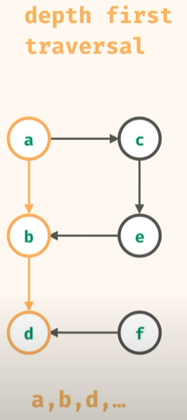

In the breath first traversal, the algorithm will visit nodes in the sequence of A🡪B🡪C….