1. Enable the following functions inside the main() function of **main.cpp**

* generateControlSurface_Angle_vs_Angle_Dot();
* saveDataToFile("data_angle_vs_angle_dot.txt");

1. Inside generateControlSurface_Angle_vs_Angle_Dot(), check to see if the inputs agree with your fuzzy system design. If you are using Yamakawa’s approach, you should combine the inputs together first, before passing them to the fuzzy_system() function.
2. Next, compile, then execute your **program**. Press escape once the simulation starts. This will start generating and collecting data points for recording.
3. Look for the txt file named “data_angle_vs_angle_dot.txt". Open this text file using Excel.
4. Excel will load the Text Import Wizard, prompting you to select the file type suited for your

data:

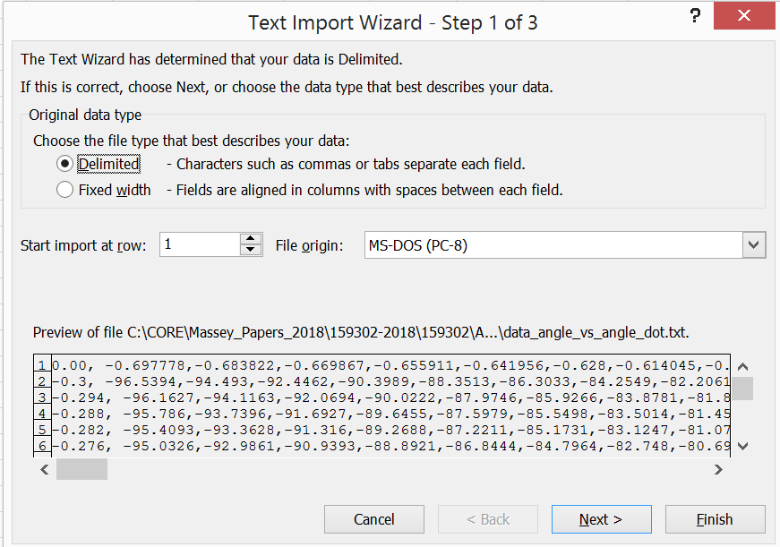

1. Select Delimited, the click on Next.
2. Another dialog box will appear, prompting you for the type of delimeter used in your data. Click on the Comma check box:

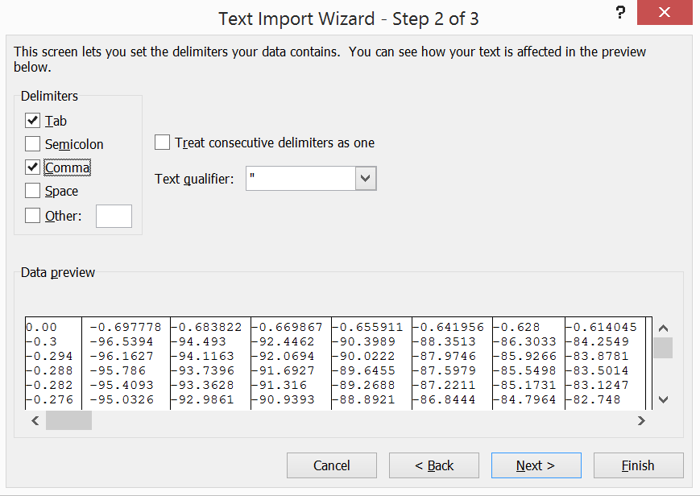

1. Click on Finish
2. Once the worksheet appears, delete the zero entry on the upper left corner of the worksheet. This cell should be left blank.

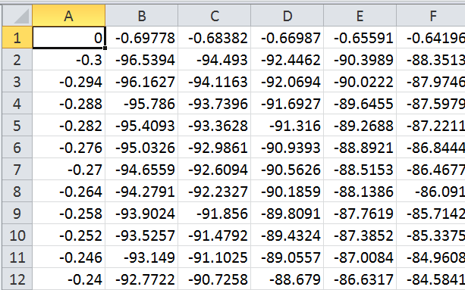

1. Press Ctrl+A to select the entire worksheet’s content.
2. Insert a Chart by selecting the Surface area chart:

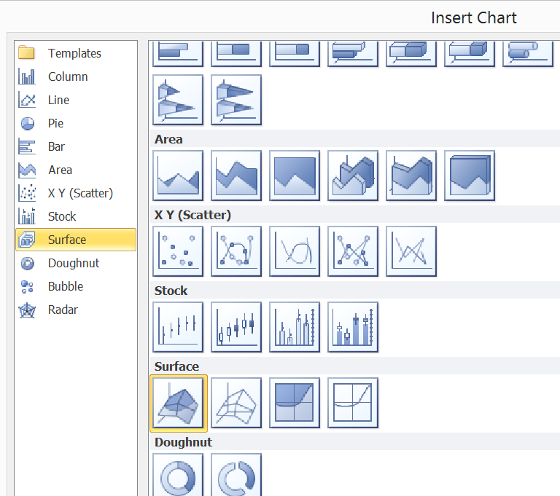

1. You may customise this chart’s appearance by right-clicking the chart, then selecting 3-D Rotation.

--Nothing follows.--