Small Files Aggregation Operations Guide.

Table of Contents
1 Introduction 4
2 Structure of enstore caching system. 4
2.1 Hardware for cache 7
2.2 Files and cache 7
2.2.1 File names in cache. 7
2.2.2 Package file. 8
2.2.2.1 Package file name convention 8
2.2.2.2 Additional entries in file table of enstore DB 9
2.2.2.3 Cached file information 9
2.3 Enstore Caching System Components. 10
2.3.1 Library Manager Configuration Changes. 10
2.3.2 Library Manager Director. 10
2.3.2.1 Library Manager Director configuration. 10
2.3.2.2 Policy File Format 11
2.3.2.3 Library Manager Director enstore commands 13
2.3.2.4 Encp Interaction with Library Manager Director. 13
2.3.3 Modified File Clerk 14
2.3.3.1 Additional File Clerk Enstore Commands 14
2.3.4 Policy Engine Server. 14
2.3.4.1 File List Format. 15
2.3.5 Migration Dispatcher. 16
2.3.5.1 Migration Dispatcher Configuration 16
2.3.6 Python implementation of Policy Engine Server and Migration Dispatcher – Dispatcher. 16
2.3.7 Migrator. 21
2.3.7.1 Migrator configuration and enstore commands. 21
3 Write and read request processing. 23
3.1 Write request processing of files written via cache 23
3.2 Read request processing. 24
3.3 Purge file from cache 25
4 Administration. 26
4.1 Configuring enstore cache components. 26
4.1.1 Clustered Disk Cache 26
4.1.2 AMQP Broker 26
4.1.3 Enstore Cache Servers. 27
4.1.4 Configuring Small File Aware Library Manager 29
4.1.4.1 Enabling Small Files Aggregation Feature 29
4.1.4.2 Disabling Small Files Aggregation Feature 29
4.1.5 Adding or modifying a policy 29
4.2 Starting enstore cache components 33
4.2.1.1 AMQP broker 33
4.2.2 Enstore Cache Servers. 33
4.3 Stopping enstore cache components 35
4.3.1.1 AMQP broker 35
4.3.2 Enstore Cache Servers. 35
4.4 Monitoring enstore cache components 35
4.4.1.1 AMQP broker 35
4.4.2 Enstore Cache Servers. 37
4.5 Monitoring and controlling write requests. 39
4.6 Emergency data migration to tape. 40
4.7 Migration to new media. 40
5 Document Change log 41

Introduction
This project is primarily driven by the need to aggregate small files into bigger packages for more efficient use of tape drives.
Tape drive transfer rates depend on the size of the files. If the size of a file is relatively small then overall average data throughput rate is less than for the relatively big file size. There are several reasons for this: seeking to the files position, starts/ stops etc. The optimal size for a file on tape depends on the tape technology and currently is about 1GB with tendency to grow. The upper limit on the small file depends on a particular tape technology and has tendency to grow. For now and foreseeable future the reasonable limitation is 500 MB. Today's large file is tomorrow's small file
Users can not always easily control the size of files they write to tapes, and many storage systems provide transparent aggregation of files for the user. Enstore does not provide this functionality and this project is intended to provide this. It is of particular interest to existing and upcoming Neutrino experiments, whose data files are typically small.
Another fact to take into considerations is that there are already many files with relatively small sizes stored in the Fermilab enstore tape systems. We are migrating from tapes with small files to tapes with much larger capacity, resulting in tapes with tens of thousands of small files on them. The access to such files can be quite slow and inefficient, tying up valuable resources. To optimize access and transfer rates for relatively small files we need to create a mechanism of packaging such files as a single entity (package), stored on tape, while at the same time permitting transparent access to each file in a package.
Packaging files before writing them to tape requires a disk buffer to aggregate files into a package. Unpacking files from their package retrieved from tape before they get delivered to users requires a disk cache. This disk space can not be requested on the user side because users may not be able to give up a part (sometimes substantial) of their disk space for packaging. This disk cache must be an internal to enstore , allowing to optimize packing / unpacking and delivery of individual files.
This cache/buffer will be used by multiple migrators/stagers to transfer files (packaged or not) between disks and tapes in a distributed environment. Files will arrive from client nodes to the caching system and will be stored on its disks. To provide a flexible environment for such files the caching system should provide access to each file in cache from any host involved in transfer, packaging, migration, staging, and unpacking. Thus the main requirement for such a cache is to provide a global access to any file, which can be achieved by using a clustered file system.

Structure of enstore caching system.

The structure of integrated caching system is illustrated in fig 1. Such a system will easily scale by adding migrators and by expanding the clustered file system. The clustered file system sustain simultaneous high data throughput to multiple sources and destinations.
Enstore caching system is implemented with encp clients and disk movers. This implementation allows to reuse reliable data delivery mechanisms already incorporated into enstore, such as CRC calculations, internal retries, etc. The data caching system is shown in Fig. 1.
Communication between enstore caching system components in Fig.1 is supported by two protocols: Enstore UDP (EUDP) and AMQP. EUDP protocol is used because some components of enstore caching systems are standard enstore servers and clients. AMQP is used to communicate with components involving Policy Engine because it is one of its possible communication protocols.

Fig 1. Structure of integrated data caching and tape system using encp and disk movers.
Library
Manager
Director
encp
encp
File
Clerk
Disk Library
Manager
Policy Engine
Server
And
Migration
Dispatcher
Cache
Disk Mover
Disk Mover
Migrator
Tape Storage
Migrator
The Library Manager Director (LMD) functionality is to determine whether to send data to tape library directly or to cache first. Encp (client) sends to Library Manager Director request (ticket) containing library name from “library” tag in pnfs directory it tries to write file to. Library Manager Director has associated with it Policy Engine with set of rules defining selection of ether tape or disk library manager. The selection rules can be based on different parameters. These parameters are discussed in details later. The main is the file size. Each external encp client may contact LMD for write request if it uses a special option “--enable-redirection”. In the future the default behavior may get changed so that each encp will contact LMD.
Very important detail in this structure is that all disk movers are connected to the same clustered file system, so that they all can access any file in cache. Further we will address details of enstore caching system using encp clients and disk movers.

Hardware for cache
The enstore cache will be implemented as a clustered file system available for access by any migrator. It must be very reliable to reduce to the minimum possible corruption of data for files written to cache and awaiting their migration to tapes. It has been decided to use Oracle ZFS based disk system Advanced HPC File Server Nexenta OS (Open Solaris with Linus user level utilities with 63 TB of disk space, 48 GB memory and 10 GB Ethernet network interface.

Files and cache

File names in cache.
Files written into cache by disk mover have their path and names derived from the file pnfs id. Pnfs id consists of 36 hexadecimal digits. To prevent having too many files in a single directory in cache the pnfs file id maps to the corresponding file name according to algorithm:
file_id_hex = int("0x"+file_id, 16)
first = "%s"%((file_id_hex & 0xFFF) ^ ( (file_id_hex >> 24) & 0xFFF),)
second = "%s"%((file_id_hex>>12) & 0xFFF,)
path = os.path.join(root, first, second, file_id)
So for instance:

root = "/data_files"
file_id = "00001E9281CFB7054652B62737ED1ED3B3F6"
return value:
"/data_files/3816/3387/00001E9281CFB7054652B62737ED1ED3B3F6"
Thus each path will contain not more than 0xfff (4095) files. And files will be evenly distributed between different directories.
All files get written by disk mover into a temporary directory, with name unique for each disk mover:
/prefix/DN
  - where DN is a disk mover name from enstore configuration
When disk mover completes write file transfer into this directory it immediately renames it according to a pnfs id name convention. Only one file can be in this temporary directory for each disk mover.
This approach guaranties that there will be no partially files on disk due to disk mover failures during file transfers (for write operations).

Package file.
Package file contains a files packaged according certain criteria defined by policy and a special file README.1ST with the following format:
List of cached files and original names
cached_file_path_1 file_name_in_the_name_space1 CRC1
cached_file_path_2 file_name_in_the_name_space2 CRC2
....
cached_file_path_N file_name_in_the_name_spaceN CRCN
This file makes package file self describing and allows to recover files from tape to their original locations in cases when enstore database is absent. These cases may be:
- Loss of the database
- Transfer of the tape to another system, which may be enstore or some other tape based storage system.

Package file name convention
Package files are written and read by encp client, so they are regular enstore and pnfs files.
Package files for archiving (to get written to tape) will be kept in the special archiving area.
The separate directory for a packaged file is needed to not allow a conflict between package file contents during packaging.
Staged package files will be kept in staging area
/<stage>
where <archive> and <stage> paths to archiving and staging areas.
Archiving and staging areas can be part of enstore cache or just local disk areas on Migrator nodes.
Package file path in the name space is:
<name_space_for_package>/<volume_family>/<tape>/package-<Migrator>-YYYY-mm-ddT%HH:%MM:%SSZ.tar,
where <Migrator> is the name of migrator, which wrote this file. Time stamp suffix is in accordance to ISO8601 time format.

Additional entries in file table of enstore DB
Additional entries in file table of enstore DB are:
packageId - character varying default '' - This entry is a bfid of a package file, indicates that the file is a part of package and can not be accessed as an individual file directly on tape.
PackageFileCounter integer default -1 – counter of active files in package (gets updated only for a package file).
PackageFileNumber integer default 0 – total number of files in a package.
Package can be deleted when PackageFileCounter=0.

Cached file information
If file was written to cache it will have the following additional entries in file table of enstore DB:
cache_status character varying default ''
archive_status character varying default ''
cache_mod_time timestamp without time zone
archive_mod_time timestamp without time zone
where:
- cache_status – shows if file is in cache/migration/purge status. It can have the following values:
  - CREATED – file was written to cache
  - PURGING – file is being purged
  - PURGED – file was deleted in cache
  - STAGING_REQUESTED – staging of the file has commenced
  - STAGING – file is being staged to cache from tape
  - CACHED – file is in cache
  - FAILED – something wrong happened, requires investigation
  - None – default value
- archive_status – file migration/purge status. It can have the following values:
  - ARCHIVING – file is being written to tape. This state is useful for the recovery from failure
  - ARCHIVED – file was written to tape
  - FAILED – something wrong happened, requires investigation
  - None – default value
- cache_mod_time – time when cache_status has changed
- archive_mod_time – time when archive_status has changed
New table in file DB holds a status of files in transition – files_in_transition. This table contains files written to cache but not yet migrated to tape.
bfid character varying
file_status character varying default ''
cache_mod_time timestamp without time zone.

Special purge rules in PE Server define if a certain file needs to get purged.

Enstore Caching System Components.
In this section Enstore Section Components shown in Fig. 1 will be described.

Library Manager Configuration Changes.
Configuration dictionary for each Library Manager may have entry with new key “use_LMD” with value containing reference (key) configuration dictionary entry for LMD, e.g.
configdict['LTO3.library_manager'] = { …,'use_LMD': 'lm_director',}
When 'use_LMD' entry is present, encp shall contact specified LMD to get configuration entry for Library Manager to be used for transfer. When entry is not present encp acts in a “classical” way.

Library Manager Director.
The Library Manager Director (LMD) functionality is to determine shall client send data directly to tape library or use file aggregation in cache. External encp clients contact LMD first. LMD decides destination of the transfer: tape or enstore cache based on the set of policy rules defined to perform selection of tape or disk based Library Manager. The selection rules can be based on different parameters most importantly file size.
The LMD is a regular enstore server, monitored by inquisitor and shown on System Status page and Servers page. It can be started and stopped just as other enstore servers using “enstore start/stop” command. The LMD can be used without UDP2AMQP server (see comments to LMD configuration).

Library Manager Director configuration.
Library Manager Director configuration is as:
configdict['lm_director'] = {
'host': 'pmig01.fnal.gov',
'port': 5602,
'logname':'LMDSRV',
'udp_port': 5602, # set the same as 'port'
'policy_file': "/home/enstore/policy_files/lmd_policy.py"
}
'host' - host on which “lm_director” is running
'port' - “lm_director” communication port as enstore server
'logname' - “lm_director” log name
'udp_port' – legacy parameter. Set the same as 'port'.
'policy file' – file containing policies for a given LMD.
Note! The 'use_LMD' for Library Manager should point to 'lm_director'.

Policy File Format
Library Manager Director and implemented in Python Policy Engine Server / Migration Dispatcher use the same policy file, although it can be different.
The policy file is a Python dictionary and has a following format:
{Library_Manager1: {policy1:
{'rule':
{'storage_group': 'G1',
'file_family': 'F1',
'wrapper':'cpio_odc'
}
'minimal_file_size': 2000000000L
'min_files_in_pack': 100,
'max_waiting_time': 300,
'max_member_size': 200000000,
'resulting_library': 'new_library'
}
{policy2:
{
.....
},
....
},
Library_Manager2: { policy1:
....
}
Here is an example and explanation
'LTO3.library_manager':{1: {'rule': {'storage_group': 'G1',
'file_family': 'F1',
'wrapper':'cpio_odc'
}
'minimal_file_size': 2000000000L
'min_files_in_pack': 100,
'max_waiting_time': 300,
'resulting_library': 'disk_library'
}

'minimal_file_size' - if file is less than this size the file will be aggregated
'min_files_in_pack' - minimal number of files in package,
if total size of files to be aggregated is less than minimal_file_size
and number of files >= min_files_in_pack then files will get packaged
'max_member_size' - if file is bigger it will not be packaged (optional)
'max_waiting_time' - if time of collection of files for a package exceeds this value (sec),
the files will get packaged
If request comes from encp with library LTO3.library_manager and it satisfies this rule and minimal_file_size conditions (less than the minimum) it will be sent to ' disk_library'.

Library Manager Director enstore commands
Library Manager Director is a regular enstore server, monitored by inquisitor and shown on System Status page and Servers page. It can be started and stopped just as other enstore servers using “enstore start/stop” command. It responds to the following commands:
[enstore@dmsen02 test_dir]$ enstore lmd
Usage: lmd [OPTIONS]...
-a, --alive
prints message if the server is up or down.
--do-alarm <DO_ALARM> turns on more alarms
(snip ...)
--load load a new policy file
--retries <ALIVE_RETRIES> number of attempts to resend alive requests
--show - print the current policy in python format
--timeout <SECONDS> number of seconds to wait for alive response
--usage - prints short help message
The options of interest are –load and –show.

Encp Interaction with Library Manager Director.
The new encp switch allows users to select whether they want to use the file aggregation feature: enable-redirection. The default value of this switch is to not use Library Manager Director to select a library manager. If this switch is specified the encp will try to send a request to a Library Manager Director.
User side encp client extracts library name from “library” tag in pnfs directory (name space) where it tries to write file to. For enstore pnfs tags see “The Enstore and dCache User's Guide. Chapter 4: PNFS Namespace 4-1”. Enstore configuration file will have entry specifying if caching is enabled for concrete tape Library Manager. The configuration dictionary entry for Library Manager may have entry “use_LMD”. For backward compatibility, if there is no such entry encp acts in a old way, encp does not contact LMD and it contacts Library Manager directly. When “use_LMD” entry is present in configuration its value contains key in configuration dictionary for LMD. Encp contacts specified LMD to get configuration entry for Library Manager to be used for transfer. Encp sends ticket to LMD in the same format it usually sends to Library Manager. The ticket contains library name from “library” tag in pnfs directory (name space).
The choice of caching Library Manager is described by LMD Policy Engine rules. As a simple case, each original tape Library Manager has corresponding Caching Library Manager. LMD make decision to cache or not to cache and selects one of LMs from the pair.
LMD receives ticket from encp, processes the ticket in policy engine, modifies ticket field ticket[“vc”][“library”] if necessary and then sends ticket as a reply back to encp.

Modified File Clerk
Existing File Clerk (FC) was modified to notify Policy Engine (PE) Server when files are created in cache and when read file is requested. For the communications with PE Server file clerk uses AMQP API, described in “Messaging HLD”. The specific of enstore file write operation is such that the file may not get considered as written into enstore even if mover successfully completed data transfer. File is considered as written into enstore when enstore client (encp) sets the pnfsId of written file in enstore file database by calling a corresponding File Clerk Client (FCC) method, which in turn sends a message to FC. When this is done File Clerk sends CACHE_WRITTEN event to PE Server. A special process (thread) in File Clerk will set timeouts when File Clerk gets a new_bit_file request from disk mover. If set_pnfsid request does not arrive from encp for the corresponding bfId, File Clerk raises an alarm and makes an entry into the list of suspect files on disk. This is needed for the subsequent cleanup of not completed file writes.
For read requests Library Manager checks if requested file is on disk and if not it sends an Open request to File Clerk, which sends CACHE_MISS event to PE Server.
More details about File Clerk modifications can be found in File Clerk and enstore DB modifications

Additional File Clerk Enstore Commands
The following command options were added:
--children <BFID> find all children of the package file
--replay replay cache written events – replays events for files_in_transition table
--package Force printing package files and non-packaged
files (used along with --list)
--pkginfo Force printing information about package_id
archive/cache status (used along with --list)

Policy Engine Server.
Policy Engine Server (PE Server) collects events from other servers (particularly from File Clerk) combines them into the request lists and submits them to Migration Dispatcher. This is why it is implemented as a part of the process running both PE Server and Migration Dispatcher. The communication between PE Server and Migration Dispatcher is done via shared memory. The events destined for PE Server are described in the corresponding “Messaging HLD” document. PE Server receives event from File Clerk specifying that the new file arrived into cache or the file written to tape needs to get staged from it. PE Server has 3 types of file lists:
- Archive Lists. List of files to be written to tape (cache_written pool).
- Stage Lists. Lists of files to be staged from tape(s) to cache (cache_missed pool).
- Purge Lists. Lists of files to be purged in cache (cache_purge pool).
Lists may be groups of files belonging to a certain storage group, file family, directory, having certain size limits, time in cache, etc. Dispatcher has
- filling – list is being populated with new files
- full – list is full
- work – list is sent for the execution
- done – execution was completed successfully
- failed – execution failed.
When policy rule is satisfied for a certain list it gets put into migration_pool. Migration Dispatcher picks up lists from migration_pool and puts them into migrators work queue. Migrators pick up lists from this queue for processing.

File List Format.
File list format is as follows:
File list ID - unique file list id.
list_item_1[, list_item_2, ... , list_item_N]
where list_item_i is:
enstore bit file ID(BFID) – assigned when file gets written into enstore disk cache
name space file id (pnfs Id) – name space (pnfs) id. This allows to avoid contacting file clerk to fetch a file on disk
file path – complete file path. This allows to avoid contacting file clerk.
tape library list – information from pnfs library tag
file CRC
All information about requested file can be obtained from enstore file database referring by BFID.
Tape library list is needed to identify to tape(s) from what library (or libraries for multiple copy) the files will be written of from what tape in what library it will (or may be) staged. The operation type (archive, stage, purge) performed on the list is specified in the message sent to the server.

Migration Dispatcher.
Migration Dispatcher (MD) receives file lists from Policy Engine Server via corresponding methods and distributes file lists between Migrators. There must be at least 1 write, read and purge migrators configured to serve requests from dispatcher. For the scalability of the file storage the disk library is provided in the request list. Clusterisation of the storage is implemented around specific disk library. If clusterisation is required dispatcher configuration will contain the following entry: 'clustered_configuration': True. In this case dispatcher will create and use AMQP exchanges to send lists to migrators. In such case each migrator will have 'disk_library' set in its configuration. For non-clustered configuration simple queues are used. When migrator replies with result of the work, MD sends corresponding event to Policy Engine Server.

Migration Dispatcher Configuration
Migration Dispatcher configuration is described in enstore configuration file, presents a python dictionary, and contains the following attributes:
'host': - MD host (string)
'port': - MD port (string)
'logname': - MD log name in enstore log (string)
'norestart':' - automatic restart flag (string)

Python implementation of Policy Engine Server and Migration Dispatcher – Dispatcher.
Python implementation of Policy Engine Server and Migration Dispatcher has both these components running in the same process, because they share a lot of information. They run in separate threads.
The Dispatcher is a regular enstore server, monitored by inquisitor and shown on System Status page and Servers page. It can be started and stopped just as other enstore servers using “enstore start/stop” command. Its configuration is as:
configdict['dispatcher'] = {
'host': 'pmig01.fnal.gov',
'port': 5603,
'logname':'DISP',
'queue_work': 'policy_engine',
'queue_reply': 'file_clerk',
'queue_write': 'encache.write_requests',
'queue_read': 'encache.read_requests',
'queue_purge': 'encache.purge_requests',
'migrator_reply': 'migrator_reply',
'policy_file': "/home/enstore/policy_files/lmd_policy.py",
'max_time_in_cache': 600,
'purge_watermarks':(.8, .4),
'clustered_configuration': True,
'libraries_to_purge': ['CD-DiskSF', 'CD-DiskSFT']
}
'host': - sever host
'port' - server port
'logname' – server log name
'queue_work': - events (from file clerk) come to this queue
'queue_reply': - replies (if needed) are sent on this queue
'queue_write': - queue or exchange for write requests
'queue_read': - queue or exchange for write requests
'queue_purge': - queue or exchange for purge requests
'migrator_reply': - replies from migrators come to this queue
'policy_file': - policy file (same as for Library Manager Director).
'max_time_in_cache': 600 – purge file if it was written max_time_in_cache ago
'purge_watermarks':(.8, .4) – start purging staged files if occupied space is more than .8*Total,
stop purging files if occupied space is less than .4*Total
'clustered_configuration': if True use clusters named by the disk library in the request.
'libraries_to_purge': ['CD-DiskSF', 'CD-DiskSFT']: - select purge candidates only for these disk libraries.
Dispatcher responds to the following commands:
[enstore@pmig01 src]$ enstore disp --help
Usage:
disp [OPTIONS]...

-a, --alive prints message if the server is up or down.
--delete-work <DELETE_WORK> delete list from migration pool identified
by its id
--do-alarm <DO_ALARM> turns on more alarms
--do-log <DO_LOG> turns on more verbose logging
--do-print <DO_PRINT> turns on more verbose output
--dont-alarm <DONT_ALARM> turns off more alarms
--dont-log <DONT_LOG> turns off more verbose logging
--dont-print <DONT_PRINT> turns off more verbose output
--get-queue print content of pools
-h, --help prints this message
--id <ID> get information about specific ID in migration pool.
--load load a new policy file
--retries <ALIVE_RETRIES> number of attempts to resend alive requests
--show print the current policy in python format
--start-draining start draining write requests
--timeout <SECONDS> number of seconds to wait for alive response
--usage prints short help message
-v, --verbose verbose output. Used with –get-queue

The options of interest are load, show (same as for Library Manager Director), get-queue, id,
delete-work, start-draining
Here is an example output of “enstore disp –get” command:
[enstore@dmsen03 ~]$ enstore disp --get
Pool cache_missed Pool size 0
Pool cache_purge Pool size 0
Pool cache_written Pool size 1
Pool migration_pool Pool size 6
id e2db31c4-61bc-4cbd-9a53-64f484fb9b8c policy LTO3GS.ANM.FF1.cpio_odc. list length 19 type CACHE_WRITTEN time_qd Tue Mar 27 14:40:24 2012
id 96ea70d9-30ed-4c3d-a7de-01b4ae33138e policy LTO3GS.ANM.FF1.cpio_odc. list length 9 type CACHE_WRITTEN time_qd Tue Mar 27 14:34:27 2012
id ba71a926-f702-4d5f-a8db-b0661f256b5b policy LTO3GS.ANM.FF1.cpio_odc. list length 21 type CACHE_WRITTEN time_qd Tue Mar 27 14:31:39 2012
id 1332877307_0 policy Purge_1332877307_0 list length 6 type MDC_PURGE time_qd Tue Mar 27 14:41:47 2012
id cda34e66-6031-448c-8a63-27b813b858c7 policy LTO3GS.ANM.FF1.cpio_odc. list length 18 type CACHE_WRITTEN time_qd Tue Mar 27 14:42:26 2012
id 04ce6bbb-6732-4b3e-842d-9656b596e784 policy LTO3GS.ANM.FF1.cpio_odc. list length 22 type CACHE_WRITTEN time_qd Tue Mar 27 14:32:23 2012

Here is a example of verbose output:
'cache_purge': {},
'cache_written': {'LTO3GS.ANM.FF1.cpio_odc.': id=27ba6428-c548-484a-99dc-14f9e0997c5d name=LTO3GS.ANM.FF1.cpio_odc. type=CACHE_WRITTEN content [{'libraries': ['LTO3GS'], 'path': '/pnfs/data2/file_aggregation/LTO3/moibenko/dmsen06/torture_test/tape/dmsen03/38/dmsen03_7e1e0bdc784311e1a6040030487c224e.data', 'bfid': 'GCMS133287747300000', 'nsid': '00007658E5192007424CB813BDA090EDA855', 'complete_crc': 3228300499}, {'libraries': ['LTO3GS'], 'path': '/pnfs/data2/file_aggregation/LTO3/moibenko/dmsen06/torture_test/tape/dmsen03/35/dmsen03_7e5dfae4784311e1961b0030487c224e.data', 'bfid': 'GCMS133287748200000', 'nsid': '0000A87F4BEEF4174DD18C7EFFC3B7A59937', 'complete_crc': 3548739519}, {'libraries': ['LTO3GS'], 'path': '/pnfs/data2/file_aggregation/LTO3/moibenko/dmsen06/torture_test/tape/dmsen03/63/dmsen03_7fe45d36784311e186e10030487c224e.data', 'bfid': 'GCMS133287748300000', 'nsid': '00008A59D1665648461F80577323B427F95C', 'complete_crc': 2683267258}, {'libraries': ['LTO3GS'], 'path': '/pnfs/data2/file_aggregation/LTO3/moibenko/dmsen06/torture_test/tape/dmsen03/32/dmsen03_80dd3db6784311e1b4a80030487c224e.data', 'bfid': 'GCMS133287749800000', 'nsid': '00006472BDD7B7D642DCB3B7543DA3537C07', 'complete_crc': 2603776297}, {'libraries': ['LTO3GS'], 'path': '/pnfs/data2/file_aggregation/LTO3/moibenko/dmsen06/torture_test/tape/dmsen03/30/dmsen03_81eab3aa784311e1a98d0030487c224e.data', 'bfid': 'GCMS133287750000000', 'nsid': '0000C49CA019CB44458C8C381A5BE54C2E15', 'complete_crc': 3652691175}, {'libraries': ['LTO3GS'], 'path': '/pnfs/data2/file_aggregation/LTO3/moibenko/dmsen06/torture_test/tape/dmsen03/41/dmsen03_834829b2784311e18aa00030487c224e.data', 'bfid': 'GCMS133287751500000', 'nsid': '0000680410435A834296B3A5B90438D411D5', 'complete_crc': 400400435}, {'libraries': ['LTO3GS'], 'path': '/pnfs/data2/file_aggregation/LTO3/moibenko/dmsen06/torture_test/tape/dmsen03/43/dmsen03_84635e52784311e185780030487c224e.data', 'bfid': 'GCMS133287751700000', 'nsid': '0000B34B12E1C9E04EF597214BF3F4AC15CB', 'complete_crc': 400400435}, {'libraries': ['LTO3GS'], 'path': '/pnfs/data2/file_aggregation/LTO3/moibenko/dmsen06/torture_test/tape/dmsen03/15/dmsen03_857db242784311e190930030487c224e.data', 'bfid': 'GCMS133287751900000', 'nsid': '0000C33037FCA2A2475BB96B4F12E9A69699', 'complete_crc': 175899208}, {'libraries': ['LTO3GS'], 'path': '/pnfs/data2/file_aggregation/LTO3/moibenko/dmsen06/torture_test/tape/dmsen03/14/dmsen03_86376930784311e184bb0030487c224e.data', 'bfid': 'GCMS133287752300000', 'nsid': '0000346CABC0DD034784B685B43751410482', 'complete_crc': 647363521}, {'libraries': ['LTO3GS'], 'path': '/pnfs/data2/file_aggregation/LTO3/moibenko/dmsen06/torture_test/tape/dmsen03/44/dmsen03_87662332784311e1b4b80030487c224e.data', 'bfid': 'GCMS133287752400000', 'nsid': '00004E3E06C90891479F80AA6CCAC37D0689', 'complete_crc': 3175043570}, {'libraries': ['LTO3GS'], 'path': '/pnfs/data2/file_aggregation/LTO3/moibenko/dmsen06/torture_test/tape/dmsen03/95/dmsen03_885ee044784311e1aed40030487c224e.data', 'bfid': 'GCMS133287752800000', 'nsid': '00001362D9957B8B497DB7040990C4DAD51E', 'complete_crc': 3908708536}, {'libraries': ['LTO3GS'], 'path': '/pnfs/data2/file_aggregation/LTO3/moibenko/dmsen06/torture_test/tape/dmsen03/66/dmsen03_89b4d96c784311e194b80030487c224e.data', 'bfid': 'GCMS133287752900000', 'nsid': '00007F0592EFAD0E47D0BB572F993F8A7D75', 'complete_crc': 1639662650}, {'libraries': ['LTO3GS'], 'path': '/pnfs/data2/file_aggregation/LTO3/moibenko/dmsen06/torture_test/tape/dmsen03/88/dmsen03_8a5734a0784311e188a90030487c224e.data', 'bfid': 'GCMS133287753300000', 'nsid': '0000844BDA7422B24FC9A3F4DC685901CEE2', 'complete_crc': 269296325}, {'libraries': ['LTO3GS'], 'path': '/pnfs/data2/file_aggregation/LTO3/moibenko/dmsen06/torture_test/tape/dmsen03/53/dmsen03_8b2bf35c784311e183560030487c224e.data', 'bfid': 'GCMS133287753300001', 'nsid': '0000D8E536712B7341CA89F14399B93FC8A2', 'complete_crc': 2669110146}, {'libraries': ['LTO3GS'], 'path': '/pnfs/data2/file_aggregation/LTO3/moibenko/dmsen06/torture_test/tape/dmsen03/47/dmsen03_8de9be12784311e1a4e00030487c224e.data', 'bfid': 'GCMS133287753900000', 'nsid': '000078C334FDB740443ABD1FB654079DB704', 'complete_crc': 4098067407}, {'libraries': ['LTO3GS'], 'path': '/pnfs/data2/file_aggregation/LTO3/moibenko/dmsen06/torture_test/tape/dmsen03/67/dmsen03_8db911cc784311e184dd0030487c224e.data', 'bfid': 'GCMS133287753900001', 'nsid': '00000174FB37557348678DC8CDD00DE2F825', 'complete_crc': 650822416}, {'libraries': ['LTO3GS'], 'path': '/pnfs/data2/file_aggregation/LTO3/moibenko/dmsen06/torture_test/tape/dmsen03/75/dmsen03_8f6df262784311e19c0e0030487c224e.data', 'bfid': 'GCMS133287754600000', 'nsid': '0000D1D2C4964BA34E36829DE799A381F702', 'complete_crc': 4187926220}, {'libraries': ['LTO3GS'], 'path': '/pnfs/data2/file_aggregation/LTO3/moibenko/dmsen06/torture_test/tape/dmsen03/94/dmsen03_904121d2784311e1a2020030487c224e.data', 'bfid': 'GCMS133287754900000', 'nsid': '00004B7B12525A4E4037A61E89969A6A4338', 'complete_crc': 3898010988}, {'libraries': ['LTO3GS'], 'path': '/pnfs/data2/file_aggregation/LTO3/moibenko/dmsen06/torture_test/tape/dmsen03/42/dmsen03_92acfed2784311e1b9e00030487c224e.data', 'bfid': 'GCMS133287756300000', 'nsid': '0000F1A65780D87448BEAA43F7F9386D3100', 'complete_crc': 3393179417}]},
'migration_pool': {'04ce6bbb-6732-4b3e-842d-9656b596e784': {'id': '04ce6bbb-6732-4b3e-842d-9656b596e784',
'list': [{'bfid': 'GCMS133287669900000',
'complete_crc': 647363521,
'libraries': ['LTO3GS'],
'nsid': '00008B73EABBAC7B4C55BA9C416A86C46DA2',
'path': '/pnfs/data2/file_aggregation/LTO3/moibenko/dmsen06/torture_test/tape/dmsen03/14/dmsen03_2ad5a19c784311e184bb0030487c224e.data'},
{'bfid': 'GCMS133287670100000',
'complete_crc': 3175043570,
'libraries': ['LTO3GS'],
'nsid': '00003DCE96614D794BC88E9BEF5D44437FD3',
'path': '/pnfs/data2/file_aggregation/LTO3/moibenko/dmsen06/torture_test/tape/dmsen03/44/dmsen03_2c110312784311e1b4b80030487c224e.data'},
{'bfid': 'GCMS133287670300000',
'complete_crc': 3908708536,
'libraries': ['LTO3GS'],
'nsid': '0000476A21DB3D42461599D185DBBD8966C7',
'path': '/pnfs/data2/file_aggregation/LTO3/moibenko/dmsen06/torture_test/tape/dmsen03/95/dmsen03_2cb46a3e784311e1aed40030487c224e.data'},
{'bfid': 'GCMS133287670500000',
'complete_crc': 1639662650,
'libraries': ['LTO3GS'],
'nsid': '000067BD428141FF4E83BADE60525D3EE558',
'path': '/pnfs/data2/file_aggregation/LTO3/moibenko/dmsen06/torture_test/tape/dmsen03/66/dmsen03_2e004624784311e194b80030487c224e.data'},
.....
sen03_3ff6fc9c784311e1aba20030487c224e.data'},
{'bfid': 'GCMS133287676300000',
'complete_crc': 1095276467,
'libraries': ['LTO3GS'],
'nsid': '0000E4CAAA521864407A9C44F23A0A31864B',
'path': '/pnfs/data2/file_aggregation/LTO3/moibenko/dmsen06/torture_test/tape/dmsen03/68/dmsen03_413540fa784311e1a6860030487c224e.data'}],
'policy': 'LTO3GS.ANM.FF1.cpio_odc.',
'time_qd': 'Tue Mar 27 14:34:27 2012',
'type': u'CACHE_WRITTEN'},
.....
}}}

Migrator.
Migrator is responsible for moving files between Enstore disk cache and tapes in both directions and purging cache. Migrator can be configured to write, read, or purge. Each migrator is connected to the corresponding queue or exchange defined by 'migrator_work' parameter in it configuration. In addition the 'disk_library' parameter in migrator configuration defines a key by which migrator pulls requests from dispatcher exchange for clustered configurations. Migrator receives a list of files from Migration Dispatcher. If this list is a list of files to be written to tape, Migrator aggregates these files into container and writes this container to tape. It then notifies MD that the file was written to tape, for each file in the list. If list, received from Migration Dispatcher is a list of files to be staged from tape Migrator stages requested files from tape to cache. Migrator will also stage files that happen to be in the package along with requested files.

Migrator configuration and enstore commands.
Migrator is a regular enstore server, monitored by inquisitor and shown on System Status page and Servers page. It can be started and stopped just as other enstore servers using “enstore start/stop” command. Migrator configuration is described in enstore configuration file, presents a python dictionary, and contains the following attributes:
'host': - migrator host name (string)
'port': - migrator port number (integer)
'logname': - migrator name in the enstore log file (string)
'migration_dispatcher' – pointer to migration dispatcher structure in enstore configuration (keyword)
'migrator_work': - queue or exchange on which migrator receives work from dispatcher,
'data_area' – disk area where files are stored
'archive_area' – disk area where archive is created during data archiving (string)
'stage_area' – disk area where archived files get staged from tape (string)
'tmp_stage_area' – disk area where staged files are temporarily stored (string)
'packages_dir' - directory in name space for packages
'dismount_delay' – delay for dismounting tape
'check_written_file' - if greater than 0, then randomly check files written using this number as the mean (default value:0 - don't check)
'aggregation_host' – host on which package will be built
'staging_host' – host on which package will be staged from tape
'tar_blocking_factor' – tar parameter
'disk_library' - serve request for this disk library (key used in AMQP exchange for clustered configuration)
'max_process' – maximum number of processes serving requests
Migrator responds to the following enstore commands:
[enstore@enmvr005 ~]$ enstore mig
Usage:
mig [OPTIONS]... migrator_name
-a, --alive prints message if the server is up or down.
-h, --help prints this message
--offline offline migrator
--retries <ALIVE_RETRIES> number of attempts to resend alive requests
--status print migrator status
--timeout <SECONDS> number of seconds to wait for alive response
--usage prints short help message

Here is an example output of migrator status:
[enstore@dmsen03 ~]$ enstore mig --status M1
{'status': ('ok', None), 'internal_state': 'WRITING_TO_TAPE', 'work': 'get_status', 'time_in_internal_state': 5.0869381427764893, 'state': 'ARCHIVING', 'time_in_state': 84.499337911605835}
Currently migrator can be in the following states:
Intermediate:
PURGING – in process of being purged in cache
STAGING - staging from tape to cache
STAGING_REQUESTED – staging from tape was requested
ARCHIVING - in process of being packaged and written to tape.
Final:
ARCHIVED - on tape
PURGED - purged from cache
CACHED - in cache
FAILED – failed, needs special attention

Internal states:
IDLE
PACKAGING - packaging file before sending to tape
UNPACKAGING - unpackaging files from package, staged from tape
CHECKING_CRC – checking crc of packaged files before sending to tape
WRITING_TO_TAPE
REGISTERING_ARCHIVE – registering files as ARCHIVED
CLEANING - cleaning files after operation on them was completed.
PREPARING_READ_FROM_TAPE – sate before reading from tape in STAGING
READING_FROM_TAPE - reading from tape in STAGING
Migrator “offline” command option is like the corresponding move option. When issued it causes migrator to finish its current work and exit (this is different from mover behavior).

Write and read request processing.
Write and read request processing is graphically explained in “File Aggregation in Enstore” (CS-doc-4596-v1)
Here it will be described what is presented on corresponding pages in this document on page 10 (write) and 11 (read)

Write request processing of files written via cache
- Encp sends write request to Library Manager Director (LMD).
- LMD defines the library manager to send a request to, according to policy and sends reply to encp with modified (if required by policy) ticket[“vc”][“library”] and the name of the original library in ticket[“vc”][“original_library”]
- Encp sends write request to Library Manger (LM) defined by ticket[“vc”][“library”]
- Disk Mover (DM) sends a request for work to LM. LM sends write_to_hsm work to DM
- DM transfers data from encp
- To disk.
- DM creates new bit file calling new_bit_file method of File Clerk Client. File Clerk creates bfId, sets cache_status to CREATED, makes entry in file_in_transition table and starts waiting for create_pnfsId call from encp
- Encp completes file operations and calls create_pnfsId FC Client method
- FC sets pnfsId, sets cache_status to CACHED, and sends CACHE_WRITTEN event to PE Server
- PE Server creates lists of of events grouped according policy. The policy can be “group all files with certain volume family if the size of the individual file is less than specified”, “immediately migrate the file”, etc. When list fills in (satisfies fill in criteria, such as size of all files in the list) it gets handed over to Migration Dispatcher. Migration dispatcher sends this list to common queue and. Then it moves the list into active lists internally.
- Migrator pulls list from common queue, packs files into package if necessary, sets all files cache_status to ARCHIVING
- Migrator sends the package to tape using encp. The package gets written to tape according to pnfs tags, common to files in the package (as described in 2.2.2.1). Migrator sets statuses of all packaged files to ARCHIVED and removes corresponding bfids from files_in_transition in enstore DB

Read request processing.
- Encp gets the library manager from the file's record in enstore DB (this is a standard way for encp, no changes are needed). It then send a request to library manager. If request comes to tape Library Manager, it gets sent to tape mover (when request for work comes from the mover). It then gets transferred to encp (client). If request comes to disk Library Manager, it checks whether the file is in cache using File Clerk information contained in the incoming request. If file is in cache (cache_status == CACHED ) the request gets sent to disk mover (when request for work comes from the mover). It then gets transferred to encp (client) – skip to step 10. If file is not in cache and its cache_status != CACHED then there could be the following scenarios:
  - cache_status == STAGING: This means that the file is being processed by one of migrators or is a part of package, one of which files is being processed by migrator. If disk LM can not find this file in at_movers list it moves this file in on_hold list.
    - When migrator completes file stage from tape it sets cache_status = CACHED
    - It then sends the stage confirmation to disk mover if there is one, waiting for a file, and to Disk Library Manager
  - cache_status == purged: request gets sent to disk mover in this case:
- Disk Library Manager sends open_bitfile request for the bfid of a package files containing requested file.
- When disk mover requests for the work Disk LM sends work for the requested file to it. Disk mover switches to state SETUP and waits until cache_status of requested file becomes STAGED. This may tape a long time as this process includes waiting in the queue of Tape Library Manager and reading from tape.
- File clerk sends CACHE_MISSED event to Dispatcher
- File Clerk sets cache_status to STAGING
- Dispatcher sends stage request to the common migrator queue.
- Migrator stages package file from tape.
- Migrator unpacks package and sets cache_status to CACHED for all files in the package which status is not CACHED.
- Mover detects this change and transfers a file from cache
- To client encp

Purge file from cache
When cache fills in the files get purged in it. If separate caches are used for writes and reads the files get purged from write cache as soon as the maximum time in cache expires. This parameter is configurable and is defined in “Python implementation of Policy Engine Server and Migration Dispatcher – Dispatcher” configuration.
For files staged into read cache files will be purged if the high watermark in read cache is passed based on FIFO policy. The purge stops if the low watermark is passed (see configuration parameters in “Python implementation of Policy Engine Server and Migration Dispatcher – Dispatcher”.
Purge is done by migrators.

Administration.

Configuring enstore cache components.
Enstore cache comprises Clustered Disk Cache and enstore cache servers.

Clustered Disk Cache
Clustered Disk Cache is currently implemented as nfs mounted ZFS appliance. It is running on pagg01. By convention it has 3 cache areas:
/volumes/aggwrite/cache - write cache
/volumes/aggread/cache - read (stage cache)
/volumes/aggpack/cache - packaging cache where files written into write cache get packaged and written to tape.
These areas need to be nfs mounted on hosts running disk movers and migrators, as well as on the server where enstore web server runs (*srv2n).
Currently we have 2 hosts for enstore disk movers and migrators: pmig01, pmig02.
The mount points in /etc/fstab are:
pagg01:/volumes/aggwrite/cache /volumes/aggwrite/cache nfs4 rw,hard,intr,bg,rsize=32768,wsize=32768 0 0
pagg01:/volumes/aggread/cache /volumes/aggread/cache nfs4 rw,hard,intr,bg,rsize=32768,wsize=32768 0 0
pagg01:/volumes/aggpack/cache /volumes/aggpack/cache nfs4 rw,hard,intr,bg,rsize=32768,wsize=32768 0 0
/etc/idmapd.conf must have
Domain = fnal.gov

AMQP Broker
AMQP broker is a part of enstore cache messaging system. It comes as part of enstore rpm (SLF5 only, for SLF6 qpid rpms need to be installed separately) and starts automatically on boot. It has a corresponding entry in enstore configuration file. The example of broker configuration is:
configdict['amqp_broker'] = {
'host':enstore_qpid_broker_host,
'port':5672,
}

Enstore Cache Servers.
Enstore cache servers are:
Library Manager Director, Dispatcher, Migrators.
The examples of configuration for these servers are:
Library Manager Director
configdict['lm_director'] = {
'norestart':'INQ',
'host': 'pmig01.fnal.gov',
'port': 5602,
'logname':'LMDSRV',
'udp_port': 5602,
'policy_file': "/home/enstore/policy_files/lmd_policy.py"
}

Dispatcher
configdict['dispatcher'] = {
'norestart':'INQ',
#'host': 'dmsen02.fnal.gov',
'host': 'pmig01.fnal.gov',
'port': 5603,
'logname':'DISP',
'queue_work': 'policy_engine',
'queue_reply': 'file_clerk',
'migrator_work': 'migrator',
'migrator_reply': 'migrator_reply',
'policy_file': "/home/enstore/policy_files/lmd_policy.py",
'max_time_in_cache': 600,
'purge_watermarks':(.8, .4),
}
Migrator
configdict['M1.migrator'] = {
#'host':'dmsen02.fnal.gov',
#'host':'enmvr007',
'host':'pmig01',
'port': 5610,
'logname': "M1MG",
'packages_dir':migrator_pack_dir,
'data_area': write_cache_area,
'archive_area': archive_area,
'stage_area': stage_area,
'tmp_stage_area': tmp_stage_area,
'norestart':'INQ',
'migration_dispatcher':'dispatcher',
'dismount_delay': 2,
'check_written_file': mvr_check_f,
'aggregation_host': nfs_host,
'tar_blocking_factor':tar_blocking_factor,
}

All configurations were described in chapter 2.3

Configuring Small File Aware Library Manager

Enabling Small Files Aggregation Feature
To enable Small Files Aggregation for a certain library manager add to its configuration:
“use_LMD”: “lm_director” and re-load configuration (using, for instance, “enstore conf –conf $ENSTORE_CONFIG_FILE –load” command). Note!!! If the change is done using mod_config, configuration re-loading is done automatically.

Disabling Small Files Aggregation Feature
Small Files Aggregation for a certain library manager can be disabled by the following:
- remove “use_LMD”: “lm_director” from the library manager configuration
- modify “use_LMD” value like “use_LMD”: None, or “use_LMD”: “” (empty string)
After the change is done re-load configuration. Note!!! If the change is done using mod_config, configuration re-loading is done automatically.
To disable SFA for the whole system modify “use_LMD” key for all library managers, if they have it, as described above.

Adding or modifying a policy
To add or modify a policy the following information is required from a user.
- Storage Group
- File Family
- File Family Wrapper.
- Tape library you are writing to (for duplicate files the 1st in the list).
- Minimal file size - the minimal size of the file which will go directly to tape.
- Maximal number of files in the package. If there is this many file written to cache they will be aggregated and sent to a tape even if the minimal file size (of aggregated file) is not reached.
- Maximal waiting time. Files will be aggregated and sent to tape even if 5 and 6 have not been met.
Determine what disk library manager encp requests will be redirected if destined to tape library (item 4 from the list above).
Suppose the following values were given:
- storage_group = novaM
- file_family = reco_NDOS
- wrapper = cpio_odc
- library = CD-LTO4F1
- minFileSize = 5000000000
- maxNumFiles = 50
- maxWaitTime = 86400
- disk_library = CD-DiskSF
Find what is the policy file:
[enstore@pmig01 ~]$ enstore conf --show lm_director
{'host': 'pmig01.fnal.gov',
'hostip': '131.225.13.70',
'logname': 'LMDSRV',
'norestart': 'INQ',
'policy_file': '/opt/enstore/etc/stken_policy.py',
'port': 5602,
'status': ('ok', None),
'udp_port': 5602}

The policy file to modify is /opt/enstore/etc/stken_policy.py on host pmig01.fnal.gov.
Login as user “enstore” to pmig01.fnal.gov and modify /opt/enstore/etc/stken_policy.py.
The policy file is as:
[enstore@pmig01 ~]$ cat /opt/enstore/etc/stken_policy.py
# This file contains library manager director policies
policydict = {'CD-LTO4F1.library_manager': {1: {'rule': {'storage_group': 'nova',
'file_family': 'rawdata_NDOS_unmerged',
'wrapper': 'cpio_odc',
},
'minimal_file_size': 5000000000L,
'resulting_library':'CD-DiskSF',
'max_files_in_pack': 50,
'max_waiting_time': 24*3600,
},
},
'CD-LTO4F1T.library_manager': {2: {'rule': {'storage_group': 'ssa_test',
'file_family': 'ssa_test',
'wrapper': 'cpio_odc',
},
'minimal_file_size': 2000000000L,
'max_files_in_pack': 100,
'max_waiting_time': 120,
'resulting_library':'CD-DiskSF'
}

},
'CD-LTO4GST.library_manager': {1: {'rule': {'storage_group': 'ssa_test',
'file_family': 'ssa_test',
'wrapper': 'cpio_odc',
},
'minimal_file_size': 2000000000L,
'max_files_in_pack': 100,
'max_waiting_time': 120,
'resulting_library':'CD-DiskSF'
}

},
}

It already has an entry for 'CD-LTO4F1.library_manager'. Cut and paste it:
{1: {'rule': {'storage_group': 'nova',
'file_family': 'rawdata_NDOS_unmerged',
'wrapper': 'cpio_odc',
},
'minimal_file_size': 5000000000L,
'resulting_library':'CD-DiskSF',
'max_files_in_pack': 50,
'max_waiting_time': 24*3600,
},
Modify:
{2: {'rule': {'storage_group': 'novaM',
'file_family': 'reco_NDOS',
'wrapper': 'cpio_odc',
},
'minimal_file_size': 5000000000L,
'resulting_library':'CD-DiskSF',
'max_files_in_pack': 50,
'max_waiting_time': 24*3600,
},

Re-load the policy file:
[enstore@pmig01 ~]$ enstore lmd –load
Check that new policy was loaded:
[enstore@pmig01 ~]$ enstore lmd –show
Check that tape library manager in enstore configuration file for which the policy was added has a redirection key: 'use_LMD': 'lm_director', add if not present, and re-load configuration according to the corresponding procedure. See “Library Manager Configuration Changes” for more details.

Starting enstore cache components

AMQP broker
AMQP broker starts on boot. It can also be started by the following command (under root account):
[root@dmsen03]# /etc/init.d/qpid_broker start
Checking if the broker runs (on the host where qpid broker is supposed to run):
[root@dmsen03 enstore]# /opt/enstore/sbin/qpid_broker status
qpidd (pid 17910) is running

Enstore Cache Servers.
Enstore cache servers start by “enstore start ...” command as any other enstore server (under enstore account). The “enstore restart ...” command also works for enstore cache servers.
“EPS” and “Enstore EPS ...” commands can be used to check if the processes associated with enstore case servers run:
[enstore@pmig01 src]$ EPS
enstore 22578 0.0 0.0 154092 22578 1 ? S Mar26 00:00:00 /usr/bin/postmaster -p 5432 -D /var/lib/pgsql/data
enstore 22586 0.0 0.0 154208 22586 1 ? Ss Mar26 00:00:01 postgres: writer process
enstore 22587 0.0 0.0 154092 22587 1 ? Ss Mar26 00:00:00 postgres: wal writer process
enstore 24166 0.0 0.1 306428 24166 8 pts/4 Sl 09:54 00:00:00 python /opt/enstore_cache/sbin/dispatcher
enstore 24166 0.0 0.1 306428 24173 8 pts/4 Sl 09:54 00:00:00 python /opt/enstore_cache/sbin/dispatcher
enstore 24166 0.0 0.1 306428 24174 8 pts/4 Sl 09:54 00:00:00 python /opt/enstore_cache/sbin/dispatcher
enstore 24166 0.0 0.1 306428 24175 8 pts/4 Sl 09:54 00:00:00 python /opt/enstore_cache/sbin/dispatcher
enstore 24166 0.0 0.1 306428 24176 8 pts/4 Sl 09:54 00:00:00 python /opt/enstore_cache/sbin/dispatcher
enstore 24166 0.0 0.1 306428 24177 8 pts/4 Sl 09:54 00:00:00 python /opt/enstore_cache/sbin/dispatcher
enstore 24166 0.0 0.1 306428 24178 8 pts/4 Sl 09:54 00:00:00 python /opt/enstore_cache/sbin/dispatcher
enstore 24166 0.0 0.1 306428 24179 8 pts/4 Sl 09:54 00:00:00 python /opt/enstore_cache/sbin/dispatcher
enstore 7378 0.0 0.0 148892 7378 1 ? S Mar26 00:00:00 python /opt/enstore_cache/sbin/lm_director
enstore 7385 0.0 0.0 159464 7386 2 ? Sl Mar26 00:02:24 python /opt/enstore_cache/sbin/lm_director
enstore 7385 0.1 0.0 159464 7385 2 ? Sl Mar26 00:02:50 python /opt/enstore_cache/sbin/lm_director
root 1187 0.0 0.0 262212 1187 5 pts/4 Sl 10:54 00:00:00 python /opt/enstore_cache/sbin/migrator M3.migrator
root 1187 0.0 0.0 262212 1194 5 pts/4 Sl 10:54 00:00:00 python /opt/enstore_cache/sbin/migrator M3.migrator
root 1187 0.0 0.0 262212 1195 5 pts/4 Sl 10:54 00:00:00 python /opt/enstore_cache/sbin/migrator M3.migrator
root 1187 0.0 0.0 262212 1196 5 pts/4 Sl 10:54 00:00:00 python /opt/enstore_cache/sbin/migrator M3.migrator
root 1187 0.0 0.0 262212 1197 5 pts/4 Sl 10:54 00:00:00 python /opt/enstore_cache/sbin/migrator M3.migrator
root 1218 0.0 0.0 262224 1218 5 pts/4 Sl 10:54 00:00:00 python /opt/enstore_cache/sbin/migrator M5.migrator
root 1218 0.0 0.0 262224 1225 5 pts/4 Sl 10:54 00:00:00 python /opt/enstore_cache/sbin/migrator M5.migrator
root 1218 0.0 0.0 262224 1226 5 pts/4 Sl 10:54 00:00:00 python /opt/enstore_cache/sbin/migrator M5.migrator
root 1218 0.0 0.0 262224 1227 5 pts/4 Sl 10:54 00:00:00 python /opt/enstore_cache/sbin/migrator M5.migrator
root 1218 0.0 0.0 262224 1228 5 pts/4 Sl 10:54 00:00:00 python /opt/enstore_cache/sbin/migrator M5.migrator
root 1246 0.0 0.0 262076 1246 5 pts/4 Sl 10:54 00:00:00 python /opt/enstore_cache/sbin/migrator M1.migrator
root 1246 0.0 0.0 262076 2681 5 pts/4 Sl 11:04 00:00:00 python /opt/enstore_cache/sbin/migrator M1.migrator
root 1246 0.0 0.0 262076 2682 5 pts/4 Sl 11:04 00:00:00 python /opt/enstore_cache/sbin/migrator M1.migrator
root 1246 0.0 0.0 262076 2683 5 pts/4 Sl 11:04 00:00:00 python /opt/enstore_cache/sbin/migrator M1.migrator
root 1246 0.0 0.0 262076 2684 5 pts/4 Sl 11:04 00:00:00 python /opt/enstore_cache/sbin/migrator M1.migrator

Stopping enstore cache components

AMQP broker
AMQP broker can be stopped by the following command (under root account):
[root@pmig01]# /etc/init.d/qpid_broker stop

Enstore Cache Servers.
Enstore cache servers stop by “enstore stop ...” command as any other enstore server (under enstore account).

Monitoring enstore cache components

AMQP broker
AMQP broker is monitored by qpid console on the host where the broker runs.
The console starts automatically, but can also be started by the following commands:
[root@pmig01]# source /opt/enstore_cache/cumin/setup-cumin
[root@pmig01]# cumin-database start
[root@pmig01]# cumin --console > /var/log/cumin/master.log 2>&1 &
Monitoring of qpid broker status and queues can be done over web interface. For this start firefox on the host where the broker runs and use the following URL:http://localhost:45672.
The page looks like:
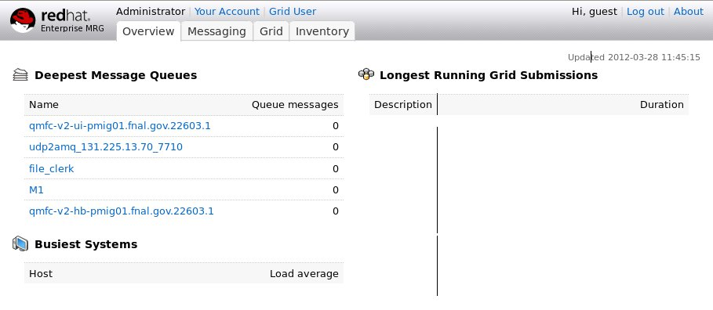
Select tab “Messaging”:
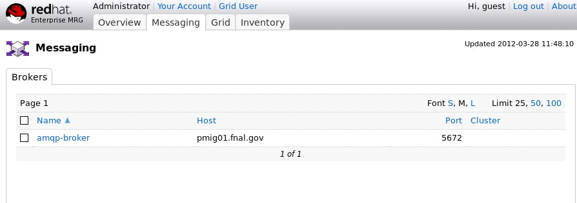
Select “amqp-broker”
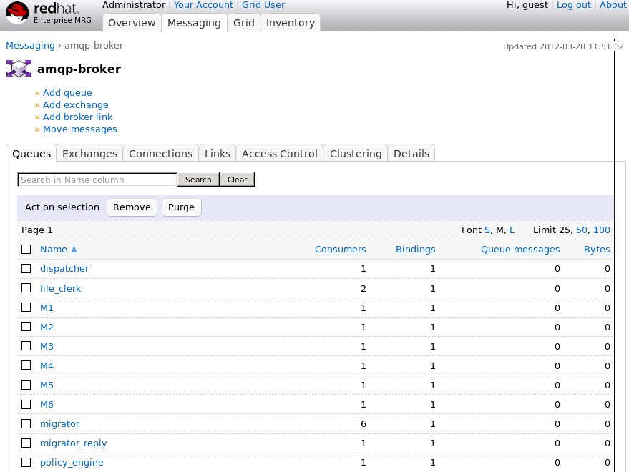
On this page you can see different queues and their status. The columns of interest are: “Queue Messages” and “Bytes”. “Queue messages” show how many messages are queued. “Bytes” show how many bytes are queued.
You can see all queues described in configuration plus individual queue for each migrator named by its name in configuration.

Enstore Cache Servers.
The state of enstore cache servers can be checked at enstore monitoring web pages.

Status at a glance page (fragment):
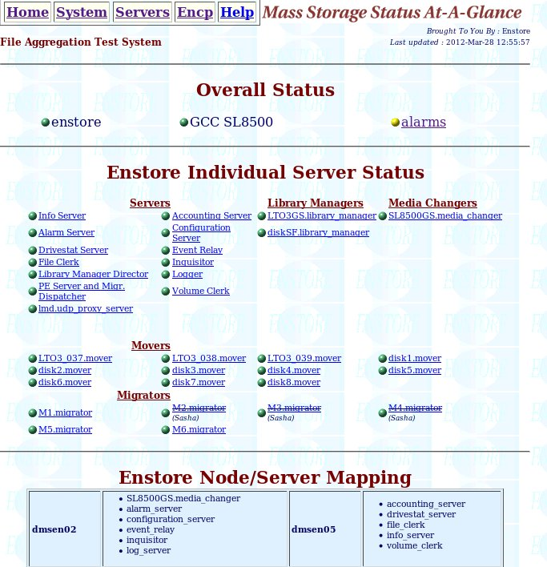

Enstore Servers page (fragment):
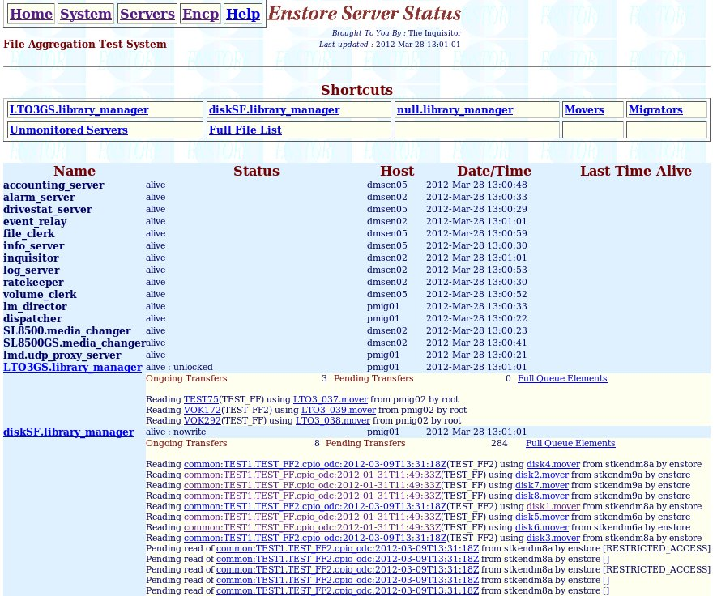
Enstore alarms is raised if any of its servers is down, the e-mail is also sent in this case just as for any existing enstore servers.

Monitoring and controlling write requests.
All files written into cache get registered in files_in_transition table in enstore DB. When file is written to tape the corresponding entry is removed from files_in_transition table. File clerk periodically checks this table an generates warning alarms: “N files stuck in files_in_transition table”, where N is the total number of such files. The list of bfids in files_in_transition table is referred to in “Additional Information” column on alarms page. Note that this is just a warning and usually does not require any action. However if the number of such files continuously grows this may mean that some investigation is needed to find the reason. The possible actions may be:
Check SAAG and Servers web pages
Check statuses of migrators (enstore mig –status) to find out if they do any work.
If migrator is down start it (enstore start).
Check queues in dispatcher (enstore disp –get-q). Check migration pool size. If it is 0 it is safe to re-play events for files_in_transition table by the following command:
enstore file –replay
If migration pool size is not 0 check few minutes later. When files are in migration pool lists they are queued for migration by migrators. If migration pool size does not get smaller this means that the system is busy and you may want to check how encp requests from nodes, running migrators proceed by examining “Enstore encp history” (http://www-stken.fnal.gov/enstore/encp_enstore_system.html for instance), or checking enstore log files.
Note that for re-played events the corresponding lists in the intermediate (cache_written, cache_missed, and purge_pool) pools have time_qd (time the first event was queued) since the last re-play. Thus the time for the corresponding policy restarts. This is done on purpose to avoid writing not grouped files to tape and allow administrator to make a decision how to proceed with such files. If administrator decides that files in the intermediate cache_written lists needs to get written to tapes immediately he can issue “enstore disp –start-draining command, which moves all lists from intermediate pools to migration_pool and initiates migration.
If packaging and migration to tapes does not resume (enstore mig –status <migrator> is one of the ways to check this) contact developers.

Emergency data migration to tape.
Some system operations, such as scheduled or unscheduled system shutdowns may require flushing all files not yet written to tape to get written even if criteria defined in the Policy Engine Server were not met. The special enstore command and the corresponding event will be designed for this.
Enstore command:
enstore disp –start-draining - this command instructs the policy engine to send all its current lists for migration to tapes.

Migration to new media.
In enstore there is a need of consistent migration of data form one tape media to another as the old media and drives get replaced with new technology. The natural way of providing such migration for packaged files is to stage them to cache with subsequent repackaging and archiving to a new tape. This approach does not require any changes in migration scripts.

Document Change log

v2 | 03/28/12 | Sasha | Initial release
v3 | 04/03/12 | Sasha | Changed per comments from John
v4 | 08/27/12 | Sasha | Added description for configuration without UDP2AMQP server
V6 | 10/26/12 | Sasha | Added a step to “Adding or modifying a policy”
v7 | 12/05/12 | Sasha | Added details about Migration Dispatcher pools and what happens after replay command
v8 | 04/10/13 | Sasha | Modified Monitoring and controlling write requests.
v9 | 04/26/13 | Sasha | Added description of enabling/disabling SFA
v10 | 05/02/13 | Sasha | Minor change per comments from Alex
v11 | 06/10/14 | Sasha | 1. Removed all about proxy server. It is not needed.  2. Added clustered configuration  3. Added separate migrators for write, read, and purge requests

We consider an optimal file size the size, which provides the throughput not less than 90% of maximum

