A case study

In partial fulfillment of the requirements

for the course Web Programming

TSU Registrar's Office: Streamlined Appointment Scheduling for

Students

http://tsu-registrar-for-student.kesug.com

http://tsu-registrar-online-booking.kesug.com

**Submitted by:**

Abella, Tyron D.

Enriquez, Allen Roy L

Quiambao, Eric Jansen P.

Ramirez, Irish Faith G.

Reyes, Elmer Herson S.

**BSCS-3A**

**Submitted to:** Muñoz, Raine Micaela

**Submission Date:** December 6, 2024

# Table of Contents

Table of Contents 1

1. Project Context 2

2. Objectives 3

3. Scope and Limitations 12

4. Purpose and Description 13

5. References 27

# 1. Project Context

Tarlac State University is one of the institutions that lead in higher education in Central Luzon and offers excellent learning opportunities. The registrar's office is a significant department that is essential to helping students from the moment of registration till they graduate. [1]

The TSU Registrar's Office is also responsible for quite a few important tasks within the university. They participate in the formulation and implementation of the policy on admission, enrollment management and graduation matters. They oversee student records maintenance, registration activities as well as academic auditing. They are also involved in data handling, attending to academic record requests, and maintenance of student data. In general, they coordinate the operations of students, academic staff, and the documentation management for the university.

With the large population of students and staff at Tarlac State University interacting with the Registrar's Office, long lines are starting to become a problem. These long lines are making the system less efficient due to the sudden increase in people coming to the office every now and then, an abundant amount of walk ins swarming the office, while also causing the people coming to wait in line for ages, whether students, teachers, or others to wait for an annoying period until their matters can be handled with by the registrar staff.

To address these issues, we are proposing a project based on implementing an appointment booking system specifically aimed at students, faculty and the general staff body. Considering that the current TSU Registrar Office system is having difficulties depending on certain times of the academic calendar or in general on some occasions every now and then, to help with satisfying the ever-increasing demands of the college body at large, the new system we are proposing intends to support the current one. To streamline and improve the interaction between the Registrar's Office and target users by providing the option to book an appointment with the registrar in advance, and for the user to just come to the office at their booked time and date.

# 2. Objectives

The main objectives of this case study is to design and implement an online booking system for the Tarlac State University Registrar, by way of a website that will be accessible for all people both in desktop and mobile form. The project is aiming to reduce the need to wait whenever the intended user; students, faculties, and visitors; is intending to visit the registrar office by further improving the efficacy of the already existing system through giving them the option to book a specific time slot in advance.

The following now will be a more in-depth explanation in numbered list format on how our site would help in solving this issue:

1. To Make the System Accessible for All Users
   1. Provide An Accessible Website

We plan to make a website using all our knowledge learned from our Web Programming (WebProg) class. We will be using the programming languages HTML, CSS, JavaScript, PHP, and SQL (MySQL) and some features of the Bootstrap framework to make the site and will be using a free hosting platform known as InfinityFree. Through making the system web-based we will be giving an easy way of accessing our system; by only needing a link to the site they will be able to access it.

* 1. Make The Website Responsive to All Screen Sizes (Mobile / Desktop)

1. The website will be as responsive as possible to all screen sizes guaranteeing as much ease of access towards all target users, by providing responsiveness to screen sizes, we guarantee that no user will be left behind and that you won’t need a desktop to be able to access this proposed system complement for the Registrar.
2. To Design and Develop the TSU Registrar Booking System for Our Users, We Will Have the Following Features and Functionalities for Our Site:
   1. Log In / Sign Up System

A log-in and sign-up feature makes the booking system more secure and organized. Students can track their appointments, cancel if needed, and access their info anytime, while the registrar can manage data easily and prevent fake bookings. It’s simple and keeps everything running smoothly.

* 1. Window and Transaction Type Selection

Users will be able to choose which window they have business with, our window selection page will be based on the existing face to face KIOSK right beside the registrar office on the main campus, through this we ensure that we remain true and as close as we can to the existing system. The user will then be asked before finalizing their appointment what specific transaction type they require for the office. This will be important information for the office because with this they will already know what kind of help the user will be seeking from them in advance and may be able to prepare for it if so wished.

* 1. Dynamic Callendar

Our dynamic calendar feature makes booking super easy by letting users switch between previous, current, and next months. It follows the registrar’s existing schedule of Tuesday to Friday, so students can only pick valid dates. Plus, past dates are automatically locked, so no one can book appointments for days that have already passed. This keeps everything organized and ensures appointments match the office’s availability.

* 1. Time Slots Selection

Our time slot feature lets users pick the exact time for their appointment, making the process quick and hassle-free. By providing the users with the option to choose in advance what time they would like to appear and handle their registrar-related matters, we will be removing the need to wait as much as possible for the registrar's office.

Time slots run from 8 AM to 5 PM and are divided into 10-minute intervals, so students have plenty of options to choose from. We will also have a break period from 12pm-1pm for the registrar staff to have their own break time. This setup will help avoid overlapping schedules and ensure everything runs smoothly throughout the day.

With the explained features and functionalities stated above, we believe we will be able to help further improve the efficacy and quality of experience of the registrar's office. By making it a site and responsive to all screen sizes, we will be able to reach out to all our intended users.

Allowing users to choose a specific date and time in advance brings a lot of benefits. It helps students plan ahead, so they don’t waste time waiting in long lines at the registrar’s office. It also ensures that the registrar can manage their workload better since appointments are evenly spread out throughout the day and will also be informing them in advance of the expected time they will come and what business they have with them. Plus, it reduces the chances of double-booking and makes the whole process more efficient for both students and staff.

# 3. Scope and Limitations

This section will be defining the scope and limitations of the proposed appointment booking system for the Tarlac State University's Registrar's Office. In this context, scope sets off the project's goals, features, and intended users, whereas the limitation portion encompasses the potential problems or influencing factors that could arise upon the implementation and usage of our system.

**Scope**

This paper is focused on the design and development of the online appointment booking system for the Tarlac State University Registrar's Office. The project aims to develop a web-based system that is accessible on both desktop and mobile platforms to streamline the scheduling of appointments for the intended users, that being the students, faculties, and visitors. In short, anyone with business with the TSU Registrar Office.

The functionalities include user log-in and sign-up, dynamic calendar navigation, time slot selection, and the ability to specify which window you have business with, and what your transaction type is. The system is developed to match the registrar's schedule so that it operates from Tuesday to Friday. Time slots are from 8:00 AM to 5:00 PM with 10-minute increments, due to the developers limited knowledge we also are using military time but are keeping the AMs and PMs.

The system was developed using HTML, CSS, JavaScript, PHP, and SQL (MySQL) in VSCode. Bootstrap was also used in some minor parts for the design. The system is currently being hosted with InfinityFree with their free option package, so that the access is easily available and you only need a link. This project solely focuses on the TSU body, that is, students, faculty, and related visitors, to enhance the experience with registrar-related services.

**Limitation**  
 The proposed system has specific constraints that affect its implementation and use. It is designed specifically for TSU students and faculty, and it limits the handling of appointment bookings for the registrar's office alone. It does not interlink with other university systems, so certain processes will be handled manually. In other words, it is not connected to any other digital systems used by the university. Therefore, as a result, tasks such as verifying the student's information, confirming transactions, or updating records will still need to be done manually by the registrar's staff.

Furthermore, the system relies on internet connectivity that may not be accessible to some students, especially in remote areas. Users with limited access to technology also face challenges in utilizing the platform. Finally, due to the usage of a free hosting platform, we are expecting to have DNS errors where users are unable to connect to the site as the hosting platform does not prioritize our traffic. The project operates within the confines of a free hosting service and that can impact the scalability and reliability of the system over a long period.

# 4. Purpose and Description

This new scheduling system for the TSU Registrar's Office will try to further increase the efficiency of the process by offering the users a chance to prebook their preferred timeslot, thereby making it easier and more convenient for them to go through the process. It will ease administrative burdens on the office staff when lines get long because there will be no pressure in that regard. It also helps avoid scheduling conflicts when students can prebook an appointment. This will allow the registrar staff to effectively manage their workloads.

The system will benefit the users since waiting times will be minimized. Students will not need to wait for a long time in line as they can come at the booked time and make their visit to the office. Therefore, the process will become even more convenient, saving a lot of time for students. The fact that appointments are booked beforehand will make it easier for the office to prepare their schedules and manage the work by distributing it more effectively.

This will allow the users, usually students, to book ahead of time. Thus, the system shall make the registrar's office operate much smoother. It shall ensure that both the workflow is smooth and that, on one hand, the workplace is being handled in its most efficient manner, at the same time, students receive their services in the minimum time required. Thus, the scheduling shall result in a much easier and stress-free experience to both the registrar's staff and users.

### Who Benefits from This System?

1. **Students**
   1. **Convenience -** Students can schedule appointments anytime, anywhere, without needing to visit the office in person.
   2. **Better Time Management -** Choosing specific time slots helps students balance their studies, work, and personal lives.
   3. **Peace of Mind -** Clear and instant notifications for bookings, rescheduling, or cancellations mean no more confusion or uncertainty.
2. **Registrar’s Office Staff**
   1. **Streamlined Operations -** The system takes care of scheduling, so staff can focus on their core responsibilities without being swamped by walk-ins.
   2. **Optimized Planning -** With an organized schedule, the office can prepare for busy times and staff accordingly.
3. **The Institution**
   1. **Stronger Reputation -** A system like this shows TSU’s commitment to modern, student-friendly solutions.
   2. **Valuable Insights -** Data on appointment trends can help TSU identify and address student needs more effectively.

### Who Will Use It?

The system is designed for:

* **Students -** They’ll use the platform to book and manage their appointments easily, ensuring a smoother experience when interacting with the Registrar’s Office.
* **Faculty / Staff –** Like the students, they will be able to book and manage their appointments easily and also if so, ever they will need to visit the registrar's office.
* **Visitors** – Non-students who need registrar services can also use the system to schedule appointments.
* **Enrollees** – Newly enrolled students can use the system to manage initial registrar tasks if they need to.
* **Registrar’s Office Staff –** They'll be able to theoretically monitor and handle the appointments effortlessly.

There’s no need for extra administrative staff to manage this system. Its intuitive design ensures both students and staff can use it without requiring constant technical support.

### What the System Offers

1. **Log In and Sign Up**:
   1. **Login**: Just enter your username and password.
   2. **Sign Up**: Provide your name, username, and password—it’s quick and simple.
2. **Navigation Bar**:
   1. Easily access bookings, profile settings, and log-out options.
   2. The bar stays at the top of the page, so it’s always within reach.
3. **Alert Box**:
   1. Instant updates for actions like:
      1. Incorrect password entry.
      2. Successful bookings or cancellations.
      3. Account updates.
4. **Interactive Buttons**:
   1. Easy to spot and use, with color contrasts and hover effects that make the experience smooth and engaging.
5. **Dynamic Date Booking:**
6. Book for Tomorrow: Quickly secure an appointment for the next day.
7. Book for Next Week: Choose a preferred day and time within the upcoming week.
8. Book for Next Month: Slots available in the next month.

This project highlights accessibility, simplicity, and a focus on the user. It’s designed to improve the experience for students, faculty, and related visitors at the TSU Registrar’s Office.

**Purpose Description of each function, area, and UI/UX on the project system**

**Figure 1:** Login page

Figure 1 shows the login page where users can enter their login credentials, such as username and password. For users who do not have an account, the page provides options to sign up for a new one.

**Figure 2:** Sign Up Page

Figure 2 shows the sign-up page where new users can create their accounts. This page typically requires users to provide information such as their name, username, and password.

**Figure 3:** Sing Up successful dialogue box

Figure 3 shows a confirmation message that appears after a successful account signup. It tells the user they can now log in to their account.

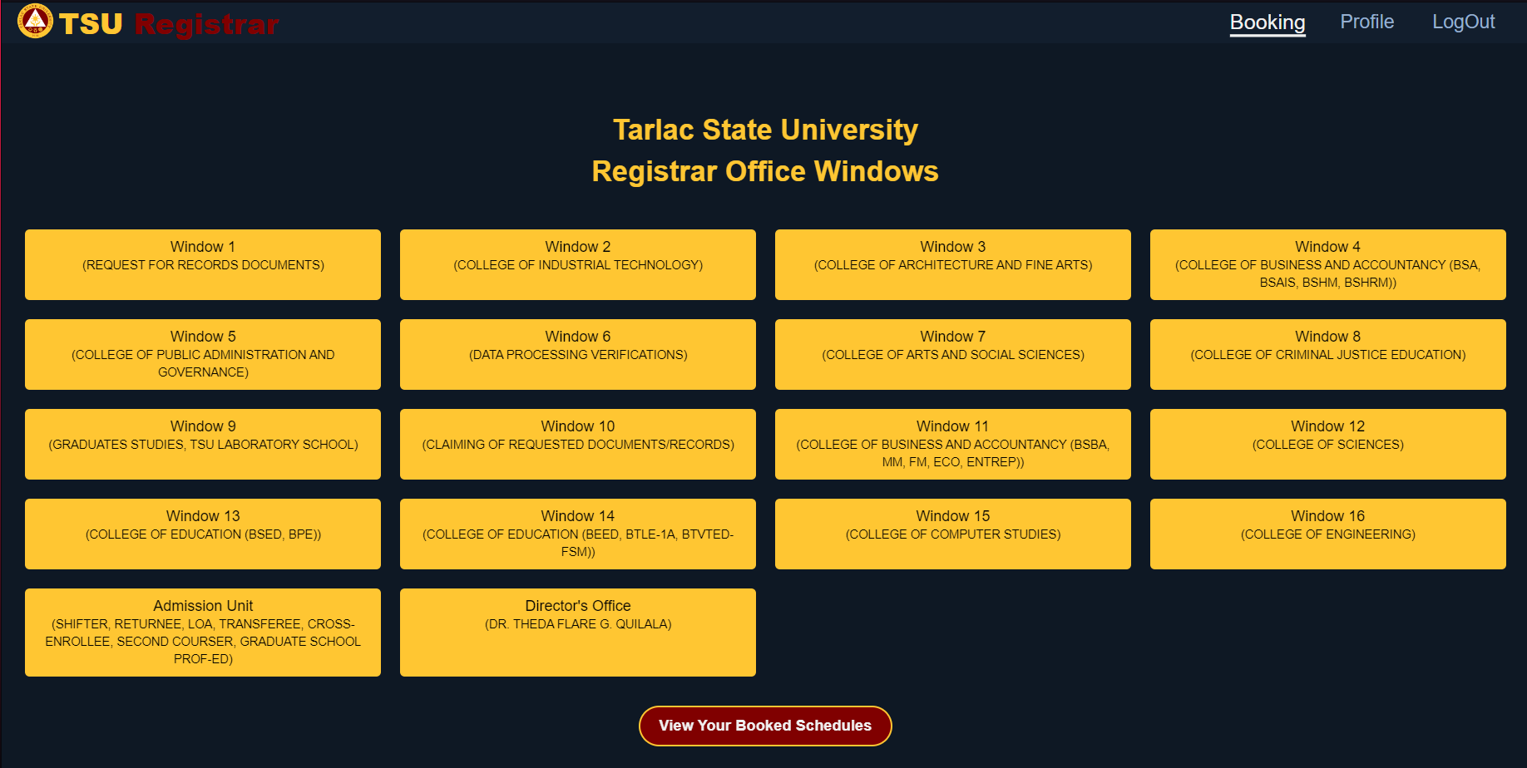

**Figure 4:** Booking Window Page

Figure 4 Displays a window where users require to select their respective departments from a window before booking an appointment. Additionally, there are specially designed windows for the admission unit and the dean's office.

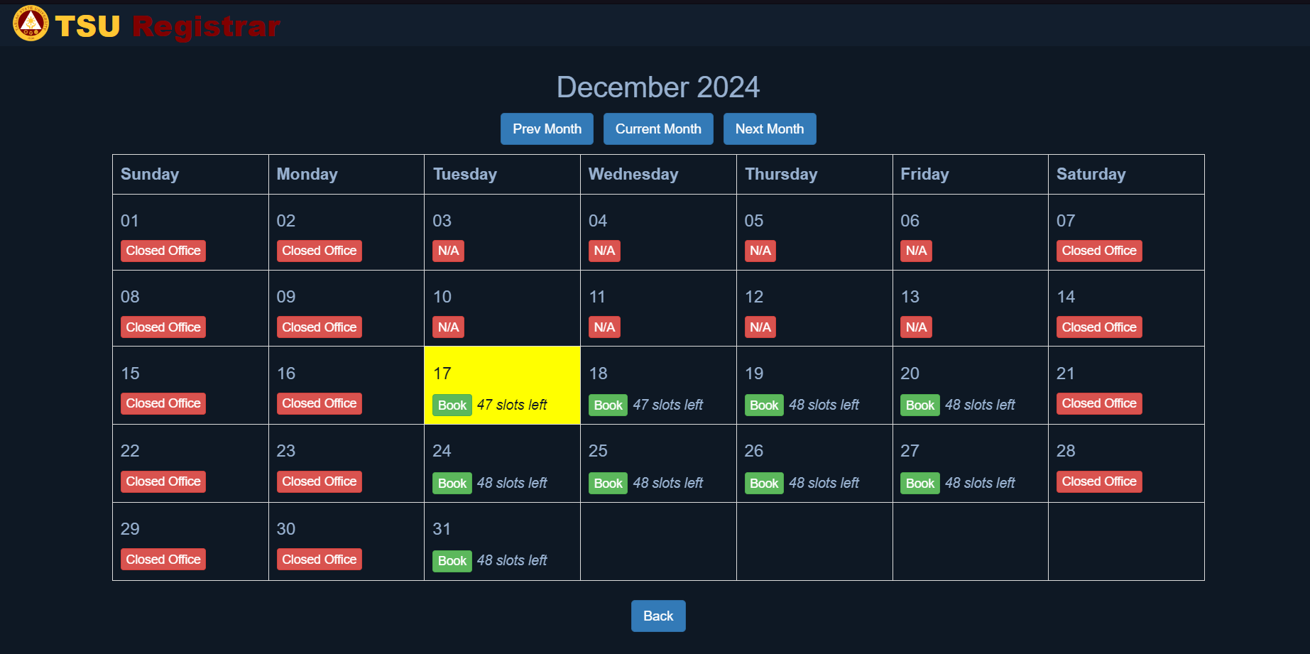

**Figure 5:** Booking Page

Figure 5 displays the available days slots for booking an appointment, the page also allows users to choose their desired slots for an appointment for the next following months.

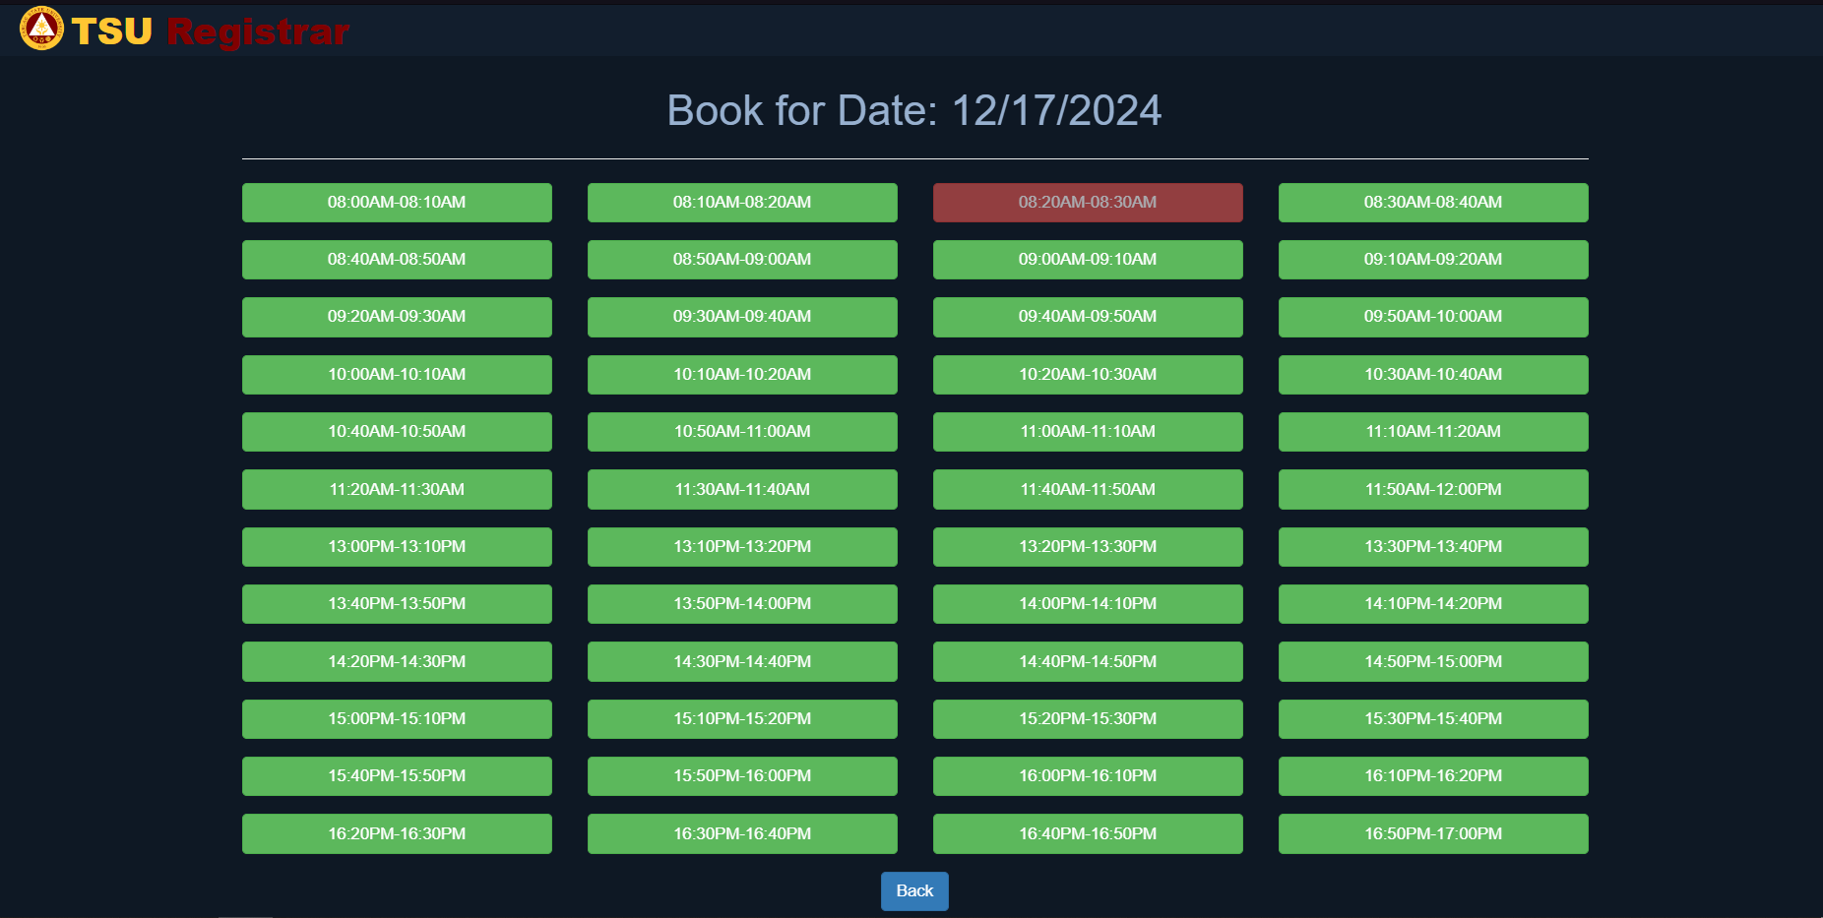

**Figure 6: Booking Time Page**

After the user chooses their desired day of appointment, the system will display the available times for that day. Red indicates unavailable times, while green indicates available times.

**Figure 7:** Booking Confirmation Page

Figure 12 shows the appointment confirmation screen, where the user's name and selected appointment date and time are automatically displayed. Additionally, users can select their transaction type from the available options.

**Figure 8:** User Dashboard Page

Figure 13 displays the window number, date and time and the details of transaction type where the user booked their appointment on the registrar office. It also allows users to cancel their booked appointment by just simply clicking the cancel button.

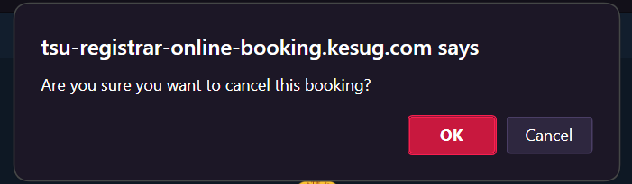

**Figure 9:** Booking Cancelation

Figure 13 after canceling a booking, a confirmation dialog asks the user to verify if they want to cancel their booking. The user can proceed with the cancellation by clicking “OK” or keep the booking by selecting “Cancel”

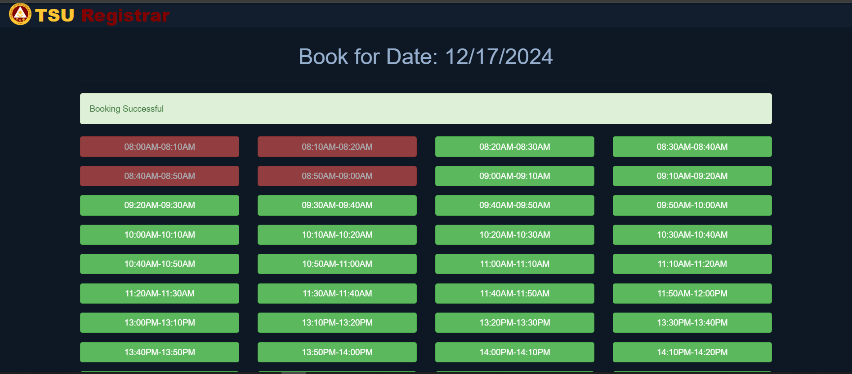

**Figure 10:** Successful Booking Message

Figure 11 shows that after choosing a time slot and booking an appointment, a dialog box will pop up on the user's device, indicating that the booking was successful.Users can acknowledge the message by clicking the “OK” button to proceed. This confirmation ensures users are immediately informed of their successful booking, providing a clear and reassuring end to the booking process.

**Figure 11:** Successful Cancelation of Appointment

Figure 14 shows a dialog box confirming a successful appointment cancellation. The message “Appointment canceled successfully!” is displayed, and users can click the “OK” button to proceed.

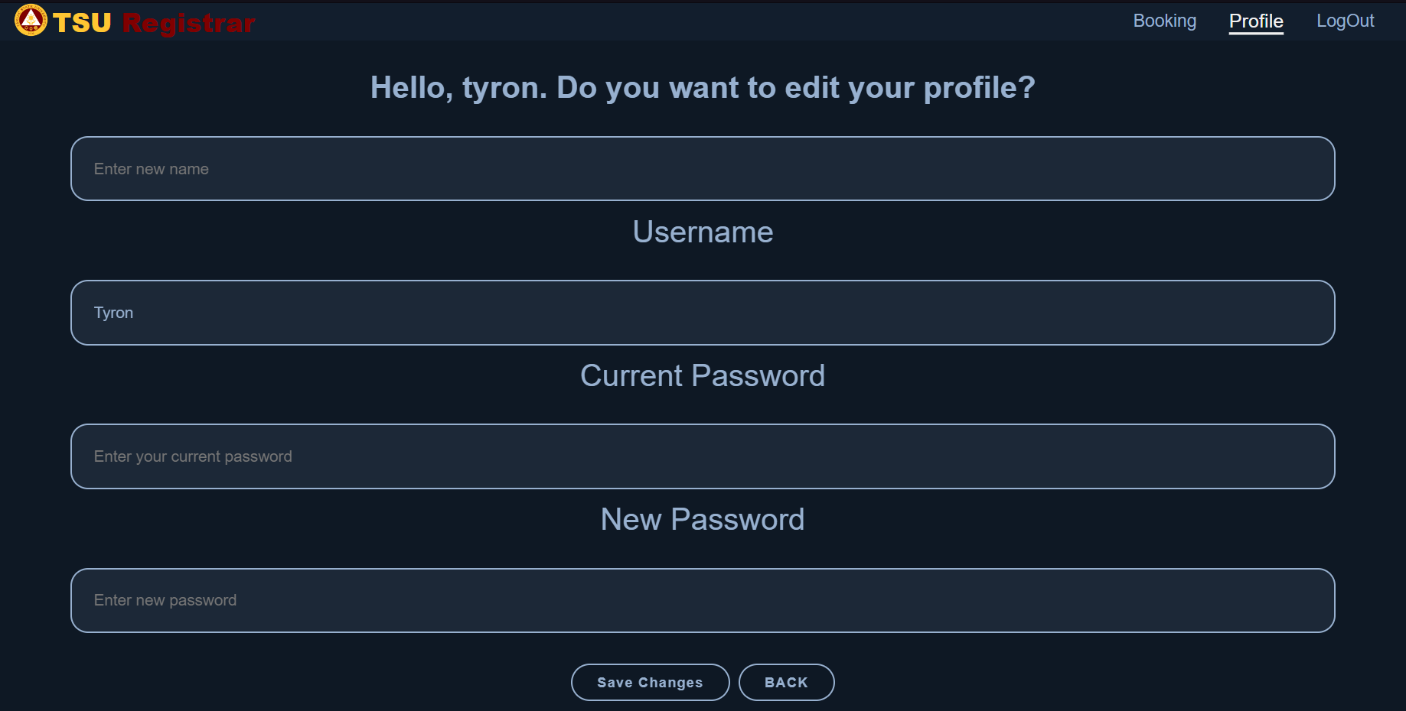

**Figure 12:** Users Editing Profile page

Right After clicking the edit profile on the previous page, Figure 12 allows users to update their account details by entering their username, current password, and new password. They can save their changes by clicking “Save Changes” or return to the previous page with the “back” button.

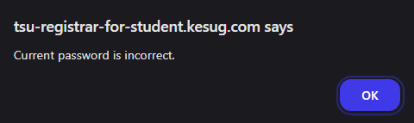

**Figure 13:** Incorrect Current Password

After editing your profile Figure Shows a dialog box that appears when user enters an incorrect password. The message “Current password is incorrect” is displayed, and the user can acknowledge it by clicking the “OK” button.

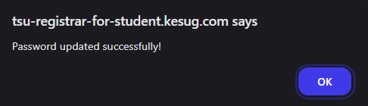

**Figure 14:** Password Updated

Figure 17 shows a dialog box confirming a successful password update. The message “Password update succesfully!” is displayed, and users can click the “OK” button to proceed.

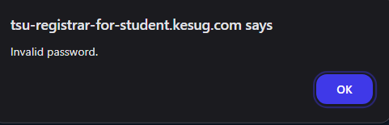

**Figure 15:** Invalid Password

Figure 18 shows a dialog box that appears when a user enters an incorrect password during login.

* **Usability Testing**  
    
  The system has been tested on three different screen types: Desktop, Tablet, and Phone. During each test, the design and functionality were evaluated to identify any issues or inconsistencies.

**Figure 16:** Login Page Desktop View

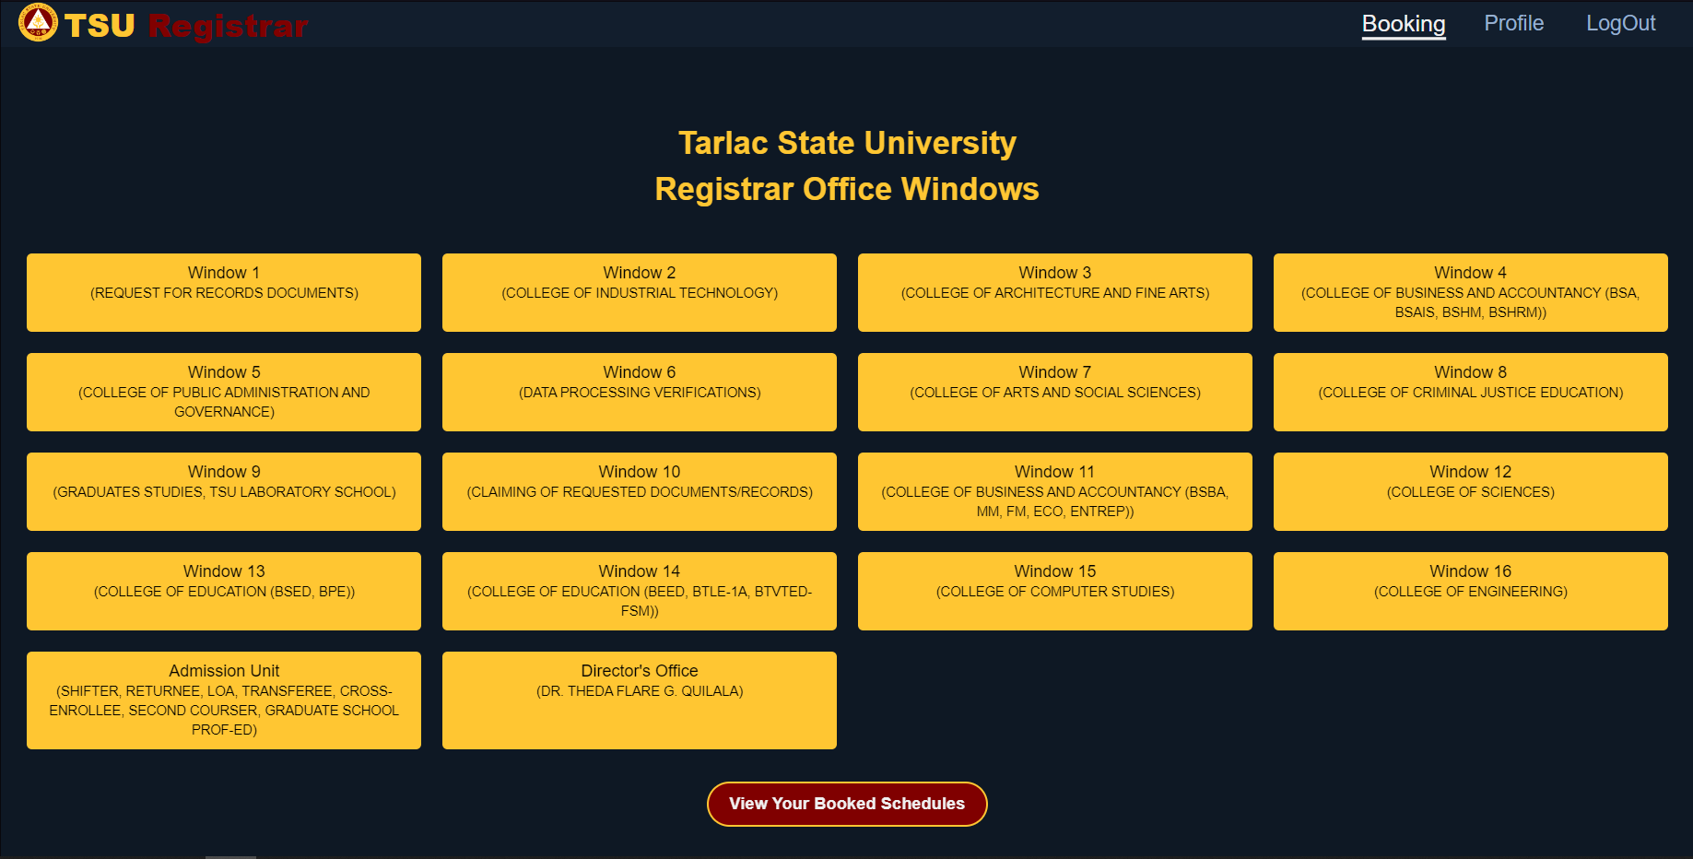

**Figure 17:** Booking Window Page Desktop View

**Figure 18:** User Dashboard Page Desktop View

Figure 19- 21 showsthe desktop view is the default layout of the website, and other screen sizes are compared to it since it represents the website's original design.

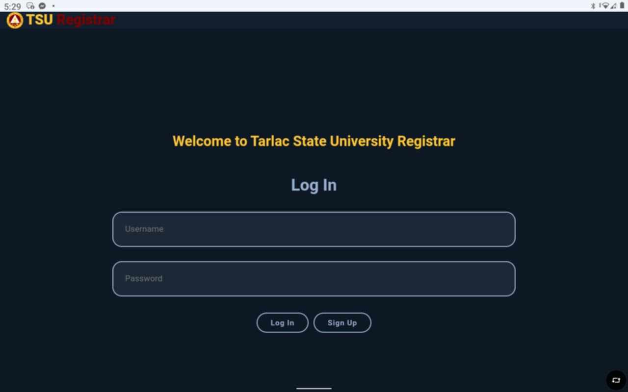

**Figure 19:** Login Page Tablet View

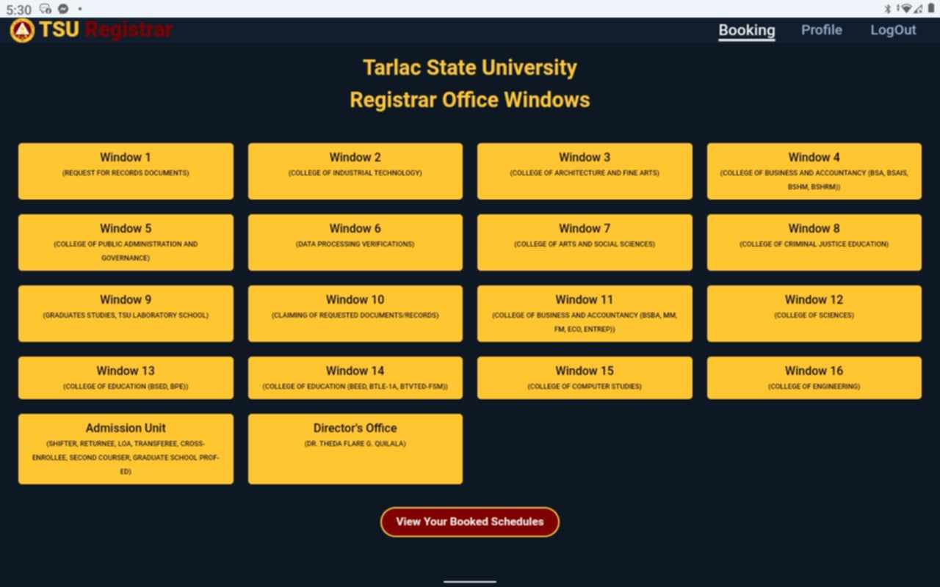

**Figure 20:** Booking Page Tablet View

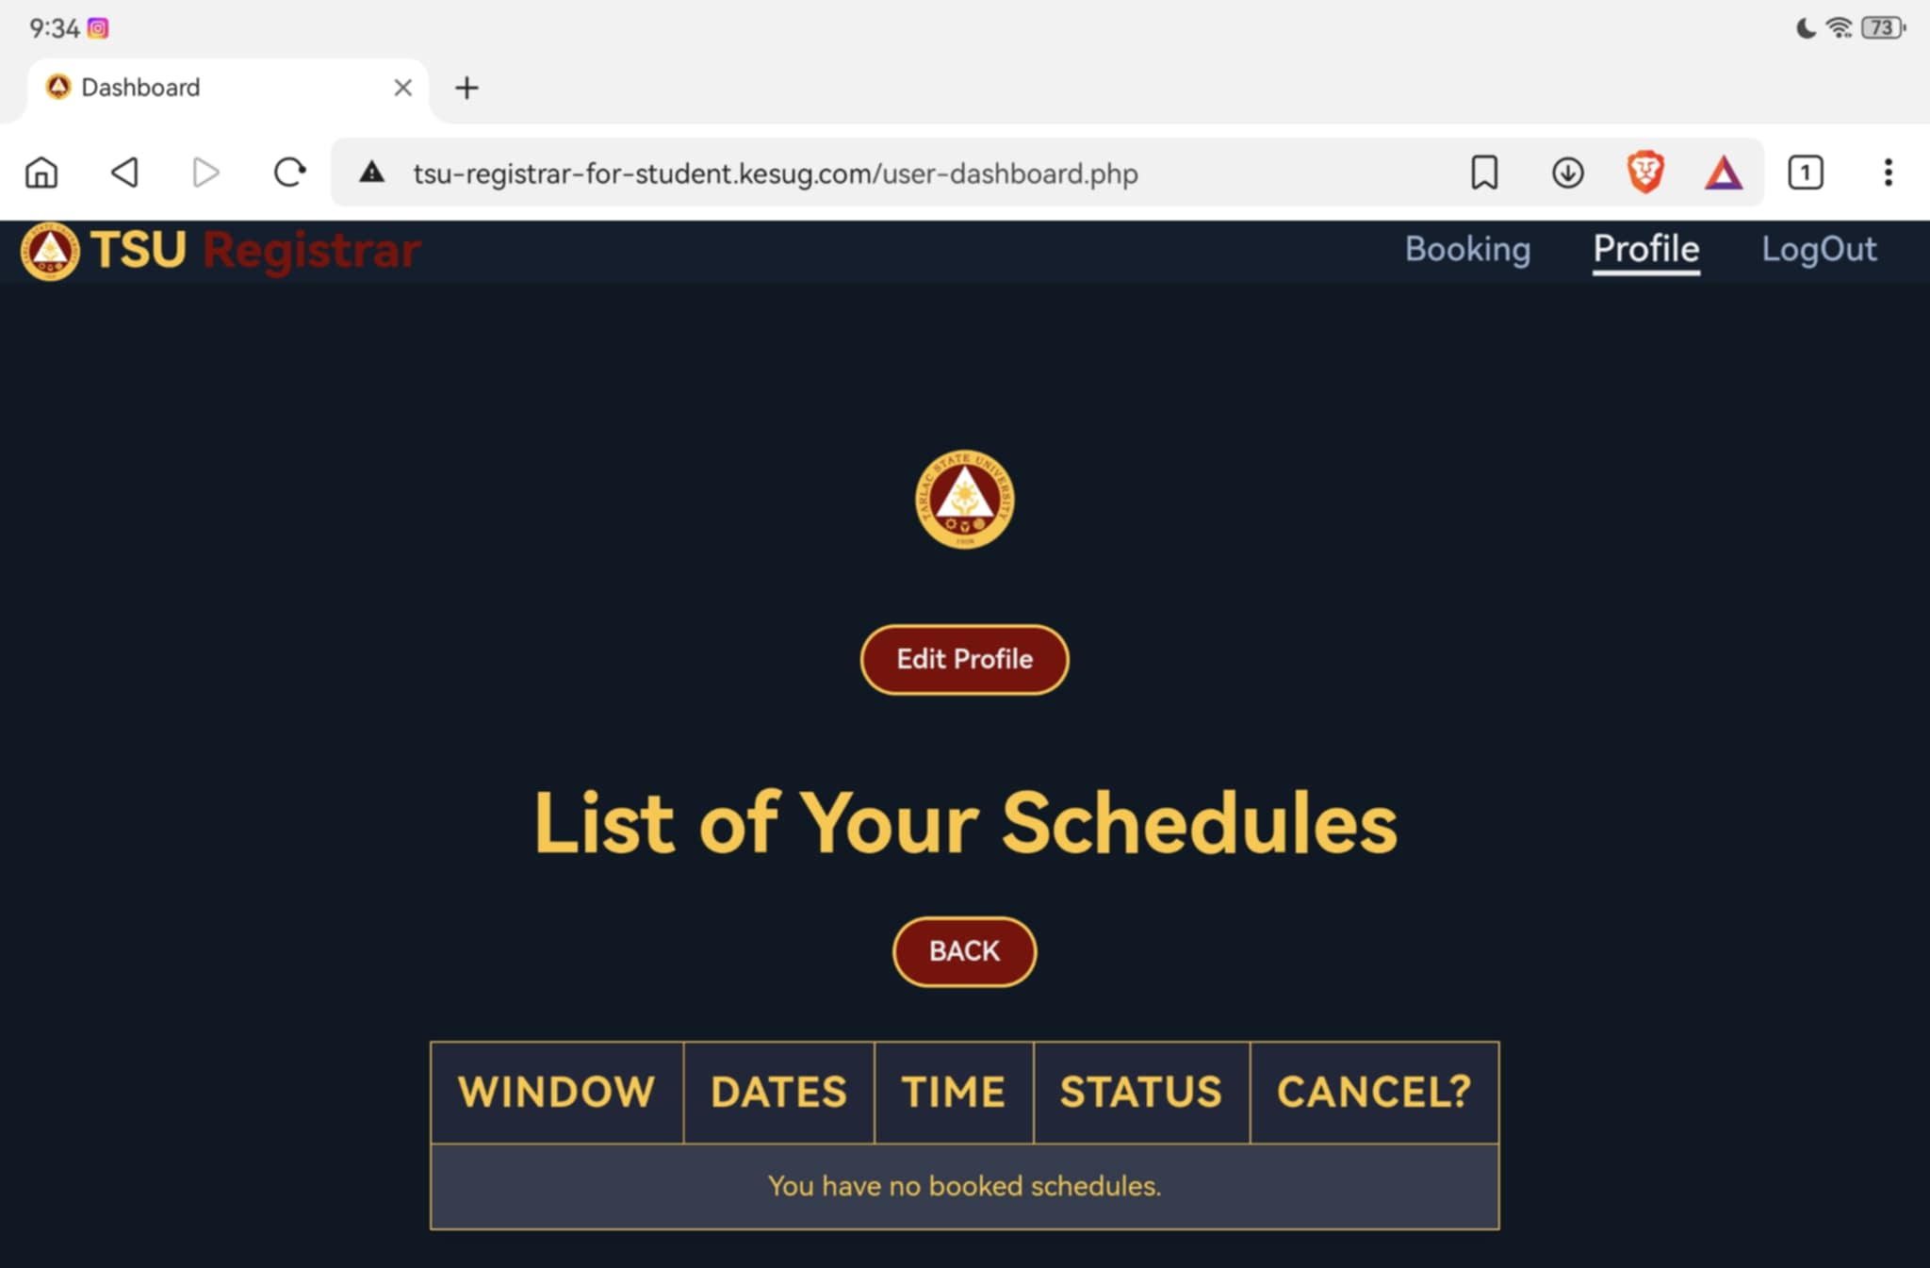

**Figure 21:** User Dashboard Page Tablet View

**Figure 22-24** Tablet View, where the layout remains largely unchanged from the desktop view, ensuring consistent experience across devices. The design adjusts smoothly to fit the tablet screen without major differences.

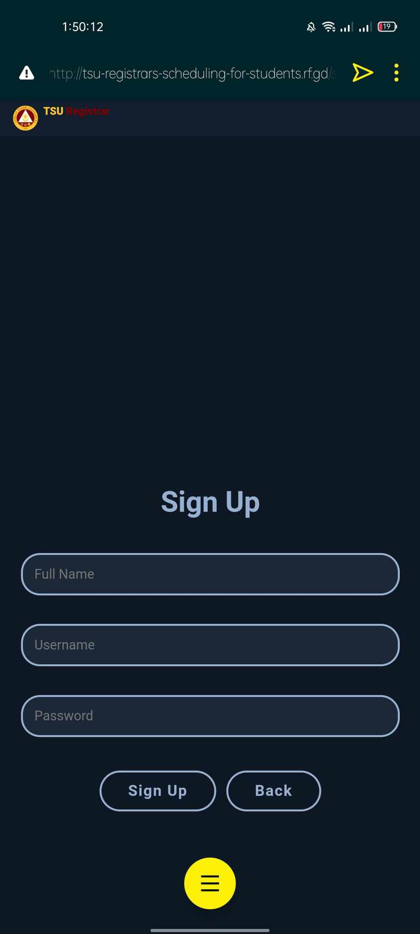

**Figure 22:** Login Page Phone View

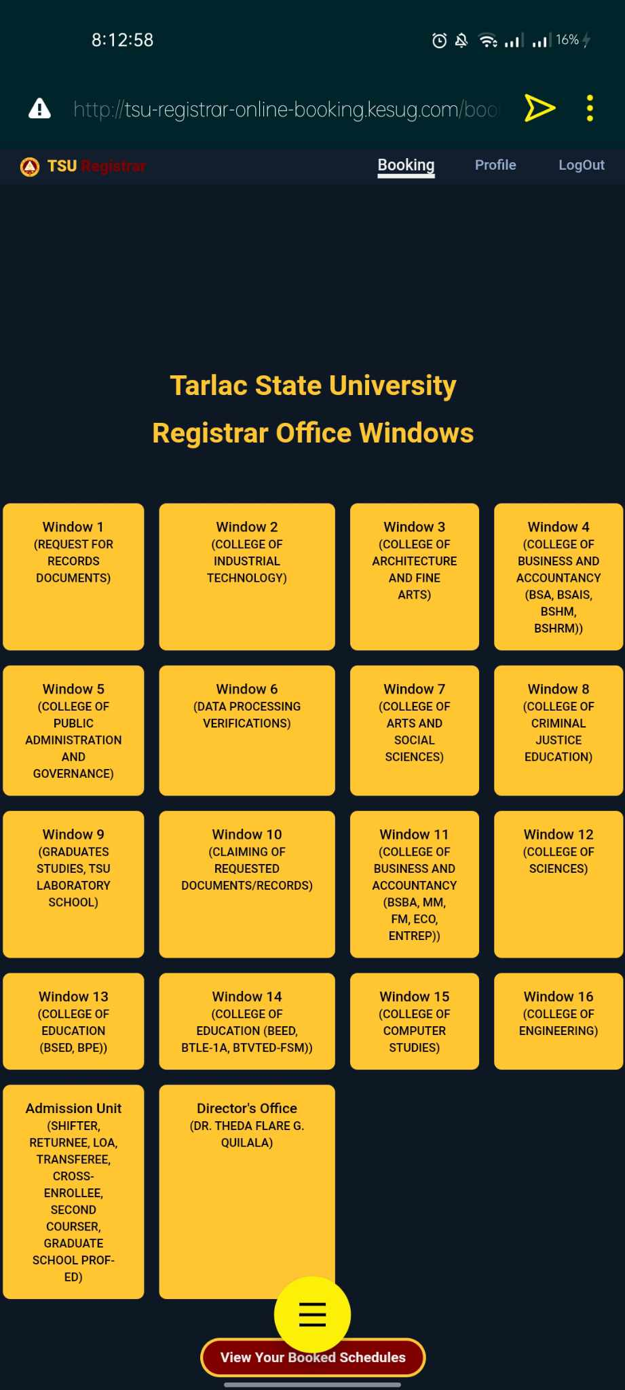

**Figure 23:** Booking Page Phone View

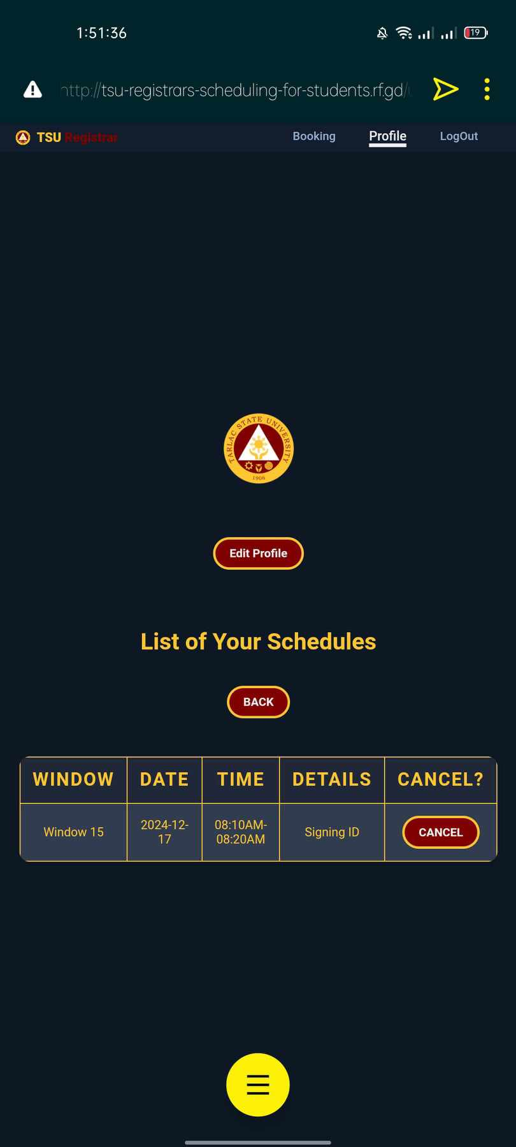

**Figure 24:** User Dashboard Page Phone View

Figure 25- 27 shows Phone View, how the system looks on smaller screens. The design stays mostly the same, but there are small changes, such as some text moving to a new line to fit the screen better.

**TESTING METHODS**

We have tested our system on two fronts, firstly, by Developer Testing by manually checking all of the features ourselves, making sure everything works as intended. Secondly, by User Testing by finding people to test our site through a purposive sampling method, we managed to get students from different colleges of the university as well as one registrar staff to test our site and give feedback.

**Developer Testing**

There are several testing methods that one can use to create a functional website and ensure that the site functions properly. The approaches that our developers have used to ensure that the system website functions properly as envisioned involve the following testing methods as discussed below, which are Responsive Design Testing and Manual Functionality Testing, and Cross Browser Compatibility Testing. A more in-depth explanation bellow:

1. Responsive Design Testing

The developers used browser developer tools to ensure that the website functions perfectly on different devices, including mobile phones, tablets, and desktop computers. This ensures that the interface remains user-friendly and accessible on screens of different sizes.

1. Manual Functionality Testing

All features that include buttons, links, animations, and interactive functionality were hand-tested to ensure such elements execute their intended action correctly and consistently.

1. Testing for cross-browser compatibility

The website was tested to ensure its performance and its appearance on various browsers including Chrome, Firefox, Edge, and Opera. Therefore, the site would perform correctly and uniformly display in all the different platforms.

**User Testing**

Another approach that has been used was the user testing method where the developers conducted website testing to users and explained the purpose of the website and how does the website work, right after the respondents tested the website the developers conducted a survey to get the feedback for the users from the website.

While conducting a study at Tarlac State University, we the researchers chose to select 2 respondents from each college department. This approach ensures that every department at Tarlac State University is represented in the sample.

The process of user testing involved purposive sampling to identify suitable participants. A diverse group of users, including students from different colleges and a registrar staff member, were chosen to ensure a well-rounded evaluation of the system. Participants were first introduced to the purpose and functionality of the website. After testing the website, they completed a survey to provide feedback on their experience.

Now that we have explained our testing methodologies, we will now be discussing the in depth results of said testing in the following pages.

|  |  |  |  |  |  |
| --- | --- | --- | --- | --- | --- |
| Login Authentication Feature | Validation | Wrong username | Alert “No account found with that username.” | Alert “No account found with that username.” | Passed |
| Login Authentication Feature | Validation | Correct username, Correct password | Logged In | Logged In | Passed |
| Button for booking | Functional button | Clicking “book” button | Booked success | Booked success | Passed |
| Button for viewing your schedules | Functional button | Clicking “View Your Booked Schedules” button | Display schedule that you booked | Display schedule that you booked | Passed |
| Button for canceling your booked schedule | Functional button | Clicking “Cancel” button | Confirmation before action | Confirmation before action | Passed |
| Edit Profile feature while logged in | Validation | Wrong current password | Alert “Current password is incorrect” | Alert “Current password is incorrect” | Passed |
| Edit Profile feature while logged in | Validation | Correct current password | Alert “Password updated successfully!” | Alert “Password updated successfully!” | Passed |

Table 1: Functionality Testing Table

In table 1, the functionality testing table shows strong verification and operational integrity of key features on the website. All functions were checked for conformance to the expected behavior, including login authentication and signup validations, interacting with interactive components like booking, viewing, and canceling schedules. The results show that all functional requirements, including the handling of wrong input, error messages, buttons working normally, and editing the profile, were as expected, resulting in a clean pass on all inspections. This thorough testing process will ensure that the website is user-friendly and trustworthy, while risks of system failure are minimized, and the overall fun quotient gets higher.

**Survey Methodology**

The developers sent the survey questions through as much as possible, students through various colleges of Tarlac State University using Google Forms, which is very easy to use and accessible across many devices. For fairness' sake, we have also managed to get one respondent from the registrar's office.

The digital approach of Google Forms also allows respondents to respond conveniently at their own pace while ensuring that the data is collected efficiently and simultaneously in real time. In addition, the auto-options of Google Forms, like instant submission tracking and data aggregation, make it easier to organize and analyze the responses, so insights can be drawn in a faster and more accurate manner.

This method used is purposive sampling since the developers were targeting certain groups of users, the students from different colleges of the university, from whom the proposed system would directly benefit. Since the data collected is of direct relevance to the needs and expectations of the system's intended users, the study was guaranteed to have relevant data for the purpose of the study. This method helps in the collection of meaningful feedback, but it may not equally represent the whole population of the university.

|  |  |  |
| --- | --- | --- |
| **College Department** | **Respondents Number** | **Status** |
| CASS | Respondent 1 | Student |
| CASS | Respondent 2 | Student |
| CAFA | Respondent 3 | Student |
| CAFA | Respondent 4 | Student |
| CBA | Respondent 5 | Student |
| CBA | Respondent 6 | Student |
| CCS | Respondent 7 | Student |
| CCS | Respondent 8 | Student |
| COE | Respondent 9 | Student |
| COE | Respondent 10 | Student |
| CIT | Respondent 11 | Student |
| CIT | Respondent 12 | Student |
| CCJE | Respondent 13 | Student |
| CCJE | Respondent 14 | Student |
| CPAG | Respondent 15 | Student |
| CPAG | Respondent 16 | Student |
| COED | Respondent 17 | Student |
| COES | Respondent 18 | Student |
| COS | Respondent 19 | Student |
| COS | Respondent 20 | Student |
| N/A | Respondent 21 | Staff |

**Table 2:** Respondents

The participants are categorized by their respective college departments and their status as either students or staff. The College of Arts and Social Sciences (CASS) includes Respondent 1 and Respondent 2 as students. The College of Architecture and Fine Arts (CAFA) includes Respondent 3 and Respondent 4 as students. The College of Business Administration (CBA) includes Respondent 5 and Respondent 6 as students. The College of Computer Studies (CCS) includes Respondent 7 and Respondent 8 as students. The College of Engineering (COE) includes Respondent 9 and Respondent 10 as students. The College of Industrial Technology (CIT) includes Respondent 11 and Respondent 12 as students. The College of Criminal Justice Education (CCJE) includes Respondent 13 and Respondent 14 as students. The College of Public Administration and Governance (CPAG) includes Respondent 15 and Respondent 16 as students. The College of Education (COED) includes Respondent 17 as a student. The College of Environmental Science (COES) includes Respondent 18 as a student. The College of Science (COS) includes Respondent 19 and Respondent 20 as students. Additionally, there is one staff member, Respondent 21, who is not affiliated with a specific college. This distribution provides a broad perspective on the experiences and opinions of students across different fields of study within the institution

|  |  |
| --- | --- |
| **Department** | **Total Number of Respondents per College department** |
| **CASS** | 2 |
| **CAFA** | 2 |
| **CBA** | 2 |
| **CCS** | 2 |
| **COE** | 2 |
| **CIT** | 2 |
| **CCJE** | 2 |
| **CPAG** | 2 |
| **COED** | 2 |
| **COS** | 2 |
| **REGISTRAR OFFICE STAFF** | 1 |
| ***Mean*** | 1.91 |
| ***Variability Index*** | 0.2873 |

**Table 3:** Total Number of Respondents per College Department

Table 3 show the division of respondents from various College Department. Specifically, there are 2 respondents each from the College Departments and there is 1 respondent from the staff category. With an overall mean response of 1.91, and a variability index of 0.2873**.**

|  |  |  |  |  |  |
| --- | --- | --- | --- | --- | --- |
| **Overall** | **Students** | **Faculty** | **Staff** | **Mean** | **Variability Index** |
| 21 | 20 | 0 | 1 | 7 | 9.20 |

**Table 4:** Users Status

Table 4 illustrates that the majority of the respondents who provided their feedback on the current and new scheduling systems at TSU are students from various college departments, with only one staff member participating in the survey. With an overall mean User Status of 7, and a variability index of 9.20.

|  |  |  |  |  |  |  |  |
| --- | --- | --- | --- | --- | --- | --- | --- |
| **Overall** | **5**  *(Very Satisfied)* | **4**  *(Satisfied)* | **3**  *(Neutral)* | **2**  *(Dissatisfied)* | **1**  *(Very Dissatisfied)* | **Mean** | **Variability Index** |
| 21 | 3 | 5 | 12 | 1 | 0 | 3.48 | 0.797 |

**Table 5:** Users Satisfactory on the Current Scheduling Procedure

Table 5 illustrates the Users Satisfaction with the Current Scheduling Procedure feedback on the current scheduling procedure. Specifically, 3 respondents who are Very Satisfied rated the procedure as 5, 5 respondents are Satisfied rated it as 4, 12 respondents are Neutral rated it as 3, 1 respondent Dissatisfied rated it as 2, and no respondents rated it as "Very Dissatisfied." The overall mean rating is 3.48, indicating a somewhat neutral to perception of the current scheduling procedure. The variability index, which measures the spread of responses, is 0.797, suggesting a moderate level of variation in the respondents' satisfaction levels.

|  |  |  |  |  |  |  |  |
| --- | --- | --- | --- | --- | --- | --- | --- |
| **Overall** | **VERY EASY** | **EASY** | **NEUTRAL** | **DIFFICULT** | **VERY DIFFICULT** | **Mean** | **Variability Index** |
| 21 | 10 | 5 | 6 | 0 | 0 | 4.19 | 0.8512 |

**Table 6:** Ease of Use of the Proposed Appointment Booking System

Table 6 Shows theEase of Use of the Proposed Appointment Booking System with 10 respondents rated the system as "Very Easy," 5 respondents rated it as "Easy," 6 respondents rated it as "Neutral," and no respondents rated it as "Difficult" or "Very Difficult." The overall mean rating is 4.19, indicating a general positive perception of the system’s ease of use. The variability index, which measures the spread of responses, is 0.8512, suggesting that while most respondents found the system easy to use,

|  |  |  |  |  |  |  |  |
| --- | --- | --- | --- | --- | --- | --- | --- |
| **Overall** | **5**  *(Very Satisfied)* | **4**  *(Satisfied)* | **3**  *(Neutral)* | **2**  *(Dissatisfied)* | **1**  *(Very Dissatisfied)* | **Mean** | **Variability Index** |
| 21 | 8 | 7 | 5 | 1 | 0 | 4.05 | 0.8987 |

**Table 7:** Users Satisfactory with the overall functionality

Table 7 illustrates the feedback on the overall functionality of the system. Specifically, 8 respondents are Very Satisfied and rated the system as 5, 7 respondents are Satisfied rated it as 4, 5 respondents are Neutral rated it as 3, 1 respondent is Dissatisfied rated it as 1, and no respondents rated it as "Very Dissatisfied." The overall mean rating is 4.05, indicating a generally high level of satisfaction with the system’s functionality. The variability index, which measures the spread of responses, is 0.8987, suggesting that while most respondents are satisfied, there is some variation in their levels of satisfaction.

# 5. References

[1] A. Author, "Streamlining Education: The Appointment Scheduler," Audiri, 2023. [Online]. Available: https://audiri.com.au/streamlining-education-the-appointment-scheduler. [Accessed: 10-Oct-2023].