Report

There are 2 vehicles, and each vehicle picks up one passenger from origin node 1 to destination node 4.
Our goal is to minimize the total vehicle travel cost by using Dantzig-Wolfe decomposition approach.
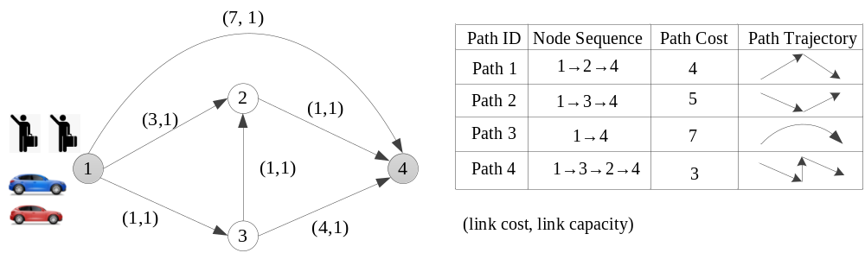
My Answer：
Iteration 1 | Sub problem | New column: path 4: 1,3,2,4. Column cost = 6.
Iteration 1 | Master problem | Using sub_1; excess = 1;  λ = 1; μ₁₃ = -1; μ_{else} = 0; π = 2;
Iteration 2 | Sub problem | New column: path 3:1,4. Column cost = 14. z_sub = -2.
Iteration 2 | Master problem | Using sub_2; excess = 0;  λ₁ = 0.5; λ₂ = 0.5; μ₁₃ = -4; μ_{else} = 0; π = 14;
Iteration 3 | Sub problem | New column: path 1:1,2,4. Column cost = 8. z_sub = -6.
Iteration 3 | Master problem | Using sub_2; excess = 0;  λ₁ = 0.5; λ₂ = 0.5; μ₁₃ = -1; μ₂₄ = -3; μ_{else} = 0; π = 14;
Iteration 4 | Sub problem | New column: path 2:1,3,4. Column cost = 10. z_sub = -2.
Iteration 4 | Master problem | Using sub_2; excess = 0;  λ₁ = 0.5; λ₂ = 0.5; μ₁₃ = -1; μ₂₄ = -2; μ_{else} = 0; π = 12;
Iteration 5 | Sub problem | New column: path 2:1,3,4. z_sub = 0.(迭代终止)
Given Answer：
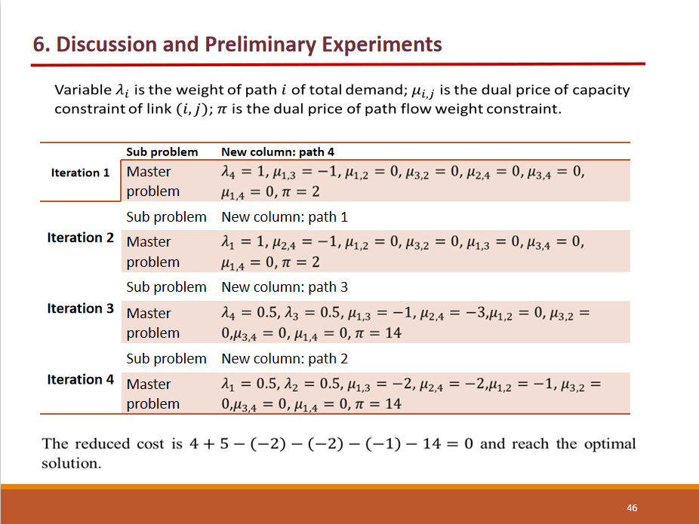

Questions:
- The reason to use the shadow price as the candidate of μ and π in the next iteration.
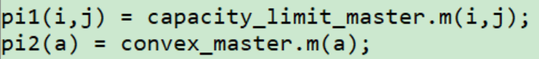
- The reason to use two phase. I don’t think it is necessary, but I can not get the right answer after I ignore it.
(不清楚为什么选sub1，sub2之一作为目标函数，同时还必须和上次迭代的master问题对应)
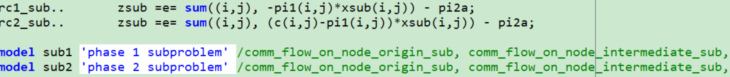
主问题中也用了两种：
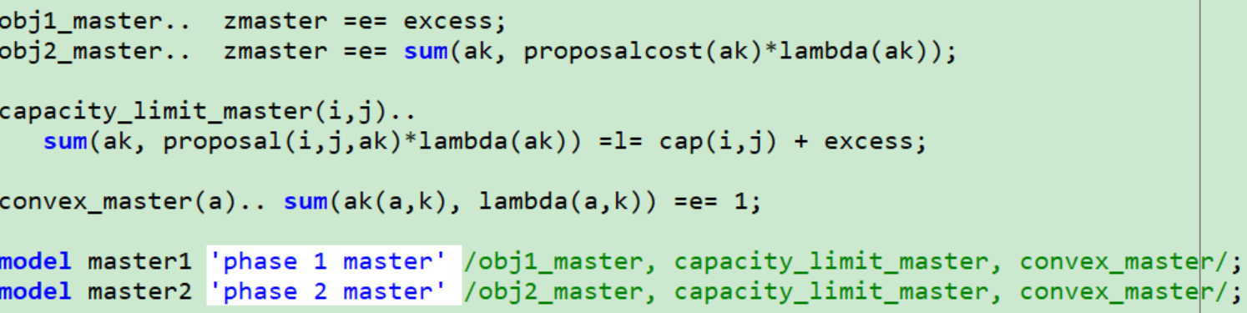
- The meaning of excess in master problem. When excess = 0, we need to solve the other master obj-function.
- If we can not generate a new column(or proposal), What should we do?(貌似不可能，总会有最短路的，但是在生成全column之前，每次都应该不同吗？

