OSM2GMNS: A tool for generating GMNS standard data file
from OpenStreet Map
Version 0.9

OpenStreet Map (OSM) is a free, crowdsourced, worldwide mapping project and geospatial data repository. This user guide describes a data conversion tool of OMS2GMNS based on OSMnx, to directly download the OSM map data and then generate node and link network file in the GMNS format. For more information, you can visit OpenStreet Map website at https://www.openstreetmap.org/, and check out the latest development about OSMnx at https://geoffboeing.com/.

1. Understanding GMNS
GMNS(General Travel Network Format Specification), proposed by the Zephyr Foundation, which aims to advance the field through flexible and efficient support, education, guidance, encouragement, and incubation. Further details can be found at https://zephyrtransport.org/projects/2-network-standard-and-tools/
A transportation network in GMNS format typically includes node.csv and link.csv files, as shown in the following table.
node.csv:
name | node_id | zone_id | ctrl_type | node_type
x_coord | y_coord | geometry
link.csv:
name | link_id | from_node_id | to_node_id | dir_flag
length | lanes | free_speed | capacity | link_type
 | geometry
A list of typical link types from OSM includes the following.
link_type | link_type_name
1 | motorway
2 | trunk
3 | primary
4 | secondary
5 | tertiary
6 | residential
7 | others

2.How to install OSMnx?
Further details about OSMnx can be found: https://geoffboeing.com/2016/11/osmnx-python-street-networks/.

Step 1: Set a new virtual environment in Anaconda 3 with Python 3.7
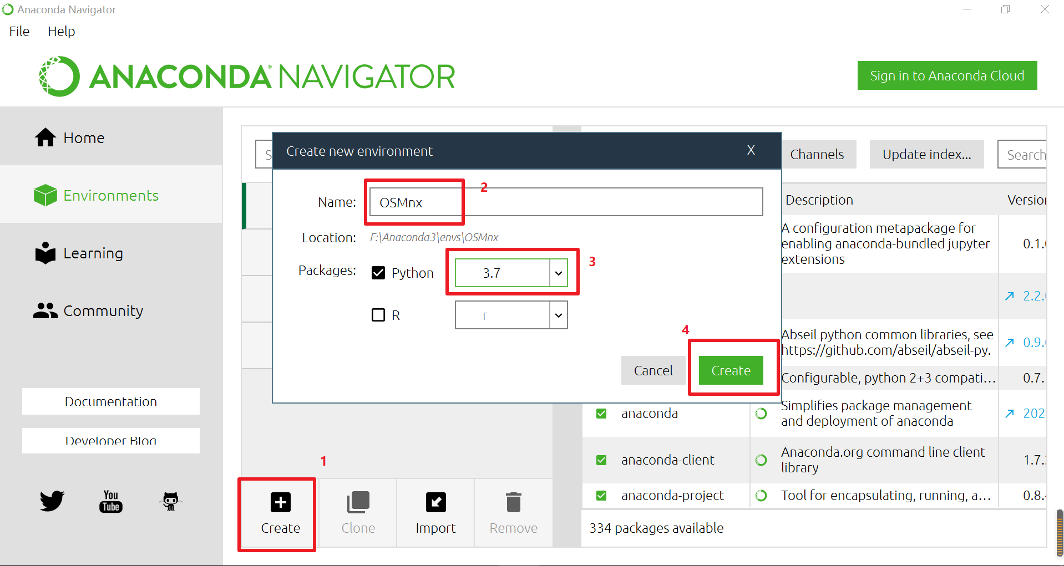
Step 2: Open Terminal in this virtual environment, and install 3 packages namely rtree, gdal, fional in sequence. Input the command line in terminal: pip install XXXX.whl, while the specific versions as recommended as follows:
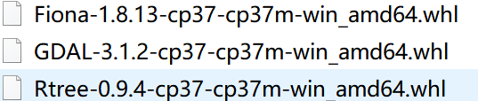
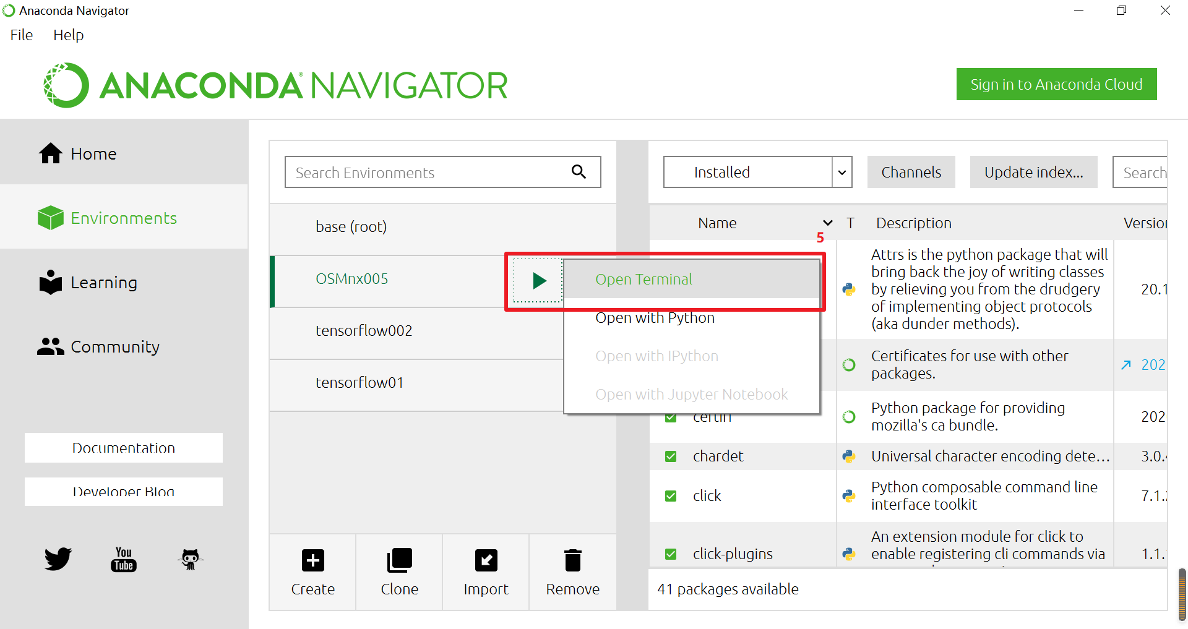
Step 3: Install OSMnx, Type a command line: pip install osmnx
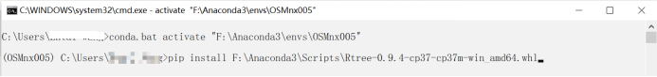
Step 4: Open the Python IDE such as Pycharm for a typical configuration.

3.How to use OSM2GMNS?
We will use the city of Tempe as an example to illustrate how to use OSM2GMNS tool.
Step 1: Determining the research boundary of the map
For example, we want to obtain the map data of Tempe campus of ASU, with a boundary shown in the map below.
First, please adjust the map to the location of interest:
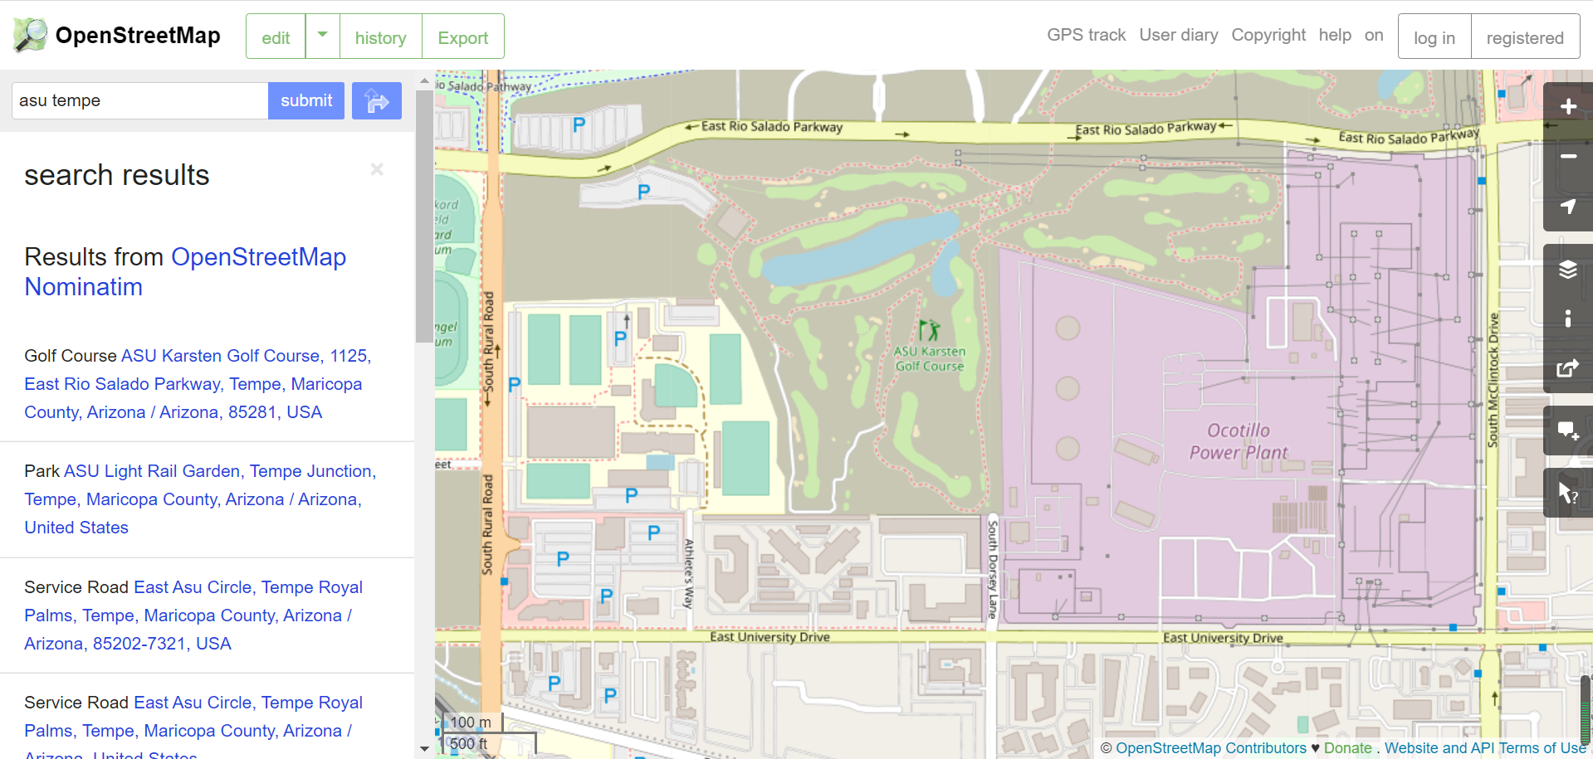
Second, click on the “export” button:
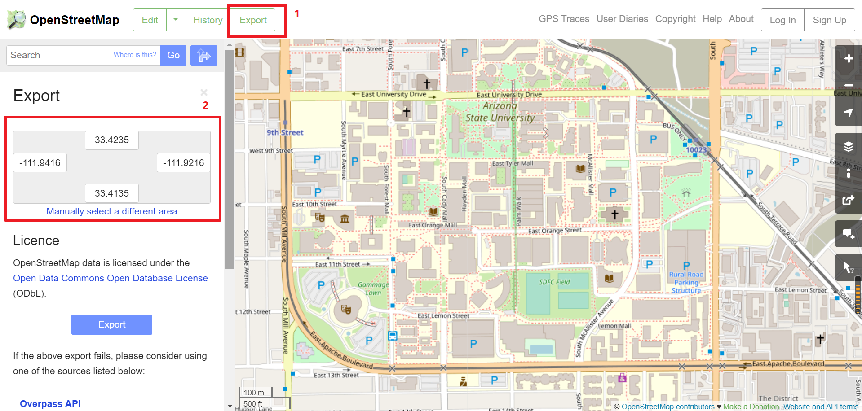
Then, we can obtain the latitude and longitude coordinate range on the left side of the window. Please take a note about 4 coordinate values. In this example, the four values are 33.4135, 33.4235, -111.9216, and -111.9416, to be used as the input for bbox in the Python code.

Step 2: Determining the parameters of the map crawler
Go to the Python environment and modify the bbox parameter as bbox = [33.4135, 33.4235, -111.9216, -111.9416] in the codes.
Remarks:
(1) G = ox.graph_from_bbox(*bbox, network_type='all'): 'drive' means that we only obtain vehicle road, and 'all' means that we can obtain all types of roads.
- attributes = ox.graph_to_gdfs(G, edges=False): edges=False means that no link data will be obtained. Similarly, nodes=False means that no node data will be obtained.

Step 3: Running the OSM2GMNS Python code

Step 4: Outputting files
There are three output files, namely node.csv, link.csv, and demand.csv from the OSM2GMNS package. The node and link attributes are saved in node.csv and link.csv respectively, while the O-D demand file is automatically generated with default values.

Step 5: Visualization in NEXTA
You can open the Traffic network project(node.csv) with NEXTA and then the downloaded map data can be visualized with GMNS format(node.csv, link.csv).
