# **Registering the CA certificates to the server and working with the PyFOS under the secured mode, CA.**

There are 2 different ways to update/register certificates on the VM server.

## Method 1: Use of /usr/share/ca-certificates directory:

Go to the /usr/share/ca-certificates directory and then copy <switchIP>.pem and ca.cert.pem files from the /root/ca and /root/ca/certs directories. Change the file permission to 644. Then rename both .pem file to .crt file.

(Note: Change the suffix of these file names have no impact on the contents of these files. Data integrity is preserved even after…)

e.g.,

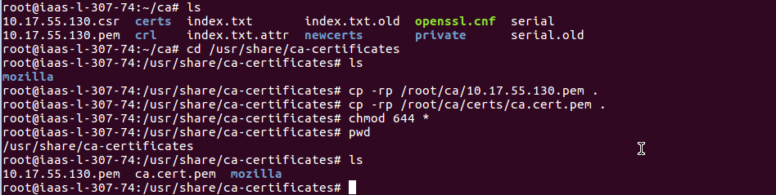



If you are going to use the /usr/share/ca-certificates directory then execute

T

**e.g.,**

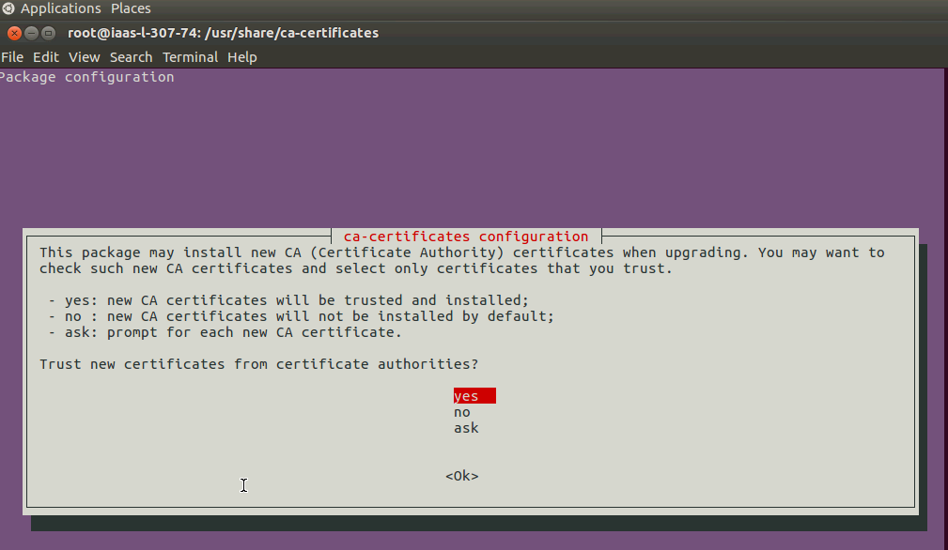

Hit <Enter>. It will bring up another dialog window.

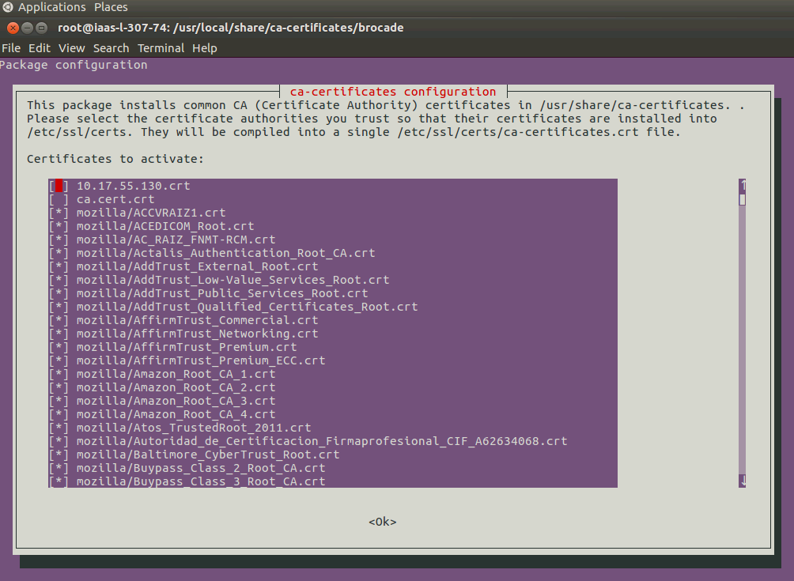

Before you hit <Enter>, check to make sure you see the “ca.cert.crt” and “switchIP.crt” files are present. Then hit <Enter>.

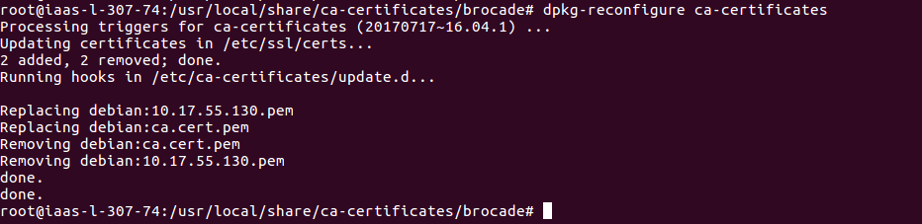

(Note: If you don’t see anything added to the /etc/ssl/certs…” then you probably have to do a method 2 as additional steps.)

Then execute the “**update-ca-certificates**” command.

## Method 2: Use of /usr/local/share/ca-certificates directory:

Go to the /usr/local/share/ca-certificates directory and then create a directory with a 755 permission. Copy <switchIP>.pem and ca.cert.pem files from the /root/ca and /root/ca/certs directories to the newly created directory. Change the file permission to 644. Then rename both .pem file to .crt file.

(Note: Change the suffix of these file names have no impact on the contents of these files. Data integrity is preserved even after…)

Then execute the “update-ca-certificates” command.

e.g.,



