Statute: 1937(a)(1)(B) and (a)(2); 1902(k)(1); 1903(i)(26)
Regulation: 42 CFR 440.305(b) and (c); 42 CFR 440.310; 42 CFR 440.315;
42 CFR 440.320

INTRODUCTION
This is the first in the series of Alternative Benefit Plan (ABP) fillable PDFs (state plan pages) in which the state or territory provides assurances concerning the enrollment of Medicaid beneficiaries into an ABP. This particular state plan page must be completed if the ABP population includes the Adult eligibility group under section 1902(a)(10)(A)(i)(VIII) of the Act, either alone or in combination with other eligibility groups.
In the ABP1 - Alternative Benefit Plan Populations state plan page the state/territory indicates the eligibility groups that are included in the ABPs population. Based on the selection(s) made the appropriate assurances reflected in the state plan pages must be completed. There are three state plan pages, each with a different set of assurances and descriptions of the processes the state/territory will follow to comply with the assurances:
- The ABP2a – Voluntary Benefit Package Selection Assurances – Eligibility Group under Section 1092(a)(10)(A)(i)(VIII) of the Act state plan page pertaining to individuals otherwise exempt from mandatory participation in a section 1937 ABP who are eligible in the Adult eligibility group under section 1902(a)(10)(A)(i)(VIII) of the Act
- The ABP2b - Voluntary Enrollment Assurances for Eligibility Groups other than the Adult Group under section 1902(a)(10)(A)(i)(VIII) of the Act state plan page pertaining to voluntary enrollment requirements for exempt individuals in eligibility groups other than the Adult eligibility group
- The ABP2c - Enrollment Assurances - Mandatory Participants state plan page pertaining to mandatory enrollees regardless of eligibility group

BACKGROUND

Overview
Section 1937(a)(2)(B) of the Act and 42 CFR 440.315 specify the types of Medicaid beneficiaries who are exempt from mandatory enrollment in a section 1937 ABP. (See the Implementation Guide section for the ABP1 - Alternative Benefit Plan Populations state plan page for lists of the categories of these beneficiaries and the eligibility groups that are exempt from mandatory enrollment and those who may be required to enroll.)
Although the above-cited provisions make certain individuals exempt from enrollment in section 1937 Alternative Benefit Plans, all members of the eligibility group under section 1902(a)(10)(A)(i)(VIII) of the Act (hereinafter referred to as the “Adult group”), must be enrolled in an ABP. This is required by sections 1902(k) and 1903(i)(26) of the Act. Therefore those in the Adult group who meet the exemption criteria must be presented with the option to enroll in either an ABP that includes the Essential Health Benefits (EHBs) and is subject to section 1937 requirements or an ABP that is the state/territory’s standard approved Medicaid state plan (not subject to the inclusion of EHBs and section 1937 requirements). This state plan page therefore presents assurances related to these options and requires that the state/territory provide certain information concerning its processes for complying with these assurances.

Exception if Section 1937 ABP Fully Aligned with Medicaid State Plan
The state does not have to complete these assurances if the section 1937 ABP that the state/territory is providing to the Adult group beneficiaries that includes EHBs and is subject to section 1937 requirements and the state/territory’s standard approved Medicaid state plan that is not subject to section 1937 requirements are exactly the same set of benefits including limitations on amount, duration and scope. However, the state/territory is required to explain how it has fully aligned its benefits that comprise the ABP using the EHBs and subject to 1937 requirements with the benefits that comprise the state/territory’s approved Medicaid state plan (not subject to 1937 requirements). Coverage must be the same.
For example, the state/territory’s approved Medicaid state plan must include the same coverage of the EHB preventive services, including a federal definition of minimum coverage for the Essential Health Benefit. Please note, this will likely require a state plan amendment to sections 3.1-A and B to revise the scope of 1905(a) preventive services. Rehabilitative and Habilitative Services and Devices is another EHB that requires alignment and may pose some challenges for states/territories as they try to align the benefits. Additionally, mental health parity requirements must also be met. If the state/territory has aligned the ABP that is its Medicaid approved state plan (not subject to section 1937 requirements) with the Alternative Benefit Plan that includes EHB (subject to section 1937 requirements), then the state does not need to pursue identification and notification of people who might meet the exemption criteria.
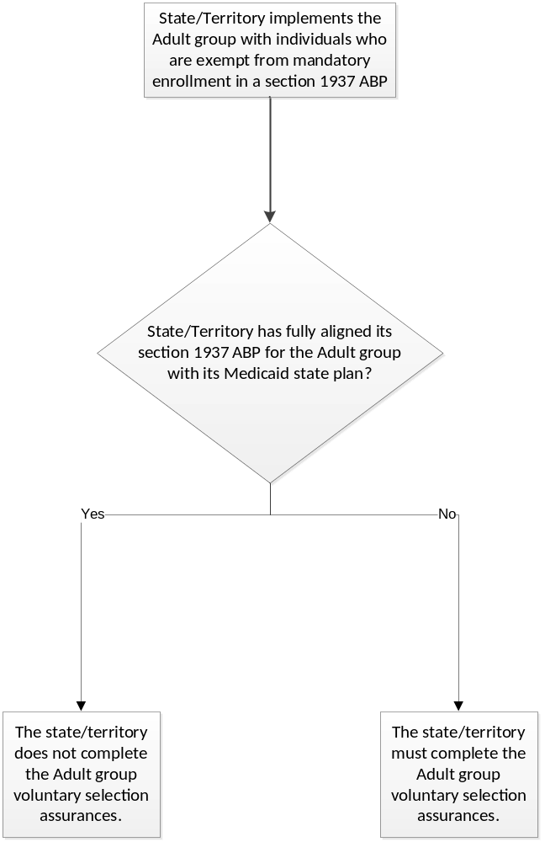

Assurances and Descriptions in State Plan Page
If the state/territory’s ABP for the Adult group (subject to EHB and section 1937 requirements) is not fully aligned with its ABP that is the approved Medicaid state plan (not subject to 1937 requirements), then the state/territory must provide the following assurances:
The state/territory shall enroll all participants in the "Individuals at or below 133% FPL Age 19 through 64" (section 1902(a)(10)(A)(i)(VIII)) eligibility group in the ABP specified in this state plan amendment, except as follows: A beneficiary in the eligibility group at section 1902(a)(10)(A)(i)(VIII) who is determined to meet one of the exemption criteria at 45 CFR 440.315 will receive a choice of a benefit package that is either an ABP that includes EHB and is subject to all 1937 requirements or an ABP that is the state/territory’s approved Medicaid state plan not subject to 1937 requirements. The state/territory’s approved Medicaid state plan includes all approved state plan programs based on any state plan authority, and approved 1915(c) waivers, if the state has amended them to include the eligibility group at section 1902(a)(10)(A)(i)(VIII).

Once an individual is identified, the state/territory assures it will effectively inform the individual of the following:
  - Enrollment in the specified ABP is voluntary;
  - The individual may disenroll from the ABP defined subject to section 1937 requirements at any time and instead receive an ABP defined as the approved state/territory Medicaid state plan that is not subject to section 1937 requirements; and
  - What the process is for transferring to the state plan-based ABP that the state/territory effectively informs any such individuals of the ABP benefit options, that they may disenroll from the section 1937 ABP at any time and enroll in the standard approved state plan ABP, and what the process is for such a transfer,
The state/territory assures it will inform the individual of:
  - The benefits available as ABP coverage defined using section 1937 requirements as compared to ABP coverage defined as the state/territory's approved Medicaid state plan and not subject to section 1937 requirements; and
  - The costs of the different benefit packages and a comparison of how the ABP subject to 1937 requirements differs from the ABP defined as the approved Medicaid state/territory plan benefits.
The state/territory must also indicate and describe how it informs individuals of their options, when it will inform them, and its processes for transferring their coverage from one of the ABP options to the other. It must also accept the following assurance:
The state/territory assures it will document in the exempt individual's eligibility file that the individual:
  - Was informed in accordance with this section prior to enrollment;
  - Was given ample time to arrive at an informed choice; and
  - Chose to enroll in ABP coverage subject to section 1937 requirements or defined as the state/territory's approved Medicaid state plan, which is not subject to section 1937 requirements.
It then must provide a description of how it maintains documentation related to its informing processes.

Finally it must accept the following assurance concerning tracking data associated with voluntarily enrolled individuals:
The state/territory assures that it will maintain data that tracks the total number of individuals who have voluntarily enrolled in either ABP coverage subject to section 1937 requirements or ABP coverage defined as the state/territory's approved Medicaid state plan, which is not subject to section 1937 requirements.

TECHNICAL GUIDANCE

The state/territory must indicate, Yes or No, whether it has fully aligned its benefits in the ABP using EHB and subject to section 1937requirements with its ABP that is the state’s approved Medicaid state plan that is not subject to section 1937 requirements.

- If Yes, the state must provide an explanation in the text box provided of how the state has fully aligned its benefits in the ABP using EHB and subject to 1937 requirements with its ABP that is the state’s approved Medicaid state plan that is not subject to 1937 requirements.
Review Criteria
The explanation should be sufficiently clear, detailed and complete to permit the reviewer to determine that the state/territory’s election meets applicable federal statutory, regulatory and policy requirements. If this standard is not met the SPA cannot be approved.
- If No, the state will be presented with the remainder of the state plan page containing ABP selection assurances for Adult group beneficiaries.

- The state/territory must affirmatively acknowledge that it will comply with the first four assurances.
- The state/territory provides these affirmative assurances by checking the box next to each assurance.
Review Criteria
The state/territory must acknowledge each of the four assurances by checking the box next to each one. If each box is not checked the SPA cannot be approved.
Next the state/territory must:
- Select one or more of the options listed for how the informing will be accomplished.
- If Other is selected, indicate and describe the other informing process.
- Attach to the SPA submission a copy of the letter, email or other communication text that will be sent to the exempt individuals.
- Describe the timeframes associated with informing individuals who are being offered the option of transferring their coverage from a section 1937 ABP to a standard approved state plan ABP.
- Describe its process for allowing these individuals to transfer their coverage from one ABP to the other.

Review Criteria
The descriptions should be sufficiently clear, detailed and complete to permit CMS to determine that the state/territory’s processes meet applicable federal statutory, regulatory and policy requirements. If the descriptions do not meet this standard the SPA cannot be approved.
- The state/territory must affirmatively acknowledge the fifth assurance concerning documenting in the voluntary individual’s eligibility file how he or she was informed of his/her enrollment selection options .
- The state/territory provides this affirmative assurance by checking the box next to the assurance.
Review Criteria
The state/territory must acknowledge the assurance by checking the box next it. If the box is not checked the SPA cannot be approved.

Next the state/territory must:
- Indicate how the informing process is documented by selecting one or more of the options presented.
- If Other is selected, indicate and describe the other method used.
- Select one or more of the options presented to indicate what documentation will be maintained in the eligibility file.
- If Other is selected, indicate and describe what the other documentation is.

Review Criteria
The descriptions should be sufficiently clear, detailed and complete to permit CMS to determine that the state/territory’s elections meet applicable federal statutory, regulatory and policy requirements. If this standard is not met the SPA cannot be approved.
- The state/territory must check the box to affirmatively acknowledge the sixth assurance, that it will maintain data that tracks the total number of individuals enrolled in either a section 1937 ABP or the standard approved state plan ABP and the total number who have disenrolled.
The state/territory provides this affirmative assurance by checking the box next to the assurance.
Review Criteria
The state/territory must acknowledge the assurance by checking the box next it. If the box is not checked the SPA cannot be approved.
- Finally, the state/territory may provide a narrative with any other information it considers important related to how it meets the requirements pertaining to options for enrollment of exempt Adult eligibility group participants in an ABP.

