MITA 4.0

Artifact & Viewpoint Reference Model Document
Version 1.0 | January X, 20XX

Version History
Version | Date | Author | Notes
0.1 | 12/15/2025 | D.Carter | Initial Outline

Table of Contents
1 Document Overview 4
1.1 Document Purpose 4
1.2 Audience 4
2 Architecture Overview 4
2.1 Artifact and Viewpoint Objective 4
2.2 Capability Architecture Overview 4
3 Architecture Component & Relationships 6
3.1 Outcome 7
3.2 Business Process 7
3.3 Information Asset 7
3.4 Application Component 9
3.5 Technical Component 10
4 Architecture Artifacts 10
4.1 Enterprise Architecture Artifacts 10
4.2 Business Architecture Artifacts 10
4.3 Information Architecture Artifacts 10
4.4 Technical Architecture Artifacts 24
5 Concept of Operations (ConOps) 24

Document Overview

Document Purpose
The MITA 4.0 Capability Document was developed to document the proposed framework for classifying the capabilities needed to support a State Medicaid Agency (SMA). It will be used to communicate the proposed framework and gather feedback from the following:
- MITA NexGen Workgroup
- SS-A Workgroup
- MITA Governance Board
- MESC MITA Workshop
Once the proposed framework has been reviewed and approved it will be combined and aligned to other MITA 4.0 reference models developed by the SS-A and MITA NextGen workgroups to create a comprehensive MITA 4.0 Reference Model Document.

Audience
The primary audience for this document includes but is not limited to:
- MITA 4.0 NextGen Members
- MITA 4.0 SS-A Workgroup Members
- MITA Governance Board
- MESC MITA 4.0 Workshop Participants

Architecture Overview

Artifact and Viewpoint Objective
The MITA 4.0 Artifact and Viewpoint Reference Model is a key component of the MITA 4.0 Framework. The primary objective of the reference model is to support the development of consistent architecture artifacts and views to support SMA’s.

Capability Architecture Overview
The MITA 4.0 includes a model for helping SMA’s develop their enterprise architecture incrementally by capability. Each capability will represent a view of the full enterprise architecture for an SMA. The enterprise architecture represents a framework for documenting and aligning the SMA roles, business processes, information and technology to achieve their desired outcomes.

Capability Architecture Definition
A capability architecture is represented through a series of different diagrams, catalogs and matrices that define how the SMA’s roles, business processes, information and technology align to support the delivery of a capability to achieve the SMA’s desired outcomes. The capability architecture helps support the following:
- Ensures IT strategies align with business goals and outcomes.
- Enhances decision-making and helps solve organizational problems.
- Streamline processes, making organizations more agile in responding to changes.
- Reduces IT complexity by standardizing systems and eliminating redundancies.
- Improves efficiency leading to better resource allocation and reduced operational costs.
- Fosters collaboration across departments by providing a shared vision of the organization.
- Establishes governance frameworks that ensure compliance with industry standards.

Capability Architecture Components
The key components that are included in the capability architecture include:
- O: Outcomes – The desired goals and outcomes that the organization would like to achieve that require the capability.
- R: Role – The roles and skills that are responsible for delivering a capability.
- B: Business Process – The processes and activities that are performed to deliver a capability.
- I: Information – The data and information that are accessed and used in order to deliver a capability.
- T: Technology – The applications and technology that are used to automate the delivery of a capability.

Capability Architecture Organization
The Capability Architecture is organized into segments that represent different perspectives
of the capability architecture. The key components of the MITA 4.0 Capability Architecture include the following segments:
- Business Architecture – Provides a view of the enterprise from the business perspective. Responsible for defining and managing the business processes and business roles.
- Information Architecture- Provides a view of the enterprise from the information perspective. Responsible for defining and managing the information and data governance roles.
- Technical Architecture – Provides a view of the enterprise from the technical perspective. Responsible for defining and managing the applications, technology and technical roles.
- Enterprise Architecture – Provides an integrated view of the enterprise that brings together business, information and technical architectures. Responsible for defining and managing items that impact all architectures including the outcomes, requirements, etc.

Capability Architecture Artifacts
Capability architecture is usually represented by means of one or more architecture models that together provide a coherent description of the full capability architecture. A single, comprehensive model is often too complex to be understood and communicated in its most detailed form, showing all the relationships between the various components. As with the architecture of a building, it is normally necessary to develop multiple views of the architecture, to enable the architecture to be communicated to, and understood by, the different stakeholders in the system.

The Capability Architecture is defined through a series of different artifacts. These artifacts represent a specific perspective or view of the capability architecture. Although there is one capability architecture, each view of the capability architecture will represent a part of the overall architecture and will be developed to support specific stakeholder’s concerns. The view will represent one of the following:
- Catalog Views - Structured lists that present key architectural elements within a system. These elements can include business functions, applications, data entities, roles, technologies, or any other components relevant to the architecture. Catalog views help stakeholders understand the scope and content of the architecture, supporting activities such as gap analysis, impact assessment, and governance.
- Matrice Views - A tabular format illustrating relationships or mappings between different architectural elements. For example, a matrix can show how business processes relate to applications, which roles access specific data, or how requirements are addressed by different components. These views are valuable for identifying dependencies, overlaps, or gaps, and for supporting decision-making regarding integration, compliance, and optimization.
- Diagram Views - Graphical representations that visually depict the structure, relationships, and interactions among various architectural elements. Diagrams can take many forms, such as flowcharts, network diagrams, entity-relationship diagrams, or component diagrams. These views are especially useful for communicating complex concepts in an accessible and intuitive manner, facilitating shared understanding among technical and non-technical stakeholders.

Architecture Component & Relationships

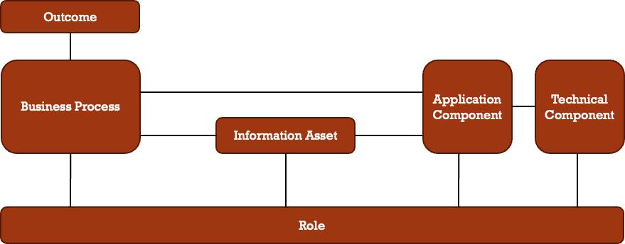

Outcome
TBD

Role
TBD

Business Process
TBD

Information Asset
The information asset represents a valuable piece of information that is organized and managed by the SMA. The information assets identified in the MITA framework are identified as either one of the following:
- Baseline Information Asset – A valuable piece of information that is currently used by an organization to support their current business processes. These assets are used by the organization for decision-making and operational efficiency. Examples include:
- Database
- Data Warehouse/Data Lake
- Data File
- Target Information Asset – A valuable piece of information that is needed to support target business processes and will enable the organization to make decisions that meet their desired outcomes. The target information asset is conceptual and helps identify data needs and requirements.

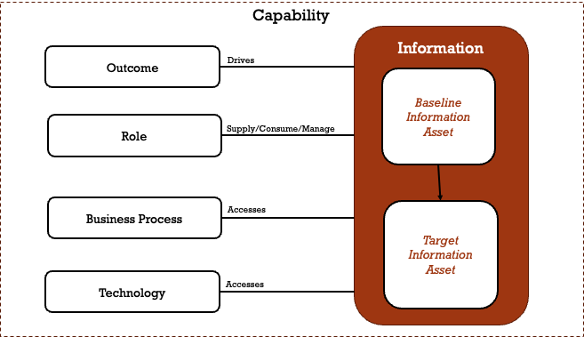
Figure 1 - Information Asset in Context

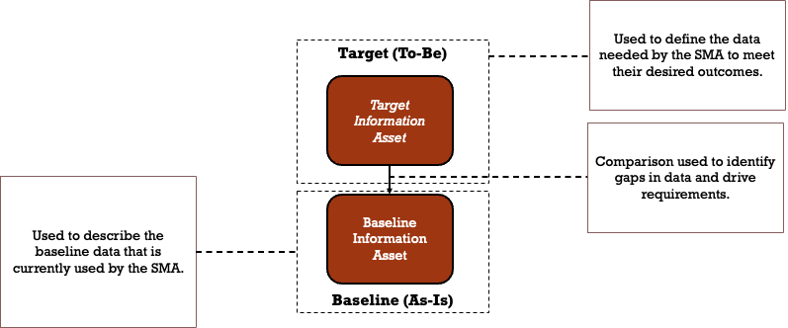
Figure 2 - Baseline and Target Information Asset Use

Application Component
TBD

Technical Component
TBD

Architecture Artifacts

Enterprise Architecture Artifacts
TBD

Business Architecture Artifacts
TBD

Information Architecture Artifacts
In the journey toward a mature and well-managed information architecture, SMAs should develop a standardized set of artifacts that provide structure, clarity, and governance over their information assets. These artifacts serve as foundational tools that enable organizations to systematically capture, document, and align data with business processes, applications, and rules. By employing a consistent framework of artifacts - including catalogs, matrices and diagrams - enterprises can achieve a holistic understanding of their data landscape. A standardized set of information architecture artifacts offers significant benefits as an enterprise matures its data capabilities. This structured approach not only facilitates better decision-making and operational efficiency but also ensures compliance, data quality, and agility in responding to evolving business needs. They promote clear communication and shared understanding among stakeholders, bridging gaps between business and IT teams. Some of these artifacts are foundational and should be developed and maintained at all levels of information maturity. Others are introduced as the SMA evolves their governance and establish a “one enterprise” view of their information assets.

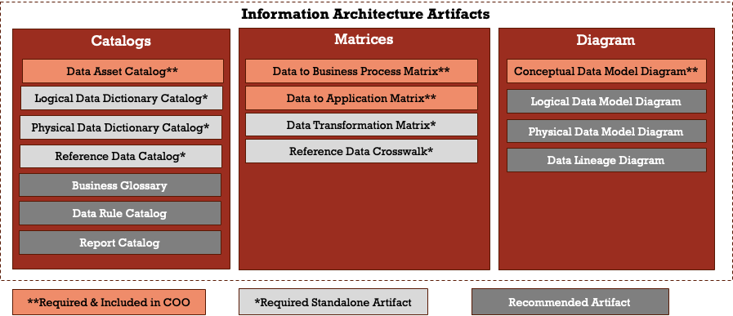

Data Asset Catalog
A list of all the data used across the enterprise, including data entities and the datasets, databases, files, and data repositories where data entities are stored. A data catalog supports the definition and application of information management and data governance policies and encourages effective data sharing and re-use.

Item | Description
Artifact | Data Asset Catalog
Requirement | Required at MITA Maturity Level 1
Associated Uses | Included in Capability ConOps
Stakeholders | Business Capability Owner, Data Owner, Business Data Steward, Data Architect, Data Governance Council
Concerns | Data ownership, data classification, data usage, regulatory compliance
Elements | Information Asset
Type | Catalog
Documentation Approach | Table that contains the following fields:  - Data Asset Name  - Data Asset Description  - Data Asset Type: Data At Rest, Data in Motion  - MITA 4.0 Data Domain  - Baseline Data Standard  - Target Data Standard

Data to Business Process Matrix
A matrix that maps data entities or data sets to the business processes that create, use, or modify them. This matrix helps organizations understand how data supports key business operations, identify critical data, and assess the impact of process or data changes.

Item | Description
Artifact | Data to Business Process Matrix
Requirement | Required at MITA Maturity Level 1
Associated Uses | - Included in Capability ConOps  - Included in Enterprise ConOps (Concept Only)
Stakeholders | Business Process Steward, Business Data Steward, Technical Data Steward, Business Analyst, Data Architect, Compliance Manager
Concerns | Data ownership, process-data alignment, regulatory compliance, data usage, impact analysis
Elements | Data Entity (or Data Set), Business Process
Type | Matrices
Documentation Approach | Two-dimensional matrix with Data Entities as rows and Business Processes as columns (or vice versa). Matrix cells indicate the relationship (e.g., “Created”, “Used”, “Modified”, “Archived”) between data and process. Cells may be annotated with CRUD or similar codes.

Data to Application Matrix
A matrix that maps data entities or data sets to the applications that create, use, update, or delete them. This matrix helps identify data ownership, integration points, data redundancy, and supports impact analysis for changes in data or applications.
Item | Description
Artifact | Data to Application Matrix
Requirement | Required at MITA Maturity Level 1
Associated Uses | - Included in Capability ConOps  - Included in Enterprise ConOps (Concept Only)
Stakeholders | Data Architect, Business Process Steward, Technical Data Steward, Business Data Steward, Business Analyst, Data Owner, Chief Data Officer
Concerns | Data redundancy, data integration, ownership, system dependencies, data flow, change impact, data lifecycle management, compliance
Elements | Data Entity (or Data Set), Application
Type | Matrices
Documentation Approach | Two-dimensional matrix with Data Entities as rows and Applications as columns (or vice versa). Matrix cells indicate relationships such as “Create”, “Read”, “Update”, “Delete” (CRUD) or other relevant interactions.

Conceptual Data Model
A Conceptual Data Model Diagram provides a high-level, business-oriented view of an organization’s core data entities and their relationships. It focuses on defining what data is important, using business language, and is independent of technology or detailed data structure.

Item | Description
Artifact | Conceptual Data Model
Requirement | Required at MITA Maturity Level 2
Associated Uses
Stakeholders | Business Analyst, Data Architect, Technical Data Steward, Business Capability Owner, Business Data Steward; Business Subject Matter Expert, Data Governance Council
Concerns | Business terminology alignment, scope definition, stakeholder consensus, data requirements gathering, conceptual clarity
Elements | Entity (business concepts), Relationship (associations between entities); typically, no attributes or only key attributes are shown
Type | Matrices
Documentation Approach | High-level Entity-Relationship Diagram (ERD) notation, simple rectangles for entities, labeled lines for relationships, business-oriented names, minimal or no attributes, no technical or implementation details

Data Dictionary
Detailed definitions and descriptions of data elements within a logical or physical data model. It includes data types, allowable values, relationships, and business meanings, supporting data consistency and clarity across applications and systems.
Item | Description
Artifact | Data Dictionary
Requirement | - Logical Data Dictionary – Required at MITA Maturity Level 3  - Physical Data Dictionary – Required at MITA Maturity Level 3
Associated Uses
Stakeholders | Data Governance Council, Business Subject Matter Expert, Data Architect, Data Steward, Technical Data Steward, Data Analyst, Business Capability Owner, Business Process Steward, Business Analyst; Compliance Manager; Privacy Officer
Concerns | Data consistency, semantic clarity, metadata management, naming conventions, data quality, compliance
Elements | Data Element (Field/Attribute), Data Type, Allowed Values, Description, Relationships
Type | Catalog
Documentation Approach | Table for each data asset that contains the following:  - Data Element Name  - Data Element Description  - Data Field  - Data Field Type  - Data Field Description  - Data Filed Size and Precision (Physical)  - Indexing Options (Physical)  - Constraints and Default Values (Physical)  - Allowed Values (Code Set & Values)  - Primary/Foreign Key Indicators

Reference Data Catalog
A Reference Data Catalog contains standardized sets of data used across multiple systems and applications. It includes non-volatile, predefined data such as codes, classifications, and enumerations, ensuring consistency and interoperability across the organization.
Item | Description
Artifact | Reference Data Catalog
Requirement | Required at MITA Maturity Level 3
Associated Uses
Stakeholders | Business Data Steward, Business Analyst, Technical Data Steward, Data Architect, Data Owner, Chief Data Officer
Concerns | Consistency of reference data, standardization, version control, data governance, integration across systems
Elements | Reference Data Set, Code, Description, Valid Values, Version
Type | Catalog
Documentation Approach | Table for each data asset that contains the following:  - Reference Data Set Name  - Code (unique identifier)  - Description  - Valid Values  - Version Information

Reference Data Crosswalk
A crosswalk provides a mapping between reference data values used in different systems, domains, or standards. It enables interoperability, data integration, and consistency by aligning codes or values such as country codes, statuses, or terminologies across platforms.
Item | Description
Artifact | Reference Data Crosswalk
Requirement | Required at MITA Maturity Level 3
Associated Uses
Stakeholders | Business Data Steward, Business Analyst, Technical Data Steward, Data Architect, Data Owner, Chief Data Officer, Compliance Officer
Concerns | Data consistency, value alignment, interoperability, integration accuracy, compliance with standards, change management, documentation
Elements | Source Reference Value, Target Reference Value, Source System, Target System, Mapping Rule, Description
Type | Matrices
Documentation Approach | Tabular crosswalk listing Source Values and corresponding Target Values, with additional columns for System/Standard Name, Mapping Rules, Descriptions, and Effective Dates. Can be implemented in spreadsheets, mapping tables, or data governance tools.

Data Mapping Specification
A detailed specification that defines how data elements from a source system are mapped to corresponding elements in a target system. It documents field-to-field relationships, data transformation rules, and logic for integration, migration, or interface projects.
Item | Description
Artifact | Data Mapping Specification
Requirement | Required at MITA Maturity Level 4
Associated Uses
Stakeholders | Business Data Steward, Business Analyst, Technical Data Steward, Data Architect, Data Owner, Business Capability Owner, Chief Data Officer, Compliance Manager
Concerns | Data accuracy, transformation logic, data integrity, system compatibility, migration risk, traceability, regulatory compliance, documentation quality
Elements | Source Data Element, Target Data Element, Transformation Rule, Data Type, Default Value, Business Rule
Type | Matrices
Documentation Approach | Tabular specification listing Source Fields (with metadata) and their corresponding Target Fields, including columns for Transformation Logic, Data Type Conversions, Default Values, Validation Rules, and Comments. Often implemented in spreadsheets or mapping tools.

Data Transformation Matrix
A Data Transformation Matrix details the processes and rules for converting data from one form to another, often during data migration or integration projects. It ensures data consistency, quality, and alignment with business requirements.
Item | Description
Artifact | Data Transformation Matrix
Requirement | Required at MITA Maturity Level 4
Associated Uses
Stakeholders | Business Data Steward, Business Analyst, Technical Data Steward, Data Architect, Data Owner, Business Capability Owner, Chief Data Officer, Compliance Manager
Concerns | Data accuracy, transformation rules, data lineage, consistency, performance, error handling, compliance
Elements | Source Data, Target Data, Transformation Rules, Mapping, Validation Rules, Error Handling
Type | Matrices
Documentation Approach | Structured matrix or documentation that defines transformations with attributes, including:  - Source Data (origin of data); Target Data (destination of transformed data)  - Transformation Rules (logic and operations applied)  - Mapping (correspondence between source and target)  - Validation Rules (criteria for correctness)  - Error Handling (procedures for managing exceptions)

Business Glossary
A curated collection of business terms and their definitions, used to ensure a common and consistent understanding of vocabulary across the organization. The Business Glossary Catalog clarifies meaning, reduces ambiguity, and aligns business and technical stakeholders on terminology and data usage.
Item | Description
Artifact | Business Glossary
Requirement | Recommended but not required
Associated Uses
Stakeholders | Data Governance Council, Business Subject Matter Expert, Data Architect, Data Steward, Data Analyst, Business Capability Owner, Business Process Steward, Business Analyst; Compliance Manager
Concerns | Terminology consistency, semantic clarity, business-IT alignment, regulatory compliance, communication, standardization, data governance
Elements | Business Term
Type | Catalog
Documentation Approach | Table that contains  - Acronym (If applicable)  - Term  - Term Definition  - Synonyms/Aliases  - MITA 4.0 Data Domain

Data Rule Catalog
A centralized list of data rules that define the policies, standards, and constraints governing the creation, management, and usage of data within the organization. The Data Rule Catalog helps ensure data quality, compliance, and consistency by documenting validation, transformation, privacy, and business rules.
Item | Description
Artifact | Data Rule Catalog
Requirement | Required at MITA Maturity Level 3
Associated Uses
Stakeholders | Data Governance Council, Business Subject Matter Expert, Data Architect, Data Steward, Data Analyst, Business Capability Owner, Business Process Steward, Business Analyst; Compliance Manager, Privacy Officer
Concerns | Data quality, data validation, data integrity, regulatory compliance, data privacy, standardization, data matching, data merging/linking, business process alignment, enforceability
Elements | Data Rule (Validation Rule, Data Matching, Data Merging/Linking)
Type | Catalog
Documentation Approach | Table that contains the following fields:  • Rule Name  - Rule Description  - Rule Type (e.g., validation, data matching, data merging/linking)  - Applicable Data Element/Asset  - Business Rationale  - Enforcement Mechanism  - Compliance Requirement

Report Catalog
A Report Catalog is a comprehensive repository of all reports generated and used within an organization. It documents the purpose, content, structure, and distribution of reports, facilitating efficient report management and access.
Item | Description
Artifact | Report Catalog
Requirement | Required at MITA Maturity Level 3
Associated Uses
Stakeholders | Business Subject Matter Expert, Data Steward, Business Capability Owner, Business Process Steward, Business Analyst; Compliance Manager
Concerns | Report accessibility, accuracy, consistency, distribution, security, version control, alignment with business needs
Elements | Report Name, Description, Data Sources, Frequency, Format, Audience, Owner
Type | Catalog
Documentation Approach | Table that contains the following fields:  - Report Name  - Report Description  - Data Sources  - Frequency  - Format  - Audience  - Owner

Logical Data Model Diagram
A Logical Data Model Diagram provides a detailed representation of the data requirements and structure for a business domain, independent of any specific technology or physical implementation. It elaborates entities, attributes, and relationships, often including data types and cardinality, but not physical storage details.
Item | Description
Artifact | Logical Data Model Diagram
Requirement | Required at MITA Maturity Level 3
Associated Uses
Stakeholders | Data Governance Council, Business Subject Matter Expert, Data Architect, Business Data Steward, Data Analyst, Business Capability Owner, Business Process Steward, Business Analyst
Concerns | Data structure accuracy, normalization, business rule enforcement, integration consistency, data quality, requirements traceability, support for future physical design
Elements | Entity, Attribute (with data types and constraints), Relationship (with cardinality and optionality), Primary and Foreign Keys (logical), Unique Constraints
Type | Matrices
Documentation Approach | UML Class Diagram notation; entities as rectangles, attributes within or linked to entities, relationships as lines with cardinality symbols, explicit naming conventions.

Physical Data Model Diagram
A Physical Data Model Diagram represents the actual implementation of a database, including tables, columns with data types, indexes, constraints, and relationships as they will exist in a specific database management system (DBMS). It provides the blueprint for database creation and optimization, including storage and access methods.
Item | Description
Artifact | Physical Data Model Diagram
Requirement | Required at MITA Maturity Level 3
Associated Uses
Stakeholders | Business Subject Matter Expert, Data Architect, Technical Data Steward, Data Analyst, Business Capability Owner, Business Process Steward, Business Analyst
Concerns | Database performance, storage optimization, indexing, referential integrity, compliance with DBMS standards, physical constraints, security, scalability, backup and recovery
Elements | Table, Column (with physical data types and lengths), Primary Key, Foreign Key, Index, Constraint (e.g., unique, check), View, Partition, Tablespace
Type | Matrices
Documentation Approach | Enhanced Entity-Relationship Diagram (ERD) notation or DBMS-specific modeling tools; tables as rectangles, columns listed within tables, relationships as lines with crow’s foot or other notation, explicit PK/FK indications, physical storage attributes, and DBMS-specific conventions.

Data Lineage Diagram
A Data Lineage Diagram visually maps the flow and transformation of data from its origin to its final destination, illustrating the data’s journey through various systems, processes, and transformations. It is essential for understanding data dependencies, ensuring data quality, and supporting compliance and governance efforts.
Item | Description
Artifact | Data Lineage Diagram
Requirement | Required at MITA Maturity Level 3
Associated Uses
Stakeholders | Business Subject Matter Expert, Data Architect, Technical Data Steward, Data Analyst, Business Capability Owner, Business Process Steward, Compliance Manager
Concerns | Data traceability, accuracy, transformation transparency, compliance, data quality, impact analysis, data governance
Elements | Data Sources, Data Targets, Transformation Processes, Data Stores, Data Flows, Metadata
Type | Matrices
Documentation Approach | Visual diagrams or flowcharts representing data movement and transformation, including:  - Data Sources  - Data Targets  - Transformation Processes (logic and operations applied to data)  - Data Stores  - Data Flows (arrows indicating movement of data)  - Metadata (additional information about data, such as format, quality, and lineage details)

Technical Architecture Artifacts
TBD

Concept of Operations (ConOps)
The concept of operations is a consolidated document that includes all of the key views of an architecture to provide the audience with a general understanding of the SMA’s operations. The MITA 4.0 framework defines the ConOps at (2) different levels including:
- Capability Architecture ConOps – Consolidates the architectural artifacts in a comprehensive document to provide the audience with an understanding of how the organization delivers a specific capability to meet desired goals and outcomes.
- Overall Enterprise Architecture ConOps – Consolidates the architectural artifacts in a comprehensive document to provide the audience with an understanding of how the organization is structured to meet desired goals and outcomes.

